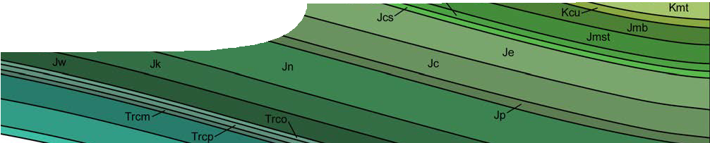
sequence overview
Geothermal energy

Links to the Australian Curriculum: Senior Secondary Physics (Unit 1)

Science understanding concepts include:
Heating processes
Provided a substance does not change state, its temperature change is proportional to the amount of energy added to or removed from the substance; the constant of proportionality describes the heat capacity of the substance (ACSPH020)
Change of state involves internal energy changes to form or break bonds between atoms or molecules; latent heat is the energy required to be added to or removed from a system to change the state of the system (ACSPH021)
Two systems in contact transfer energy between particles so that eventually the systems reach the same temperature; that is, they are in thermal equilibrium (ACSPH022)
Science as a human endeavour concepts include:
Advances in science understanding in one field can influence other areas of science, technology and engineering (ACSPH011)
Scientific knowledge can enable scientists to offer valid explanations and make reliable predictions (ACSPH014)
Scientific knowledge can be used to develop and evaluate projected economic, social and environmental impacts and to design action for sustainability (ACSPH015)
Science inquiry skills concepts include:
Conduct investigations, including using temperature, current and potential difference measuring devices, safely, competently and methodically for the collection of valid and reliable data (ACSPH003)
Select, construct and use appropriate representations, including text and graphic representations of empirical and theoretical relationships, flow diagrams, nuclear equations and circuit diagrams, to communicate conceptual understanding, solve problems and make predictions (ACSPH006)
Select, use and interpret appropriate mathematical representations, including linear and non-linear graphs and algebraic relationships representing physical systems, to solve problems and make predictions (ACSPH007)

Geothermal energy

Geotherma
EXPLORE 1 EXPLAIN 1 ELABORATE 1

ENGAGE

EXPLORE 2 EXPLAIN 2 ELABORATE 2

Background
These SPICE resources can be drawn together into a learning pathway for students to develop their understanding of concepts specific heat and latent heat in the context of use of geothermal energy. The pathway is structured around a constructivist model, based on the 5-Es, where teachers can:
- Engage students’ interest and minds in specific heat and latent heat, through developments in the use of geothermal energy in Western Australia;
- provide opportunities for students to Explore what they know about specific heat and latent heat, particularly in relation to properties of water and its use in energy transfer systems;
- Explain the concepts through models of energy transfer systems that make use of geothermal energy; and
- provide opportunities for students to Elaborate on concepts through problem-solving activities based on case studies and hypothetical scenarios.
The pathway has been designed for teachers of senior school physics but it may also be used with students in earlier years at the discretion of the teacher. Some of these resources might also have relevance to other courses such as, integrated science and earth and environmental science.

Learning pathway
EXPLORE 1 EXPLAIN 1 ELABORATE 1
ENGAGE
EXPLORE 2 EXPLAIN 2 ELABORATE 2
Geothermal energy 1: Heat beneath your feet
Heat beneath your feet comprises a video and teachers guide.
The video engages students by encouraging them to compare their own knowledge to that expressed in a ‘vox pop’. Recent developments and future plans for use of geothermal energy in Western Australia are then described. See the teachers guide for further information on the purpose and use of this resource.
EXPLORE 1 EXPLAIN 1 ELABORATE 1
ENGAGE
EXPLORE 2 EXPLAIN 2 ELABORATE 2
Geothermal energy 2: Specific heat capacity
Specific heat capacity comprises a teachers guide, procedure sheet and worksheet.
This resource enables students to explore the concept of specific heat, through observation and measurement of the specific heat of water, and apply this knowledge to problems. See the teachers guide for further information on the purpose and use of this resource.

EXPLORE 1 EXPLAIN 1 ELABORATE 1
ENGAGE
EXPLORE 2
EXPLAIN 2
ELABORATE 2
Geothermal energy 7: The geothermal alternative
The geothermal alternative comprises a teachers guide, spreadsheet and student worksheets.
This resource deepens the students understanding of concepts addressed in the whole sequence through analysis of data relating to heating a swimming pool and a case study about the use of geothermal energy for a large scale air conditioning system. See the teachers guide for further information on the purpose and use of this resource.

Acknowledgements
Thanks to staff at the Western Australian Geothermal Centre of Excellence, including Professor Klaus Regenauer-Lieb (Director), Professor Hui Tong Chua, Dr Ludovic Ricard, Florian Wellman and Sean Webb (Business Manager).
Designed and developed by the Centre for Learning Technology, The University of Western Australia.
Production team: Anton Ball, Leanne Bartoll, Jan Dook, Alwyn Evans, Bob Fitzpatrick, Dan Hutton, Emma Pointon, Paul Ricketts, Gary Thomas, Jodie Ween and Michael Wheatley, with thanks to Pauline Charman, Jenny Gull, Wendy Sanderson and Charmaine White.

SPICE resources and copyright
All SPICE resources are available from the Centre for Learning Technology at The University of Western Australia (“UWA”). Selected SPICE resources are available through the websites of Australian State and Territory Education Authorities.
Copyright of SPICE Resources belongs to The University of Western Australia unless otherwise indicated.
Teachers and students at Australian schools are granted permission to reproduce, edit, recompile and include in derivative works the resources subject to conditions detailed at spice.wa.edu.au/usage.
All questions involving copyright and use should be directed to SPICE at UWA.
Web: spice.wa.edu.au Email: spice@uwa.edu.au Phone: (08) 6488 3917
Centre for Learning Technology (M016) The University of Western Australia
35 Stirling Highway
Crawley WA 6009

