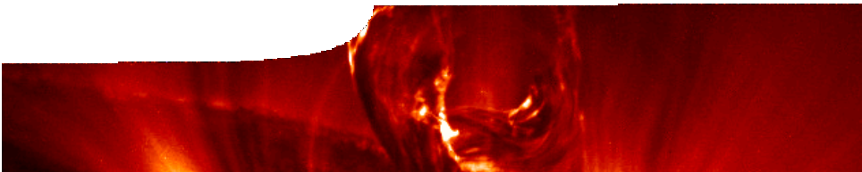
sequence overview
Electric fields

ENGAGE
EXPLORE EXPLAI

Background
N ELABORATE
Four SPICE sequences may be drawn together into a learning pathway for students to develop their understanding of electricity. This pathway deals with concepts associated with electric fields. It is structured around a constructivist model, based on the 5-Es that are interwoven throughout the sequence, where teachers can:
- Engage students’ interest and minds in the concept of fields, through ‘free play’ with magnets, as an introduction to electric fields;
- provide opportunities for students to Explore electric fields by performing an experiment;
- Explain how field diagrams are drawn through use of an interactive learning object;
- Elaborate on concepts about fields by listening to explanations from a theoretical physicist; and
- Evaluate students’ progress throughout the pathway.
Information on the second sequence, Electric fields, can be found in this overview. Information on Static electricity, Current electricity and Elecrical energy can be found in the overviews for these sequences.

STATIC ELECTRICITY | ELECTRIC FIELDS | CURRENT ELECTRICITY | ELECTRICAL ENERGY
This sequence consists of the SPICE resources:  Static electricity 1: Lightning  Engage  Static electricity 2: Exploring electrostatics Explore  Static electricity 3: Explaining electrostatics Explain  Static electricity 4: Electrostatics in action Elaborate | This sequence consists of the SPICE resources:  Electric fields 1: Exploring fields Explore  Electric fields 2: Drawing fields Explain  Electric fields 3: Properties of fields Elaborate | This sequence consists of the SPICE resources:  Current electricity 1: Electronic hearing Engage  Current electricity 2: Circuits  Explore  Current electricity 3: Batteries and cells Explore  Current electricity 4: Modelling electricity Explain  Current electricity 5: Circuit rules  Explain  Current electricity 6: Bioelectricity Elaborate | This sequence consists of the SPICE resources:  Electrical energy 1: Electrical hazards Engage  Electrical energy 2: Electrical safety Explore  Electrical energy 3: Measuring electricity Explore  Electrical energy 4: Electricity account Explain

Electric fields (overview)

ENGAGE
EXPLORE EXPLAI

Activity: magnetic fields

N ELABORATE
The purpose of this activity is for students to:
- consider how bodies carrying a charge can be affected at a distance from other bodies.

The activity:
Start with a teacher-led discussion about magnets and their ability to produce attractive and repulsion effects even at a distance.
Students then engage in ‘free play’ with magnets to experiment with a field that has characteristics similar to an electric field. Students should observe phenomena that occur when magnets are brought close to one another. Students may be asked to
duplicate similar effects with electrostatically-charged objects.
Students should arrive at the idea that forces can act at a distance, and that forces can be both attractive or repulsive. Similarities may be drawn between magnetic and electrical forces and fields.
After their experiments students can report their findings to the class. Reference to similarities between magnetic and electrical fields may be revealed in a teacher-led discussion.

N ELABORATE

ENGAGE
EXPLORE EXPLAI

Electric fields 1: Exploring fields
Exploring fields comprises a teachers guide and student worksheet.
Students perform an experiment, using seeds and oil, to visualise an electric field. See the teachers guide for detailed information on the purpose and use of this resource.

ENGAGE
EXPLORE EXPLAI

Electric fields 2: Drawing fields
Drawing fields comprises a teachers guide, interactive learning object and student worksheet.
Students use an interactive learning object to observe field patterns for different charge/plate combinations. The worksheet may be used to record their observations. See the teachers guide for detailed information on the purpose and use of this resource.

ENGAGE
EXPLORE EXPLAI

N ELABORATE

N ELABORATE
Electric fields 3: Properties of fields
Properties of fields comprises a teachers guide and video.
Students view a video presented by a theoretical physicist who explains the nature of fields. See the teachers guide for detailed information on the purpose and use of this resource.

Acknowledgements
Thanks to Professor Ian McArthur (School of Physics, The University of Western Australia).
Designed and developed by the Centre for Learning Technology, The University of Western Australia.
Production team: Leanne Bartoll, Emma Donnelly, Alwyn Evans, Bob Fitzpatrick, Trevor Hutchison, Paul Ricketts, Gary Thomas, Jodie Ween and Michael Wheatley, with thanks to Roger Dickinson, Jenny Gull and Wendy Sanderson.
Banner image: Filament erupting during a solar flare, seen at EUV wavelengths that show both emission and absorption (the filament has both). TRACE/NASA.

SPICE resources and copyright
All SPICE resources are available from the Centre for Learning Technology at The University of Western Australia (“UWA”). Selected SPICE resources are available through the websites of Australian State and Territory Education Authorities.
Copyright of SPICE Resources belongs to The University of Western Australia unless otherwise indicated.
Teachers and students at Australian schools are granted permission to reproduce, edit, recompile and include in derivative works the resources subject to conditions detailed at spice.wa.edu.au/usage.
All questions involving copyright and use should be directed to SPICE at UWA.
Web: spice.wa.edu.au Email: spice@uwa.edu.au Phone: (08) 6488 3917
Centre for Learning Technology (M016) The University of Western Australia
35 Stirling Highway
Crawley WA 6009

