On this page, draw an invertebrate  
that you have trapped.

Count:

Count:

Tree 4:

Tree 3:

My

Bush

Notebook

Name: ______________________________

My bush area: ________________________

My trap site: _________________________

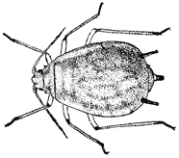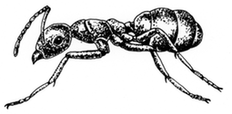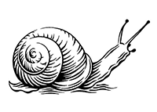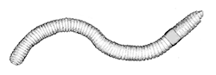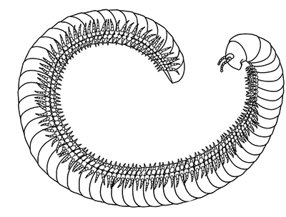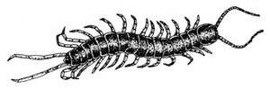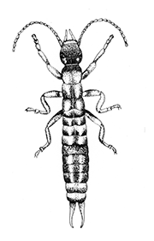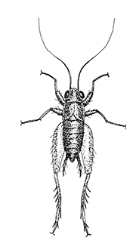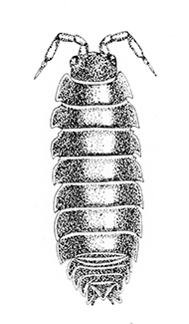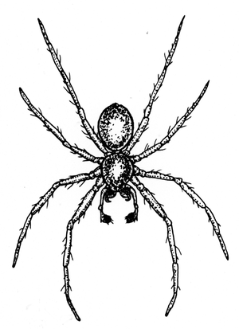

Invertebrates I trapped

Tree 2:

Count:

Things I saw in the bush:

Count:

Tree 1: