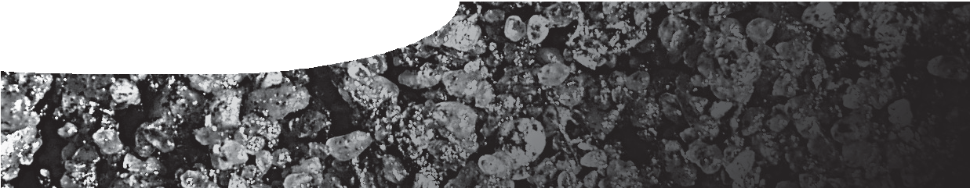
procedure sheet 3
Measuring soil organic matter
SAFETY
Handling soil and compost: Always wear safety glasses. Do not ingest or smell the soil/ compost, and avoid inhaling its dust, since harmful bacteria and fungi could be present. Wash your hands thoroughly with soap and water afterwards.

- Take a soil sample (from which you’ve extracted the soil fauna) and tip it into a large beaker.
- Pour in enough water to double the height of the sample, stir thoroughly to mix and leave to settle.
- Take a piece of filter paper, record its mass, then use it to line a funnel.
- Decant the organic matter. To do this, pour the surface material through the funnel, but leave the lower sediments behind in the beaker.
- Repeat steps 2-4 until you’ve separated off all the organic matter.
- Leave the decanted organic matter and filter paper to dry, then weigh and add its mass to the record sheet.
- Transfer your results to the collected data sheet.

Did you know?
Soil organic matter includes all the plant and animal remains in
the soil.

record sheet
Soil organic matter

sample filter paper (g) filter paper + dried organic dried organic matter
matter (g) (g/sample)
plot A | A1
 | A2
 | A3
mean
plot B | B1
 | B2
 | B3
mean

