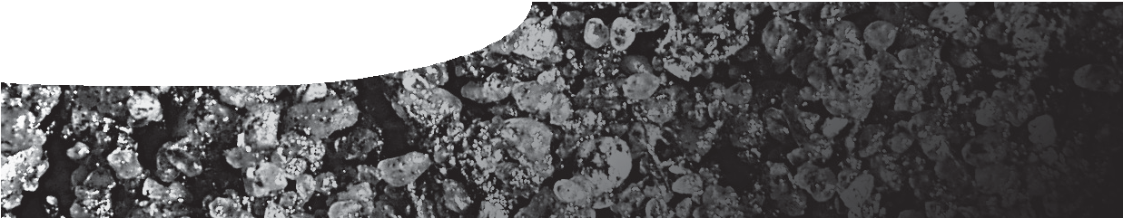
procedure sheet 4
Measuring soil bulk density and soil moisture content
SAFETY
Handling soil and compost: Always wear safety glasses. Do not ingest or smell the soil/ compost, and avoid inhaling its dust, since harmful bacteria and fungi could be present. Wash your hands thoroughly with soap and water afterwards.

- Weigh an ovenproof dish with its lid, and record the mass [W1] in your record sheet overleaf.
- Empty a soil sample (A4 or B4) into the dish, shaking out any loose bits left behind.
- Re-weigh the dish, now with soil sample plus lid, and add its mass [W2] to the record sheet.
- Now repeat with the second sample. Place the dishes into an oven, with their lids off to one side, and leave for 2 hours at 105°C until dry.
- Replace the lid and allow the sample to cool outside the oven, or place in a desiccator.
- Re-weigh the cooled dish with dried soil and lid [W3] and add to the record sheet.
- Calculate dry soil mass.
- Work out the volume of your soil sample.
- Use this information to calculate the soil bulk density.
- Calculate ‘wet’ soil mass, which is the soil’s mass before drying.
- Use this information to determine the soil’s moisture content.
- Transfer your results to the collected data sheet.

record sheet
Soil bulk density & soil moisture

 |  | A4 | B4
W1  (g) | W1 = dish + lid
W2  (g) | W2 = soil + dish + lid
Wet (g) | Wet soil mass = W2 – W1
DRY YOUR SOIL SAMPLE
W3  (g) | W3 = dry soil + dish + lid
Dry (g) | dry soil mass = W3 – W1
V  (cm3) | soil volume = (3.14 x radius2 x ring ht)
soil bulk density (g/cm3) | soil bulk density = Dry / V
moisture content (g) | moisture content = Wet - Dry
soil moisture (% dry soil mass) | soil moisture =  (moisture content / Dry) x 100

