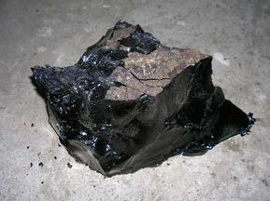
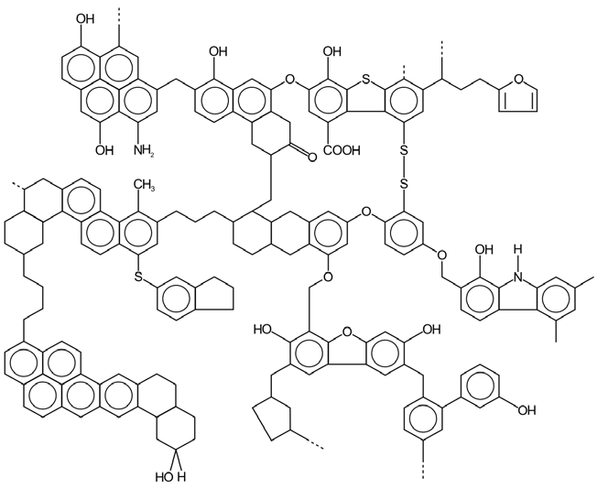
fact sheet
Hydrocarbon chemistry 4:
Hydrocarbon glossary

aviation fuel | There are two broad categories of aviation fuel: jet fuel and aviation gasoline (commonly called ‘avgas’). Jet fuel is typically a blend of C8 to C16 hydrocarbons (similar to kerosene) that is designed to maintain viscosity at low temperatures. Avgas is a highly refined form of petrol with different additives.
biodiesel | Biodiesel is a form of diesel that is produced from animal fats or vegetable oil. Both biodiesel and regular diesel consist of long-chain hydrocarbons (typically C15). However biodiesel has a methyl- or ethyl-ester group at one end of the chain (a mono-alkyl ester).
bitumen | Bitumen (also known as asphalt) is a sticky, black liquid or semi-solid. Although it occurs naturally in oil sands, most bitumen is produced by distillation of crude oil. It’s the residue after material with a lower boiling point (less than 500 °C) has been separated.  Chemically bitumen consists mainly of highly condensed polycyclic aromatic hydrocarbons. The main use for bitumen is road making.  Refined bitumen  http://commons.wikimedia.org/wiki/File:Refined_bitumen.JPG
coal | Coal is formed by the action of heat and pressure on dead plant material in a process called carbonisation. Over time a series of products is produced as the percentage of volatile material decreases, and the percentage of carbon increases.  - Peat is a precursor to coal.  - Brown coal (also called lignite) is used primarily for power generation.  - Black coal is further divided into different grades (eg bituminous coal, steam coal, anthracite).  Example structure of coal  http://commons.wikimedia.org/wiki/File:Struktura_chemiczna_w gla_kamiennego.svg
coal seam gas | Coal seam gas is a form of natural gas that is extracted from underground coal deposits. Like conventional natural gas it consists mainly of methane. Hydraulic fracturing (fracking) is one of several methods used to extract coal seam gas from deep underground.
condensate | When natural gas is extracted from gas fields some components condense as temperature and pressure reduce. These are known as ‘condensate’. Pentane (C5H12) has a boiling point of 36 °C, so is one such component.
crude oil | Crude oil (also known as petroleum) is formed by the action of heat and pressure on microorganisms (typically plankton and algae) buried in sedimentary rocks. It’s a complex mixture of hydrocarbons that includes alkanes in the range C5 to C40, cycloalkanes and a range of unsaturated cyclic hydrocarbons. Crude oil varies in composition:  - light crude oil has low specific gravity (rich in short chain alkanes);  - heavy crude oil has high specific gravity due to more cyclic compounds;  - sweet crude oil has low sulphur content (an undesirable contaminant);  - sour crude oil has high sulphur content.  Benchmark prices are set for crude oil from specific locations: West Texas Intermediate (USA); Brent (North Sea); and Tapis (Malaysia) for example.  Crude oil undergoes fractional distillation to separate specific components, based on their boiling point. These fractions are further processed to modify their properties by cracking (splitting chains); unification (joining chains); and alteration (altering chains).

diesel | Diesel (also diesel fuel or diesel oil) is a fuel for use in diesel engines. Conventional diesel (petrodiesel) is derived from crude oil. It’s the fraction that distils between 200 °C and 350 °C with a composition between C8 and C21.  A petrodiesel substitute, made from animal or plant matter, is called biodiesel. Biodiesel and petrodiesel can be blended: B20 diesel is 20% biodiesel.
gas oil | See fuel oil.
heating oil | Heating oil is a fraction produced by distillation of crude oil. It typically contains hydrocarbons in the range C14 to C20 with boiling point 250 – 350 °C. As the name suggests, its main use is for residential and commercial heating.
fuel oil | Fuel oil is similar to heating oil, but may be rather heavier (ie longer hydrocarbon chains). It is used for heating, and powering ships and trucks.
gasoline | See petrol.
kerosene | Kerosene (also called paraffin) is similar to petrol but much less flammable. It contains carbon chains of C10 to C18 with a boiling point of 150 – 200 °C. Kerosene is a fuel for jet engines and tractors, and is used as a starting material for other products.
LNG | LNG (liquefied natural gas) is natural gas (methane) that has been converted to a liquid by cooling to about -162 °C. This is done to transport gas by ship where pipelines would not be feasible. A cubic metre of natural gas is equivalent to about 1.6 L of LNG (a factor of x600 volume reduction).
lubricant | A wide range of lubricants are manufactured from crude oil. Lubricants reduce friction between surfaces. Motor oils, grease and lubricants are produced from heavy crude oil fractions: long chain alkanes (C20 to C50), cycloalkanes and aromatics with boiling point 300 – 370 °C.
LPG | LPG (liquefied petroleum gas) is a mixture of propane and butane, commonly used for heating, cooking and vehicle fuel. LPG is produced by oil refining. It is also separated from gas and crude oil as they are extracted from natural sources.  LPG cylinders for domestic use http://commons.wikimedia.org/wiki/File:LPG_cylinders.JPG
naphtha | In fractional distillation of crude oil, naphtha refers to the lighter fractions, with low boiling points. Light naphtha is typically a mixture of alkanes from C5 to C9 with boiling point 60 – 100 °C. It is a principal component of petrol. Heavy naphtha (C5 to C12) has a boiling point of 80 – 180 °C and is also used for motor fuel.
natural gas | Natural gas is formed when buried plant and animal remains are subjected to heat and pressure over millions of years. It consists primarily of methane (CH4) with small amounts of other gases.
petrol | Petrol (known as gasoline in North America) is a fuel used in internal combustion engines. It is a mixture of alkanes, alkenes and cycloalkanes with typical chain lengths of C4 to C12.  Petrol spontaneously ignites at about 250 °C — this is called its autoignition point. The octane rating of petrol measures its resistance to autoignition.  ‘E’-rated fuel contains blended ethanol. E10 for example is 10% ethanol and 90% petrol.
petroleum | See crude oil.
sales gas | Sales gas is simply natural gas that has been cleaned up for domestic use by removal of contaminants such as water.
