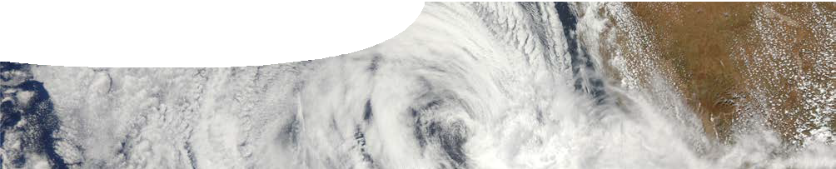
fact sheet
How do cyclones work?
NASA/GSFC/Jeff Schmaltz/MODIS Land Rapid Response Team
V

iolent tropical storms strike fear into the hearts of people in different places on Earth. They are all the same kind of extreme weather system but named differently, depending on where they occur.
In Asia they are known as typhoons, in the Atlantic as hurricanes, and in the Indian and Pacific Oceans they are called tropical cyclones.
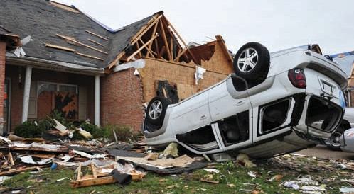
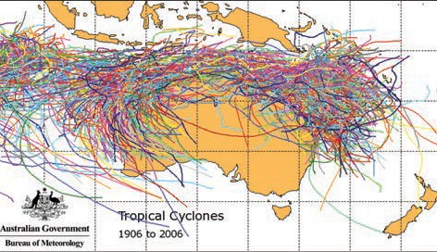
Australians, particularly those living in the north, have learned to live through and survive cyclone season.

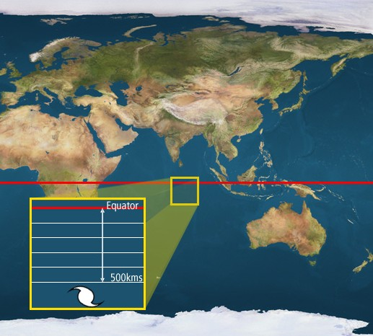
How to start a tropical cyclone
A tropical cyclone starts as a low-pressure disturbance at sea level. Low pressure is caused by warm air above the sea moving upwards and surface winds pushing air in to take its place.
The embryonic cyclone has to be at least 500 km from the Equator, otherwise there is not enough turning force from the Earth’s spin to start air masses rotating. In the southern hemisphere, Earth’s rotation causes inflowing winds to rotate clockwise in a distinctive cyclonic pattern.
Ocean temperatures of at least 26.5 °C, from the surface down to 50 m deep, are needed to provide sufficient energy to the disturbance to turn it into a tropical cyclone. Heat energy from warm water helps keep circulating winds moving.

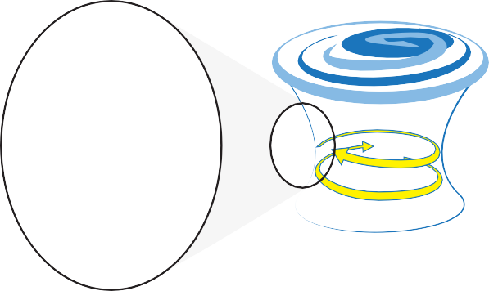How to keep a cyclone going
heat released
water condensing
moist air rising
low pressure disturbance
26.5˚C
Once a tropical cyclone has started, a continuous flow of warm, moist air is essential to keep it going. As moist air rises, water condenses and releases heat, further warming the air, which rushes upwards at greater speed, often increasing the intensity of the system. In
a severe tropical cyclone winds can reach over 280 km per hour and affect areas across hundreds of kilometres.

Meanwhile, at the centre or ‘eye’ of the cyclone, all is relatively calm as falling air prevents clouds and rain from forming.
Winds in the ‘eye of the storm’ can be as low as 10 km per hour.

Right: tropical cyclone Yasi headed toward Queensland, Australia

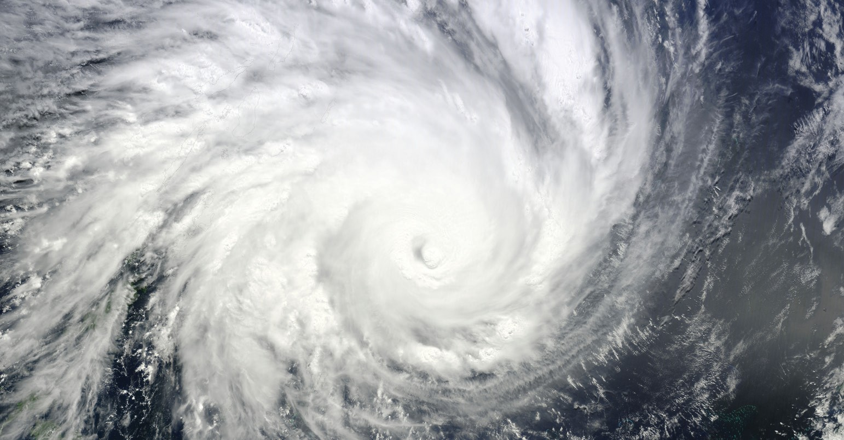

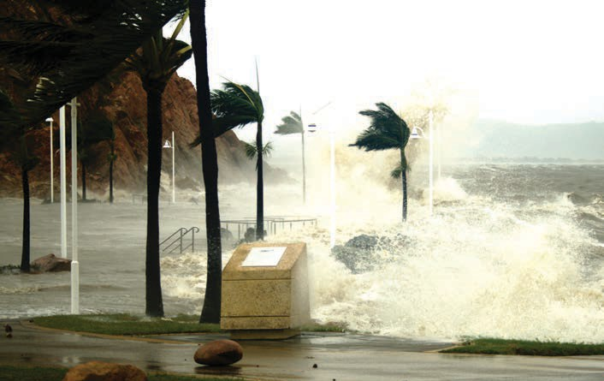
Extremely powerful winds of a tropical cyclone may also produce high waves that result in storm surges along the coast.

In the southern hemisphere, winds at the base of a cyclone move clockwise, but the direction reverses as the circulation reaches the upper atmosphere.
This pattern matches what can be seen on satellite images as clouds stream out from the center of a cyclone in a widening spiral whose beauty belies the destructive forces reeking havoc below.

Torrential rain from moisture-laden air adds to flooding and waterlogging of soil. Trees and previously safe structures may be blown over.

Left: sea surge, photo by Bannon Keft

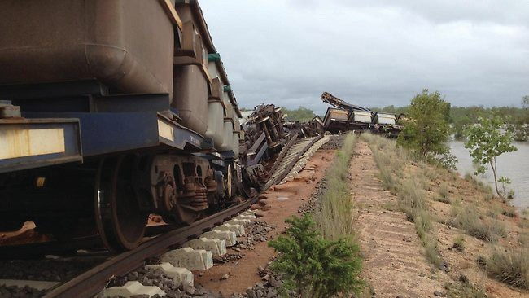

Aftermath of a cyclone
A cyclone that crosses the coast and travels across dry land fades rapidly in strength due to lack of
moisture. However it is likely to become a rain-bearing depression that may cause devastation from flooding.

Right: An iron ore train lies derailed by floodwaters in the Northern Territory, photo by Willem Westra van Holthe MLA

