photo by Mehgan Murphy © Smithsonian National Zoological Park
photo by Alan Hill
photo by Richard L. Anderson, Ph.D.

Central and South America ants and termites
forest and savannah Pilosa
lack teeth, long tongue, specialised lumbar vertebrae, double vena cava, South American origin

sub-Saharan Africa ants and termites
savannah, grassland, woodland Tubulidentata
limbs modified for digging, lack incisors and canines, long tongue

Central, South and North America ants, termites, invertebrates forest, grasslands, semi-arid Cingulata
low metabolic rate, armoured plates, specialised lumbar vertebrae, double vena cava

photo by user:1997, Wikimedia Commons

photo by Marj Kibby

photo by William Warby

Africa herbivorous forest Primates
bipedal, pronounced sexual dimorphism, prognathism (forward jutting of jaw), diminutive (less than 5 feet tall)

worldwide, excluding Arctic and Antarctic
insects, fruit, fish varied Chiroptera
forelimbs modified into wings, possible northern hemisphere origin

Africa omnivorous forest Primates
opposable thumbs, knuckle walkers, large brain case, prognathism (forward jutting of jaw)

photo by Lip Kee
photo by Brian Gratwicke
photo by Emma Pointon

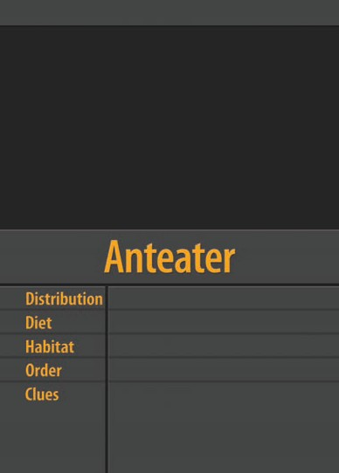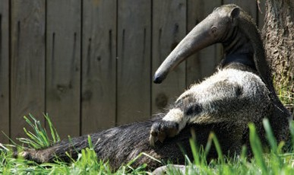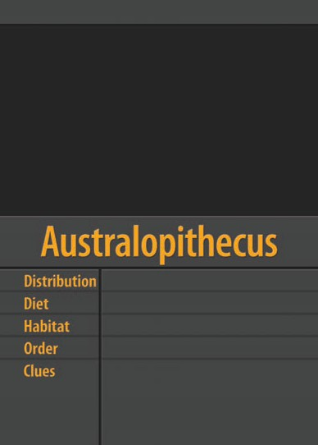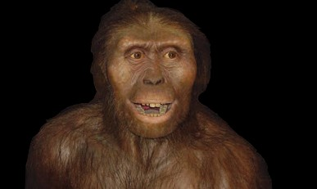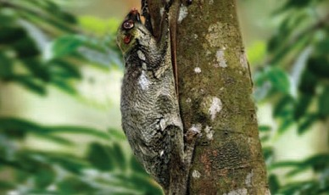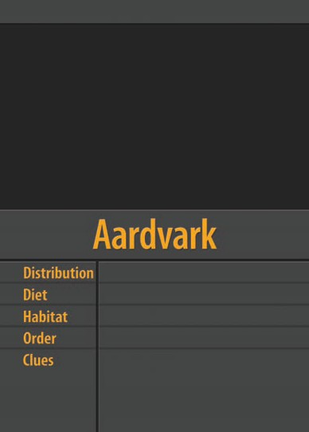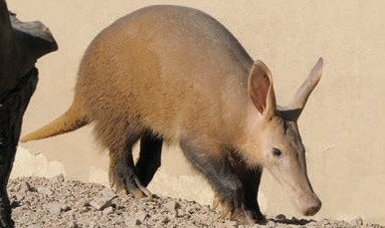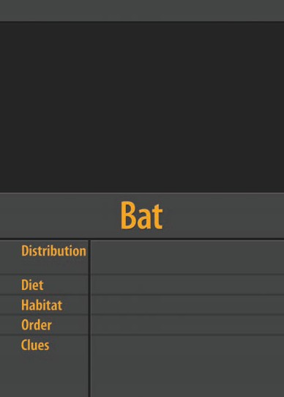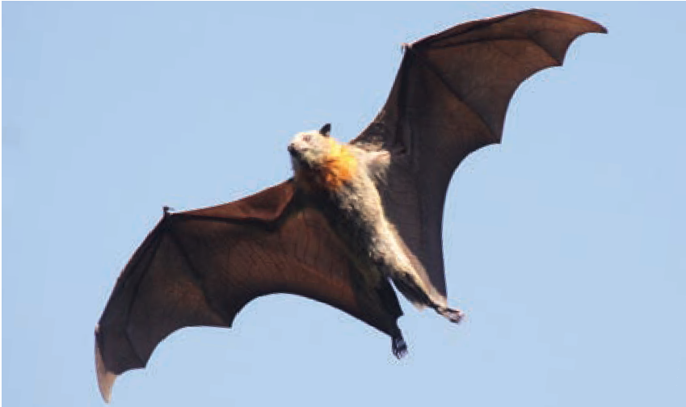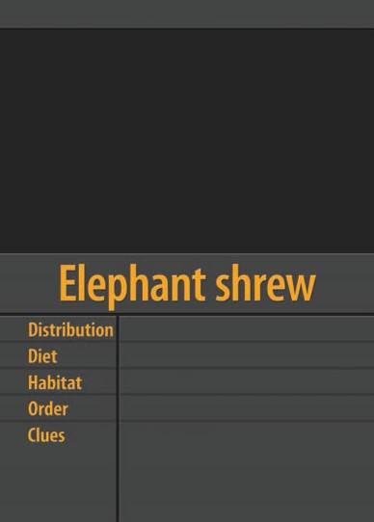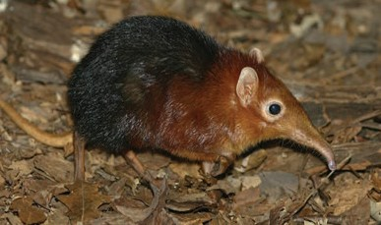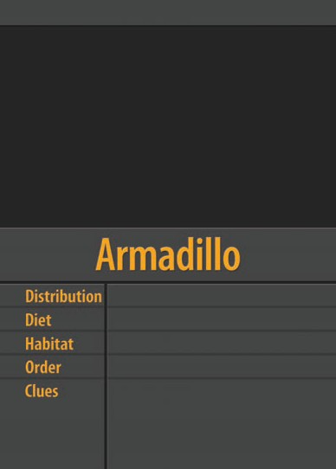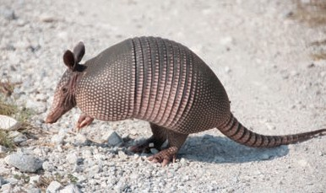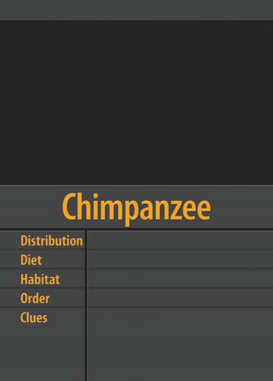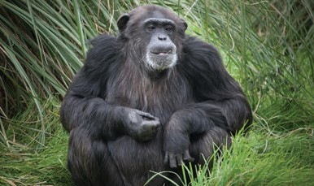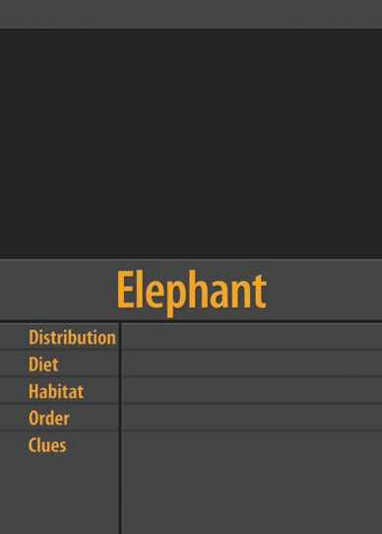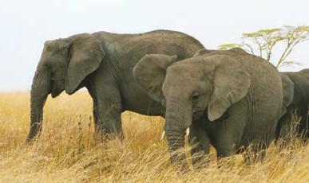
South-east Asia herbivorous arboreal Dermoptera
gliding membrane (patagium), forward facing eyes, lower incisors with comb-like cusps

Africa insectivorous varied Macroscelidea
abdominal testes, teeth similar to the hyrax

Africa and Asia herbivorous
forest, savannah, woodland Proboscidea
incisor tusks, abdominal testes, females with two teats located near the forelimbs

photo by Keith Williams
photo by Paul Ricketts © The University of Western Australia
image by Pavel Riha

Madagascar carnivorous forest Carnivora
carnassial teeth, plantigrade (walks on sole), semi-retractable claws, flexible ankles

South-east Asia herbivorous forest
Primates
opposable thumbs, ball and socket wrist joint, cleft between first and second toes on forefeet

Americas herbivorous grassland Cingulata
shell composed of thick bony plates, lack incisors and canines, South American origin

photo by Galen Rathbun, California Academy of Sciences

photo by William Beem

photo by Jeffrey Kerby

southern Africa insectivorous subterranean Afrosoricida
abdominal testes, cloaca (common urogenital opening), low body temperature

Africa herbivorous forest Primates
opposable thumbs, knuckle walkers, large brain case, prognathism (forward jutting of jaw)

Eurasia and Americas herbivorous
varied Lagomorpha
four continuously growing incisors in upper jaw, lack canines, diastema
(space between incisors and molars), Asian origin

photo by C. Lansley
photo by David Cook Wildlife Photography
photo by Drew Avery

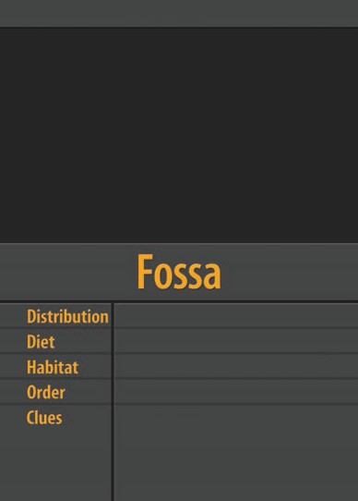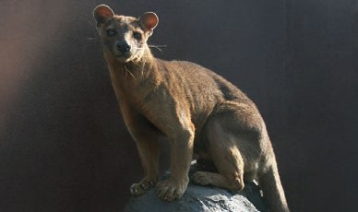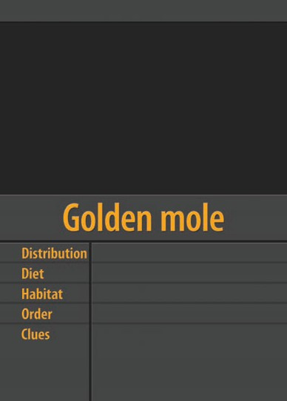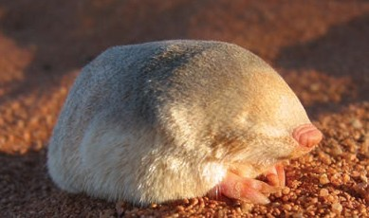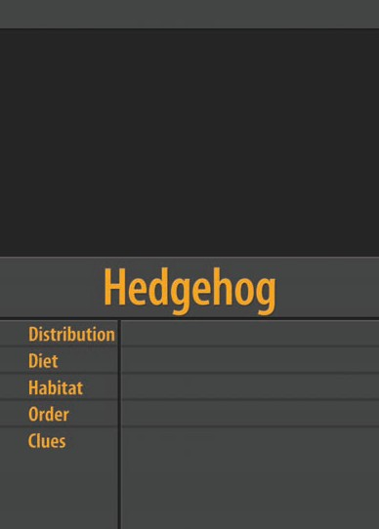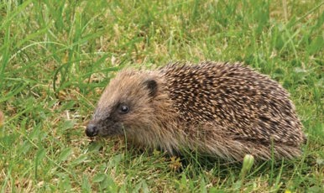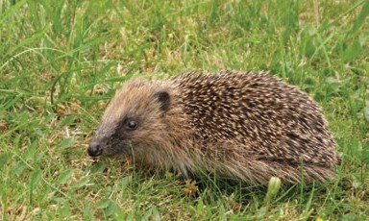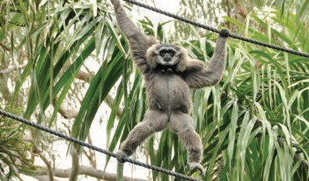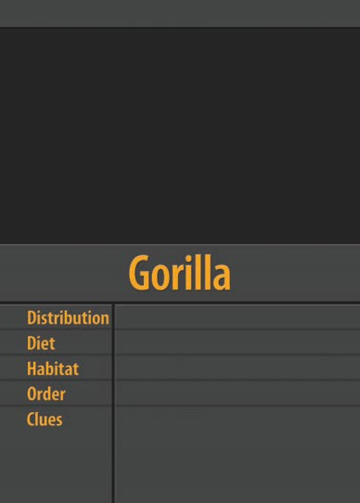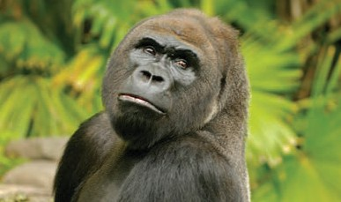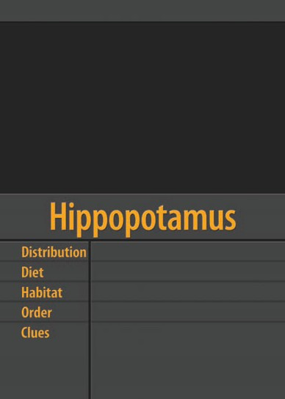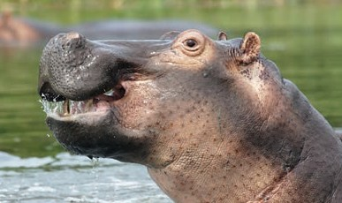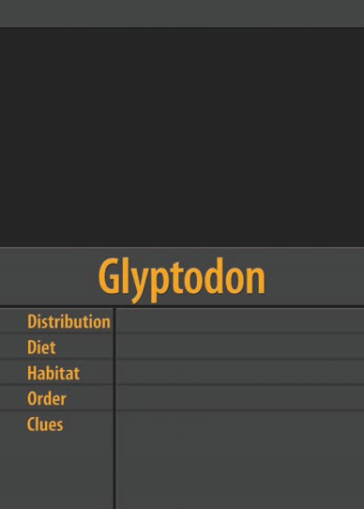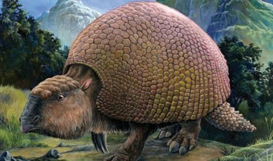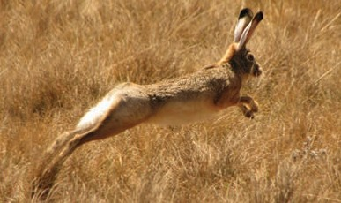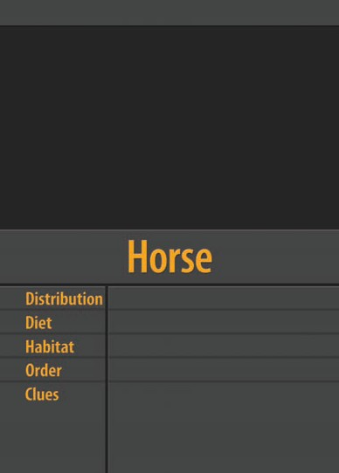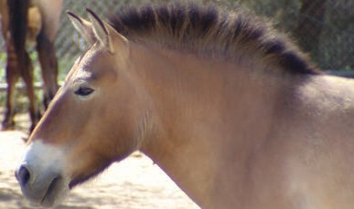
Europe, Asia, Africa insectivorous, omnivorous woodlands Erinaceomorpha
modified hairs form spines, plantigrade (walk on sole), North American origin

Africa herbivorous semi-aquatic Artiodactyla
hoofs, even-toed, shared common ancestry with whale (Cetacea)

Eurasia herbivorous
grassland, savannah, steppe Perissodactyla
hoofs, odd-toed, North American origin

photo by Bec McKinney

photo by Tarique Sani

photo by Steve Harris

worldwide, excluding Antarctica omnivorous
varied Primates
opposable thumbs, precision grip, bipedal, large brain case, reduced prognathism (forward jutting of jaw)

Africa and Middle East herbivorous
rock dwellers and arboreal Hyracoidea
abdominal testes, low body temperature, tusk-like incisors

Madagascar omnivorous, herbivorous varied
Primates
pseudo-opposable thumbs, forward facing eyes, toothcomb (grooming incisors)

photo by Mehgan Murphy © Smithsonian National Zoological Park

image by Dan Hutton © The University of Western Australia

photo by Steve Garvie

Africa, Asia carnivorous savannah, woodland Carnivora
carnassial teeth, digitigrade (walk on the toes), retractable claws, long conical canines

Africa, Europe, Asia, North America herbivorous
savannah, grassland, tundra Proboscidea
incisor tusks, two-finger trunk similar to African elephants

Europe, Asia, Africa, North America omnivorous
subterranean Soricomorpha
polydactyl hands (extra thumb), high metabolic rate, possible northern hemisphere origin

photo by Darren Deans, www.darrendeans.com

photo by Bart Wursten © National Botanic Garden of Belgium

photo by Mark Byzewski

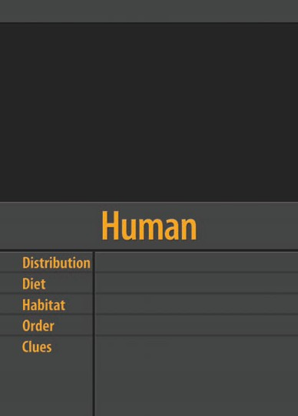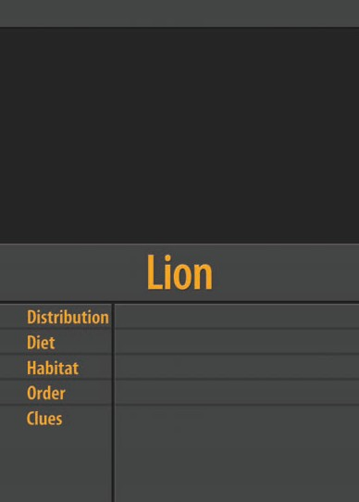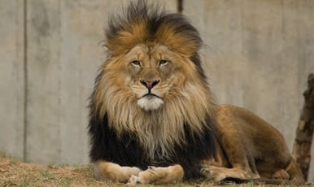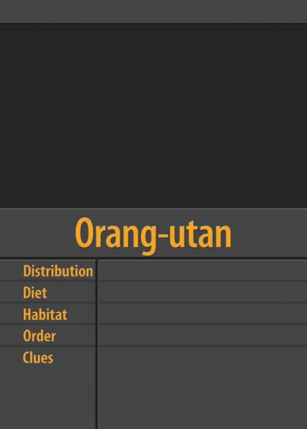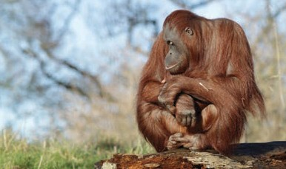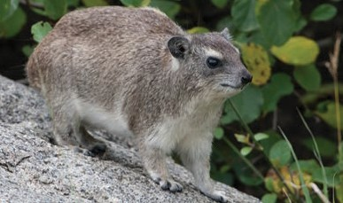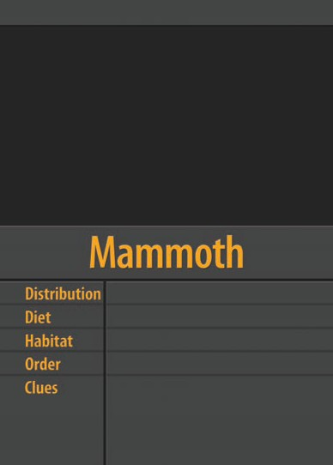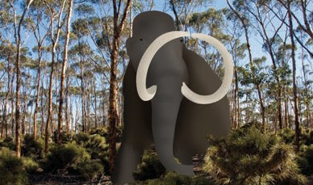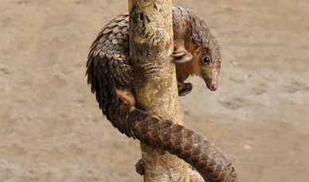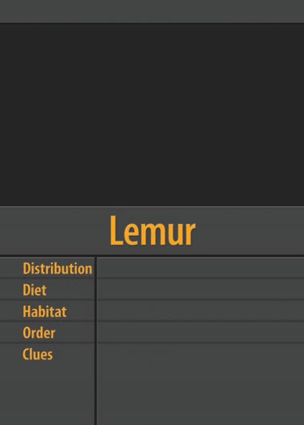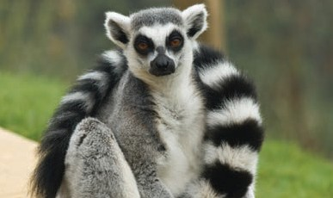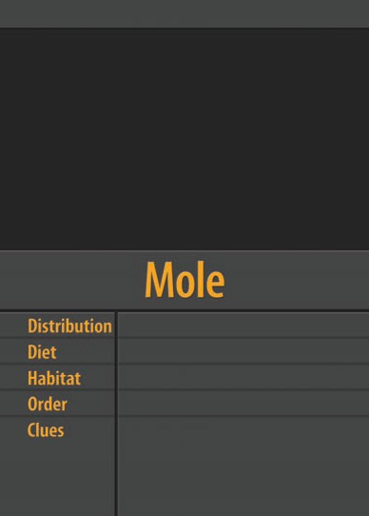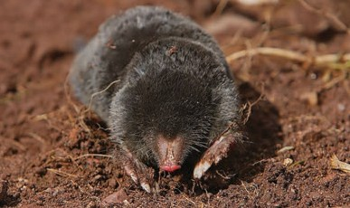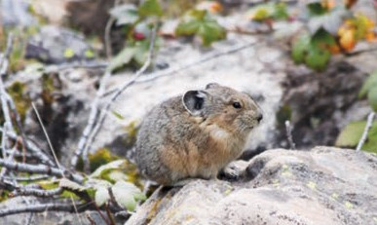
Indonesia and Malaysia herbivorous
forest Primates
opposable thumb, opposable big toe, fist walkers, elongated arms, large brain case, prognathism (forward jutting of jaw)

tropical Asia and Africa ants, termites, invertebrates forest, woodland, grassland Pholidota
overlapping scales, long tongue, lack teeth, European origin

Asia, North America, eastern Europe herbivorous
rocky mountainous terrain Lagomorpha
four continuously growing incisors in upper jaw, lack canines, diastema
(space between incisors and molars), Asian origin

photo by Mary Meagher © U.S. National Park Service

photo by Colin MJP

photo by Henri Bergius

Americas, Europe and Africa herbivorous
varied Rodentia
two continuously growing incisors in upper jaw, lack canines, diastema
(space between incisors and molars), modified hair to form quills

worldwide, excluding Antarctica omnivorous
varied Rodentia
two continuously growing incisors in upper jaw, lack canines, diastema (space between incisors and molars), Laurasian (Eurasian and North American) origin

Africa and Asia herbivorous
forest, savannah, bushland Perissodactyla
hoofs, odd-toed, one or two horns

photo by Keith Ramos © U.S. Fish and Wildlife Service, Endangered Species
photo by Paul Ricketts
photo by Gilles Gonthier

Indian Ocean, western and north Pacific Ocean, Caribbean, Amazon Basin
herbivorous aquatic Sirenia
abdominal testes, incisor tusks, females with two teats located near fore flippers, vestigial toenails

Pacific, Indian, Atlantic, Arctic and Southern Ocean
carnivorous semi-aquatic Carnivora
limbs modified to form flippers, fossil evidence supports terrestrial ancestor

worldwide, excluding polar regions and Australasia
insectivorous, carnivorous varied
Soricomorpha
born with adult teeth, high metabolic rate, possible northern hemisphere origin

photo by henryalien
image by Dan Hutton © The University of Western Australia
photo by Ltshears

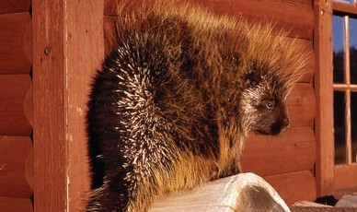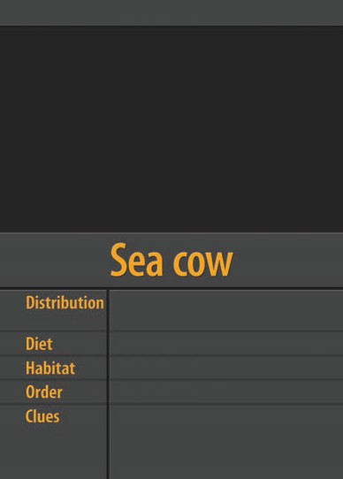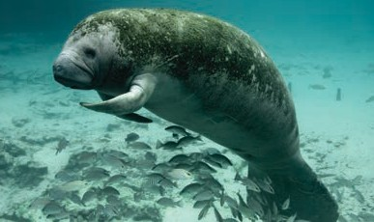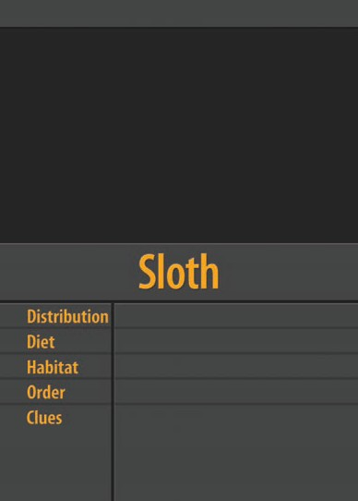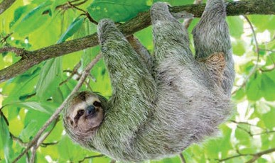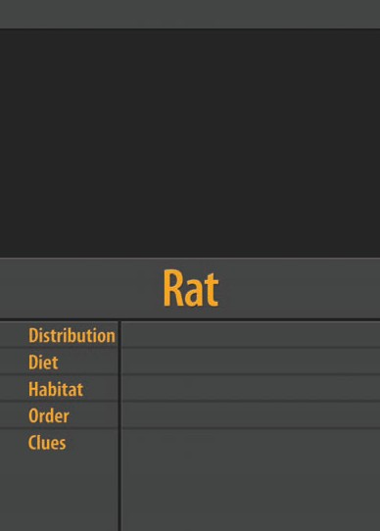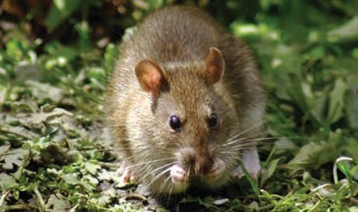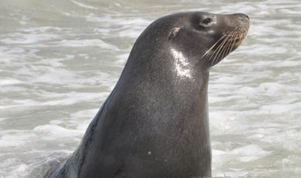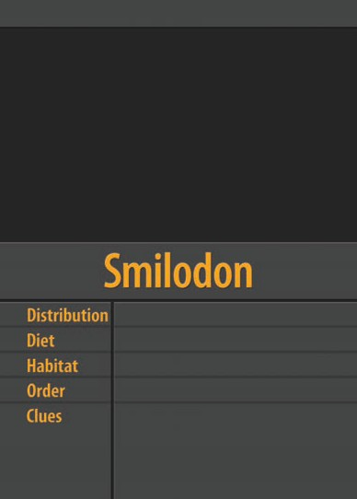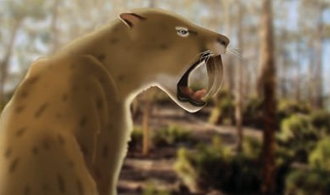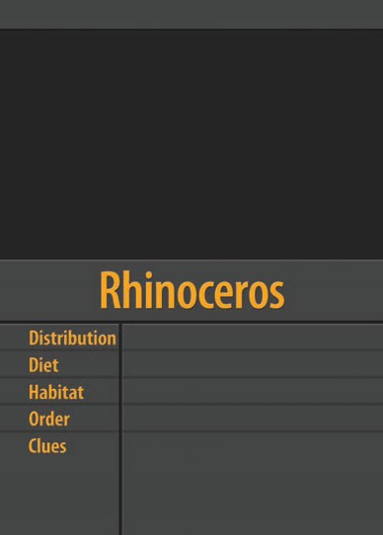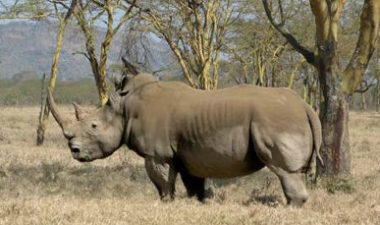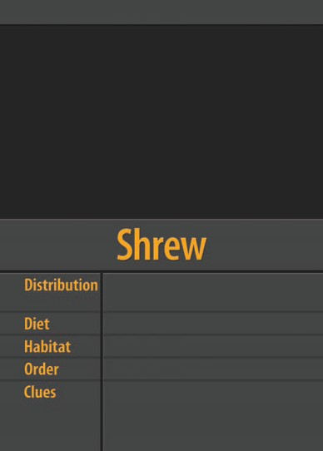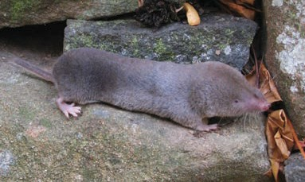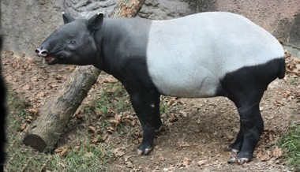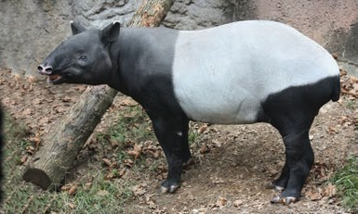
Central and South America folivores (leaf eaters) forest, arboreal
Pilosa
specialised claws, specialised lumbar vertebrae, double vena cava

North and South America carnivorous
grasslands, forest Carnivora
carnassial teeth, extremely long upper canines, North American origin

Central and South America, South-east Asia
herbivorous forest Perissodactyla
hoofs, odd-toed, flexible proboscis (snout), North American origin

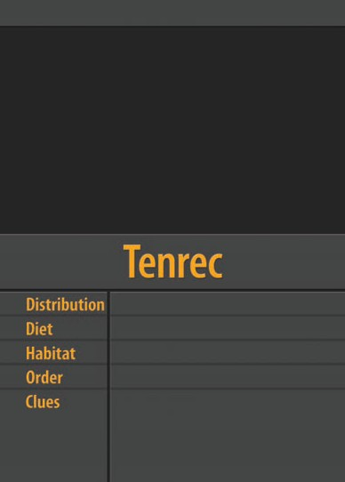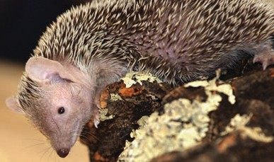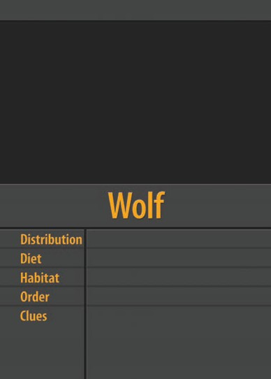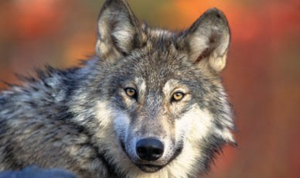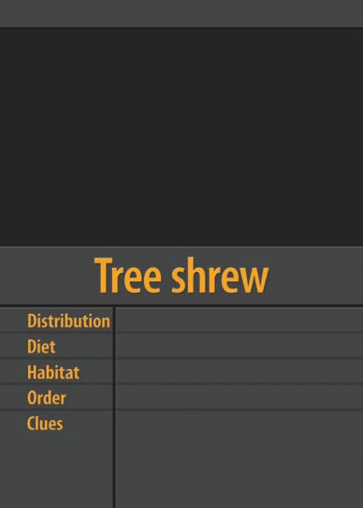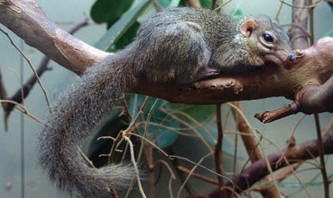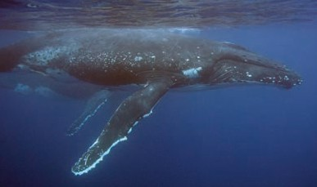photo by Debbie Grant

photo by Joachim S. Müller

photo by National Oceanic and Atmospheric Administration

Madagascar, southern Africa insectivorous
varied Afrosoricida
abdominal testes, cloaca (common urogenital opening), low body temperature

South-east Asia omnivorous forest Scandentia
side-facing eyes, toothcomb (grooming incisors), fossil evidence suggests Asian origin

worldwide oceans krill, fish, squid aquatic
Cetacea
vestigial hind limbs, fossil evidence of terrestrial ancestor, shared common ancestry with hippopotamus

photo by Gary Kramer © U.S. Fish and Wildlife Service

Eurasia, North America, North Africa carnivorous
varied Carnivora
carnassial teeth, digitigrade (walk on toes), Eurasian origin

I’m the common ancestor of a group of mammals known as Afrotheria, that:
- existed 90 million years ago, and
- lived in Africa.

I’m the common ancestor of a group of mammals known as Xenarthra, that:
- existed 100 million years ago, and
- lived in South America.

image by Dan Hutton © The University of Western Australia

Some of my descendants share the following features:
  - cloaca (common urogenital opening),
  - abdominal testes (internal testicles),
  - incisor tusks, and
  - low body temperature.

image by Dan Hutton © The University of Western Australia

All my descendants share the following features:
  - specialised lumbar vertebrae (support the spine),
  - two vena cava (large blood vessel),
  - toothless or reduced number of teeth, and
  - low metabolic rate.

I’m the common ancestor of a group of mammals known as Laurasiatheria, that:
- existed 90 million years ago, and
- lived on the northern supercontinent of Laurasia (Eurasia and North America).
I’m the common ancestor of a group of mammals known as Euarchontoglires, that:
- existed 90 million years ago,
- lived on the Laurasian island group (Europe), part of Laurasia (Eurasia and North America), and
- some of my descendants are the most successful animals on the planet.

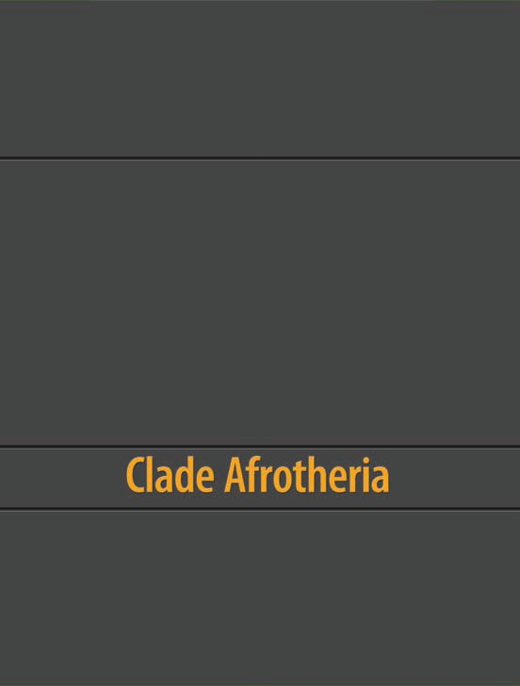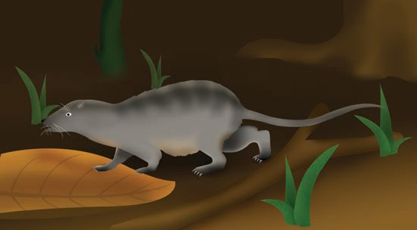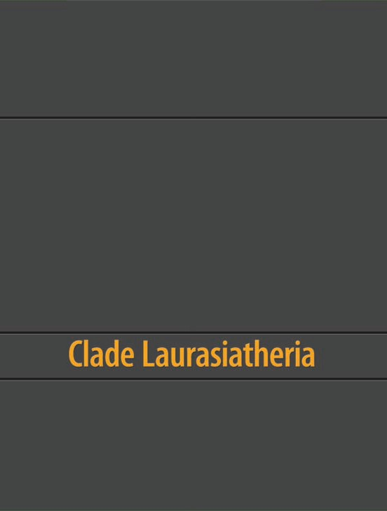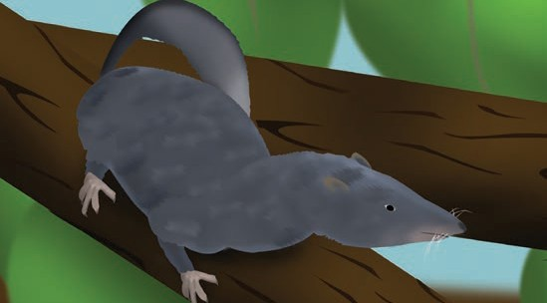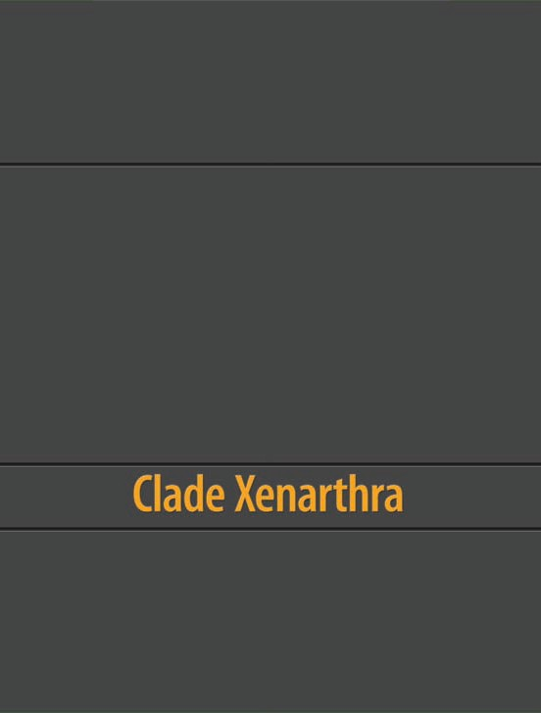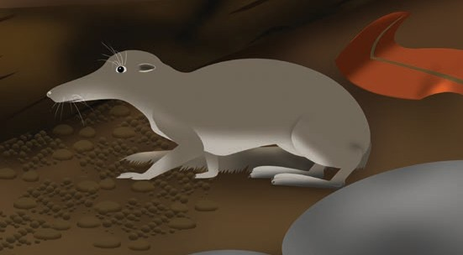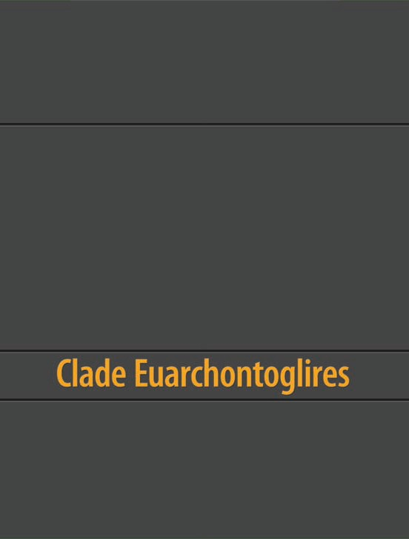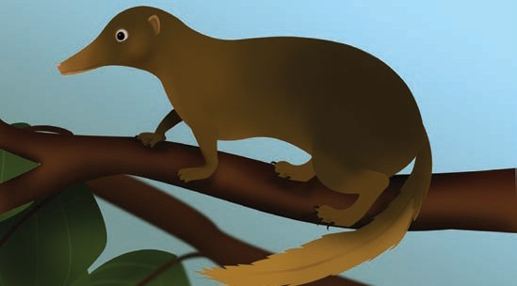image by Dan Hutton © The University of Western Australia

Some of my descendants share these features:
  - hoofs (modified toenails),
  - lengthened limbs (great for a fast getaway), and
  - reduced or missing canine teeth. And others share these features:
  - predominantly carnivorous (prefer meat),
  - well developed canine teeth (great to catch meat), and
  - cheek teeth with cutting edges (carnassial teeth).
image by Dan Hutton © The University of Western Australia

Some of my descendants share a few features:
- lack canine teeth,
- enlarged and continuously growing incisor teeth, and
- gap between incisors and molars (diastema). BUT not all of my descendants have these features.

