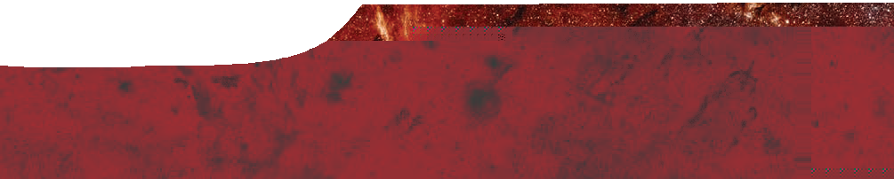
background sheet
Galaxy classification

Galactic Center Survey
credit: NASA, ESA, Q.D. Wang (University of Massachusetts, Amherst), and S. Stolovy (Caltech)

A galaxy is a massive conglomeration of stars, stellar remnants, interstellar gases, dust and dark matter, held together by gravitational forces. There are probably more than 170 billion (1.7 × 1011) galaxies in the observable Universe.
Galaxies range from dwarfs with as few as ten million stars to giants with hundreds of trillions of stars that orbit a common centre of mass. They vary in diameter from a few thousand light years to several hundred thousand light years and are typically millions of light years apart.
Galaxies are distributed unevenly in space. Some have no close neighbour, while others occur in pairs that orbit each other. Most galaxies are found in clusters, which may contain from a few dozen to several thousand members. Clusters of galaxies may group into still larger structures, called superclusters.

The Hubble sequence
In 1926, Edwin Hubble proposed a classification system for galaxies, based on their shape as observed from Earth.
The Hubble sequence divides regular galaxies into three broad classes: elliptical; lenticular and spiral. A fourth class is used for galaxies with irregular appearance.

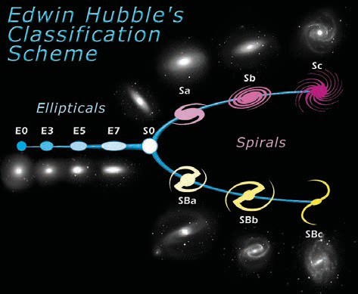
Edwin Hubble’s classification scheme
credit: NASA/ESA, PD, en.wikipedia.org/wiki/File:HubbleTuningFork.jpg

Elliptical galaxies

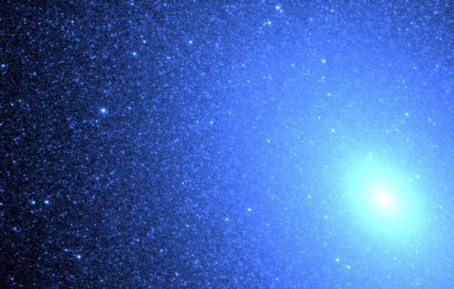
M 32, an elliptical galaxy in the constellation Andromeda
credit: NASA and T. Brown, apod.nasa.gov/apod/ap991103.html

Elliptical galaxies have smooth, featureless light distributions and appear as ellipses in photographic images. They show little evidence of the presence of young stars, gas or dust.
Stars in elliptical galaxies tend to move in more random fashion than those in spiral galaxies.

Lenticular galaxies

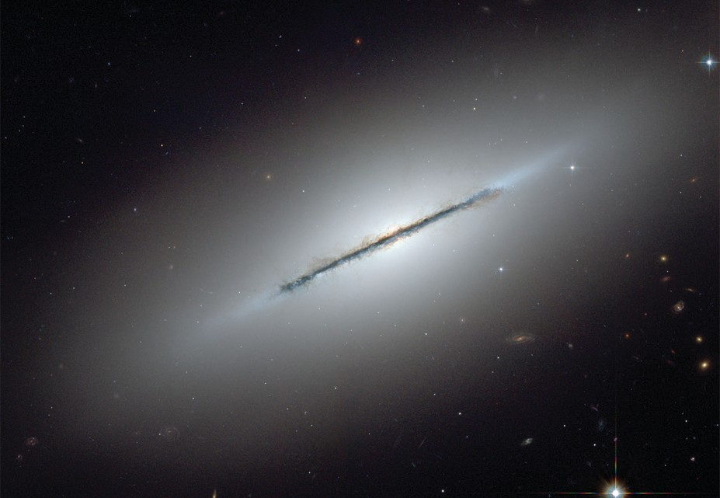
NGC 5866 (the Spindle Galaxy), a lenticular galaxy in the constellation of Draco
credit: NASA, ESA and The Hubble Heritage Team (STScI/AURA)

Lenticular (lens-shaped) galaxies are located on the Hubble sequence where the elliptical branch joins the two spiral arms. These galaxies have a bright central bulge surrounded by an extended disk-like structure.
Some lenticular galaxies have a bar, similar to spiral galaxies. These are called barred lenticular galaxies.

Spiral galaxies
Spiral galaxies consist of a flattened disk with stars that form a spiral structure. There are usually two arms, that may be more or less tightly wound, and a central concentration of stars known as a bulge. Almost half of all spiral galaxies have a bar-like structure, extending from the central bulge and leading to the spiral arms.
The arms of spiral galaxies are prominent because they are regions of active star formation that contain many hot, young, blue and blue-white stars. In contrast, the nucleus of a spiral galaxy is typically more red in colour, which indicates the presence of many old stars.
Stars in spiral galaxies tend to rotate around the galactic centre.

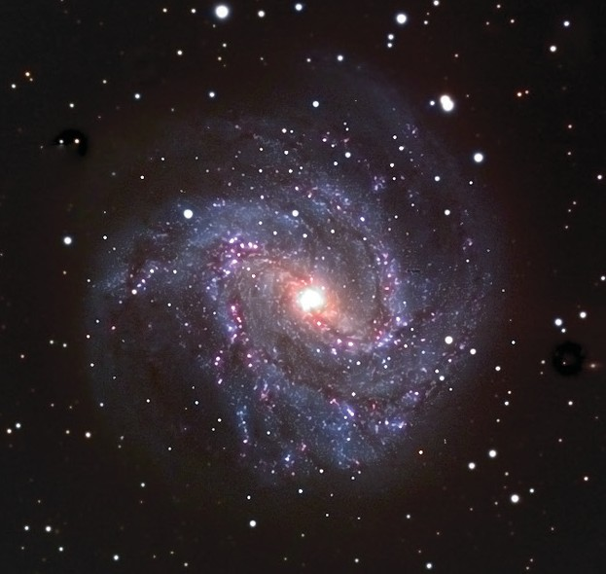
M 83, a spiral galaxy in the constellation of Hydra
credit: SPIRIT

Irregular galaxies
There is also a class of irregular galaxies, which have no regular structure. Astronomers believe distorted shapes of irregular galaxies may be caused by gravitational attraction from neighboring galaxies. The Large and Small Magellanic Clouds are irregular galaxies that orbit the Milky Way galaxy.

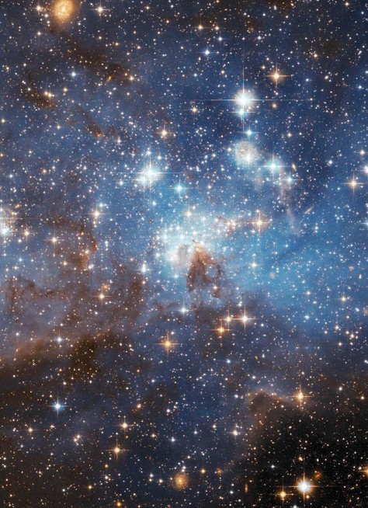
The Large Magellanic Cloud (LMC), a dwarf irregular galaxy. credit: NASA, ESA and the Hubble Heritage Team (STScI/AURA)- ESA/Hubble Collaboration

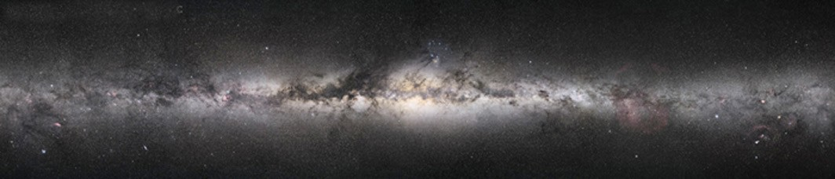

360° photographic panorama of the Milky Way by Digital Sky LLC, CC-BY-SA-2.5, en.wikipedia.org/wiki/File:Milkyway_pan1.jpg

The Milky Way
Our galaxy, the Milky Way, is a giant spiral galaxy, 100 000 light years in diameter, with a mass of around one trillion solar masses. Our Sun is one of several hundreds of billions of stars in the Milky Way.
Our nearest neighbours are two dwarf galaxies, the Large and Small Magellanic Clouds, which are only a few hundred thousand light years distant. Our nearest giant neighbour, the Andromeda Galaxy (M 31), is also a spiral galaxy, about 2.5 million light years away. Collectively, the cluster of 50 or so galaxies closest to us is called the Local Group.

