fact sheet

Forgeries, fakes and fingerprinting

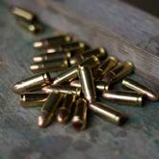mart criminals wear gloves. Why? Because everyone knows that fingerprints can be used to identify individuals from millions, as

lead bullets

cotton
JMP photography, CC-BY-2.0
Kimberly Vardeman, CC-BY-2.0
S
no two people have the same patterns.

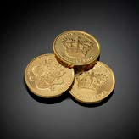Scientists have been investigating how materials, such as those below, can be ‘fingerprinted’ too.

wine

gold

ochre from paintings
Paul Mannix, CC-BY-2.0
Mark Herpel, CC-BY-2.0
Kai Hendry, CC-BY-2.0
Joe Shlabotnik, CC-BY-2.0
Creative Tools, CC-BY-2.0

pork

olive oil

Forensic scientists use distinctive ‘fingerprints’ of each of these substances to tell if two samples match. This may be useful for discovering where a substance came from; finding forgeries; or analysing crime scene evidence.

Inductively coupled plasma – mass spectrometry (ICP-MS) is one technique used to fingerprint substances.
ICP-MS uses an electrical flame to ionise elements in a sample. This means atoms lose electrons and become positively charged. Then, a mass spectrometer sorts these charged atoms of elements. This is possible because different elements have different masses. A detection system counts how many charged atoms of each element are present.
count
count

ICP-MS may be used to find concentrations of different elements in a substance. It’s so accurate it can measure concentrations down to one part in a trillion. Relative concentrations of each element depend on where a material is from, or where it was made. The closer the fingerprints of two samples are, the greater the chance they originate from the same source.
Figure 1: The ICP-MS sorts a mixture of atoms into their elements and counts them. The pattern this creates is a ‘fingerprint’.
mass
mass

Scientists at the University of Western Australia have developed this ground-breaking technique to fingerprint diamonds, gold, micro debris from crime scenes, oriental porcelain and tea.

DIAMONDS
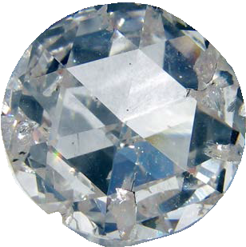
Diamonds are valuable gemstones. They’re often stolen, so forensic scientists have been working on a way to fingerprint them.
Scientists analysed relative concentrations of trace elements, in samples of diamonds from five major diamond-producing countries, and found each source had a distinctive pattern of trace elements.

What the scientists did
A microscopically small area of diamond (less than you can see with the naked eye) is vaporised with a laser and passed into an ICP-MS instrument to
be analysed. The hole in the diamond made by the laser is so small it can easily
be polished out, which is good because no one wants to destroy a precious stone.

What the scientists found
The amount of trace elements in a diamond depends on which country it came from. For example, Russian diamonds contain lots of tungsten and South African diamonds have high levels of lead, molybdenum and rubidium. Diamonds from the same country are similar to each other and share a characteristic ‘fingerprint’.

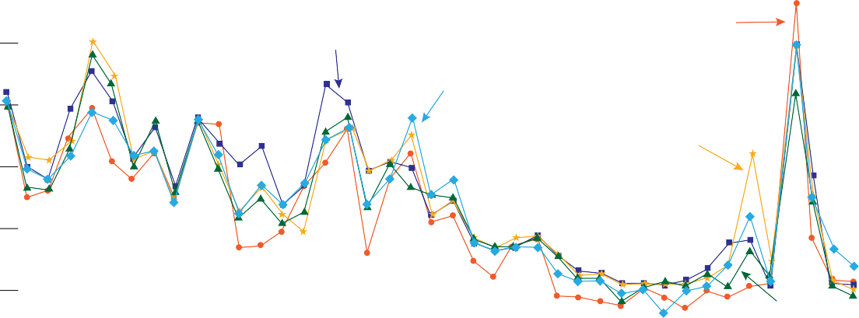10 000 000
Australia
South Africa
China
Russia
Zaire

1 000 000

100 000

10 000

1000

100

10

1
Ca 44
Ti 49
V 51
Co 59
Cu 65
Zn 66
Ga 69
Ge 73
Se 82
Rb 85
Sr 88
Y 89
Zr 91
Nb 93
Mo 95
Sn 120
Sb 121
Te 126
Cs 133
Ba 137
La 139
Ce 140
Pr 141
Nd 146
Sm 152
Eu 153
Gd 158
Tb 159
Dy 162
Er 166
Er 168
Tm 169
Yb 172
Lu 175
Hf 177
W 182
Tl 203
Pb 208
Bi 209
Th 232
U 238

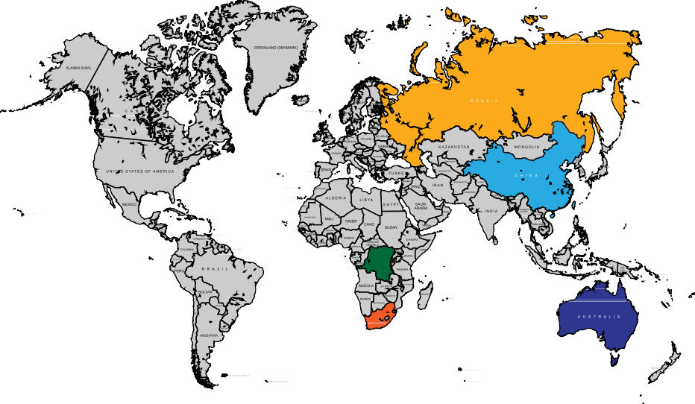Figure 2: The graph shows how ICP-MS fingerprints vary between diamonds from different countries. A recovered stolen diamond could be tested and matched

ZAIRE

major diamond producing countries
to the graph to find out where it was from.

Why are there differences in trace elements?
Trace elements in diamonds vary between countries. They depend on the composition of rocks around the diamonds and where in Earth’s crust they formed. Diamonds formed in the same place are formed under the same conditions, so they contain the same elements in similar amounts.
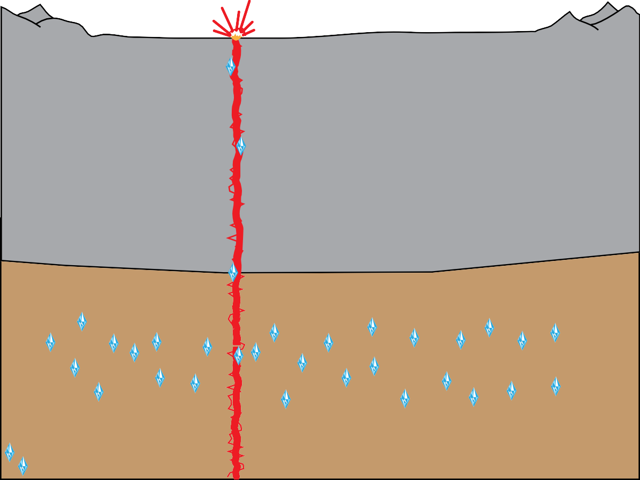
deep source eruption
continental plate
upper mantle
diamond stability zone
diamonds
Figure 3: Diamonds form deep in the Earth’s mantle when carbon-containing minerals are subjected to high pressure and temperature. They are pushed toward the surface by volcanic eruptions.

The future
This method of identifying diamonds is quick and relatively simple. In the future, a computer database of diamond fingerprints could be developed so stolen diamonds can be traced back to where they came from.
These techniques are useful in identifying ‘conflict diamonds’ — defined by the United Nations as ‘diamonds that originate from areas controlled by forces or factions opposed to legitimate and internationally recognised governments’.

Reference
John Watling, R. (1995). Analysis of diamonds and indicator minerals for diamond exploration by laser ablation– inductively coupled plasma mass spectrometry. Analyst, 120(5), 1357-1364.
World Diamond Council. (n.d.). Conflict diamonds, retrieved 24 July 2103 from http://www.diamondfacts.org/ index.php?view=article&id=12

FORENSIC ANALYSIS OF MICRO DEBRIS
Criminals try not to leave too much forensic evidence, such as fingerprints, at the scene of a crime. Forensic scientists are one step ahead though, and are looking at ways to analyse micro-evidence that is too small to be seen.
One type of micro-evidence is spherules, produced when safes or other metal objects are cut using an oxy-
acetylene gas cutter. Metal is melted by intense heat from a flame and forms a gas which, when it condenses, forms tiny solid spherules. These spherules are so small they travel on air-currents and are found both at a crime scene and on an offender’s clothing, unseen by the criminal.

What the scientists did
Samples can be collected, from clothing and a crime scene, using a sticky disk. Spherules are tiny so a laser is used to vaporise a few particles. This vapour is then passed into an ICP-MS for analysis (a process called laser ablation ICP-MS).
It takes less than five minutes to match two samples using this technique.

What the scientists found
Research scientists analysed three safes and confirmed that there were differences in the steel they were made from.
They were then able to match spherules of steel from a shirt, worn by a person of interest while using an oxy- acetylene cutter, with those from a safe at the crime scene, confirming a link between suspect and crime scene.

Comparison of POI to crime scene (SAFE A): single spherule LA-ICP-TOF-MS protocol for analysis of oxy-acetylene cutting debris recovered from POI and crime scene
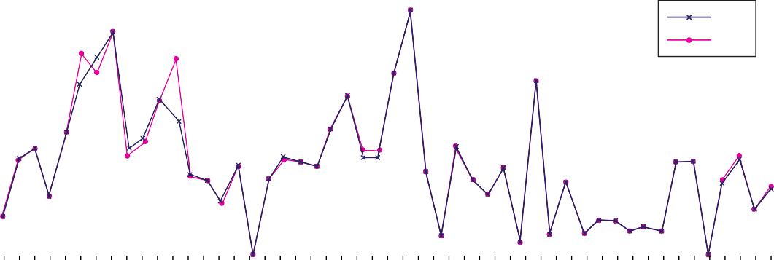10 000 000
Safe
Shirt

1 000 000

100 000
Abundance

10 000

1 000

100

10

1
Li 7
Be 9
B 11
Al 27
Sc 45
Ti 48
V 51
Cr 52
Mn 56
Co 59
Ni 60
Cu 65
Zn 66
Ga 71
As 75
Se 82
Rb 85
Sr 88
Y 89
Zr 90
Nb 93
Mo 98
Cd 111
In 115
Sn 120
Sb 123
Te 126
Cs 133
Ba 138
La 139
Ce 140
Pr 141
Nd 146
Eu 151
Sm 152
Gd 158
Tb 159
Dy 162
Ho 165
Er 166
Tm 169
Yb 172
Lu 175
Hf 178
Ta 181
W 182
Ti 205
Pb 208
Bi 209
Th 232
U 238

Element
Figure 4: The graph compares micro debris fingerprints from a crime scene and person of interest. The graphs have matching shapes so the steel fingerprint from the offender’s clothing matches the steel fingerprint from the safe.

Why are there differences in trace elements?
Steel manufacturing is a carefully controlled process so there’s not much variation between different batches of steel. However, raw materials that make steel contain tiny amounts of different trace elements that vary, depending on where the materials are from.

Reference
Scadding, C. J., Watling, R. J., & Thomas, A. G. (2005). The potential of using laser ablation inductively coupled plasma time of flight mass spectrometry (LA-ICP-TOF-MS) in the forensic analysis of micro debris. Talanta, 67(2), 414-424.

DETECTING ORIENTAL PORCELAIN FORGERY
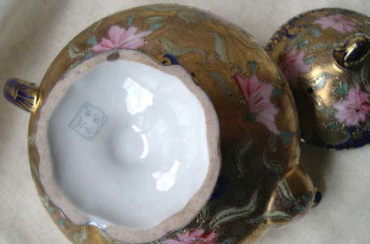
Ancient Chinese artefacts are valuable. Forgers make modern copies and sell them for lots of money, but it’s hard to tell fakes from the real articles just by looking and feeling them.
By Le Petit Poulailler, CC-BY-2.0
Experts estimate that about 20% of Chinese artefacts are fraudulent, so this is a big problem.

What the scientists did
Scientists don’t want to damage real artefacts during testing, so they use a laser to vapourise a tiny area on the porcelain surface. The volatilised material is transferred directly into an ICP-MS instrument to be analysed. Holes made by the laser are only 0.1 mm in diameter, so you can’t see them with the naked eye.

What the scientists found
Porcelain from China, Japan and England was analysed and differences found between countries. There were also some variations between different regions of a country.

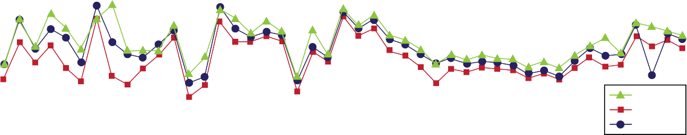1 000 000
English
Japanese Chinese
100 000
10 000
Abundance
1 000
100
10
1
A

Isotope
Be 9
Ca 44
Sc 45
Ti 49
V 51
Cr 53
Mn 56
Co 59
Ni 60
Cu 65
Zn 66
Ga 69
Ge 73
As 75
Rb 85
Sr 88
Y 89
Zr 90
Nb 93
Mo 98
Sn 120
Sb 121
Ba 138
La 139
Ce 140
Pr 141
Nd 145
Sm 152
Eu 153
Gd 158
Tb 159
Dy 162
Ho 165
Er 166
Tm 169
Yb 172
Lu 175
Hf 178
Ta 181
W 184
Tl 205
Pb 208
Bi 209
Th 232
U 238

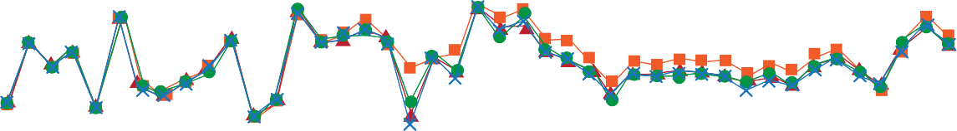1 000 000
100 000
Abundance
10 000
1 000
100
10
1
B
Be 9
Ca 44
Sc 45
Ti 49
V 51
Cr 53
Mn 56
Co 59
Ni 60
Cu 65
Zn 66
Ga 69
Ge 73
As 75
Rb 85
Sr 88
Y 89
Zr 90
Nb 93
Mo 98
Sn 120
Sb 121
Ba 138
La 139
Ce 140
Pr 141
Nd 145
Sm 152
Eu 153
Gd 158
Tb 159
Dy 162
Ho 165
Er 166
Tm 169
Yb 172
Lu 175
Hf 178
Ta 181
W 184
Tl 205
Pb 208
Bi 209

Isotope

Figure 5: Diagram A compares fingerprints of Chinese, Japanese and English porcelain: differences can be seen. Diagram B compares samples from 13 shards of porcelain made in Japan between 17th and 19th centuries: they match closely.

Why are there differences in trace elements?
Genuine Chinese artefacts were made hundreds of years ago when transport was limited, so clays used to make porcelain came from nearby locations. Also, techniques used by potters to make and fire porcelain varied between regions because communication was restricted.

The future
Scientists found that trace elements present in porcelains are distinctive in each place of origin. This means that a porcelain object can be tested to see where it’s from, and whether it’s ancient or a modern fake.

Reference
Bartle, E. K., & Watling, R. J. (2007). Provenance Determination of Oriental Porcelain Using Laser Ablation Inductively Coupled Plasma Mass Spectrometry (LA ICP MS)*. Journal of forensic sciences, 52(2), 341-348.

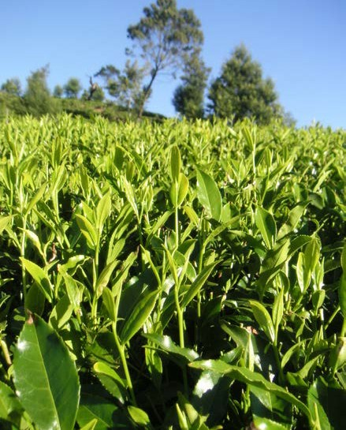
TRACING TEA
Indi Samarajiva, CC-BY-2.0
Many types of food and drink are fraudulently labelled because higher prices may be charged for products from places with a good reputation for that product. Often it’s difficult to tell the difference between cheap and expensive products, and it is not always easy to test them.
Both buyers and sellers need protection from fraud. People buying food may be concerned about disease, pesticides, fair trade or other factors involved in the way food is processed and produced. Fraud disadvantages sellers of a genuine product, as unprincipled people undercut their market.

What the scientists did
Scientists at The University of Western Australia fingerprinted tea. Tea is grown mainly in Africa and Asia, and its price depends on where it’s from.
Samples of tea from a variety of regions in India, China, Taiwan and Sri Lanka were analysed. Scientists dissolved tea leaves in acid and tested the solution using ICP-MS.
Tea is made with leaves from the Camellia sinensis plant.

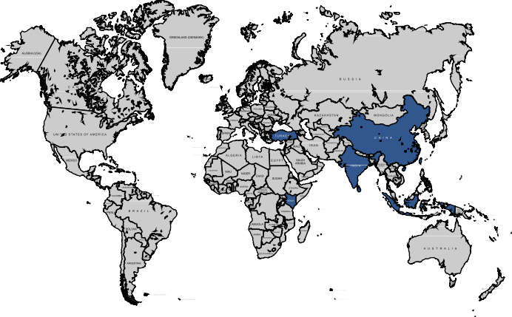What the scientists found

ZAIRE
Trace elements and isotopes in tea leaves were specific to countries in which they were grown. A further study of tea from a region in India found leaves could be traced right back to their original plantation.
When the scientists tried to find the origin of 20 unlabelled samples, by matching them against the known samples they had fingerprinted, 97% were correctly identified.
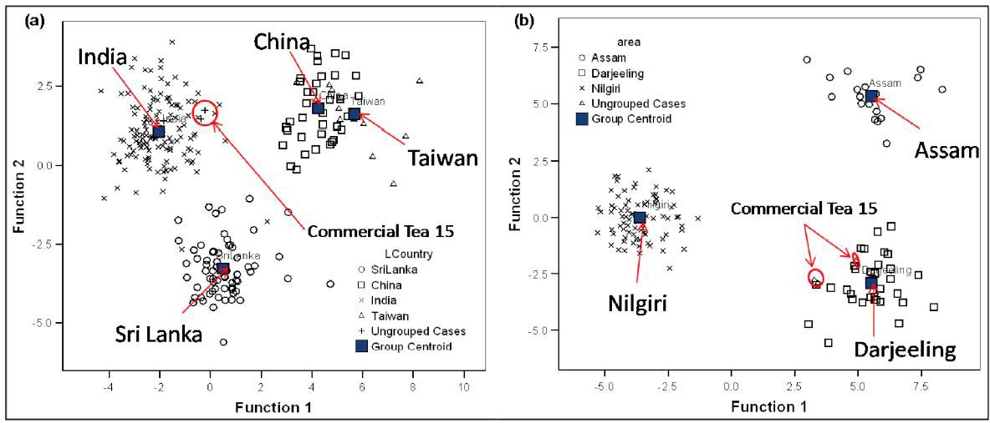
Figure 6: Discriminant plot indicating the grouping of commercial sample 15 (labelled Darjeeling) compared with (a) the Asian tea database and (b) the Indian tea database.

Figure 6 shows how an unlabelled sample, ‘Commercial Tea 15’, was identified. Samples that contain similar trace element fingerprints are found close together on the graphs. Graph (a) shows all Indian teas contain similar trace elements and are found close together in the top left of the graph. It indicates that Commercial Tea 15 is an Indian tea, while graph (b) suggests it comes from the Darjeeling region.

Why are there differences in trace elements?
Many foods can be fingerprinted because they’re produced in different geographical and geological locations. Trace elements and light stable isotopes are transferred from soil to plants, and on to animals. Quantities of these isotopes and elements are based on many factors including distance from sea, climate, temperature, elevation, underlying geology and soil composition.

into animals
into plants

trace elements in soil

The future
Scientists found the fingerprint of tea from an area stays the same over time. It’s only affected by major climate change or changes in the way a crop is grown and managed, for example, use of a new fertiliser. Fingerprints are unaffected by variety of tea, harvest year or quality. This means a database could be built to compare tea samples.

Reference
Pilgrim, T. S., Watling, R. J., & Grice, K. (2010). Application of trace element and stable isotope signatures to determine the provenance of tea (Camellia sinensis) samples. Food Chemistry, 118(4), 921-926.
Watling, R. J., Lee, G. S., Scadding, C. J., Pilgrim, T. S., Green, R. L., Martin, A. E., ... & Valentin, J. L. (2010). The Application of Solution and Laser Ablation Based ICP-MS and Solution Based AES for the Provenance Determination of Selected Food and Drink Produce. Open Chemical and Biomedical Methods Journal, 3, 179- 196.

Image credits
- ‘Bullets’ by JMR Photography, CC-BY-2.0, www.flickr. com/photos/jmrosenfeld/3154082633/
- ‘Cotton harvest’ by Kimberly Vardeman, CC-BY-2.0, www.flickr.com/photos/kimberlykv/4087572467/
- ‘Aboriginal rock painting, Nourlangie, Kakadu National Park, Australia’ by Paul Mannix, CC-BY-2.0, www.flickr.com/photos/paulmannix/303565495/
- ‘Pure gold coins’ by Mark Herpel, CC0-BY-2.0, www. flickr.com/photos/digitalcurrency/2438939932/
- ‘Lean pork’ by Kai Handry, CC-BY-2.-, www.flickr. com/photos/hendry/2448028059/
- ‘Wine’ by Joe Shlabotnik, CC-BY-2.0, www.flickr.com/ photos/joeshlabotnik/2294658165/
- ‘Olive oil’ by Creative Tools, CC-BY-2.0, www.flickr. com/photos/creative_tools/4292166101/
- ‘Synthetic diamond’ by Steve Jurvetson, CC-BY-2.0, www.flickr.com/photos/jurvetson/156830367/
- John Watling, R. (1995). Analysis of diamonds and indicator minerals for diamond exploration by laser ablation–inductively coupled plasma mass spectrometry. Analyst, 120(5), 1357-1364.
- Scadding, C. J., Watling, R. J., & Thomas, A. G. (2005). The potential of using laser ablation inductively coupled plasma time of flight mass spectrometry
(LA-ICP-TOF-MS) in the forensic analysis of micro debris. Talanta, 67(2), 414-424.
- ‘19th century antique Japanese porcelain tea service’ by Le Petit Poulailler, CC-BY-NC-ND-2.0, www.flickr. com/photos/three_french_hens/2398944726/
- Bartle, E. K., & Watling, R. J. (2007). Provenance Determination of Oriental Porcelain Using Laser Ablation-Inductively Coupled Plasma-Mass Spectrometry (LA-ICP-MS)*. Journal of forensic sciences, 52(2), 341-348.
- ‘Tea leaves’ by Indi Samarajiva, CC-BY-2.0, www. flickr.com/photos/indi/126488992/
- Watling, R. J., Lee, G. S., Scadding, C. J., Pilgrim,
T. S., Green, R. L., Martin, A. E., ... & Valentin, J.
L. (2010). The Application of Solution and Laser Ablation Based ICP-MS and Solution Based AES for the Provenance Determination of Selected Food and Drink Produce. Open Chemical and Biomedical Methods Journal, 3, 179- 196.

