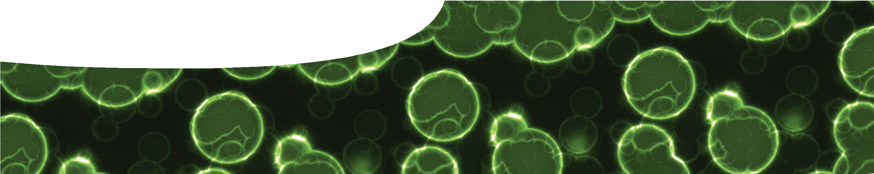
fact sheet
Fighting the ‘flu
Image by Patrick Hoesly, www.zooboing.com


Evolution is considered to be a process that occurs over very long time frames, and for many species it occurs over millions of years. However viruses, which are small pieces of DNA or RNA enclosed in a protein coat, evolve much, much faster. Their reproductive cycles may take only a few hours. With so many cycles, occurring so quickly, there’s a greater chance of changes (mutations) to their RNA sequences. For example, influenza virus type A, focus of this fact sheet, can produce 100 000 copies in only 6 hours. This means its RNA sequence can change extremely quickly.

Influenza virus: global pandemics
significant outbreaks and their death toll

40-50 million deaths

Spanish ‘flu 1918
1910
1920
1930
1940
1950
1960
1970
1980
1990
2000
2010

1.5-2 million deaths


Asian ‘flu 1957-58

1 million deaths

Hong Kong ‘flu 1968-69

18 thousand deaths

swine ‘flu 2009

H1N1 H2N2 H3N2 H1N1

Influenza is a virus. Annually, between 250 000 and 500 000 people die from infection with influenza; and pandemics, such as Spanish ‘flu in 1918, have killed millions of people. There are three types of influenza virus: A, B and C. Influenza type A is the most significant (and most studied). Each pandemic shown above was caused by an influenza type A virus.

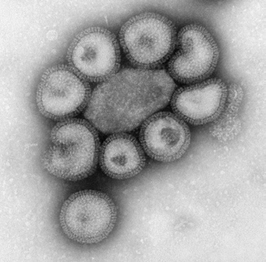
Type A influenza viruses are named after surface proteins present on the outside of the protein coat. They can be visualised using an electron micrograph. Two surface proteins are used to name viruses: haemagglutinin (H) and neuraminidase (N). There are currently 17 variants of H and 10 variants of N. The swine ‘flu pandemic of 2009
was variant H1N1 (that is, variant 1 of haemagglutinin and variant 1 of neuraminidase).

Electron micrograph of influenza A virus shows surface proteins haemagglutinin and neuraminidase forming a coat around each virus particle.
image: Center for Disease Control / Dr F A Murphy


fact sheet
Fighting the ‘flu
Like other viruses, influenza is made of genetic material, in this case RNA, enclosed in a protein coat. Viruses are extremely small (20–300 nm) and need to enter a living cell to reproduce (they are, essentially, an intracellular parasite). Once inside cells, viruses reproduce to make virions, which then leave to infect new cells.
Influenza viruses are generally species-

specific (they infect a single species). Influenza A subtypes H1N1, H1N2 and H3N2 mainly affect humans. Influenza B viruses also affect humans but they are not categorised into subtypes.
Proteins haemagglutinin (H) and neuraminidase (N), located on the outside of viruses, enable them to attach to, then infect, host cells.
When an influenza virus infects a population it goes through thousands of replications.
During these replications changes to RNA sequences may occur. For example, RNA sequences coding for H and N surface proteins may change slightly. These changes are called antigenic drift. A host’s immune system is stimulated by recognition of H and N proteins, amongst others on the virus surface. Small changes to the virus surface may result in hosts failing to recognise and respond to a virus.
Another type of mutation may occur if a host cell is infected by two strains of virus simultaneously. Viruses may exchange genetic material to produce a new type of virus. This is called antigenic shift.
Animals also become infected with influenza. In fact, birds are considered to be natural reservoirs of all influenza A
viruses in animals, including humans. Every combination of H and N has been found in wild birds. Pigs can be infected with both human and avian (bird) influenza viruses, in addition to swine influenza viruses. If a pig was infected with all three viruses at the same time, they could, potentially, mix
together (reassortment) and produce a new virus that had genes from all three (antigenic shift). This new virus might then infect humans.
neuraminidase (N) haemagglutinin (H)
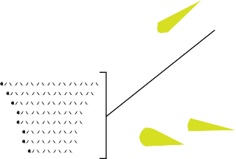
RNA
Influenza A, with surface proteins Haemagglutinin and Neuraminidase labelled
Antigenic drift and antigenic shift
antigenic drift

antigenic shift

Small changes to viral RNA may lead to small changes in surface proteins (called antigenic drift). This can make it difficult for antibodies of a host’s immune system to recognise and bind to surface proteins of the virus.
Exchange of genetic material between viruses can lead to large changes in viral surface proteins (called antigenic shift). Viruses may spread to many cells before a host produces sufficient antibodies to fight them.

