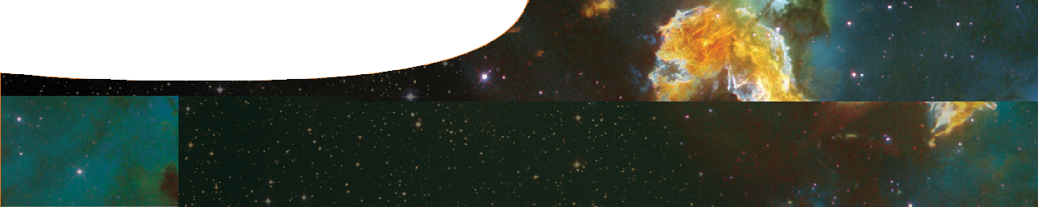
fact sheet
The future of the Universe

The future of the Universe will be determined by the struggle between the momentum of its expansion and the pull of gravity.
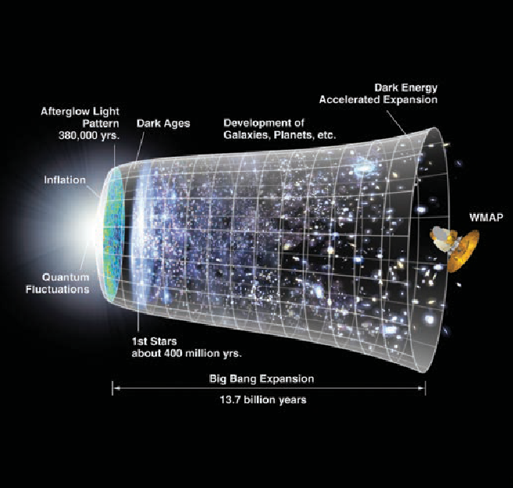
Key ideas:
- Our capacity to predict the future of the Universe is limited by how much of it we can observe.
The image (right) represents the evolution of the Universe over 13.7 billion years. The Big Bang is depicted at the left of the image followed by
a period of exponential growth (inflation). The vertical scale indicates the size of the Universe.
For the next several billion years, the expansion of the Universe gradually slowed down due to the effects of gravity on matter.
In more recent times, the expansion of the Universe has begun to accelerate again due to the repulsive effects of dark energy.
- Our predictions about the Universe are based on the assumption that the laws of physics apply consistently to all parts of it. This is called the
cosmological principle. NASA/WMAP Science Team
Predicting the future of the Universe
Scientific predictions about the future of the Universe are based on the idea that the effect of gravity on matter determines the shape of the Universe, which then determines its future.
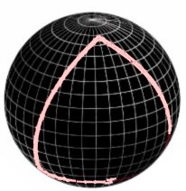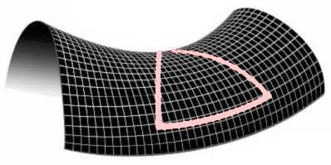Critical density is the average density of matter in the Universe at which gravity is just sufficient to halt its expansion, but only after an infinite time. The future of the Universe depends on whether its density is greater than, equal to, or less than the critical density. There are three possible scenarios:

Scenario 1: A closed Universe
If the density of the Universe is greater than critical density, gravity will be strong enough to stop its expansion and eventually reverse it.
The geometry of spacetime can be thought of as being shaped like the surface of a sphere. A triangle drawn on the surface of the sphere has an angle sum greater than 180°.
Eventually, gravity will cause a closed Universe to collapse back in on itself, ending in the ‘Big Crunch’.

Scenario 2: An open Universe
If the density of the Universe is less than critical density, gravity will be too weak to stop its expansion and the Universe will expand forever at an ever- decreasing rate.
The geometry of spacetime can be thought of as being shaped like the surface of a saddle. A triangle drawn on such a surface has an angle sum less than 180°.
As the Universe continues to expand, all the stars and galaxies will eventually exhaust their energy and the Universe will cool down, ending in the ‘Big Chill’.

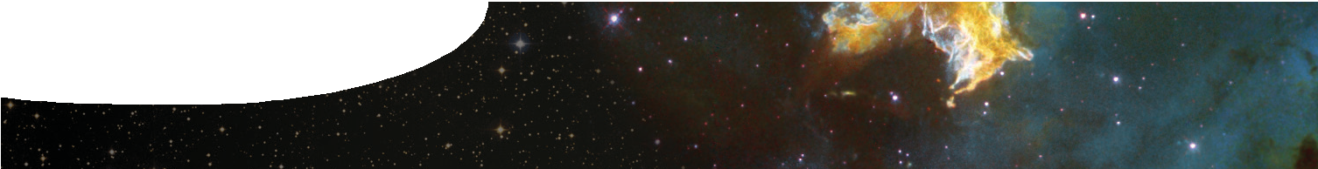
fact sheet
The future of the Universe


Scenario 3: A flat Universe
If the density of the Universe is equal to critical density, gravity will be just sufficient to stop its expansion, but only after an infinite time.
The geometry of spacetime can be thought of as being flat. In a flat Universe, a triangle has an angle sum of 180°.
A flat Universe will expand at an ever-decreasing rate, but at a slower rate than for an open Universe.

What is the most likely future of the Universe?
In order to make a reliable prediction about the future of the Universe, cosmologists need to know its average density. To do this, they need to know what it’s made of.
Until about thirty years ago, astronomers thought that the Universe was composed almost entirely of the ‘ordinary’ matter that makes up stars, galaxies and us.
However, in recent years the evidence suggests there is something else in the Universe that we can’t see, perhaps some new kind of matter.
Today, cosmologists believe that the Universe contains radiation, baryonic (ordinary) matter, dark matter and dark energy.
dark energy 72%

TODAY

dark matter 23%

atoms 5%

radiation | Radiation consists of massless (or nearly massless in the case of neutrinos) particles that travel at the speed of light, such as photons and neutrinos.
baryonic matter | This is ‘ordinary’ matter, such as protons, neutrons and electrons.
dark matter | Astrophysicists have calculated that there isn’t enough visible matter in the Universe to explain how clusters of galaxies hold together, or how spiral galaxies hold together at high rotational speeds.  Dark matter has been hypothesised to explain the ‘missing’ mass in the Universe. While it has never been observed directly, dark matter is thought to interact weakly with matter through gravity. However, astrophysicists aren’t agreed on what dark matter really is.
dark energy | Observations of distant supernovae indicate that the Universe is expanding at an accelerating rate. Astrophysicists suggest that this expansion is caused by dark energy, which has a gravitationally repulsive effect on matter. As with dark matter, there is no general agreement on what dark energy really is.

This leads to a fourth possible scenario for the future for the Universe
In a Universe that is expanding at an accelerating rate:
- galaxies we now see will recede out of sight, one by one;
- tens of billions of years from now, the Milky Way will be the only galaxy we’ll be able to see;
- our Sun will have shrunk to a white dwarf star that will provide little light and heat to Earth;
- stars will slowly burn out and collapse into black holes; and
- the Universe will be a vast, empty, dark and cold place.

