fact sheet

Measuring metabolism
How much energy do you

need to survive?
To find out energy requirements, you need to study metabolism. Metabolism refers to chemical processes going on inside cells, all the time. These processes produce heat.
If the amount of heat produced over a period of time can be measured, we have a measure of metabolic rate. Sounds simple
— but is it?
Scientists measure changes in heat with a calorimeter. This piece of equipment usually holds a body of liquid (such as water) that surrounds a heat source (in this case, a human). By measuring temperature changes in the liquid, scientists can calculate the energy involved in a chemical reaction in the
human. However, this is complex science that relies on complete control of the environment, and it’s definitely not cheap.

For some experiments, human subjects live in a respiration chamber for days at a time.

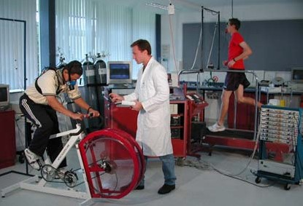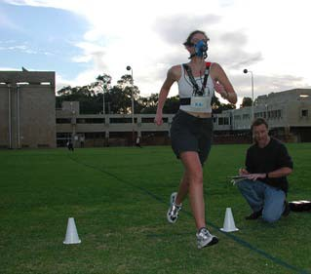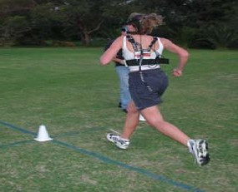
These subjects are attached to analysers and flow meters that collect information about oxygen consumption and carbon dioxide production.

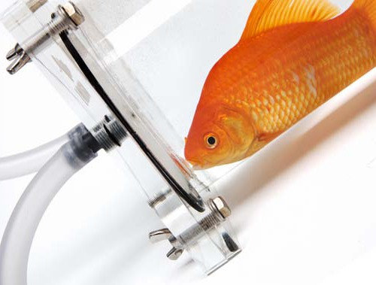
Measuring metabolism
Rather than measuring metabolism through heat change, it is possible to measure metabolism indirectly in a process called indirect calorimetry. The most common indirect method is to measure gas input and output.
Oxygen consumption and carbon dioxide production are used as an indirect measure of metabolic rate.
This works because oxygen is used to break down food during cellular respiration, whilst water, carbon dioxide and energy are produced.
The good news is it’s easier to measure gas input and output than it is to measure heat. Using indirect calorimetry, scientists can measure a subject’s metabolism during sleep, rest and physical activity.

fact sheet
Measuring metabolism

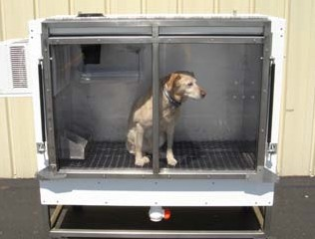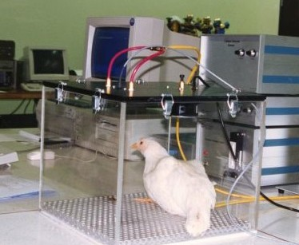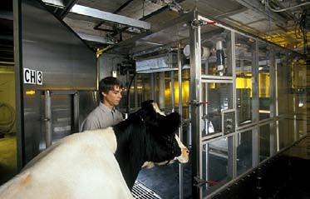
Animals in different types of respiration chambers.

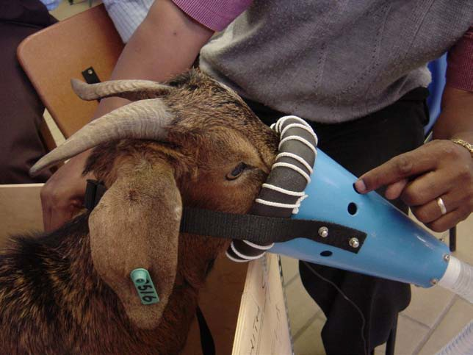
What’s wrong with a laboratory?
Scientists routinely conduct metabolic research with animals in a laboratory. Working with non-human animals poses many challenges. Not all animals are willing, or able, to cooperate.
Laboratory methods generally only provide information about energy expenditure when an animal is at rest, and conditions may be unnatural as animals are confined, restrained or wearing unusual apparatus. All of these factors may bias collected data or result in inaccurate data.

Working in the wild
Determining energy expenditure of free-living animals helps scientists estimate the amount of food they need to survive. Scientists can follow
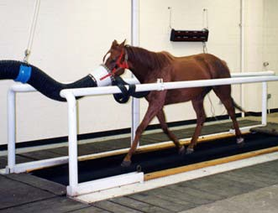
animals in the wild and document what they eat, collect their faeces, or catch them and see what’s in their stomachs. But these intensive, expensive or potentially deadly practices show what an animal eats, but
not necessarily how much. Surely there’s a better way.
There is! It involves putting labels on water. Instead
of collecting information on gas input and output, scientists can use another indirect method: the doubly-
labelled water (DLW) method. This technique uses isotopes of hydrogen and oxygen, for example 3H (tritium) and 18O (heavy oxygen), to ‘label’ water that is injected into a study animal.

This goat wears a face mask attached to gas analysers. Working with domestic livestock is much easier than with wild animals.

Scientists know that this water is involved in a series of reactions, within the body, that are linked to cellular respiration. By measuring changes,
Why measure metabolism?
Information about metabolism that scientists collect has many applications.
In humans it can help with:
- weight management,
- improving diet,
- management of disease, and
- enhancing athletic performance.
In animals it can help with:
- livestock productivity,
- improved sporting performance,
- improved nutrition,
- conservation of endangered species, and
- understanding thermoregulation (for example, in torpor).
over time, in the concentration of these isotopic markers, scientists can calculate how much carbon dioxide is produced. From this, a metabolic rate can be calculated. An advantage of
this method is that a subject can get
on with normal life without masks, chambers or carefully controlled diets.

