fact sheet
Reaction rates 4:
Enzymes in the body

Enzymes are biological catalysts that influence the rate of chemical reactions in all living things. Research scientists often study enzymes because they have such
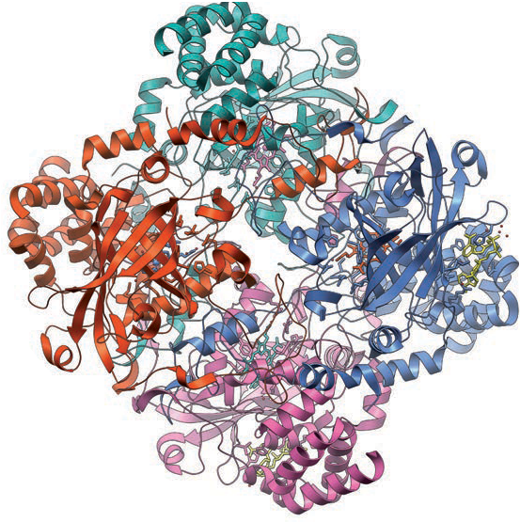
important functions in living organisms. Catalase is one such enzyme that prevents damage caused by free radicals.

What are free radicals?
Catalase structure
image: Vossman, CC-BY-SA-3.0, en.wikipedia.org/wiki/File:Catalase_Structure.png
A free radical is any molecule with a single unpaired electron in its outer
shell. Free radicals are generated in the human
body when electrons ‘escape’ from mitochondria
within cells, and latch on to oxygen molecules
to produce superoxide ( O⁻ •). The hydroxyl radical (OH•) is a variation on superoxide free radical. It is produced in the body from
2
hydrogen peroxide (H2O2). Free radicals are often dangerous to cell function.
Superoxide, hydroxyl and other highly reactive
free radicals may start chemical chain reactions that damage DNA and protein, kill cells and, over the long term, cause problems such as cataracts and vascular disease.
Free radical damage in muscle tissue is associated with muscle
wasting. Muscle wasting can occur in genetically-inherited diseases (such
as muscular dystrophy); as a consequence of old age; or even as an outcome of disuse (for example, when a broken arm is held in a cast).

Enzymes –
Hydrogen peroxide can be helpful in the body, despite it being toxic. Leukocytes (protective white blood cells) contain enzymes that combine hydrogen peroxide with chlorine to form hypochlorous acid (HOCl). HOCl is the active component of household bleach — a known bug killer!

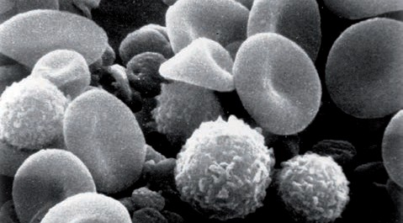
Scanning electron microscope image from normal human blood. Several white blood cells (leucocytes – spherical cells with a rough, textured surface) are visible.
National Cancer Institute (Bruce Wetzel and Harry Schaefer, photographers)

the body’s radical solutions
In the human body, enzymes such as catalase and superoxide dismutase (SOD) work together to deal with free radicals before they are able to cause damage.
SOD converts superoxide radicals to hydrogen peroxide, but this compound is still quite toxic to cells. Catalase steps in, to convert hydrogen peroxide to water and oxygen, and prevent any damage.
These equations show how SOD and catalase combine to reduce harmful effects of superoxide radicals ( O⁻ •).
2

2O− • +
2H+
superoxide dismutase→ H O + O

2
2H2O2
catalase→
2H2O + O2
2 2 2

One molecule of catalase can decompose millions of hydrogen peroxide molecules per second. But
despite this heroic effort, it is not enough to prevent all free radical damage.

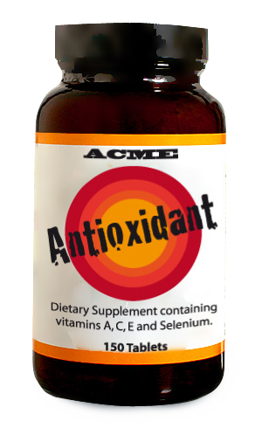How do enzymes work?
Enzyme research
Antioxidants – nature’s radical solution
Naturally occurring antioxidants, such as vitamin C and E, also protect our body against free radical damage, and work to repair damage that does occur. These antioxidants stop damaging chain reactions by removing chemical intermediates associated with free radicals. It’s not surprising that antioxidant agents, which
often contain selenium, fill shelves in health food stores and are in big demand by health conscious consumers.
But consumers must be wary. There is little reliable evidence to support most claimed health benefits and some antioxidants,
taken to excess, can be toxic.
Enzymes are large protein molecules, which work by forming intermediate complexes with reactants. In enzyme terminology, reactant molecules are called ‘substrates’. Each enzyme has a distinct 3-D structure that includes an area called the active site which is where catalysis occurs. Each enzyme can only react with particular substrate — it is ‘specific’ to a substrate, much like a lock fits with a key.
The enzyme catalase is made of four identical chains, each chain consisting of more than 500 amino acids arranged like beads on a string. These chains of amino acids are folded into a distinct shape due to intermolecular attractive forces. Each chain has an active site that contains an iron atom at its centre.
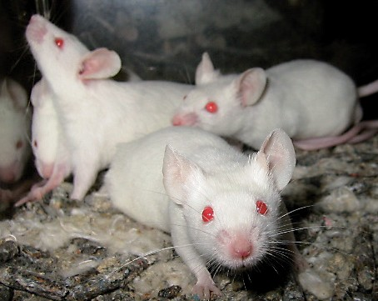
The complete mechanism of catalase interaction with a substrate is not yet known, but it seems to involve interactions with iron atoms and amino acids in active sites. As with all catalysts, an enzyme provides an alternative pathway of lower activation energy for a reaction.

‘Laboratory mice’ by Aaron Logan. CC-BY-1.0, commons.wikimedia.org/wiki/File:Lightmatter_lab_mice.jpg

Enzyme activity is sensitive to temperature and pH changes. The temperature at which enzymes work best is generally close to the temperature they encounter
in an animal or plant. Exposure to high temperatures deactivates an enzyme by weakening intermolecular forces between amino acid chains of an enzyme,
and causing a change in molecule shape. Changes in pH also affect enzyme activity by changing the way amino acid chains fold, which again alters the shape of an enzyme. With exposure to heat or changes in pH enzyme activity is diminished, and the ‘lock and key’ does not match so well.
At The University of Western Australia, a group of researchers is investigating whether the effects of aging can be prevented. This group is making use of transgenic mice. These mice have had a human gene added to their DNA that allows them to produce human catalase. Using animals to study free radical damage offers significantly more scope than a study in humans or ‘in vitro’ (in a test tube).
The research has shown that transgenic mice containing high levels of catalase exhibit a range of characteristics, including increased protection from free radical attack.
Other researchers have used transgenic mice to test the hypothesis that life expectancy can be increased by raising catalase concentration — and it worked. Mice with increased catalase lived about 5.5 months longer, which is a significant time in mouse years (about 20% longer). The mice were also healthier and their hearts did not show signs of aging normally seen in both
mice and human hearts. DNA from their muscles was checked and, once again, catalase-protected ‘super mice’ did not show the typical damage caused by free radicals.
So enzymes can affect body processes. In this case, a biological catalyst accelerates the rate of chemical reactions that remove harmful free radicals, thereby slowing the aging process.

Understanding the science helps you make decisions
What about taking catalase as a tablet? Is it going to work as an antioxidant?
Think about conditions that affect enzyme activity. Can you work out why taking catalase orally will not work?
With knowledge of science you can make your own decisions about claimed health benefits of different antioxidants.

