fact sheet
Electrical u
nits
Charge
Charge is a basic property of matter particles. As far as we know, all fundamental particles are either positively- charged (such as protons), negatively-charged (electrons)
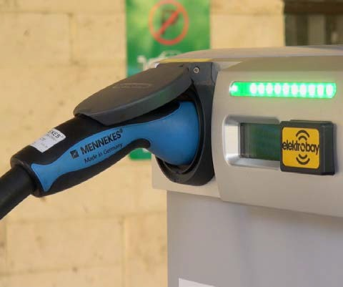or neutral (neutrons). Protons and electrons have equal but opposite charge. As the number of protons in everyday objects usually equals the number of electrons, positive and negative charges balance, and objects are electrically neutral.

Charge is carried by electrons in the cables of this electric car recharging station. In the car’s batteries charge is carried by ions.
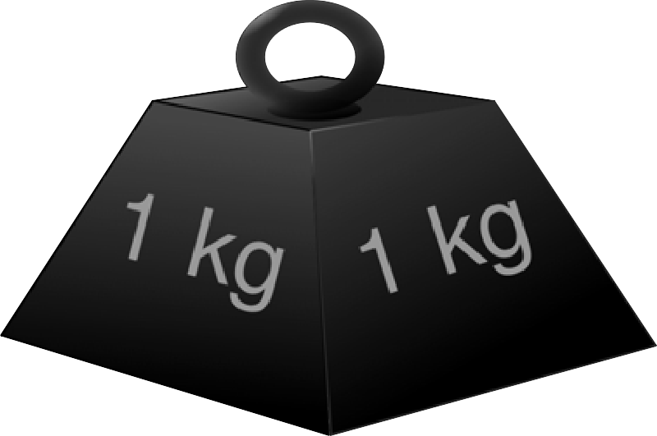

A 1 kg iron weight contains about
285 000 000 000 000 000 000 000 000 protons and
285 000 000 000 000 000 000 000 000 electrons.
It’s this balance that makes it electrically neutral.

How are charge and electricity connected?
If you could take a close look at a piece of copper wire you would see electrons jiggling about and moving randomly; but when a current flows through the wire electrons drift in one direction. An electric current consists of moving charged particles — most commonly electrons, but they can be any charged particle, such as ions.
Static electricity arises when positive and negative charges are separated. The interaction that pulls positive and negative charges together is about 1036 times stronger than gravity (it’s what holds atoms together), so it’s usually only possible to separate a small amount of charge before something like a spark or lightning bolt restores the balance.
So does this charging station fill car batteries with electric
charge? No! Energy from a charging station is used to make chemical changes in a car’s batteries. When the car is driven these chemical reactions are reversed, forcing positive and negative charges apart. The flow of electrons as charged particles come together again creates an electric current that powers the car.

Measuring charge
Electric charge is measured in coulombs. The unit is named after French scientist Charles-Augustin Coulomb (1736 – 1806) who investigated static electricity. The symbol for coulomb is C, not to be confused with the temperature unit of degrees Celsius (°C).

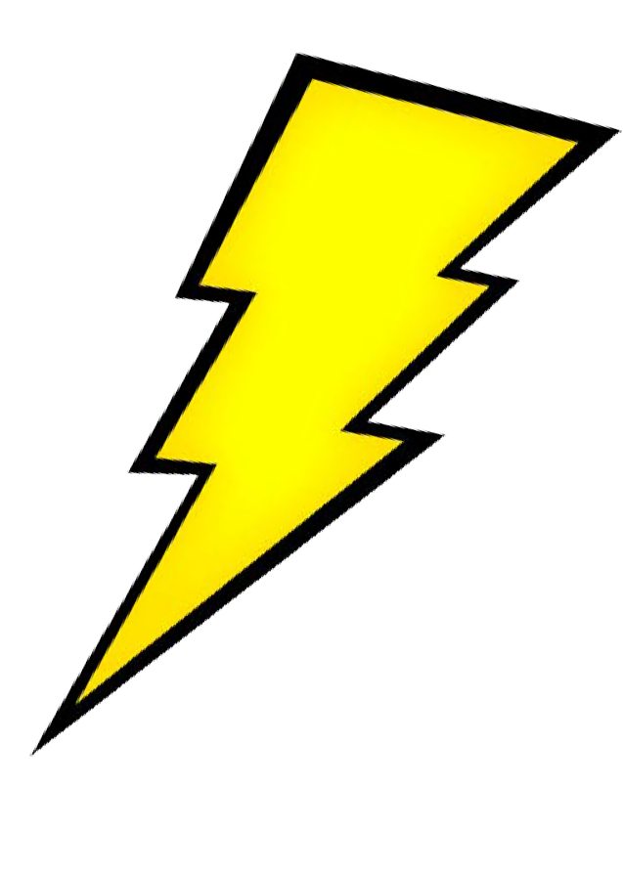
-1.6 × 10-19 C
+1.6 × 10-19 C
about 10-6 C
about 15 C
Some typical quantities of charge:
charge of a single electron charge of a single proton
excess charge on a balloon rubbed on a sweater
charge that flows through a lightning bolt

Calculations with charge

Key formula
An electric current is a flow of electric charge (such as electrons or ions) over time.
I = q / t
where I is current in amperes,
q is charge in coulombs, and
t is time in seconds.

The total charge that flows in a circuit with constant current is therefore given by:
q = I t

Which delivers more charge, an AA battery or a lightning bolt?
Typical capacity of an AA battery is 1000 mA h. That means it could potentially deliver a current of 1000 mA (one ampere) for one hour before the battery was ‘dead’. A current of one ampere is equal to 1 coulomb per second or 3600 coulombs over an hour.
A lightning bolt has a much greater current, typically
100 000 A, which is 100 000 C per second. However it lasts for a tiny amount of time, around 150 µs. That is a total charge of 100 000 × 150 × 10-6 = 15 C.
So, over its lifetime, an AA battery delivers about 3600 C of charge while a single lightning bolt delivers about 15 C.

Questions
- Would you rather be hit by the charge from an AA battery or a lightning strike? Why are they different?
- If the electromagnetic interaction is 1036 times more powerful than gravity why is the Moon held in orbit around Earth by gravity, not electromagnetism?

Current

In this photo ‘current’ is the flow of water downstream. It’s not the water itself that creates the current, it’s the movement of water. If the river stopped flowing we would say there was no current, but there would still be water.

Electrical currents are similar to water currents, but they are created by movement of electrically-charged particles, such as electrons or ions, rather than water molecules.
Current in an electrical wire is carried by loosely-bound electrons in metals. In a lightning strike it’s ionised gases that carry current, while dissolved ions carry current in a ‘wet’ battery.

Measuring current
Electrical current is measured in amperes (A), named after French physicist André-Marie Ampère (1775 – 1836).
Water currents might be measured in units of speed (metres per second) or as a flow rate (litres per second). For an electrical current the unit used is the quantity of electric charge that moves per second: one ampere is equivalent to a movement of electric charge of one coulomb per second.

Simple circuits
In a simple circuit current is the same at all points. If it wasn’t the same then charge would build up at some point.

A
A
A
A

The four ammeters (meters used to measure current) in this circuit all display the same reading.
For the same reason, if a circuit branches then current flowing into the branches equals the total current across all branches. In the circuit fragment below, ammeters A1 and A5 read the same value, which is equal to A2 + A3 + A4.
A2
A1
A3
A5
A4
RCD switches that protect electrical circuits use this property.
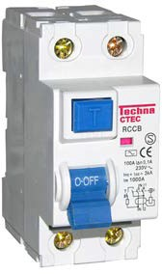
They monitor the electrical supply as it flows in and out of your house. The values should be the same, but if a difference of 10 mA or so is detected then the RCD quickly shuts off power as charge is flowing where it shouldn’t – perhaps through a person.

30 000 A
100 A
10 A
100 mA
Some typical quantities of current:
typical lightning strike car starter motor electric kettle
compact fluorescent bulb

Calculations with current

Key formulae
The specifications of a battery in a typical tablet are often quoted with two units, for example:
11 560 mA h (42.5 W h)
11 560 mA h is a measure of charge (current
× time). One ampere equals one coulomb per second, so the amount of charge this represents is:
charge (q) = 11.560 × 60 × 60
= 42 000 C
To convert this to energy we need to know the voltage rating of the battery, which in this case is
3.7 V.
energy (W) = charge (q) × voltage (V)
= 42 000 × 3.7
= 154 000 J
42.5 W h is a measure of energy that this battery can store (power x time). One watt equals one joule per second, so the energy stored by this battery is given by:
energy = 42.5 × 60 × 60
= 153 000 J

The two calculations give similar values for the amount of energy stored in the battery.
An electric current is a flow of electric charge (such as electrons or ions) over time.
I = q / t
where I is current in amperes,
q is charge in coulombs, and
t is time in seconds.
The power used by a circuit component depends on the current and the potential difference across the component.
P = V × I
where P is power in watts,
V is potential difference in volts, and I is current in amperes.

Why can I use my computer to charge a phone via USB but not a tablet?
A standard USB 2.0 port delivers a maximum of 500 mA at
5 V. We can use the formula for power, P = V × I, to calculate the maximum power that this USB port can deliver.
P = 5 × 0.5 = 2.5 W
That’s OK to drive a phone screen, but a modern tablet with high-resolution screen might require 7 W just for the display when it’s turned on. The USB port simply can’t supply enough current to charge the device, when the display is on.
It may be able to charge the device if the display is turned off, but how long will it take? We have already calculated that the USB port can deliver a maximum 2.5 W (2.5 joules per second) so now we can calculate charging time of the tablet, using the figure in the side box for the amount of energy the tablet can store.
time = 154 000 / 2.5
= 61 600 s
= 17 hours
That is, it will take at least 17 hours to charge the battery, assuming the device is using no power.

Questions
- A phone charger is typically rated at 5 W while a tablet charger might be 10 W. Why does a tablet require a different charger to a phone?
- Is it more useful to rate battery capacity in mA h or W h?

Voltage (electric potential difference)

Voltage is a familiar concept in everyday use: you know the difference between a 9 V battery and a 240 V mains power supply. But it’s harder to understand exactly what voltage means.

There’s a difference between a tin of paint at the bottom and top of a stepladder. It takes energy to carry the tin to the top: the amount of energy depends on the mass of the tin, the strength of gravity, and the height of the ladder.
We can give a value to the gravitational potential at every point in the room. The actual value is not important – it’s the difference in gravitational potential that counts. There’s not much gravitational potential difference between the bottom of the ladder and its first step, but this increases between bottom and top of the ladder.
Just as gravitational potential is derived from mass, electric potential is derived from charge. Like gravitational potential, the actual value of electric potential is not as important as the difference in electric potential between two points.

Measuring electric potential difference
Electric potential difference (or potential difference for short) is measured in volts, named after Italian physicist Alessandro Volta (1745 – 1827) who was an early experimenter with batteries.
If the potential difference between two points is one volt then it will take one joule of energy to move one coulomb of charge from the lower potential energy point to the higher. Conversely it will yield one joule of energy if a one coulomb charge moves in the opposite direction.

What happens in a battery?
Chemicals in a battery contain stored energy (chemical potential energy) in chemical bonds. Battery chemicals create a potential difference between the positive and negative poles. When a circuit is completed electrons and ions move in response to this potential difference and we get useful energy from this flow.
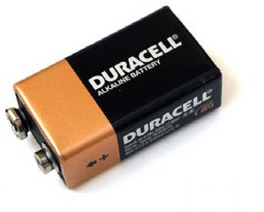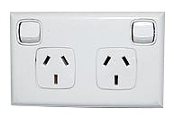As a side effect the chemicals that created the potential difference change into different forms and the potential difference reduces to zero. In effect chemical energy has been converted to electrical energy.

There’s a small potential difference between the poles on a 9 V battery and a larger difference between the pins on a mains socket
Some typical quantities of electric potential difference:
nerve cell at rest and firing 110 mV
AA battery 1.5 V
mains electricity in Australia 240 V
Perth electric rail system 25 kV
power transmission lines 120 kV

Calculations with electric potential difference (voltage)

Key formulae
An electric current flowing through a resistance will result in a electric potential difference across the resistance, as specified by Ohm’s law:
V = I R
where V is potential difference in volts, I is current in amperes, and
R is resistance in ohms.
Conversely, an electric potential difference across a resistance will cause a current to flow. The amount of energy transformed in moving a charge across a potential difference depends on the amount of charge and potential difference.
W = q V
where W is energy in joules,
q is charge in coulombs, and
- 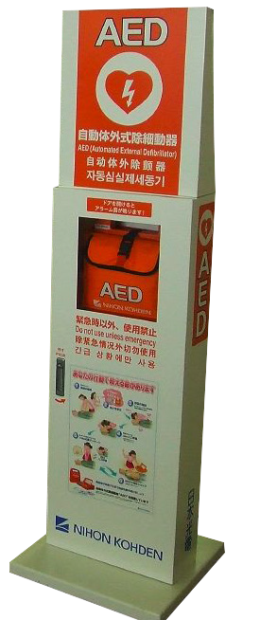is potential difference in volts.
Questions
- Western Power undertake to supply mains electricity at 240 V plus or minus 6% averaged over 5 minutes. What might happen if equipment designed for China (mains voltage 220 V) is used in Perth?
- What happens if an Australian hairdrier is used (with a plug adaptor) in the United States of America, where mains voltage is 110 V?
current (I) = 0.03 / 0.004
= 7.5 A
If this quantity of charge is delivered over 4 ms then current is given by:
= q / t
= 0.01 / 0.004
= 2.5 A
current (I)
If this quantity of charge is delivered over 4 ms then current is given by:
For an adult
Charge to be delivered is given by: charge (q) = 150 / 5000
= 0.03 C
= energy (W) / potential difference (V)
= 50 / 5000
= 0.01 C
charge (q)
For a child
Charge to be delivered is given by:

AED: Automatic external defibrillator
The human heart depends on a complex sequence of coordinated electrical pulses to pump blood through its four chambers. AEDs can be used to treat two potentially fatal conditions.
- ventricular fibrillation – Heart muscles fire in an uncoordinated manner so no blood pumping takes place.
- ventricular tachycardia – Heart muscles fire too fast for blood to pass from one chamber to the next: again the result is that blood isn’t pumped around the body.
An AED unit sends a brief pulse of electrical energy to the heart in an attemt to shock it back into correct rhythm.
The energy required varies from 50 J for a child to around 150 J for an adult. Pulse time is very brief, around 4 ms, to minimise damage. If the unit delivers a fixed voltage of 5000 V, what current is delivered?

Power

You probably get a power bill for electricity supplied to your house. But what exactly are you paying for: power, energy, charge or something else?
Power is a measurement of energy transferred or transformed per second. A low power LED bulb converts a small amount of electrical energy to light per second, while a high power heater converts a large amount of electrical energy to heat per second.
Knowing the power consumed by a device doesn’t give information on the current or voltage it uses. High power usage might arise from a large current flowing through
a small potential difference, or a small current flowing through a large potential difference.
It’s the combination of current and voltage that gives power used, using the relation:
power (watts) = current (amperes) × voltage (volts).

Light sources
These three light sources provide roughly the same amount of light, but have very different power

Measuring power
The unit for electrical power, as for other forms of power, is the watt, named after Scottish engineer James Watt (1736 – 1819). Power measures the rate of energy supply or transformation where one watt is equivalent to one joule per second.
Electricity companies charge for the number of ‘units’ of electricity supplied, where 1 unit = 1 kW h. As watts are equivalent to energy per unit time, kilowatt-hours are equivalent to (energy / time) × time, which equals energy. So your power bill should really be called an energy bill.

Saving power
Many electronic devices have power or energy-saving features, such as dimming a screen or spinning down a hard disk.
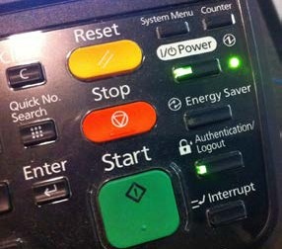
Such actions are designed to reduce the amount of current flowing in circuits, which reduces power consumption.

ratings.
The incandescent globe converts most of the electrical
energy that passes through it to heat: only around 2% is turned into useful light.
75 W 240 V incandescent globe

50 W 12 V halogen globe

The 12 V halogen light may be low voltage, but it’s not low power. It’s not much more efficient than an
incandescent light, and often several halogen lights are used to replace one incandescent light.
Because power = current × voltage, low voltage lights must use greater current.
LED lights are the most efficient, turning around 15% of electrical energy into light. The light emitted from these devices is strongly directional, which is an advantage for some applications. Although expensive, cheaper models are continually developed.

5 W 240 V LED light

Some typical quantities of power:
hearing aid smart phone LCD television kettle
1 mW
1 W
75 W
2 kW

Calculations with power

Key formulae
Power is the amount of energy transformed or transferred per unit time.
P = W / t
where P is power in watts,
- is energy in joules, and
t is time in seconds.
Energy transformed equals charge multiplied by the potential difference (W = q × V), so the formula for power can also be written:
P = q V / t
However q / t is current (charge per unit time), so power can also be expressed as:
P = V I
where P is power in watts,

Why do electric transmission lines use such high voltages, typically many thousand of volts?
Demand for energy from power stations varies considerably during the day. Equipment voltage (V) is fixed, so as power demands (P) on a generating station increase, the current (I) has to increase.
P = V I
Not all the energy fed into the line can be used at the other end. Along the way some energy is converted to heat due to line resistance. These are called ‘line losses’.
We can calculate how much energy is lost to heat by measuring the drop in voltage between ends of the transmission line: call this Vdrop.
Then the power lost to heat is given by: Ploss = Vdrop I
If the resistance of the line is Rline then Ohm’s law can be
used to substitute Vdrop = I Rline, which gives:

V is potential difference in volts, and
Ploss
= (I R
line) × I

I is current in amperes.
= I2 R

line

Remember our formula for the current in the line is given by P = V I or I = P / V, so:
Ploss = P2 Rline / V2
This equation shows power loss is inversely proportional to the square of voltage. So for maximum efficiency transmission voltage should be as high as possible.
Resistance should also be minimised by using conductors with as low resistance as possible.

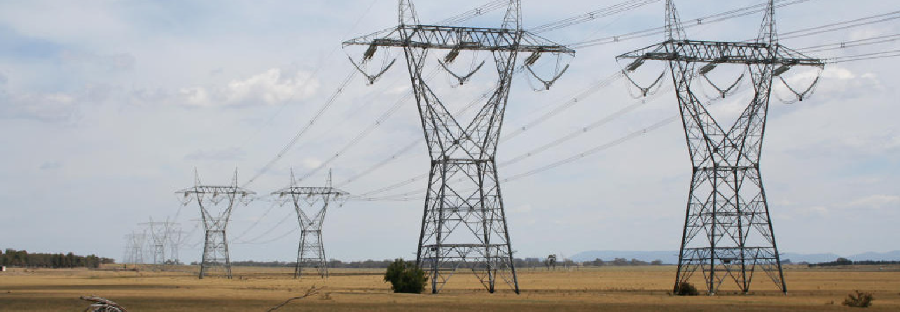
Questions
- Conduct an audit of common household appliances and calculate the current each requires.
- Could a householder reduce their electricity bill by replacing incandescent globes with low voltage halogen lights? Explain your answer.

Resistance

Think about the two funnels shown here. Water flows out of the funnel on the left faster because the stem offers less resistance to water flow.

In a similar way different materials hinder the drift of charge that makes up an electric current by different amounts. Materials that hinder electron drift have high resistance (or low conductivity), whilst materials that readily enable electron drift have low resistance (high conductivity).

Measuring resistance
Resistance is measured in ohms, named after a German physicist, Georg Ohm, who established the relationship between current, voltage and resistance known as Ohm’s law.
V = I R
Materials with low resistance are good conductors — those with high resistance are insulators. The resistance of a piece of wire depends on its length and cross-sectional area. Double its length and its resistance will double.
Double the cross-sectional area and its resistance will be halved.

Ohm’s law
Ohm’s law relates resistance, current and electric potential (voltage) through the equation V = I R.
This can be rearranged to give I = V / R. Current flow increases if electric potential is increased; or resistance is decreased.
Not every conductor follows Ohm’s law — those that don’t are called non-ohmic conductors. For example, resistance of the filament in an incandescent light increases as it heats up.

V
V
The graph on the left shows how current varies with voltage in a non- ohmic conductor. Resistance increases as voltage increases in this case. The straight-line graph on the right shows the behaviour expected for a resistance that follows Ohm’s law.
I
I
Resistance of 1 m length of wire with 1 mm diameter:
silver 0.06 Θ
copper 0.07 Θ
aluminium 0.1 Θ
graphite 1000 Θ
rubber 1020 Θ

Gold-plated audio components are popular with enthusiasts of high-quality audio due to their low resistance.

Resistors, electrical devices of fixed resistance, are a common component in circuits.

Calculations with resistance

Key formula
Ohm’s law V = I R
where V is voltage in volts,
I is current in amperes, and
R is resistance in ohms.

Estimated effects of electric currents: 1 mA barely perceptible
16 mA maximum current an average person can grasp and ‘let go’
20 mA paralysis of respiratory muscles 100 mA ventricular fibrillation threshold 2 A cardiac standstill and internal
organ damage
15 A common fuse breaker opens circuit (RCD trips on differential current of 5 – 30 mA)

What are the dangers to humans from electrocution?
Tissues in the human body with the lowest resistance are nerves and muscles, while fat and bone have the highest resistance.
An electric current that travels through the human body has to travel through the skin (which has high resistance) on its way in and out of the body.
Rtotal = Rskin + Rbody + Rskin
The resistance of dry skin may be as high as 100 000 Θ (measured from hand-to-hand), but is more typically a few thousand ohms. The resistance of the body is typically 500 Θ.
Skin resistance drops sharply if it’s wet or damaged (eg down to 500 Θ or less). If burning from electrocution damages or destroys skin then its resistance will be reduced, leading to increased current flow and further damage.
Damage comes from current (voltage is not so important).
If body resistance falls below 1000 Θ currents from mains electrocution can easily exceed 0.2 A, which is very dangerous.

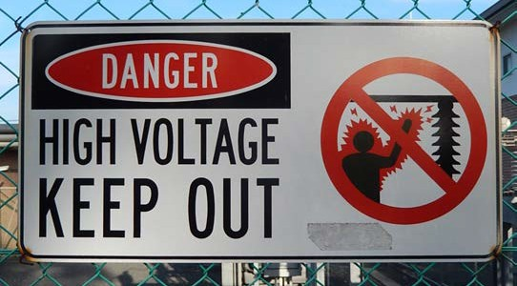
Average resistance of human body (hand-to- hand) at various voltages:
25 V 3250 Θ
100 V 1875 Θ
220 V 1350 Θ
1000 V 1050 Θ
The human body displays non-ohmic resistance. Higher voltages are more dangerous as the body offers less resistance and currents are correspondingly greater.

Questions
- Calculate current flow in the human body at various voltages, using the examples above of average hand-to- hand resistance.
- Graph results for current versus voltage to show the human body is a non-ohmic conductor.
- Compare your graph with that for a light globe (on the previous page). Sugest reasons for any differences.

Energy

Energy is a fundamental concept in physics that comes up in many different settings. You will be familiar with kinetic energy, gravitational energy and chemical energy. Electrical energy is another ‘form’ of energy.
However energy isn’t something you can hold in your hand, unlike matter. Energy is something possessed by matter as a result of its motion or position. It takes energy to separate opposite electric charges: this energy is stored as electric potential energy and gives rise to an electric potential difference.
The various transformations of energy as charge is separated, united and electric currents flow give rise to the collective term, ‘electrical energy’.

Measuring energy
As with all forms of energy, electrical energy is measured in joules, named after English physicist James Joule, who developed the relationship between heat and mechanical energy.
There are different ways of defining the joule, depending on the form of energy that is the basis of definition:
- The work done (or energy transferred) in applying a force of one newton through a distance of one metre.
- The work done (or energy transferred) in passing a current of one ampere through a resistance of one ohm for one second.
- The work done (or energy transferred) in moving an electric charge of 1 coulomb through an electric potential difference of 1 volt.
Power and energy are closely related. Power measures the rate at which energy is transferred. So a 10 W LED light turns 10 J of electrical energy into light and heat per second.

rheostat
+ –
heating element
insulation
A
outer container
+
water
-
calorimeter
thermometer
stirrer
–
V
+
Calorimeter
A calorimeter converts electrical energy into heat energy. It consists of an insulated container, a heating element connected to an external electrical circuit, and a thermometer. A known mass of water is placed into the container and a constant current established in the circuit.
The amount of electrical energy converted in the calorimeter (W) depends on the electric potential difference across the heating element (V), current (I) and time the experiment is run (t):
W = V I t
The temperature of the water in the calorimeter increases. The amount of heat energy this represents (Q) may be calculated from the change in tenperature (�T), mass of water (m) and heat capacity of water (c = 4.186 kJ kg-1 K-1):
Q = m c �T
If the calorimeter is 100% efficient then Q = W, but in practice Q < W due to heat losses.
1 kJ
10 kJ
70 MJ
Some typical quantities of energy:
energy of a studio photographer’s camera flash energy in a AA battery
electrical energy used in a typical household per day

Calculations with energy

Key formula
This formula is derived from the definition of a joule as the amount of energy required to move an electric charge of one coulomb through an electric potential difference of one volt:
W = V q
where W is energy in joules,
V is electric potential in volts, and q is charge in coulombs.

This formula expresses power as a rate of energy use:
P = W / T
where P is power in watts,
W is energy in joules, and
T is time in seconds.

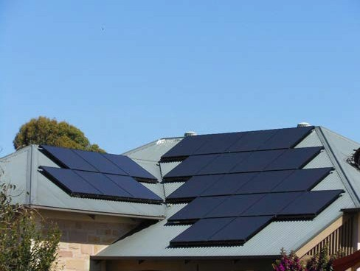

Solar power
The amount of energy in sunlight that reaches Earth’s surface is about 1 kW per square metre on a sunny day at noon. Is this enough to power a household?
Solar panels are about 15% efficient, so could generate a maximum of about 150 W m-2. If we assume the equivalent of five hours of direct sunlight per day that gives a total energy production, per square metre, per day of:
150 × 3600 × 5 = 2.7 MJ
So to get the amount of energy used by a typical household in a day (70 MJ), we would need around 25 m2 of solar panels. That’s quite a lot — which is why it’s also important to look at reducing overall energy use through energy- efficient appliances.

This house has 24 solar panels on its roof. Assuming each panel is 1068 mm × 541 mm, what energy output might it deliver?
total panel area = 1.068 × 0.541 × 24
= 13.9 m2
Assuming 1 kW solar radiation per square metre and 15% efficiency in turning this to electricity, peak power production would be:
power = 0.15 × 1000 × 13.9
= 2085 W
= 2 kW (2 kJ per second)
That’s about right, as solar panels typically produce about 100 W, so 24 panels would produce 2.4 kW.

Questions
- Conduct an audit of common household appliances and estimate their daily energy use.
- How does the energy used by a typical household appliance compare to the energy requirement of an adult, which is about 8700 kJ per day?

