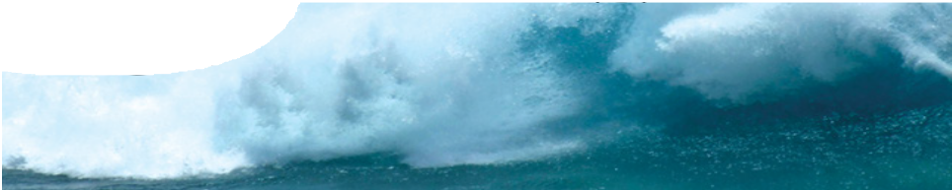
fact sheet
Dangerous waves

Getting dumped by a surf wave is never fun. After you’ve been run through the wash cycle and been driven into the sand you’re left gasping for air. Although it can be terrifying, you’re usually left unharmed. Now imagine getting dumped by a wave powerful enough to tear apart a house. Waves that dump you at the beach and a tsunami that causes millions of dollars of destruction have a lot in common. How they differ comes down to physics.

How do waves begin?
Waves you find at your favourite beach all begin with the wind. Friction between fast moving molecules of air and the water causes water molecules to ‘bunch up’ into small ripples. The tiny wave’s sloping surface increases friction and a small amount of kinetic energy from the wind is transferred to the top of the forming wave. This transfer of energy pushes it along in the direction of the wind; the greater the force of the wind, the bigger the wave. The howling, high-speed winds created by cyclones or hurricanes result in huge waves.
Tsunamis differ from normal wind-waves in a number of ways. Firstly, they begin with a ‘bang’. They form from undersea earthquakes, volcanic eruptions, meteor strikes or any other massive disturbance of the sea.
Waves they create may not be any higher than a surf wave, but have much longer wavelength (the distance between wave crests). Wind-waves have shorter wavelengths; over a minute, a dozen of them can pound the shore. But tsunamis have astonishing wavelengths (up to several hundred kilometres) and with them comes a huge volume of water on a collision course with coastlines.

The disturbance that creates a tsunami shifts a massive column of water. When the Indian tectonic plate and the Burma tectonic plate moved on Boxing Day 2004, it is estimated that 30 km3 of water were lifted! As the effect of gravity tries to restore equilibrium, a ring of waves moves away from the centre of the disturbance, like ripples made by a rock dropped in a pond. Movement of the waves is felt throughout the depth of the ocean
– even a shipwreck on the ocean floor would feel its force.
1) Bernard, E.N. (n.d.). National Oceanic & Atmospheric Administration (NOAA), U.S. Department of Commerce. Retrieved 14th June 2007, from http://www.tsunami.noaa.gov/tsunami_story.html
In September 2004, Hurricane Ivan produced a wave so tall it broke all records. The wave, which
formed in the Gulf of Mexico, was measured at a whopping 27 m tall – that’s a wall of water the size of a 10
storey building! (1)

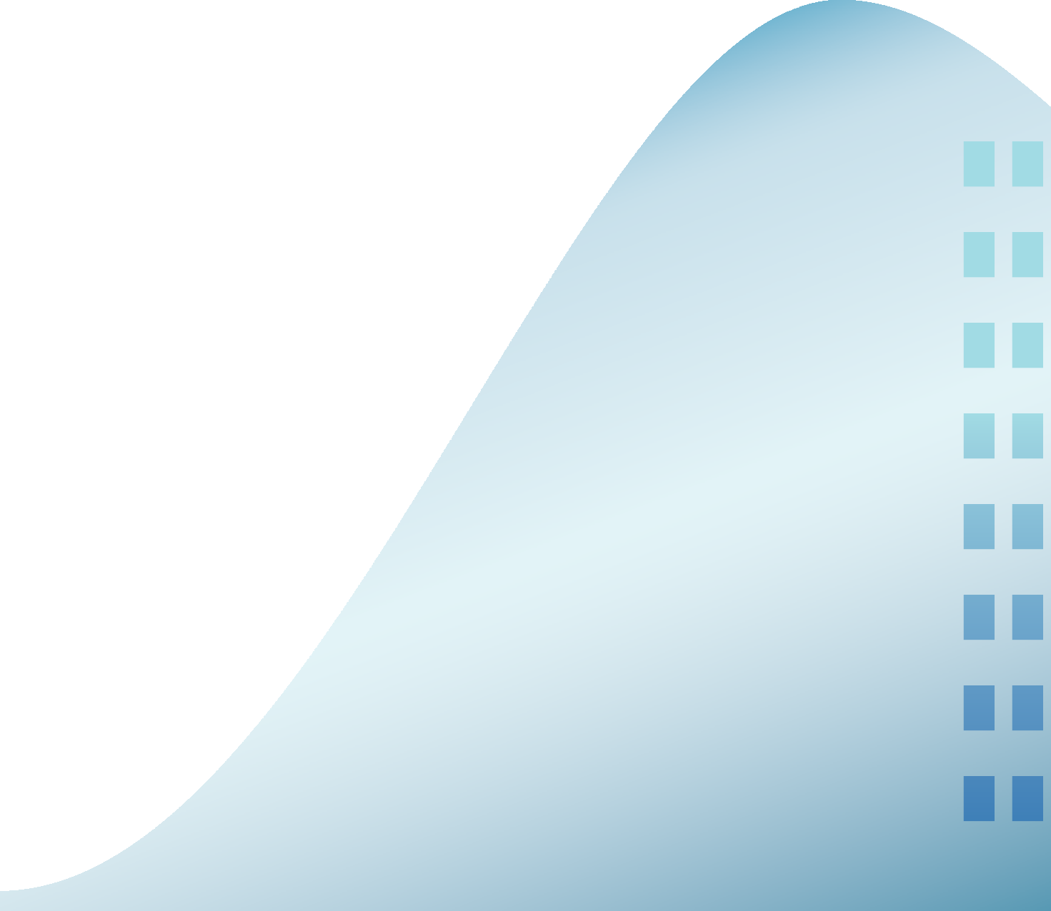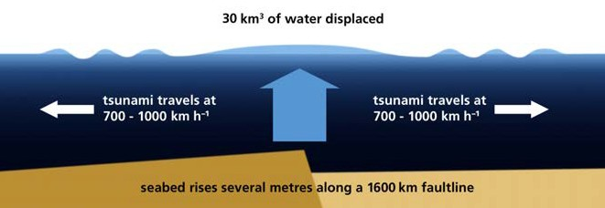average height man

ast0003 | Mechanical waves 1: Dangerous waves (fact sheet) developed for the Department of Education WA
© The University of Western Australia 2008 for conditions of use see spice.wa.edu.au/usage version 1.3 reviewed July 2014 page 1 Licensed for NEALS

Dangerous waves

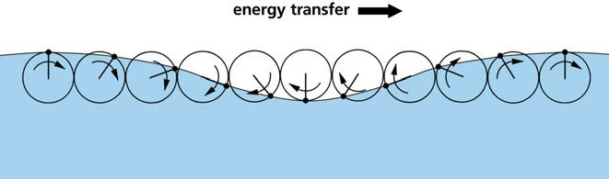
How do waves move?
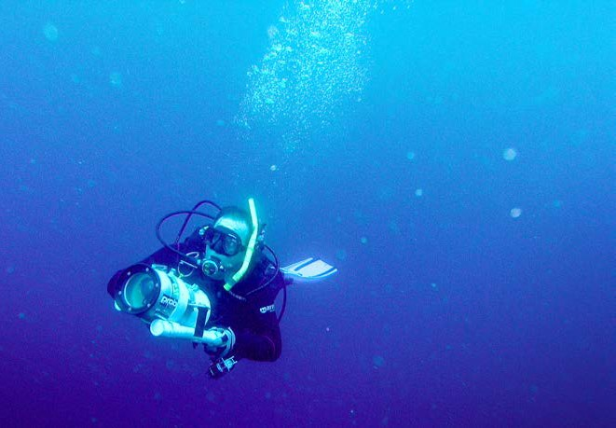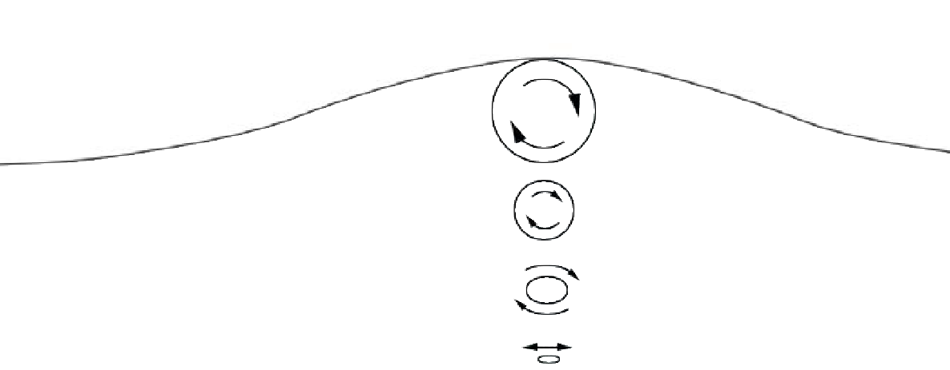In both ocean waves and tsunamis water molecules travel in circles, moving briefly in the direction of the wave, then circling back to the starting point. You can see this by watching surfers sitting on their boards. As waves pass by, each surfer moves upward and forward a little, then falls and moves back a little, but does not move towards the shore. This circular motion means that the kinetic energy of a wave moves in one direction (the
direction of the wind) but the water moves at right angles to the wave (up and down).
If you were scuba diving during a violent storm you’d be unable to feel the movement of the waves. This is because the wave’s motion diminishes the deeper you dive. The depth where the force disappears depends on the wavelength of the wave. The motion of a tsunami, with a wavelength of more than 100 km, is even felt on the ocean floor.

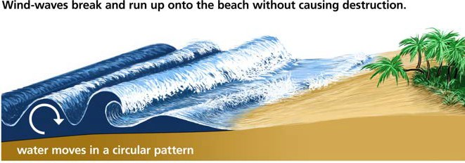
Why are tsunamis so destructive?
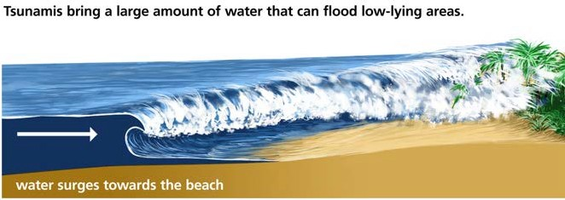
When a wind-wave reaches a beach, it involves a small volume of water and so causes little or no damage. But a tsunami, with a wavelength of perhaps 100 km, involves a huge volume of water and can cause massive damage. As it reaches shallow water, it slows down and the height of the wave increases. Over large stretches of coastline the waves of the Boxing Day tsunami reached 10 m high and crashed inland for nearly two kilometres. More than 200 000
people were killed in countries as far apart as Indonesia, Sri Lanka, India, Thailand and South Africa.

ast0003 | Mechanical waves 1: Dangerous waves (fact sheet) developed for the Department of Education WA
© The University of Western Australia 2008 for conditions of use see spice.wa.edu.au/usage version 1.3 reviewed July 2014 page 2

