fact sheet
Dangerous days ahead

cientists have made predictions about what would happen if the average temperature in Perth in 2070 is 6 ˚C hotter than in 2011. They calculated the number of dangerous days,
S
that is, days when heat stroke might occur within two hours, while undertaking physical activities. The activity level is important because the amount of metabolic heat we make depends on how hard we’re working. The scientists compared their predictions with the number of dangerous days in 2011. They found the number of days on which heat stroke is likely to occur will increase as the climate warms up.

Unacclimatised Acclimatised

Scientists at the University of Western Australia have been researching effects of increased temperatures on the human body. As a result, they’ve made some startling projections that may occur by the year 2070 – if global temperatures continue to increase.
Shane Maloney is one of the researchers and, in an interview, we asked him to summarise the projections.

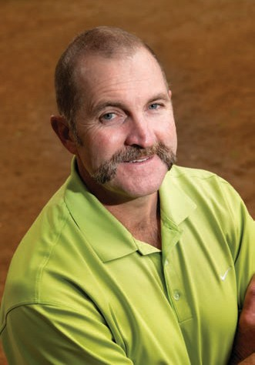

What are your projections for 2070?
What is your field of research?
I’m a thermal physiologist. I study the ways that animals, including humans, maintain a constant core body temperature, and what happens when they’re exposed to conditions where they can’t maintain that temperature. I’m interested in the costs and benefits of maintaining a constant temperature.
While many of the effects of climate change were being discussed, no one had looked at what it would mean for our ability to do things outside, in the future hotter world.

How did you carry out your research and what did you find?
We took models developed in the mining industry, and by the military, and applied them to our ability to do something like play golf in
the middle of summer. What we found was that small increases in temperature will have an impact, if not directly on health via
hospitalisations for heat illness, then at least in decreased productivity for those working outside in a hotter world.

If our modelling is accurate, in 2070 there’ll be one day per year where an acclimatised person, at rest, will be at risk of heat stroke, possibly fatal, if they don’t have access to somewhere to cool off. For unacclimatised people, and those most at risk (the elderly and those with cardiovascular or respiratory problems), the situation is worse. Already, in Perth, in the current climate, people are dying from heat-related illness, so it’s likely that without air- conditioning the death rates will be much higher in 2070.

What about working conditions?
Working outdoors provides the ‘double whammy’ of exposure to the hot environment, combined with increased metabolic heat production that accompanies physical labour. Our modelling suggests that in 2070 there’ll be between 15 and 26 days per year where outdoor manual labour won’t be possible without exposing workers to conditions likely to lead to heat stroke.

Will there be implications for playing sport?
We modelled situations for playing golf, and for fielding during a game of cricket. The effects for both situations are likely to be similar. We found that at present there are few days when an acclimatised person would be at risk from such activity. Whereas in 2070, there’ll be 5 to 14 days a year when playing golf or fielding in cricket will put an acclimatised person at risk of heat stroke. The situation for an unacclimatised person is
worse as there’ll be 34 to 45 days when they can’t do such things. However, batsmen and bowlers are likely to be impacted more than golfers. This is because batters and bowlers exercise more, and their metabolic rate and heat production is higher.

And to sum up?
Expect that doing things outside in summer will become more uncomfortable. There’ll be less opportunities to do all the things we enjoy doing outdoors.
The message is: if you want to cope better in the heat in the future, get out in it, safely, each day, and become acclimatised!

