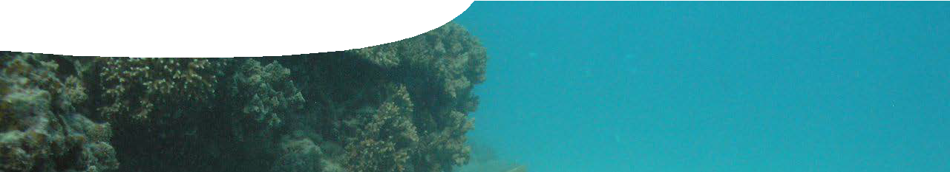
background sheet
Cottesloe Reef

Aquatic food webs are similar to terrestrial food webs. There are producers that get energy through photosynthesis, as well as first, second, third and possibly fourth order consumers. Phytoplankton are key organisms in any aquatic food web. These photosynthesising, microscopic organisms, such as diatoms, occur in surface-lit waters.
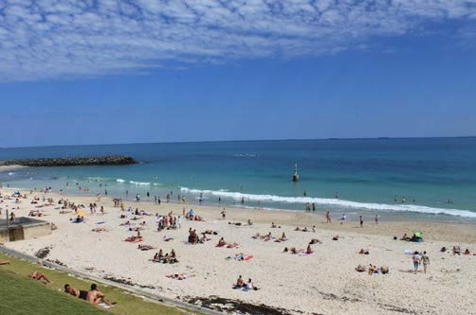
Cottesloe Reef sits on a limestone shelf close to iconic Cottesloe beach in Perth, Western Australia. This is a key beach destination during Perth’s hot summer months and an important tourist location.
In 2001 the reef was designated a Fish Habitat Protection Area (FHPA). Activities such as spearfishing, jet skiing and anchoring are banned, however recreational fishing, snorkelling and scuba diving are allowed.
The reef stretches for 4.4 km along the coast, from North Street, Cottesloe to the southern boundary of Mosman Park. It extends 1.5 km offshore through three distinct regions: lagoon, flat reef and broken reef, in order of increasing depth.
The lagoon has a mainly sandy sea floor with various

seagrasses that provide food and shelter as well as stabilise the seabed and reduce erosion. Seagrasses also sequester carbon. When seagrass leaves break away they leave behind a leaf sheath that form a fibrous matte that builds up over many years, decades or even centuries. These fibrous mattes are slow to decompose in the low oxygen environment, thereby sequestering carbon rather than releasing carbon back into the environment.
The flat reef has a rocky sea floor with relatively level reef structure. Seaweeds (macroalgae) dominate the reef structure and support a thriving, diverse invertebrate community that includes scallops, abalone, sponges and
sea stars. Invertebrates are crucial in marine webs. They link producers with higher order consumers, such as fish, and can control algae and detritus levels.
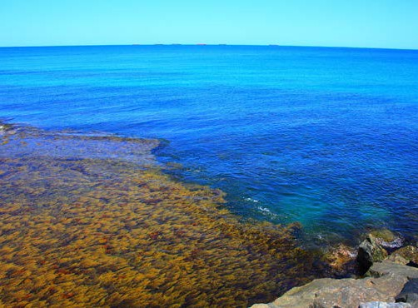
Cottesloe reef
Matty Gott
Cottesloe Beach
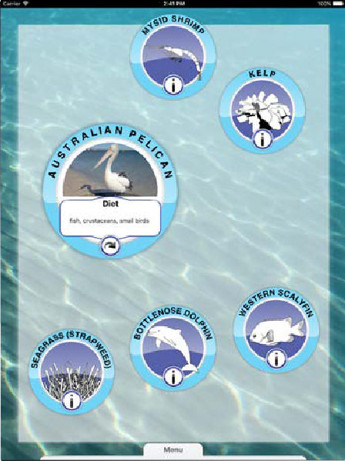Michelle/Flickr
iPad

The UWA Food webs app showcases a marine food web that illustrates connections of life in and around Cottesloe Reef. While each web includes a producer, phytoplankton doesn’t always appear. Obviously, reality is a lot more complex!

The broken reef is not level but alternates between shallow and open structures. Weedy seadragons hide amongst seagrass and reef
structures, together with sponge beds and sea corals. This part of the reef is also a breeding ground for squid, striped stingarees and sharks.
Numbers of fish increase as you move away from shore and there is a positive relationship between abundance of fish species, fish numbers and invertebrates. Local fish that may be found around Cottesloe Reef include herring, tailor, skipjack (silver trevally), whiting, morwong and tarwhine (silver bream).

Invasive species
Marine invasions can occur through shipping (hull fouling, ballast and sea chests), aquaculture, aquarium trade or release of organisms (intentional or accidental). Around Perth and Fremantle waters there are 46 known invasive marine species including the European fan worm and Asian date mussel.
The filter-feeding European fan worm (Sabella spallanzanii) forms dense colonies that can modify rates of sediment deposition as well as local water currents. It was first found in Western Australia in 1965.
It can foul reefs, man-made structures, and commercial shellfish. It competes with native species such as mussels for suspended food and space.
The Asian date mussel (Musculista senhousia) first appeared in Australia in 1983, possibly via ship fouling. Date mussels eat phytoplankton, just like local mussels and clams.
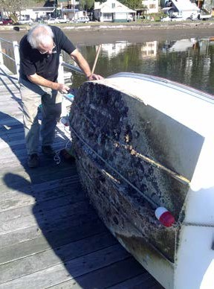
Date mussels are small: a maximum 35 mm length, but they can grow in very large clusters in shallow waters. They form dense mats with up to 150 000 individuals per square meter on both soft and hard surfaces.
Dense mats of mussels compete with native seagrass, algae
and invertebrates for food and space, disrupting natural
ecosystems. If density becomes too high, food availability for herbivores can be reduced, and so reduce food available for animals higher in the food web.
A few animals that eat local clams and mussels (such as the striped stingaree) may benefit from the increased amount
of available food. Overall, however, this invasive mussel is a pest of concern that affects

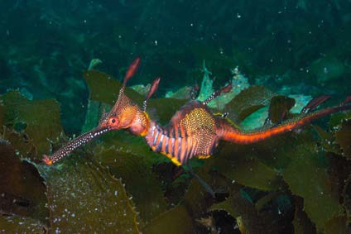
weedy sea dragon
Graham Short/Flickr

natural environments, fisheries and aquaculture.
boat fouling by marine organisms
Doug Beckers (CC-BY-SA-2.0)
Leeuwin current
The Western Australian coast between Augusta and Kalbarri, including Cottesloe Reef, has been ranked as the second most diverse marine environment in th world, in terms of unique reef organisms. This is a result of the Leeuwin current.
The Leeuwin current is a strong, offshore current of warm, low-salinity water
that originates in the tropical waters of north-western Australia. It flows 5500 km, north to south, down the
Western Australian coast, and around the southern coast to the Great Australian Bight, in the opposite direction to the prevailing wind.
Leeuwin Current
Ross et al. (2015). PeerJ doi:10.7717/perj.781
Rottnest Island
Leeuwin Current
Western Australia
Ningaloo

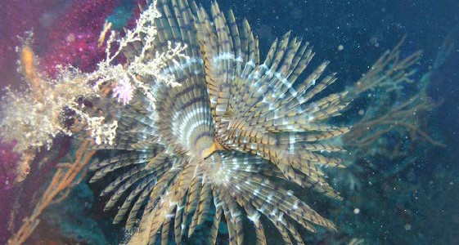
European fan worm
Anders Finn Jørgensen (CC-BY-SA-2.0)

