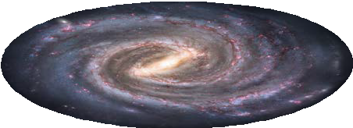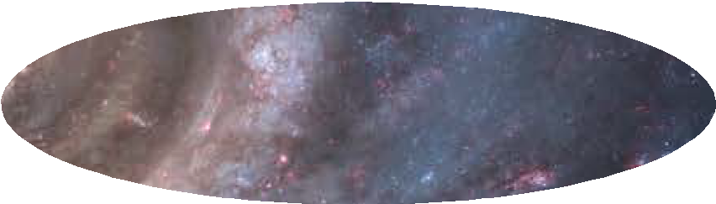4.5 billion km
How do astronomers measure distance across the Universe? Astronomers can’t travel around the Universe to make measurements; instead they use a combination of techniques that are collectively known as the cosmic distance ladder.

Sun
Neptune
Astronomers use parallax to work out the distance to planets in our Solar System, such as Neptune.

Solar System
4.2 light-years

Proxima Centauri

Astronomers also use parallax to measure the distance to nearby stars.

What is a light-year?
The distance light travels in one year, an incredible 9.5 trillion
(9 500 000 000 000)
kilometres.

10 000 light-years

Solar System
star
Stellar parallax works for stars up to 10 000 light years away.

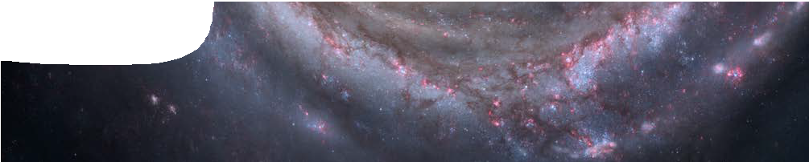
fact sheet
Climbing the cosmic distance ladder

When we take a closer look at the scale of the Milky Way, its obvious measurement of parallax from Earth doesn’t take us very far into the Universe.
Milky Way
Space satellites, such as Hipparcos, have measured the parallax of stars with much greater accuracy than we can from Earth. A new satellite to be launched in 2011, Gaia, will measure parallax angles of around 1 000 000 000 stars
NOT TO SCALE

Milky Way
To make measurements further out in the Universe, astronomers use indirect measurements.
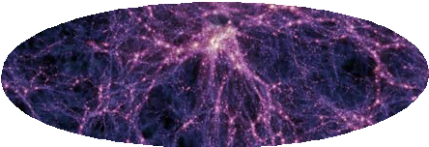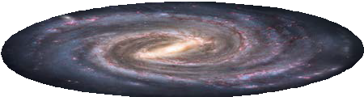These measurements are based on known properties of celestial objects, which are then used to calculate distance.

Milky Way
13 million light-years

galaxy with Cepheid

Astronomers study Cepheid variables (pulsating variable stars) to work out distances. The rate a Cepheid flashes is used to determine distances to galaxies up to 13 000 000 light-years away.

Milky Way
1 billion light-years

type 1a supernova
Type 1a supernovae always reach the same maximum absolute brightness. By measuring its apparent brightness, astronomers can calculate how far away a supernova is. Type 1a supernovae can take astronomers an incredible 1 billion light-years from Earth.
A cosmic object that has a known brightness is called a standard candle. Both type 1a supernovae and Cepheids are standard candles.

Milky Way

NOT TO SCALE
10 billion light-years

distant object
Astronomers study red shift (the change in wavelength of light coming from very distant objects) in the Universe, to work out how far away they are.
Edwin Hubble worked out that the further away an object is, the more its emitted light moves into the red part of the spectrum. Red shift helps astronomers estimate distances up to an incredible 10 billion light years.

