fact sheet
Cannibalism causes fatal disease?

Sounds fanciful doesn’t it? Well, read on …
Within the deep, dark, depths of jungle-covered slopes in eastern Papua New Guinea’s mountainous heart, unknown to the rest of the world until the 1930s, lived approximately one million people. They comprised many
linguistic groups, one being the Fore (pronounced ‘foray’) people whose land, in the Opaka area, was not officially opened to Europeans until the 1950s.
Like all other groups in the area, Fore people lived in villages. When early anthropologists began to research their lives,
a visitor to any village may have found a tranquil scene of families going about their daily activities of food preparation, making utensils and fabrics, and constructing or repairing their homes. Ceremonies were an important feature in their lives, and one, we commonly call cannibalism, widespread
in many parts of Papua New Guinea, was adopted by Fore people at the turn of the 19th century.

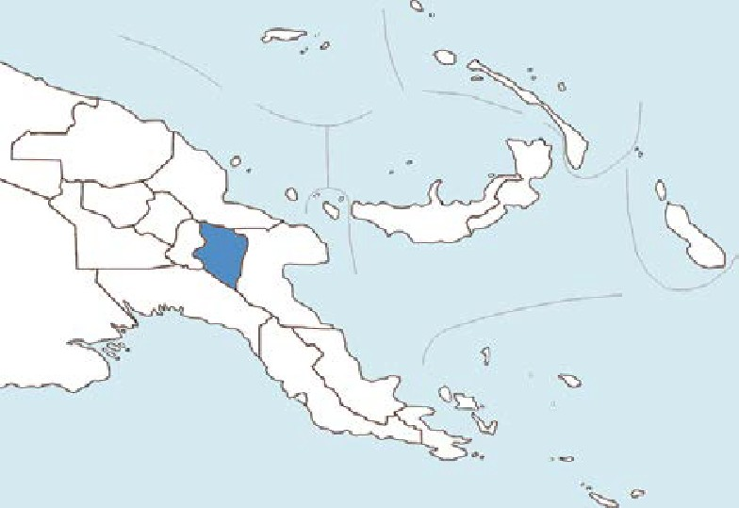
Eastern Highlands province, Papua New Guinea
Lamari Valley from the South Fore, © 2008 The Royal Society, Mathews JD (2008). Philos Trans R Soc Lond B Biol Sci.
363(1510):3679-84.
As the term cannibalism is fraught with preconceived meanings, many scientific reports refer to it as ‘transmission’. This practice involves eating dead kinsfolk in a ritualised way. Women cut up, cooked, and distributed body parts to female kinsfolk, who often shared it with their children. The brain was a special delicacy so if children begged to have some, mothers complied – out of love – but boys over the age of ten, were not allowed to touch it.
In Fore culture, a person, prior to death, may choose one of three ways to have their bodies disposed of: burial; placement in a basket or on a platform in a bamboo grove; or transmission. The latter was the most common choice as people believed it better for their bodies to be eaten by loved ones, than by insects and worms. It was also an expression of love and grief, and ensured souls reached the land of the dead.
Research suggested there was a deadly connection between cannibalism and a disease the Fore people called ‘kuru’ – literally translated as ‘shaking’. Victims of this disease were mainly women and children; early symptoms included: trembling or shaking; unsteadiness of voice, hands, and eyes; and falling over. More and more serious symptoms developed as the disease progressed, until death, usually after three to 23 months.
It was in the early 1920s, Fore people had first noticed this strange new disease that had surfaced amongst them and parts of neighbouring linguistic groups. They believed it was caused by sorcery, and sorcerers claimed to be able to strike down any chosen person, with the disease.
In the 1950s, when Australian authorities took over administration of Papua New Guinea, one of their first acts was to forbid cannibalism. Subsequently, public feasting on bodies dropped and the practice disappeared completely by the early 1960s.
In 1957, scientists first described kuru medically – but its cause was a complete mystery. Its epidemiology was
traced showing a high incidence in particular families and villages. Also in this year, DC Gajdusek, who was later awarded a Nobel prize for his work on the kuru disease, identified ‘the kuru region’ as a central highlands area that included Fore land as well as parts of that of nine other neighbouring language groups. It is approximately 65 km by 40 km in size with around 40 000 people living there,

fact sheet
Cannibalism causes fatal disease?

at that time, and kuru disease was present in epidemic proportions. Between 1957 and 1961, over 1000 people died from it, mostly women and children.
In 1959, Hadlow, a veterinarian working on scrapie, a fatal neurological disease in sheep, contacted Gajdusek and pointed out remarkable similarities in this disease and kuru.
How the disease was transmitted remained a mystery, with some scientists believing an infectious agent was responsible and others suggesting a genetic basis.
However it was soon realised that a genetic disorder could not reach the proportions it had without killing the host population. Gajdusek suggested that kuru was caused
by a slow virus that had an abnormally long incubation period – between two and 23 years.
In the 1960s, after the ritual of cannibalism had faded out, the death rate began to decline, confirming a link between cannibalism and kuru disease. New cases of kuru that appeared were attributed to its long incubation period. By the late 1960s and early ’70s deaths had dropped dramatically, and in the ’80s numbered less than 50 per annum. In the ’90s cases of kuru were rare.
The nature of kuru eluded scientists until in 1982, SB Prusiner, who had been convinced kuru was caused by a virus, as it behaved like one, instead identified an infectious agent that comprised a single protein, but
lacked nucleic acid. On the basis of these findings Prusiner

Ten year-old victim of Kuru © 2008 The Royal Society. Mathews JD (2008). Philos Trans R Soc Lond B Biol Sci. 363(1510):3679-84.

Fore initiate, 1961, © 2008 The Royal Society, Lindenbaum S (2008).
Philos Trans R Soc Lond B Biol Sci. 363(1510): 3715–3720.

proposed an infectious protein as the cause, and coined the term ‘prion’ to describe it.
All living organisms contain the nucleic acids DNA or RNA, even viruses. Without nucleic acid it didn’t seem possible that prions could be infectious.
For the next decade Prusiner battled his peers’ scepticism while steadily gathering proof he needed to convince the scientific community his claims were right.
In 1997 Prusiner was awarded the Nobel Prize in ‘Physiology or Medicine’ for his significant contributions to medical science. Prusiner frankly acknowledged the scepticism that greeted his initial claims, saying: ‘Most radical new ideas turn out to be incorrect. I think science is a process.’
Although kuru took a heavy toll on Fore people of Papua New Guinea’s central highlands, science finally solved the conundrum of its existence and nature, however research into how it works is an ongoing process. This
is yet another example of scientists’ persistence and perseverance in the face of baffling indications and unknown territory. It also highlights how application of new discoveries and understandings help to solve old problems.

