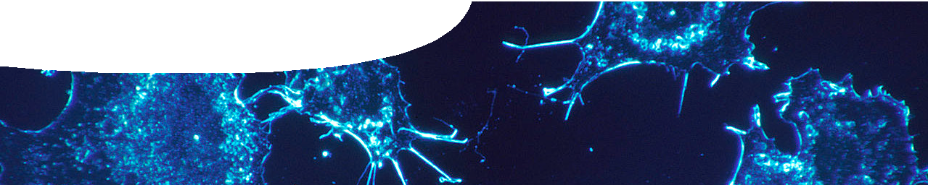
background sheet
Cancer and the cell cycle

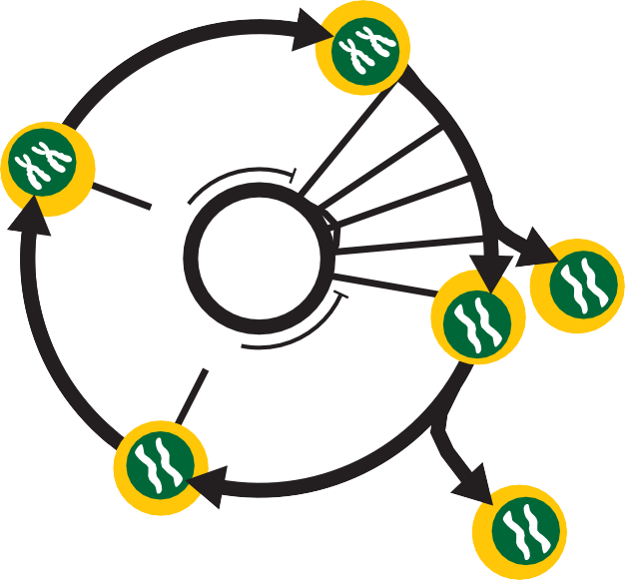What is cancer?
G0 phase
cell senescence: a phase where no
growth occurs
In most tissues, cells grow and are regularly renewed, however there are some cells that are ‘for life’ or have a very long life cycle.
Human nerve, retina and lens cells are permanent and don’t divide.
Liver cells can stay in G1 for two or three years.
G1 phase
cell growth: increase in size,
organelle duplication
S phase
chromosome replication
Once a cell has divided it may go into a period of senescence. This is shown on the diagram as G0. During this phase no growth occurs.
After interphase, cells enter the mitotic phase of cell division which includes mitosis (nuclear division) and cytokinesis (cell division).
mitosis and cytokinesis
protein production
for mitosis including
cell growth:
readiness
S (synthesis) – DNA replicated in preparation for cell division
G2 (growth) – increase in size; transcription and translation of proteins essential for mitosis
•
G2 phase
•
Cell cycle
A eukaryotic cell is essentially a factory carrying out many different processes. Like all organisms, eukaryotic cells have a life cycle where certain processes occur at specific times.
Eukaryotic cells have two distinct phases in their lifecycle: interphase and mitosis. Most time is spent in interphase, which is a time of cell growth.
Interphase is sub-divided into three main phases.
- G1 (growth) – increase in size; high activity rate; duplication of organelles; transcription and translation of proteins
Cancer is a disease of abnormal gene expression. Abnormal gene expression results from various types of mutations within genes and/or chromosomes. Mutations are usually somatic, which means they’re acquired mutations in a diploid cell. Inherited mutations in haploid gametes are less common. Both mutation types may give cells a growth advantage that allows them to proliferate and invade other tissue.

Cell cycle and cancer
Loss of control of the cell cycle is usually a critical step in cancer development. Cells become abnormal and processes regulating normal cell division are disrupted. Cancer cells are caught in an unregulated cell cycle.
Most cancers aren’t a result of a single event or factor. A number of factors are required for a normal cell to evolve into a cancerous cell and these factors include both environment and heredity. There are four main types of genetic change seen in cancer:
- spontaneous mutagenesis;
- environmentally-induced mutagenesis (causative agents include chemicals, radiations and viruses);
- environmentally-induced mutagenesis, but with genetic predisposition; and
- change due to hereditary factors.

Agents that damage DNA and generate mutations cause cancer
Somatic mutations found in a cancer cell have accumulated over the patient’s lifetime. DNA is continuously damaged by mutagens of both internal and external origin. Most damage is repaired, but a small fraction may be converted into fixed mutations.
Somatic mutations include several types of DNA and chromosomal change:
- base substitutions;
- insertions or deletions of small or large segments of DNA;
- rearrangements – DNA broken and rejoined to DNA from elsewhere;
- copy number increases (gene amplification);
- copy number reductions (loss in copies);
- insertion of new DNA sequences from viruses;
- epigenetic changes that alter chromatin structure and gene expression via methylation status;
- gain or loss of chromosomes or portions of chromosomes; and
The most pervasive environmental DNA-damaging agent is UV radiation. Chemicals produced by tobacco products are also a significant cause of cancer. Spontaneous mutations do occur, however these cells may have decreased capacity for surveillance and repair, so eventually die.

Types of gene families involved in cancer
Certain gene families are more prominent in cancer and their protein products often relate to signalling pathways. Signalling pathways are pathways that ‘signal’ cells to grow and divide. These pathways are usually tightly controlled so that cells only divide when needed (eg during development or wound healing). Cancer is often due to defects in signalling mechanisms.
A classic cell-signalling pathway, often implicated in cancer, is the mitogen-activated protein kinase (MAPK) pathway. Activation
of MAPK stimulates mitosis and hence cell division. MAPK cell- signalling involves a chain of proteins that turn ‘on’ or ‘off’ based on their phosphorylation state (addition of a phosphate group).
A membrane-bound receptor protein (tyrosine kinase) binds a signalling molecule, for example a growth factor, to activate the pathway. The signal is passed down the protein chain as a series of phosphorylation events: phosphate groups are added and removed from neighbouring proteins.
Problems arise if proteins in the chain switch on or off by themselves, or become stuck in an on or off position.
MAPK mutations are found in membrane-bound receptors. Mutations in intracellular proteins such as RAS and BRAF may also be found further along the pathway. Mutated proteins switch on without binding of the membrane receptor or getting a signal from a neighbour protein. In other words, mutated proteins constantly send a signal to grow and divide.

Cell-signalling pathway
– the role of BRAF
growth factor
cell membrane
RAS BRAF
MEK

ERK
BRAF plays a role in the rate of cell growth
and division.
Normally BRAF requires a signal from the RAS protein to become active.
BRAF then signals its neighbouring protein MEK, resulting
in cell growth.
normal cell growth

Nucleus
A MAPK signal pathway

Tumour suppressor genes may also be mutated in cancer. They normally produce proteins that prevent cell division or cause cell death, but may not function correctly or be silenced in a cancerous cell.
Proto-oncogenes are normal cell cycle genes involved in cell growth. When proto-oncogenes mutate they are known as oncogenes. Oncogenes result in unregulated cell growth.

What does a cancer cell need?
Tumour cells, like all cells, require nutrients and oxygen as they’re metabolically active. To maintain a tumour cancer cells must grow new blood vessels, invade other tissue and deregulate cell growth and programmed cell death. As a result, cancer cells or tumours often depend on abnormal proteins (encoded by mutated genes) to maintain their state.
Cancer treatments
Traditional treatments, such as chemotherapy and radiation, are used to kill cancer cells. Unfortunately, effects usually aren’t limited to tumour cells but also normal cells. New treatments are targeted to molecular and cellular changes specific to cancer cells.
Mutated proteins in cell-signalling pathways, such as mutated RAS or BRAF, are targets for therapies, as are mutated proteins that help maintain tumours.
For example, vemurafenib is a BRAF inhibitor drug that binds to mutated BRAF protein and essentially turns it off. This drug has been used to treat BRAF mutations in melanoma. While initially successful, melanoma can become resistant to BRAF inhibition. This may be due to activation of different membrane-bound receptors, or switching to a different signalling pathway.
Treatments (eg trametinib) that combine BRAF inhibitors with MEK inhibitors that block the MAPK pathway are also in clinical trial. Mutations in the c-KIT gene (that encodes a membrane receptor protein) are also found in melanoma. Clinical trials are in progress using a c-KIT inhibitor drug, nilotinib.

References
Haber, D.A., Gray, N.S. & Baselga, J. (2011). The evolving war on cancer. Cell, 145(1), 19-24. Lujambio, A. & Lowe, S.W. (2012). The microcosmos of cancer. Nature, 482, 347-355.
Petrella, T., Ernst, S., Spatz, A., Claveau, J., Wong, R. & Smylie, M. (2012). Canadian perspective on the clinical management of metastatic melanoma. New Evidence in Oncology, September, 108-119.
Stratton, M.R., Campbell, P.J. & Futreal, P.A. (2009). The cancer genome. Nature, 548, 719-724.
Knox, R.B., Ladiges, P.Y., Evans, B.K. (2009). Biology. McGraw-Hill Book Company Australia Pty Ltd, Roseville, Australia.

