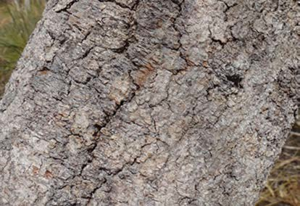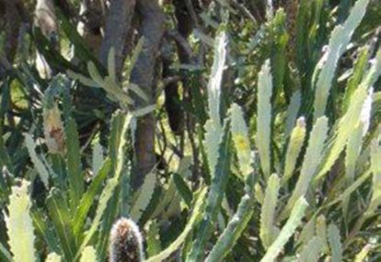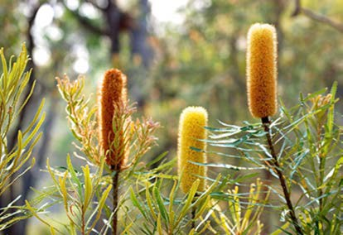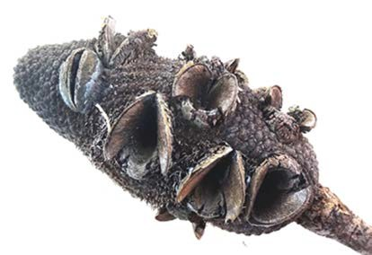
banksia (Noongar names: piara, biyara)
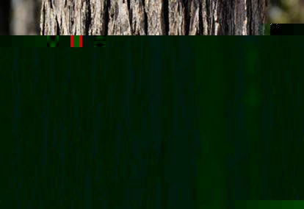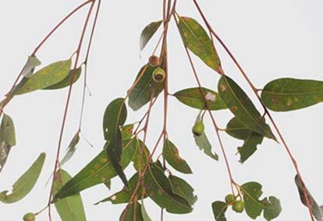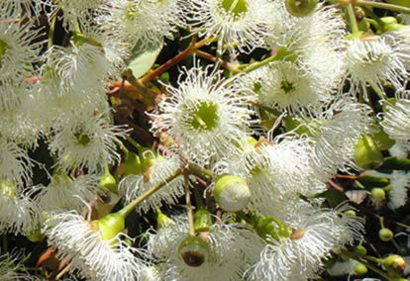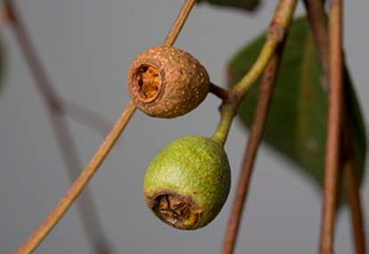photos: Margaret Owen (flower) and Felicity Bradshaw
Jarrah (Noongar names: jarrah, djarrah)
photos: Felicity Bradshaw (flower) and Paul Ricketts

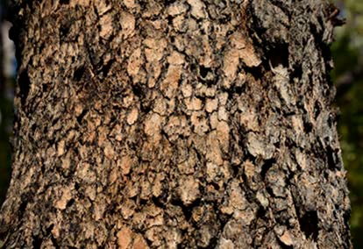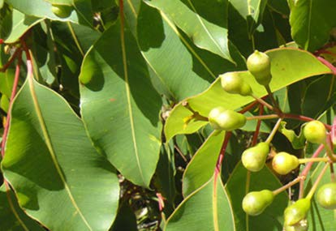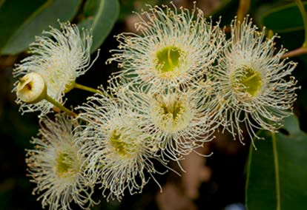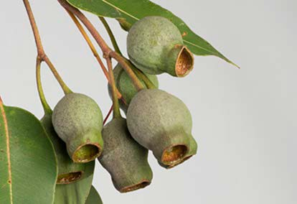
Marri marri (Noongar names: marri, kardan, mari)
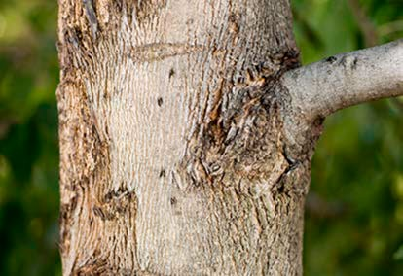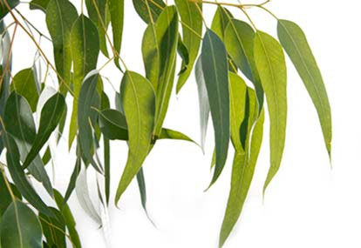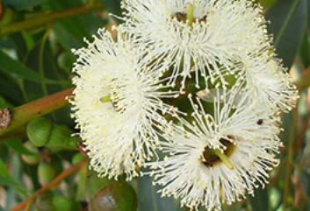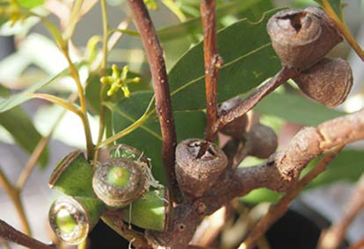photos: Paul Ricketts
Tuart (Noongar names: tuart, doowart)
photos: Ilena (flower), Michael Wheatley (nuts) and Paul Ricketts (bark and leaves)

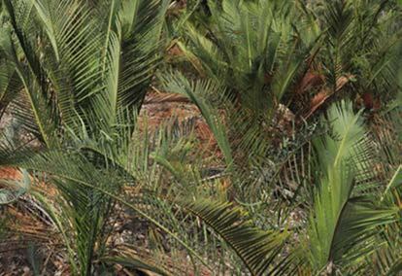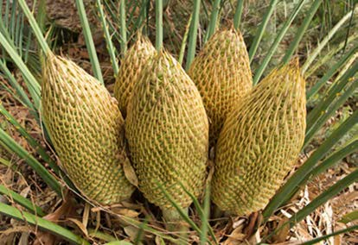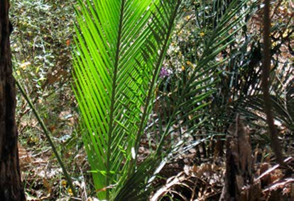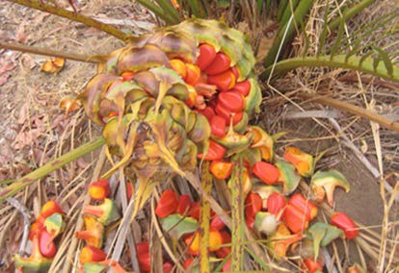
zamia (Noongar names: djiridji, biyoo, boyoo)
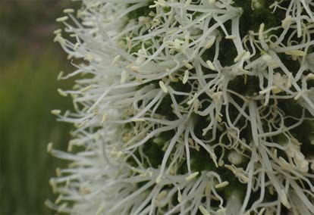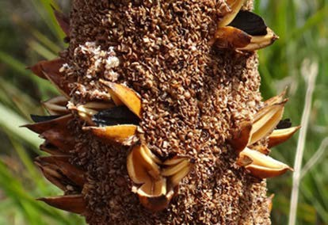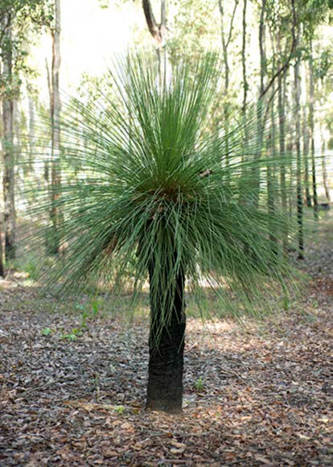photos: Paul Ricketts
grass tree (Noongar names: balga, balka)
photos: Don Bradshaw (flowers), Felicity Bradshaw (seed follicles) and Paul Ricketts

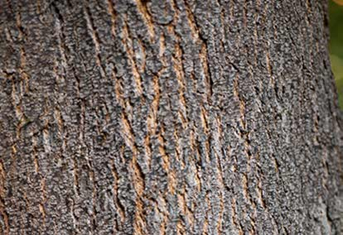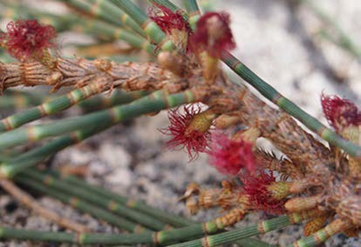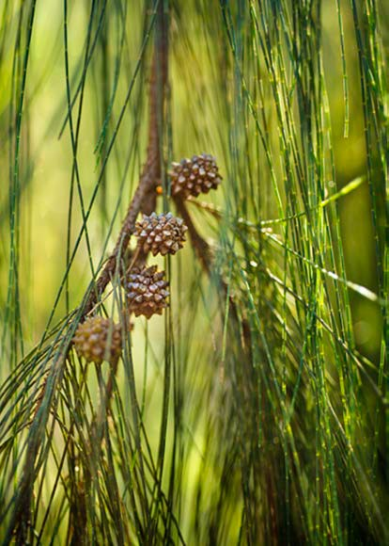
sheoak (Noongar names: kondil, kwerl)
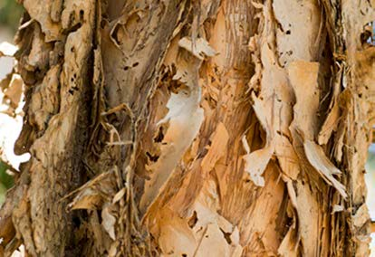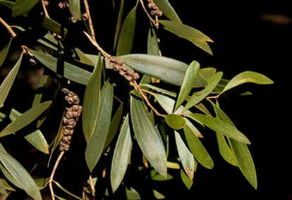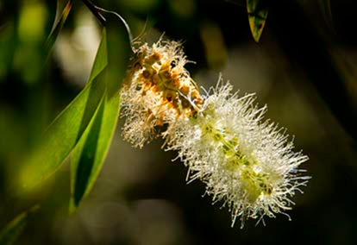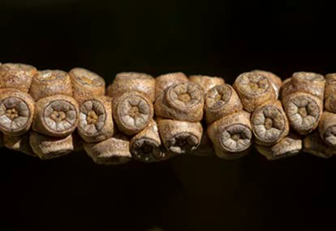photos: Michael Wheatley (flowers) and Paul Ricketts (bark and nuts)
paperbark (Noongar names: bibool, modong)
photos: Paul Ricketts

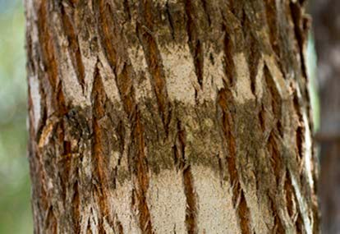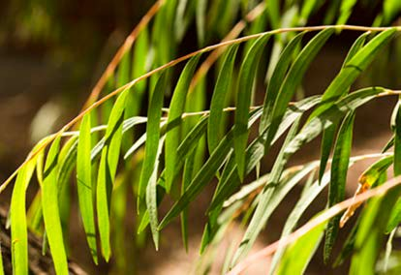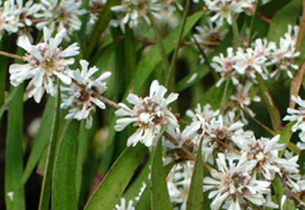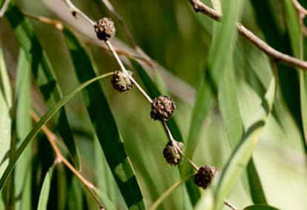
Peppermint (Noongar name: wanil)
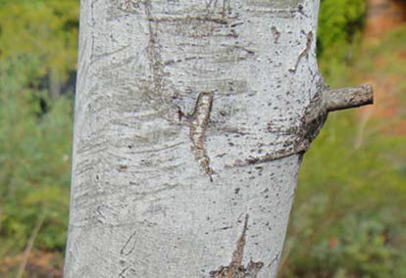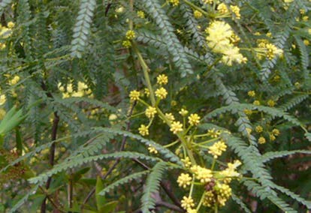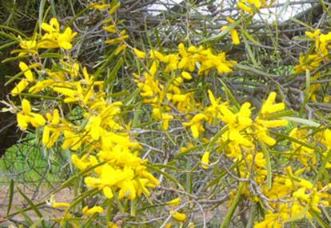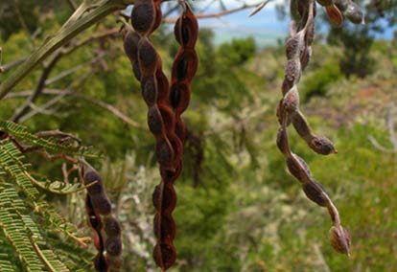photos: Felicity Bradshaw (flowers) and Paul Ricketts
Wattle (Noongar name: kalyang)
photos: Forest and Kim Starr (seed pods) and Felicity Bradshaw

some common birds of southwest Western Australia

Australian raven
photo: Julian Phillips

black-faced cuckoo shrike
photo: Clive Nealon

blue wren
photo: Roger Crabtree

brown honeyeater
photo: Tom Tarrant (www.aviceda.org)

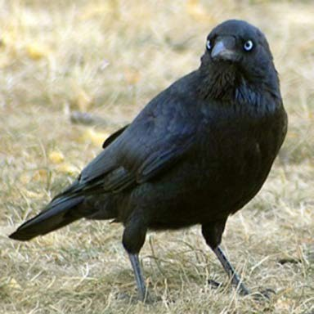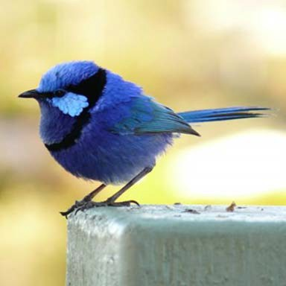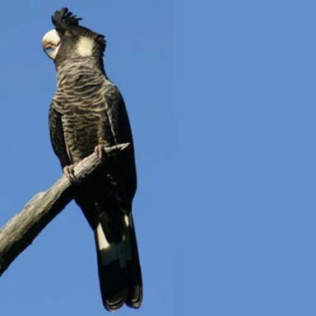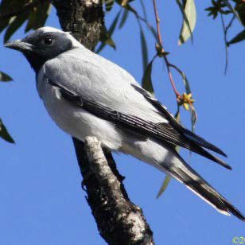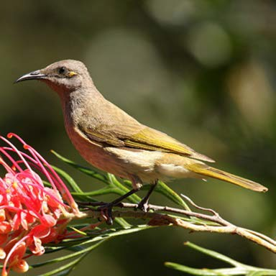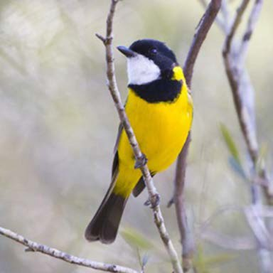Carnaby’s cockatoo
photo: Peter Head

golden whistler
photo: Paul Walbridge

New Holland honeyeater
photo: Stephen Hopper

grey fantail
photo: Tom Tarrant (www.aviceda.org)

kookaburra
photo: Paul Walbridge

magpie lark
photo: Tom Tarrant (www.aviceda.org)

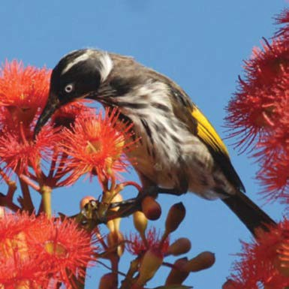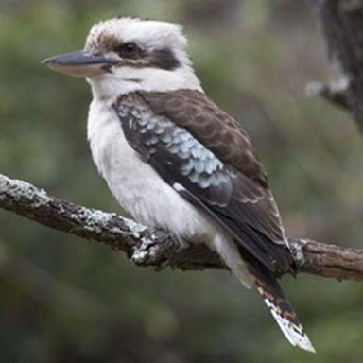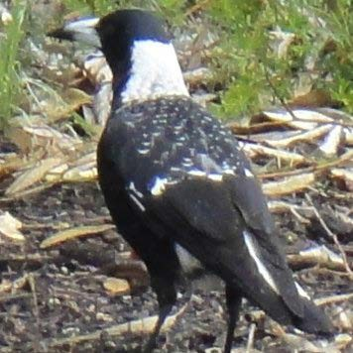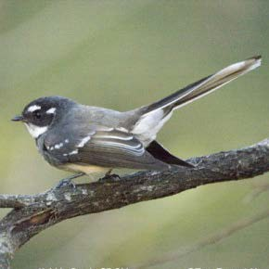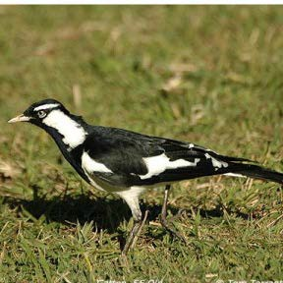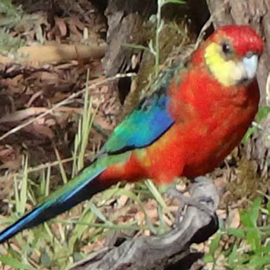magpie
photo: Don Bradshaw

Western rosella (male)
photo: Kingsley Dixon

grey butcher bird
photo: Marlene Lyall

osprey
photo: Don Bradshaw

pink cockatoo
photo: John Milbank

red wattle bird
photo: Stephen Hopper

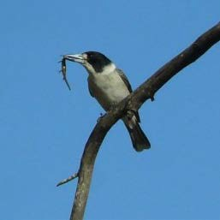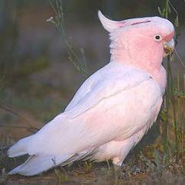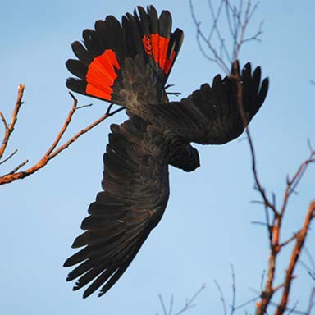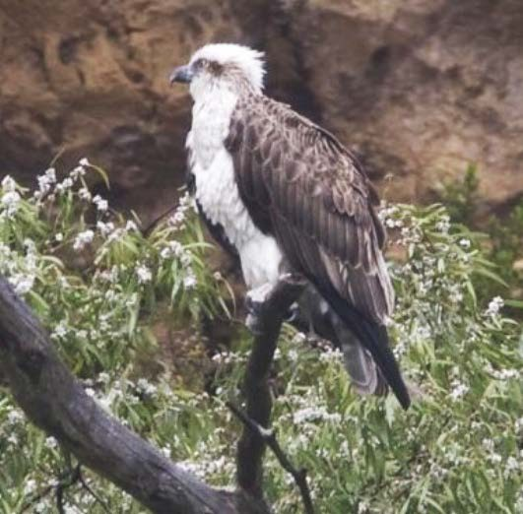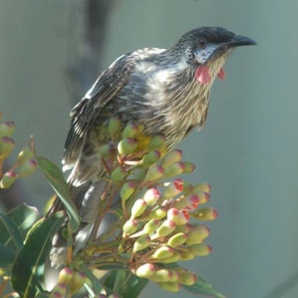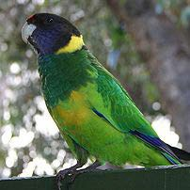red-tailed black cockatoo
photo: Margaret Owen

ringneck parrot
photo: Don Bradshaw

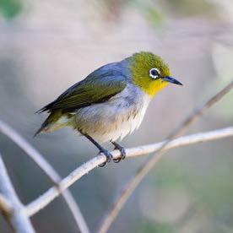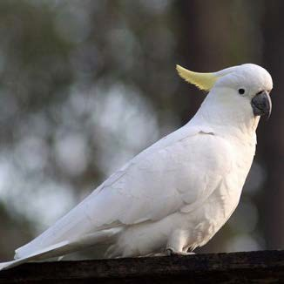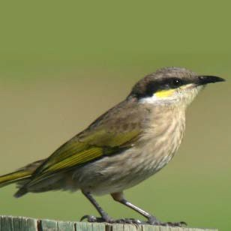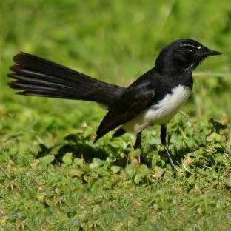
willie wagtail
photo: Peter Head
singing honeyeater
photo: Peter Head
sulfur-crested cockatoo
photo: Duncan Coles
silvereye
photo: Paul Walbridge

