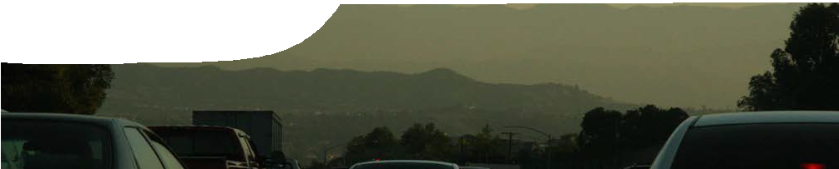
background sheet
Atmospheric chemistry
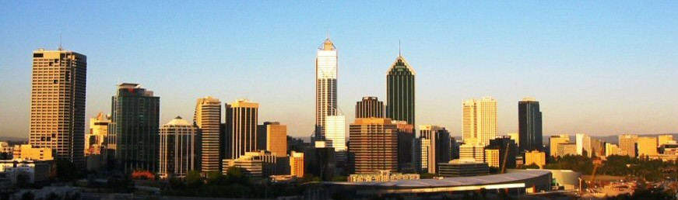

Perth, Western Australia
R R R R
C C + OH C C OH
Gary Tamin

What is photochemical smog? H H H H

First described in 1943, photochemical smog is made of a chemical mix of ozone, nitrogen dioxide, peroxyacetyl nitrate (PAN) and other related compounds. It is produced by reactions between
hydroxyl radicals, nitrogen oxides and volatile organic compounds (VOCs) in the presence of sunlight and relatively high temperatures. Although less visible
VOC hydroxyl radical hydrocarbon radical
Oxidation of volatile organic compounds (VOCs) by hydroxyl radicals and oxygen produces reactive peroxyl radicals.
Note: ‘R’ represents an alkyl chain in these formulae.

than particulate smog, photochemical smog can produce a layer of brown or grey haze over an affected area. This is common in cities with high
R R

C C OH

+ O₂
R R

C OH
O
O
C

numbers of automobiles and large-scale industry. In H H H H

Perth, photochemical smog occurs during summer months and is related to high automobile usage.
hydrocarbon radical oxygen peroxyl radical

O

The chemistry of photochemical smog

R O R

R O R

formation
There are many pathways in the complex cycle that leads to formation of photochemical smog. One of them starts with a reaction between hydroxyl radicals and VOCs. Radicals (also known as free radicals) are molecules that have an unpaired electron in their outer shell. They may be charged or electrically neutral.
Hydroxyl radicals (OH•) are extremely reactive. Although an individual molecule’s lifespan is short, hydroxyl radicals are continually formed in the atmosphere by various reactions. Hydroxyl radicals rapidly oxidise carbon-based molecules, including VOCs.
C C OH + NO C C OH + NO2
H H H H

Peroxyl radicals react with nitrogen oxide from vehicle and industrial emissions, to produce nitrogen dioxide.

NO• ^{U}^{V} →NO+ O•
2

Nitrogen dioxide radicals absorb solar energy to produce a nitrogen oxide molecule and an oxygen free radical. The cycle continues as these products react with other VOCs in
the air to produce even more nitrogen dioxide. This reaction requires sunlight with a wavelength of 280–430 nm, which is in the ultraviolet range.

O• + O2 → O3

Oxygen free radicals then react with oxygen molecules in the air to produce ozone. The rate of this reaction increases as atmospheric temperature rises.

These reactions are just one part of a complex cycle that leads to the formation of photochemical smog.
The following diagram represents this cyclic equilibrium reaction. The emphasised section includes the reactions described on the previoue page.

O₂

O3 NO₂ NO

VOC
OH, O₂
OH

R'O₂
HO₂

ROH, R_{-H}O

carbonyl products

HO₂

RO₂ RO

ROOH
O₂
NO₂ NO

NO NO₂

RO₂NO
O₃
2 RONO₂

Figure 1: Photochemical smog cycle. Adapted from Jenkin al. (2008)

Warm, sunny conditions favour the reaction of peroxyl radicals (RO2•) with nitrogen oxide to produce RO. This drives production of ozone through the process of oxidation and subsequent breakdown of nitrogen oxides.
Ozone itself is broken down in two ways:
O3 + NO → O2 + NO2
Nitrogen monoxide reacts with ozone to produce an oxygen molecule and nitrogen dioxide in a temperature- dependent reaction that limits the amount of ozone in the atmosphere.
However, the nitrogen dioxide produced also feeds back into the cycle to produce more ozone.

O3 ^{U}^{V} →O+ O2
Ozone is slowly broken down by light energy, to form molecular oxygen and atomic oxygen, but this reaction is much slower than the formation of ozone.
The chemistry of photochemical smog formation is complex. To aid student understanding, the video, Photochemical smog, concentrates on formation of nitrogen dioxide and ozone. It introduces the concept of reaction rate by examining changes in concentration of these gases during a typical day. Using these two products of the cycle, students can follow reactions that lead to formation of photochemical smog, and start to understand
environmental conditions that favour its formation.

Factors promoting the development of photochemical smog
In Perth, primary pollutants include nitrogen oxides (NO and NO2) that come predominantly from motor vehicle and industrial emissions. VOCs in the
atmosphere come from motor vehicle and industrial emissions, solvent vapours, paints, bitumen and other man-made items in the environment.
Timing is important in the development of photochemical smog. In early morning traffic the concentration of nitrogen oxides and VOCs in the atmosphere increases. As the morning progresses, nitrogen oxides and VOCs react and produce nitrogen dioxide. A developing brown haze indicates an increase in nitrogen dioxide concentration.
As sunlight intensifies, its energy increases the breakdown of nitrogen dioxide and nitrogen monoxide to produce ozone. The brown haze fades as nitrogen dioxide concentration decreases. Nitrogen dioxide also forms toxic compounds, such as PAN, when it reacts with radicals in the atmosphere.
The concentration of ozone peaks, then begins to fall at around 2.00 or 3.00 pm. Ozone concentration in the atmosphere decreases because production of ozone slows with decreasing temperature and light intensity.

0.3
aldehydes (including PAN)
NO2
NO
ozone
pollutant concentration (ppm by volume)

0.2

0.1

0.0
midnight 4am 8am noon 4pm 8pm midnight time of day

Figure 2. Generalised graph showing variation of atmospheric pollutants with time of day

Various meteorological phenomena work to either decrease or increase photochemical smog in an area. Rain decreases the amount of photochemical smog as it washes particles that can cause photochemical smog from the atmosphere. High winds also help
to disperse photochemical smog from an area, replacing it with fresh air.
Temperature inversions can trap photochemical smog. Normally, warm air at the surface rises, dispersing pollutants vertically. When a temperature inversion occurs a pocket of cool air is trapped below warm air, and pollutants are not dispersed.
Temperature inversions can remain for a few days or up to several weeks.
Topography can influence the formation of photochemical smog. Mexico City is located in a valley, with restricted air movement. Pollutants are trapped at ground level, and mixing in the atmosphere is limited. Valleys are also susceptible to temperature inversions. Sao Paulo, Brazil, has restricted air movement as it is situated between coast and mountains. Air is trapped above the city, increasing pollution concentration. Perth, situated
between the Indian Ocean and the Darling Scarp, has a similar topography.
Dori

Effects of photochemical smog
Human health effects:
- Ozone at ground level is toxic to humans.
It causes respiratory problems, eye irritation, and is linked to an increase in asthma attacks.
- VOCs can be carcinogenic, and also cause respiratory problems and eye irritation.
- Nitrogen oxides are contributors to heart and lung problems, as well as decreased resistance to infection.
- PAN can cause respiratory problems and eye irritation.
- Ozone and PAN can reduce or stop growth in plants by reducing photosynthesis rates.
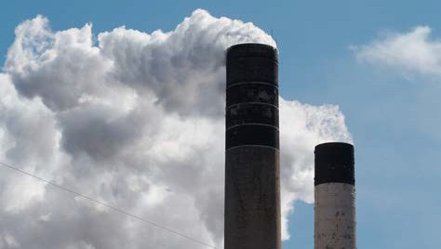
- Ozone causes cracking in rubber and paints. Ozone can also damage artworks and old books so museums implement measures to reduce the effect of ozone on valuable artefacts.

Measures to control photochemical smog
- Implement a clean air act where industrial pollutants are monitored and legislation controls industries exceeding pollutant limits.
- Ensure industries continually invest in clean air technologies.
- Offer tax benefits for companies that use the latest pollution controls.
- Reduce automobile emission by:
  - monitoring older vehicle emissions;
  - providing old vehicle trade-in grants, from government, to further reduce the number of old vehicles on roads;
  - providing incentives, such as lower road taxes, for people who buy electric vehicles or vehicles equipped to burn low emission fuels;
  - mandating inclusion of latest emission technologies in the design of new automobiles;
  - banning automobile usage during periods of high smog;
  - limiting traffic by introducing measures such as tolls and car-pooling lanes on busy highways and freeways; and
  - overhauling mass transit systems to make them attractive and user friendly.
Arndw

Cities with photochemical smog problems
In December 2005, Tehran, a city with over three million cars, experienced a severe photochemical smog that hospitalised more than 1600 people and closed schools and offices. To alleviate pollution, the city enforced a rule where cars are only allowed in the city centre on alternate days, depending on their number plate.
In one generation, Mexico City went from having good air quality to having some of the worst photochemical smog pollution in the world. In 1991, air quality was declared a public health risk for 355 days of the year. Since 1991, the government has started monitoring nitrogen oxides and ozone,
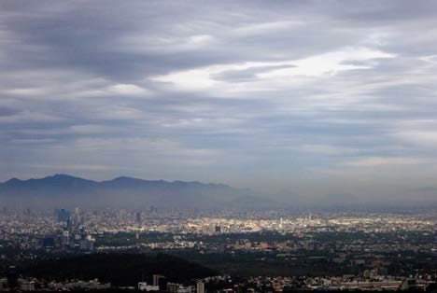
and introducing measures to reduce the incidence and severity of photochemical smog. When levels become critical measures are triggered, such as: shutting down factories, implementing the ‘day without the car’ program, and changing school hours. The city has also phased out diesel buses and, since 1993, new cars must have catalytic converters.

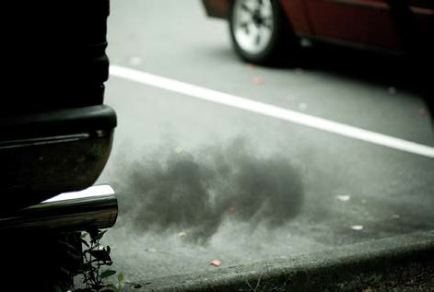
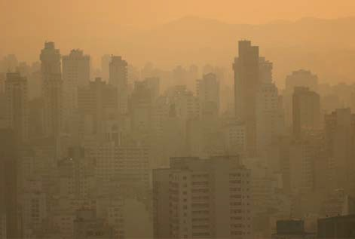
References
Michael Coppola
Thomas Hobbs
- Atkinson, R. (2000). Atmospheric chemistry of VOCs and NOx. Atmospheric Environment 34(12–14), 2063-2101.
- Baird, C. (2005). Environmental Chemistry. W.H. Freeman, New York.
- Department of Environment and Conservation, Western Australia (2007). State of the Environment Report 2007. Retrieved on July 1, 2009 from http://www.soe.wa.gov.au/report/atmosphere/photochemical-smog.html
- Department of Environmental Protection, Western Australia (1996). The Perth Photochemical Smog Study 1996. Retrieved on October 15, 2009 from http://portal.environment.wa.gov.au/pls/portal/docs/PAGE/DOE_ADMIN/TECH_REPORTS_REPOSITORY/TAB1019688/PPSS_ REPORT.PDF
- Jenkin, Watson, Utembe and Shallcross (2008). A Common Representative Intermediates (CRI) mechanism for VOC degradation. Part 1: Gas phase mechanism development. Atmospheric Environment 42, 7185–7195.
- Shodor (1998). The science of smog photochemistry. Retrieved Nov 24, 2008 from http://www.shodor.org/master/environmental/air/ photochem/smogapplication.html
- Uherek (2004). Oxidation in the atmosphere, lower atmosphere. Environmental Science Published for Everybody Round the Earth (Espere). Retrieved on November 24, 2008 from http://www.atmosphere.mpg.de/enid/24y.html

