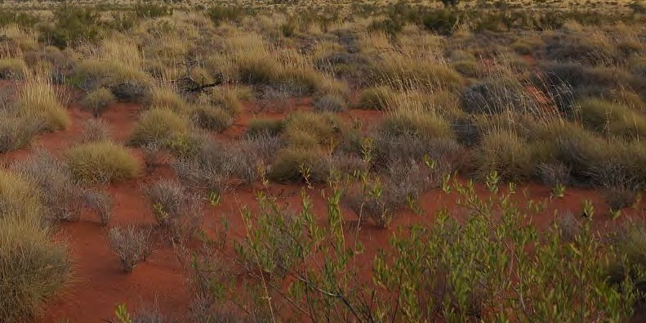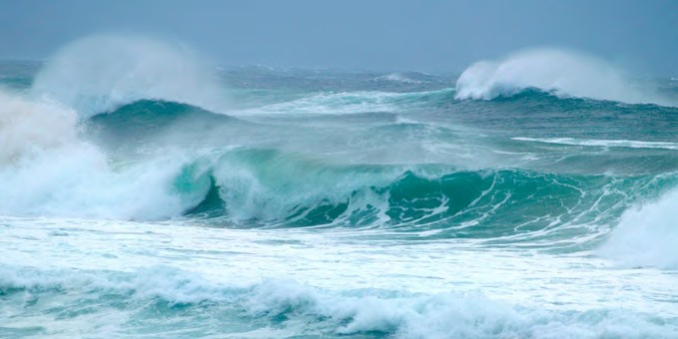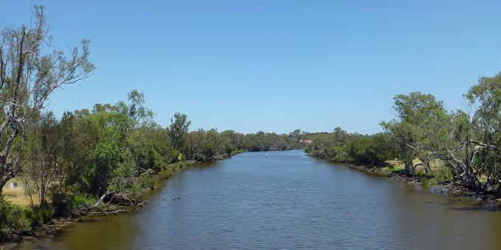

student sheet 9

who lives here?

Your task is to match an animal or plant with its environment, its adaptations, and the function of each adaptation.
Cut out each environment image.
Paste each environment image on a sheet of A4 paper. One environment per sheet.
river

© delcond

desert

© JP Gaillard

ocean

© Eric K Veland

Page 17

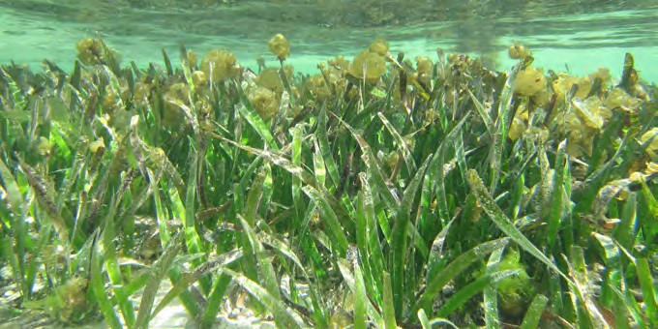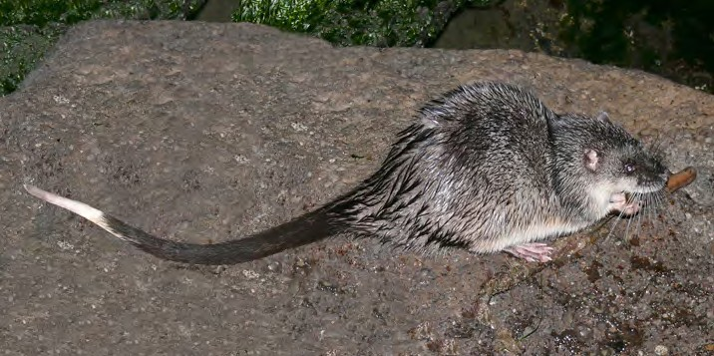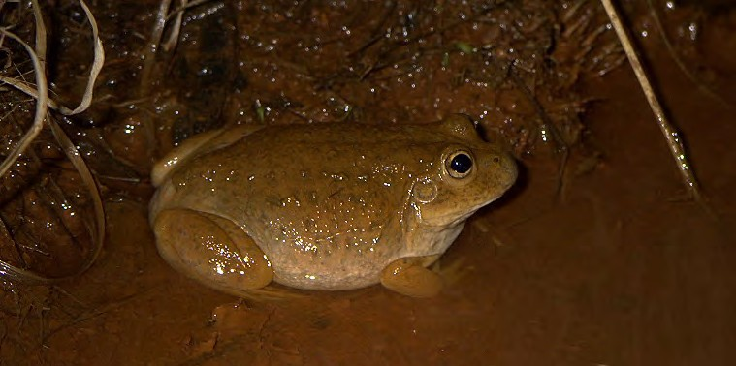student sheet 9: adaPtations match-uP

sPecies in the sPotlight
Your task is to match an animal or plant with its environment, its adaptations, and the function of each adaptation.
Cut out each animal or plant image.
Paste each animal or plant image under the correct environment image you pasted on your sheet of A4 paper.
water-holding frog

© James Ward

rakali, Australian water rat

© Andrew McCutcheon

seagrass

© Renae Hovey

Page 19

student sheet 9: adaPtations match-uP

which goes with which?
Your task is to match an animal or plant with its environment, its adaptations, and the function of each adaptation.
Cut out the adaptation images below.
Paste each adaptation image in rows next to the correct animal or plant image you pasted on your A4 sheet.

Adaptation

eyes on the top of head
Adaptation

flowers
Adaptation

streamlined body
Adaptation

flexible leaves

Adaptation
Adaptation

webbed feet
Adaptation Adaptation

grinding teeth

cocoon

whiskers

Adaptation

grey-green skin
Adaptation

retractable ears
Adaptation

webbed feet
Adaptation

strong roots

Adaptation

air spaces
Adaptation

waterproof fur
Adaptation

long tail
Adaptation

digging tool

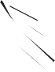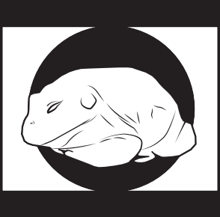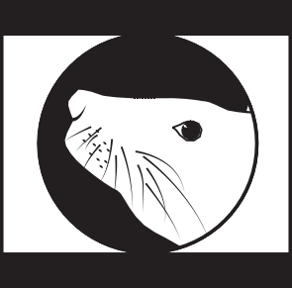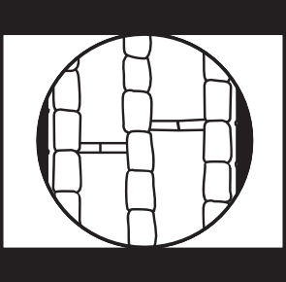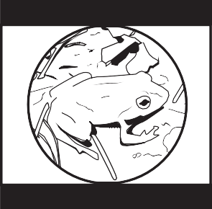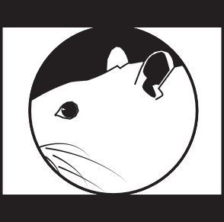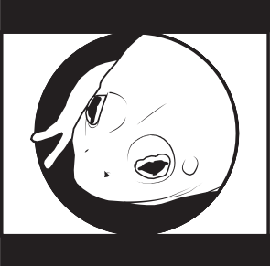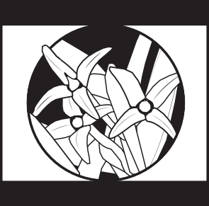

Page 21

student sheet 9: adaPtations match-uP
Function:
Function:
Function:
Function:
Function:
Function:
Function:
Function:
Function:
Function:
Function:
Function:

what is each adaPtation for?
Your task is to match an animal or plant with its environment, its adaptations, and the function of each adaptation.
The labels below describe the function (action or purpose) of each adaptation. For instance, the function of a kangaroo’s pouch is to carry young.
Cut out each function label.
Paste each function in a column under its correct plant or animal adaptation on A4 sheet.
Function:
Function:
Function:
Function:

to blend in with the environment.
to help me swim.
to anchor me to the sea floor.
to reduce drag when swimming.

to stop me drying out.
to keep me warm.
to help my leaves bend with the waves.
to keep water out.

to help me dig burrows.
to act as a rudder.
to help me keep an eye out for food.
to move gas around.

to help me swim.
to help me sense prey underwater.
to help me to reproduce.
to help me crush prey.

Page 23

student sheet 9: adaPtations match-uP

environment

animal

adaptations and functions

Page 25

student sheet 9: adaPtations match-uP

environment

animal

adaptations and functions

Page 26

student sheet 9: adaPtations match-uP

environment

animal

adaptations and functions

Page 27

