
procedure
Protein electrophoresis

Gel electrophoresis is a process used to separate and identify protein molecules in a tissue sample. Gel electrophoresis uses properties of an agarose gel to separate individual proteins, by size.
Your tasks are to:
- prepare an agarose gel;
- physically and chemically treat samples of beef, pork, chicken, veal and fish;
- load the treated tissue sample onto the agarose gel and apply an electric current, causing the individual proteins to separate through the gel; and
- stain the gel so separated proteins become visible.

Part I: Gel preparation (see Appendix 2 in teachers guide for instructions)

Part II: Sample preparation

Purpose
The purpose of this activity is to physically and chemically prepare tissue samples. Combining tissue with Laemmli loading buffer breaks some protein bonds, denatures (unfolds) protein and gives samples a negative charge. Blue bromophenol dye (contained in Laemmli buffer) provides a dye front, in the gel, that moves faster than proteins. Glycerol (also in Laemmli buffer) adds density to samples, and causes them to sink into gel wells.
Ensure you are wearing gloves and safety glasses before beginning.

Materials
samples from 4 (or more) types of muscle tissue Laemmli buffer (250 μL per sample)
4 (or more) eppendorf or micro tubes with snap tops
4 (or more) eppendorf or micro tubes with screw tops or clamps water bath at 95 °C
pipette (p200) and tips 10 mL measuring cylinder marker pen or pencil

Method

toothpicks, one for each sample gloves
dissecting scissors safety glasses stop watch
500 mL beaker for used pipette tips agarose gel prepared in Part I

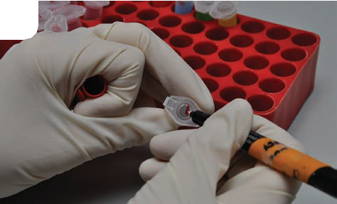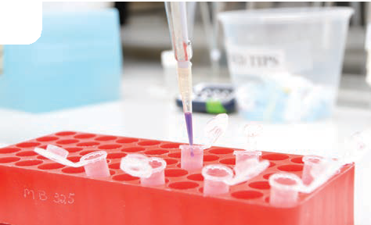
1.
2.

- Label 2 sets eppendorf or microtubes: 1 set with snap tops, the other with screw tops, or clamps, with names of tissue samples you are going to use.
- Shake Laemmli buffer well, then add, using pipette, 250 μL to set of tubes, with snap tops.

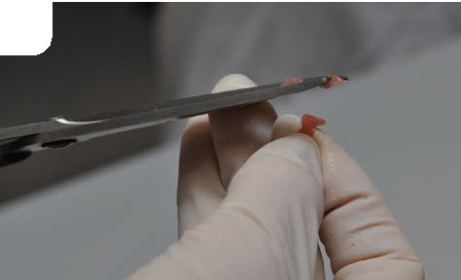
3.

- 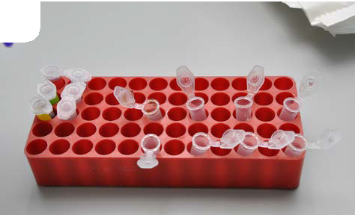Use dissecting scissors to cut a small piece of sample tissue, the size of approximately half a rice grain, into its tube.
4.
- Mix each sample and buffer well, with a vortex, or by shaking vigorously, to form a protein solution.
- Incubate for 5 mins at room temperature.

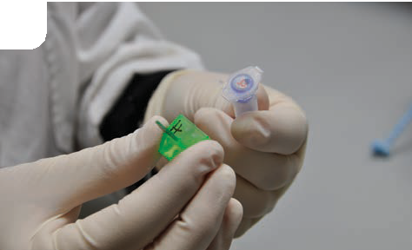
5.

- 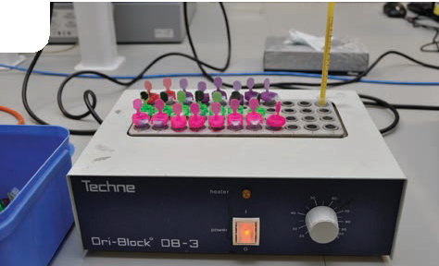Pour protein solution from each tube into the screw top tube marked with its name. Ensure liquid only is transferred – not sample.
6.
- Place screw top tubes in water bath at 95 °C, for 5 mins.
- Remove tubes from water bath.
- Allow to cool for 5-10 mins.

Part III: Gel electrophoresis

Purpose
The purpose of this activity is to separate component proteins in tissue samples, using gel electrophoresis. Unfolded proteins, under influence of an electrical current, will move through an agarose gel. Small, light proteins travel faster and further than large, heavy proteins.
Ensure you wear gloves and safety glasses during the procedure.
Materials electrophoresis unit power pack
pipette (p50) and tips
250 mL measuring cylinder safety glasses
marker pen or pencil 500 mL beaker for waste
agarose gel prepared in Parts I and II 250 mL dilute TGS buffer
gloves
plastic, flat-bottomed container, eg takeaway food container protein solution (samples) from Part II

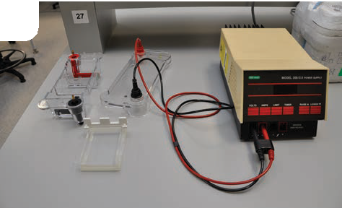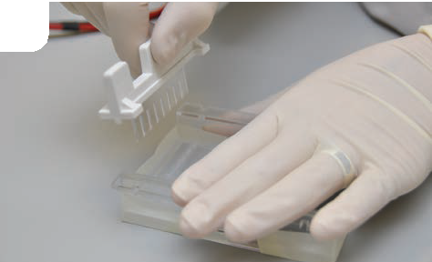
1.
2.

- Position electrophoresis unit close to power supply, ensuring leads will connect comfortably when lid is placed on unit.
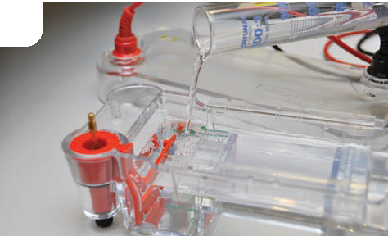
3.
- Gently pour 250 mL dilute TGS buffer over gel.

5.
wells
-

- Remove comb from gel by gently pulling it straight up. Note ‘wells’ at one end.
- Remove tape and place tray with gel into electrophoresis unit.

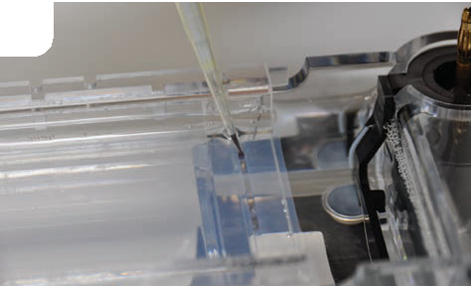
4.
- 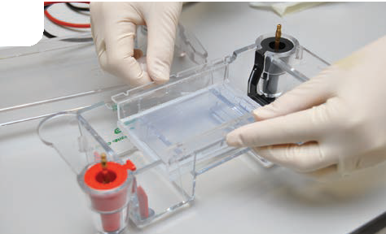Load 20 μL of each protein solution sample into a separate well in agarose gel.
6.

+
- Label each well in this diagram with sample name.

- Place lid on electrophoresis unit.
- Connect leads to power supply and set to 150 V.

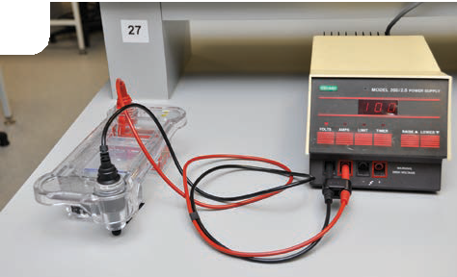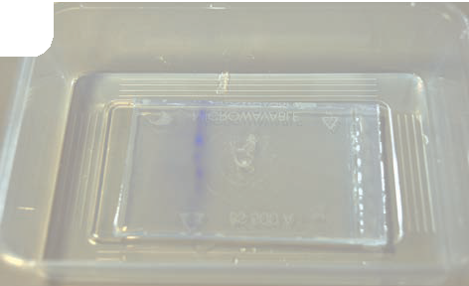
7.
8.

- Run power into gel for about 20–30 minutes.
- Monitor moving dye front to judge if gel has finished running.
- Turn off power when dye front is 3/4 length of gel.
- Remove gel from tray and transfer to plastic container for staining.

Part IV: Staining your gel

Purpose
The purpose of this activity is to stain an agarose gel to make protein bands, then make observations. Ensure you wear gloves and safety glasses during the procedure.

Materials
See Appendix 1 in the teachers guide for preparation of fixative and Coomassie Blue stain. 100 mL fixative
1 Insta-stain sheet or 250 mL Coomassie Blue stain distilled water (for multiple washes)

Method
IF USING BIO-TEK INSTA-STAIN SHEET
- Gently pour 100 mL fixative over gel in container.
- Float Insta-stain sheet in container, ensuring it is immersed in fixative.
- Leave overnight for best results.
- De-stain by discarding Insta-stain sheet, pouring off and discarding fixative, and rinsing with distilled water a number of times to remove excess stain from gel. Best results (darkest bands) are obtained by using several changes of distilled water.

IF USING BIO-TEK PROTEIN COOMASSIE STAIN
- Gently pour 100 mL fixative over gel in container – leave for 15 minutes.
- Pour off fixative and discard.
- Pour on 250 mL stain and leave overnight.
- Stain is re-useable: pour back into container when finished staining.
- De-stain with distilled water. Best results (darkest bands) are obtained by using several changes of distilled water.

Results and observations
- Insert a photo of your gel in the space below. Include labels for sample names, positive and negative anode positions.

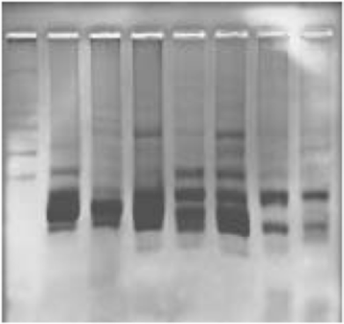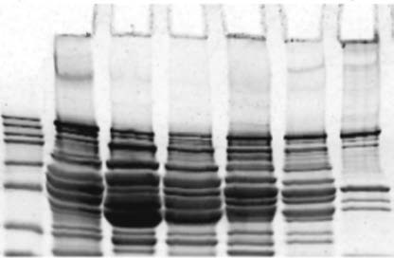
myosin heavy chain
SDS polyacrylamide gel
actin
agarose gel

- Use these images of an SDS polyacrylamide and agarose gel to label actin and myosin protein bands in your gel photograph.

- What can you say about the size of proteins that have migrated the furthest from the well?

................................................................................................................................................................................................

................................................................................................................................................................................................

................................................................................................................................................................................................

- Samples had to be physically and chemically prepared before loading into wells. Why is this necessary?

................................................................................................................................................................................................

................................................................................................................................................................................................

................................................................................................................................................................................................

................................................................................................................................................................................................

- Electrophoresis is just one technique used to study and compare proteins. What information might be gained by comparing proteins of different species?

................................................................................................................................................................................................

................................................................................................................................................................................................

................................................................................................................................................................................................

................................................................................................................................................................................................

