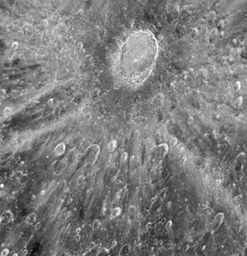
When you look at images of the Moon and some planets the most obvious feature is often craters. The Moon is covered in craters. Even craters sometimes have craters! Craters on the Moon often have ‘rays’, lighter streaks that surround them.
Craters can be made in several ways, but on the Moon they are known as impact craters. They are created when asteroids slam into the Moon’s surface. Material from deep underground is thrown out to make the rays.
In this activity you are going to recreate a landscape with craters. You will need to start by making the ground layers. What will you use: white and yellow sand, or flour and cocoa powder?
Tycho crater on the Moon
NASA, ESA, D. Ehrenreich IPAG/CNRS/Université Joseph Fourier
Perhaps you could include some ‘rocks’ in your ground. Then you will need some asteroids. How big or heavy should they be? From what height will you drop or throw them?
Your task is to investigate how craters are made. Take photos of your successful craters and print them out on paper. Draw a planet shape on the back, cut it out and stick it onto black card to create your own space object. Don’t forget to name it: astronomers often name space objects after characters from mythology or books.
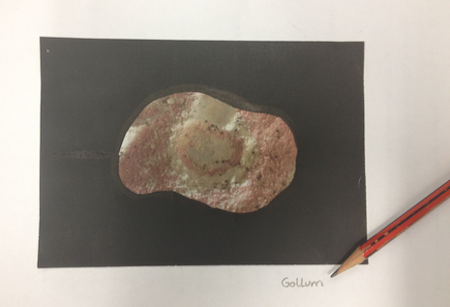
Not all features on planets and moons are created by impacts. Astronomers also see evidence of action by wind and water. Can you modify your investigation to look at these effects? Perhaps you can tilt your landscape and pour water from a jug along the surface. Can you blow loose sand into sand dunes using a straw? Look at space images of moons, planets and asteroids for ideas.
Write an explanation of how your space object and its features formed. Use scientific terms to describe the object and its features.

