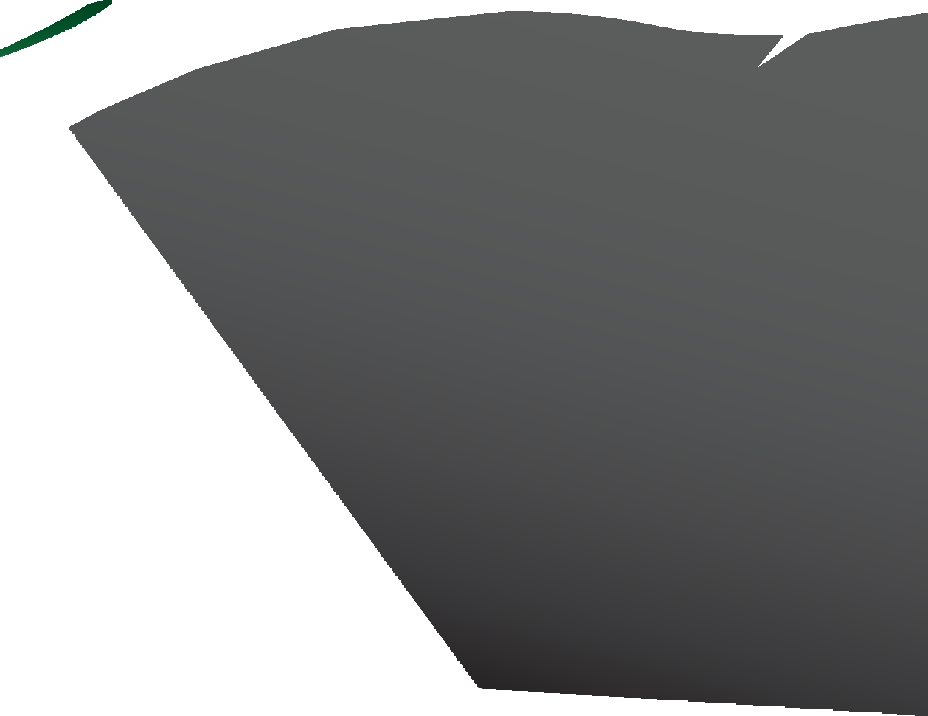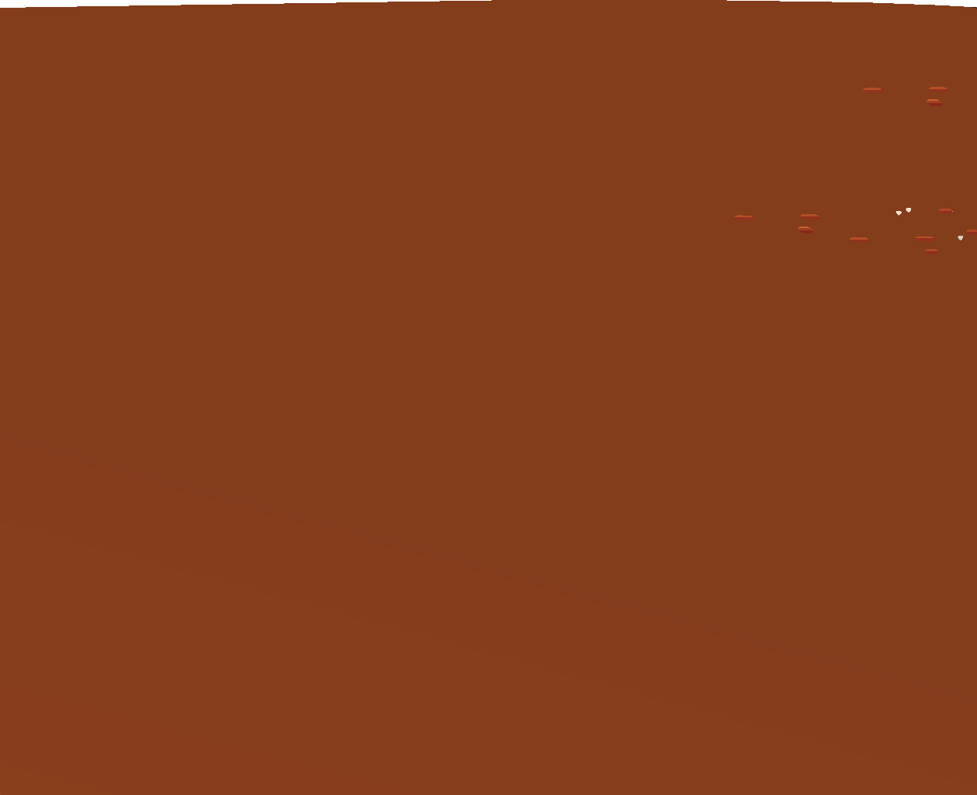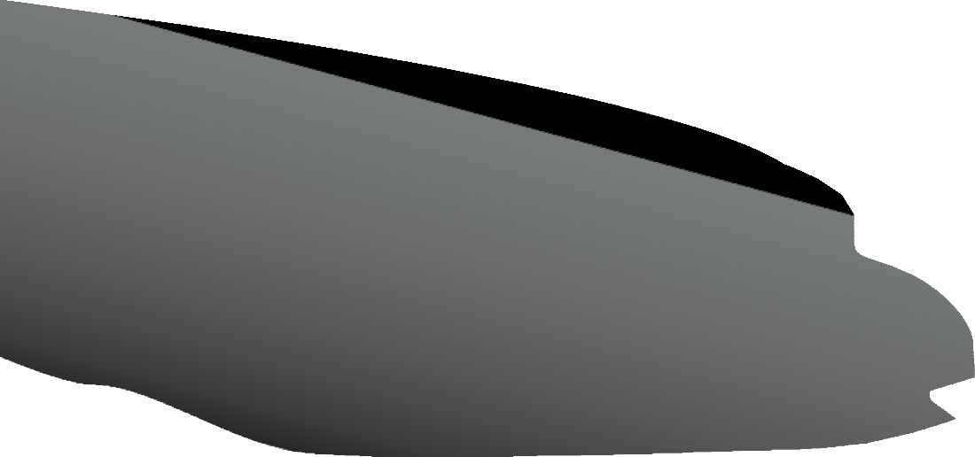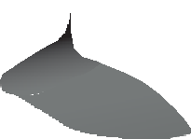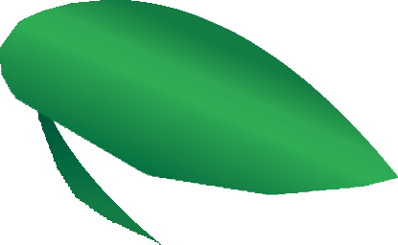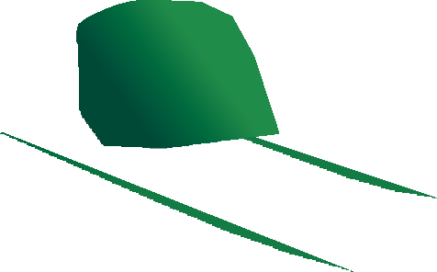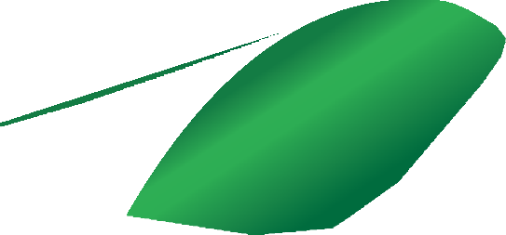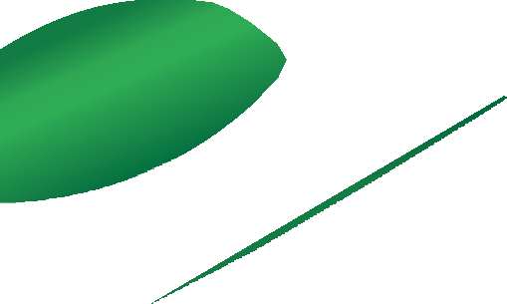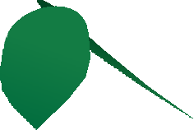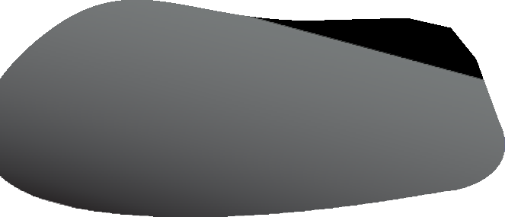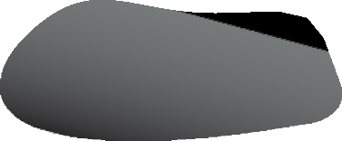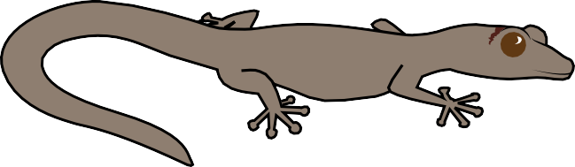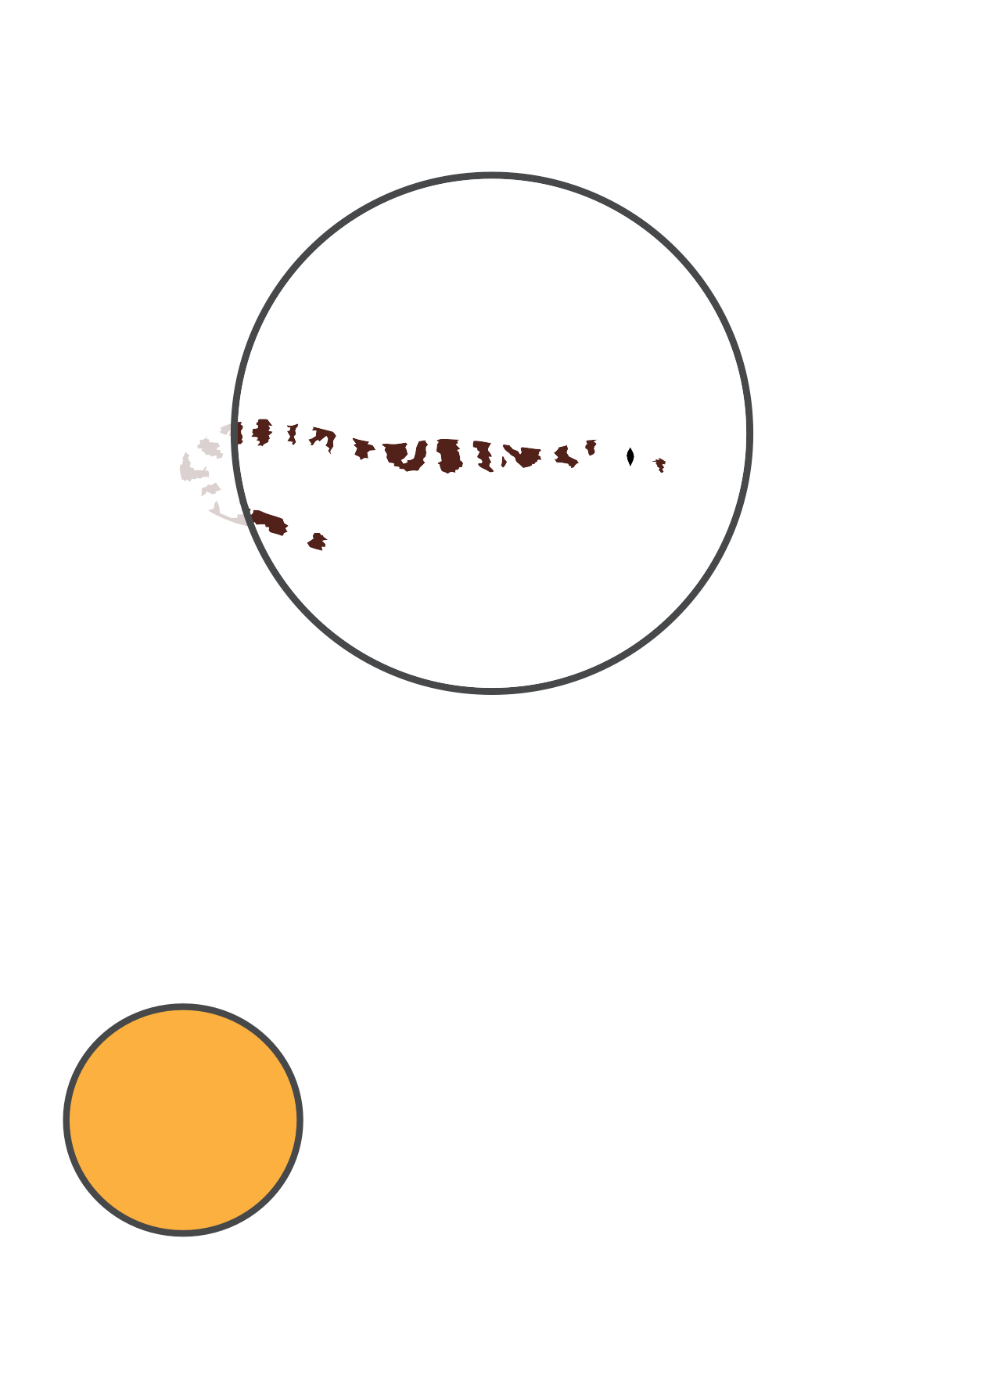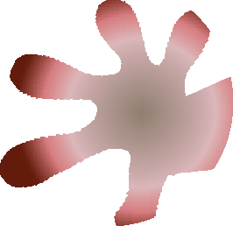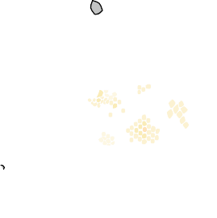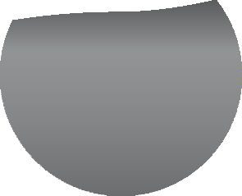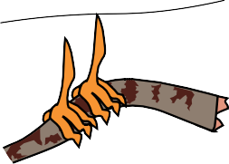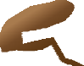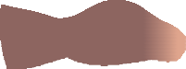

student sheet 10

Velvet gecko

I’m a reptile.

I rely on heat from the environment to warm my body. I’m nocturnal and hunt insects at night.

I live in most places around Australia, except inland deserts. I prefer living in trees or amongst rocks, where there are lots of places to hide.

I have suction cups on my toes, which means I can stick to most surfaces. I can run along panes of glass, and even, upside down on ceilings.

I have patterned skin that matches my surroundings. It helps me sneak up on my prey and also to hide from

my predators.

If someone does attack I have another trick. I drop my tail, leave it behind, and make my getaway before I end up as someone else’s dinner. Afterwards, I can grow my tail again.

student sheet 10: my adaPtations

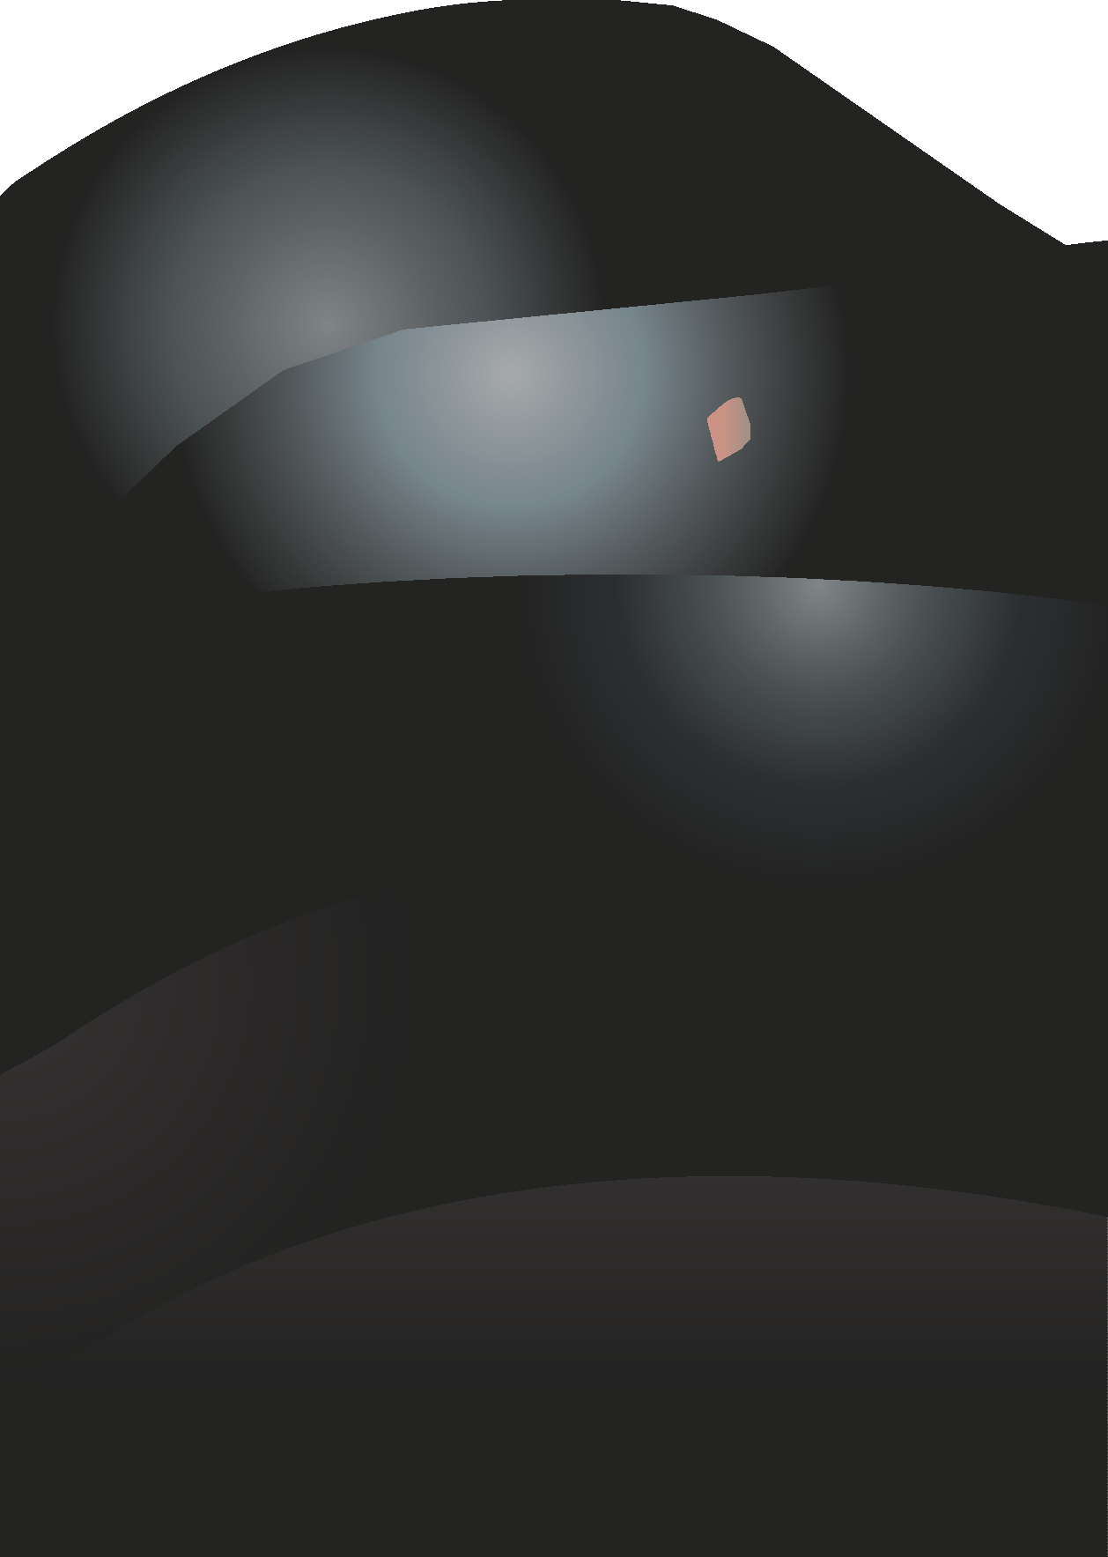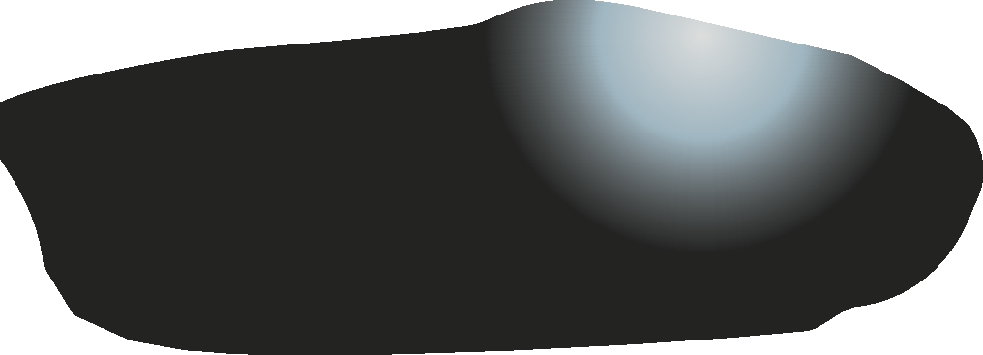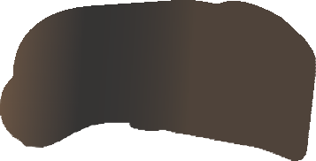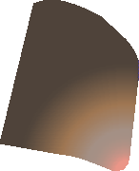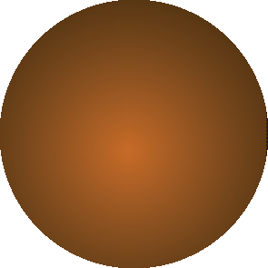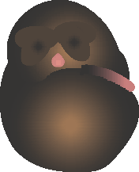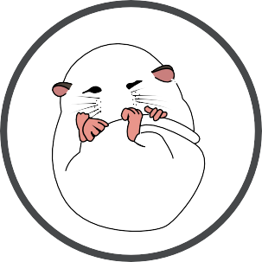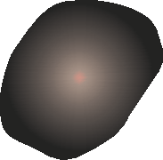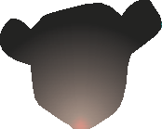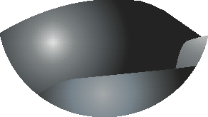

Mountain pygmy

possum

I’m a marsupial, and I’m critically endangered. I live in the Alps of eastern Australia.

I’m tiny, weighing only 45 grams.

I don’t climb trees often like other possums, instead I spend most of my time on the ground. I live in boulder fields in the mountains, hiding between rocks.

I eat insects, and especially love to snack on moths. I also eat fruit and seeds. I’m nocturnal, sleeping during the day and eating at night.

Like most marsupials I’ve a pouch for raising young. My pouch is a safe place for my young to eat, sleep and grow up.

When my young are old enough to leave the pouch I build them a nest. I

use my long grasping tail to line the nest with leaves and grasses.

In winter when it’s very cold I build a cosy den and go to sleep (hibernate). My deep sleep helps me save energy and survive the winter.

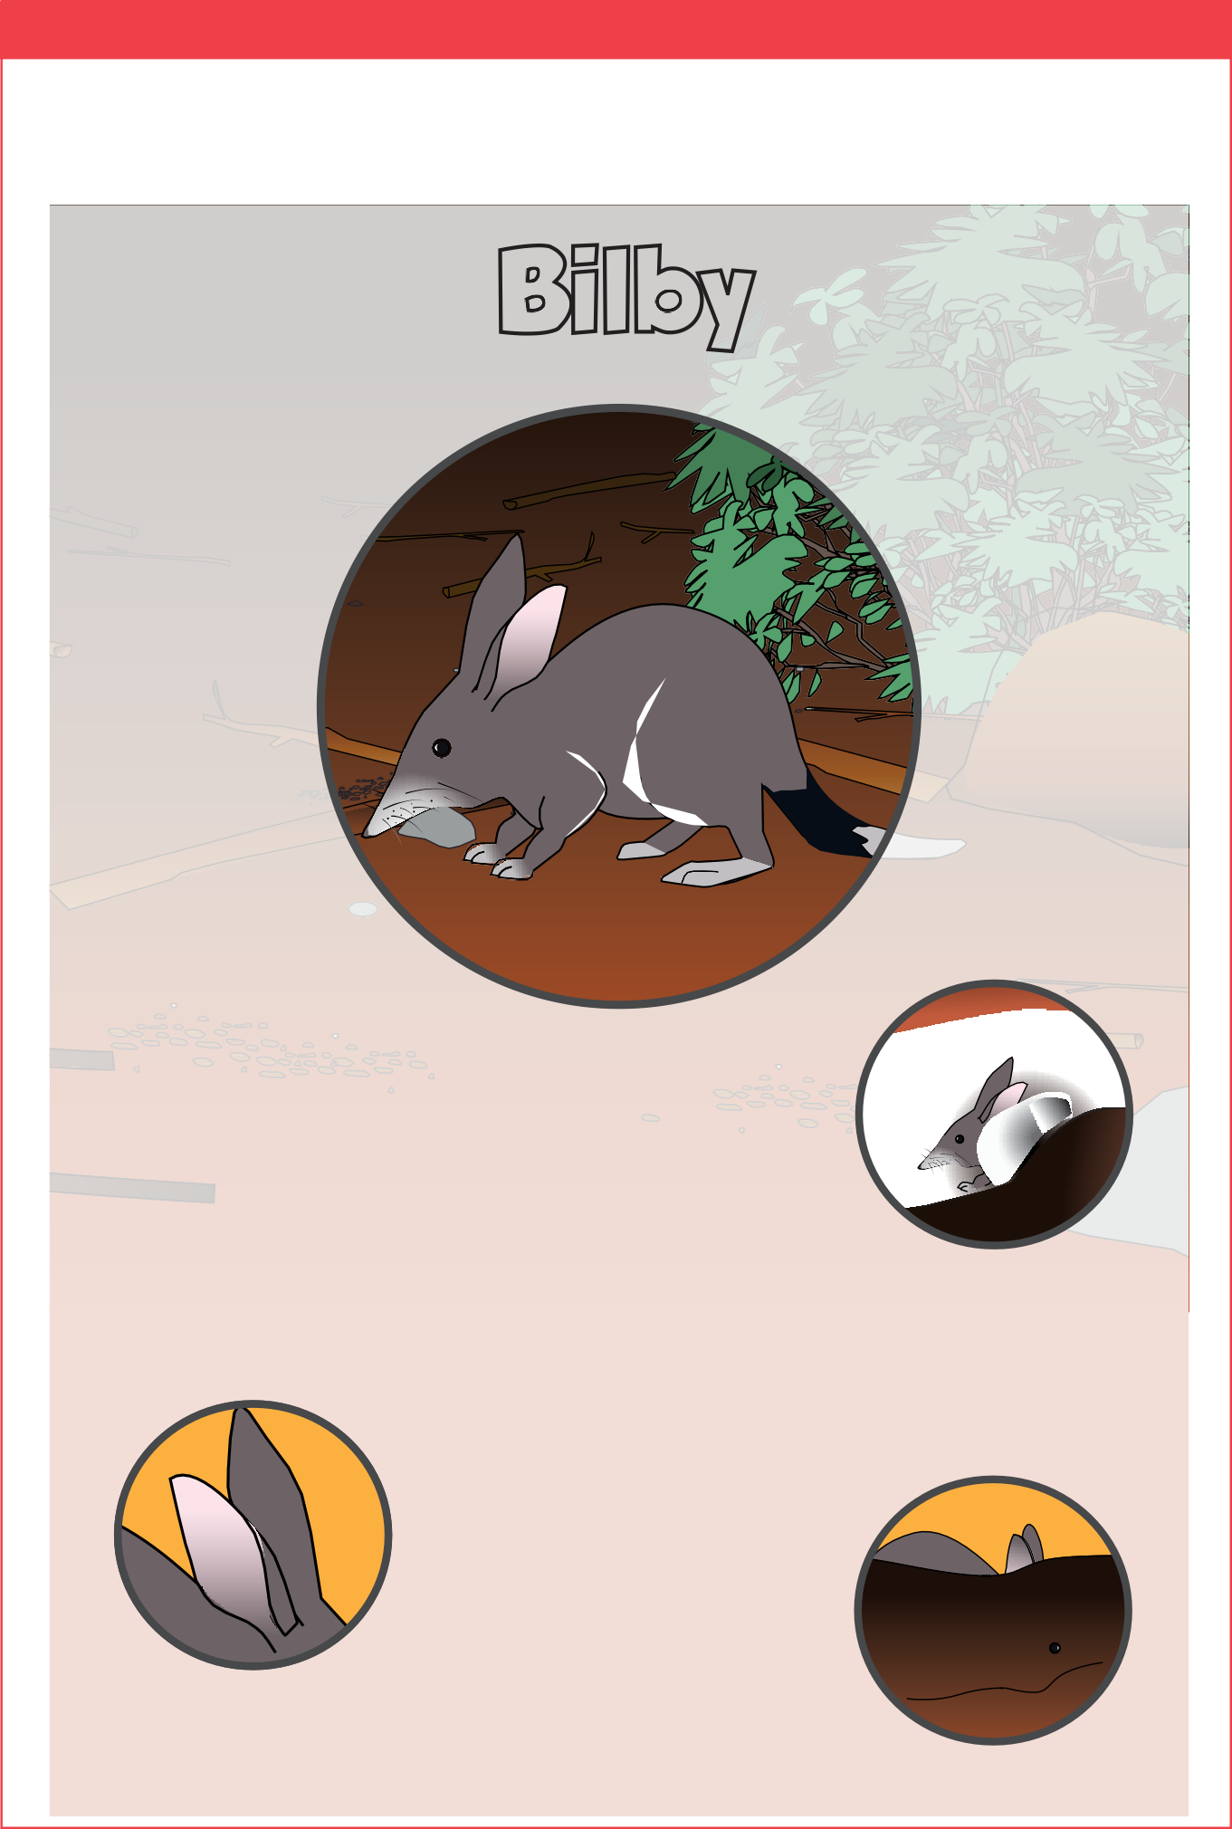student sheet 10: my adaPtations

Bilby

I’m a type of marsupial called a bandicoot, and I’m endangered.

My large ears mean I’m sometimes called Australia’s Easter Bunny.

I live in central Australia where it’s hot, dry and there’s not much water. I’m not fussy about what I eat: insects, plants, roots and fungi are all on the menu.

I don’t have great eyesight.

I have huge ears which give me super sensitive hearing so I can listen for insects underground. My super hearing is also handy

to help me avoid being eaten by predators.

I’m an expert digger. With my strong legs and sharp claws I build burrows to live in. Burrows keep me safe from predators and help me stay cool

underground when it’s hot.

student sheet 10: my adaPtations

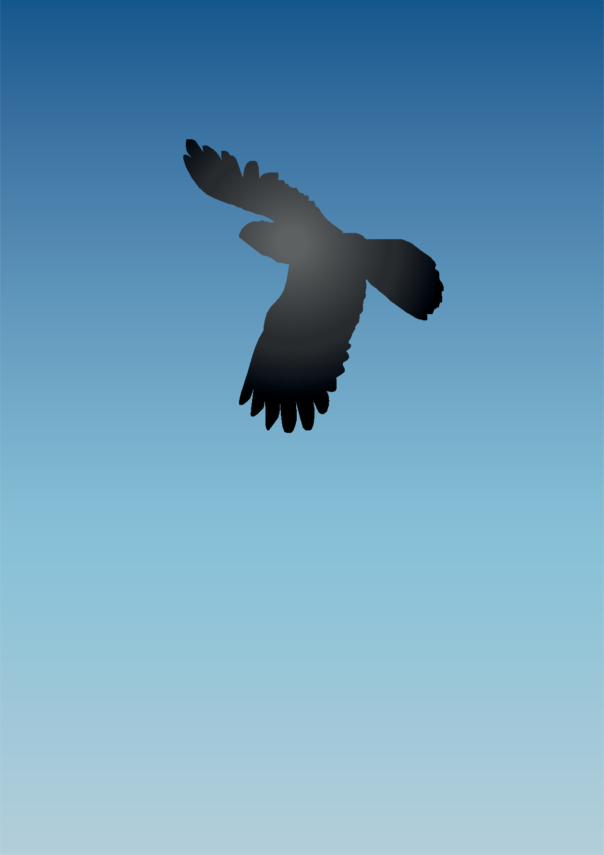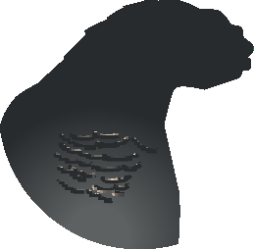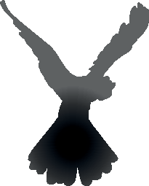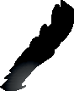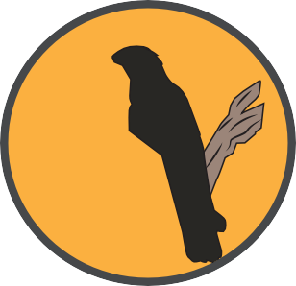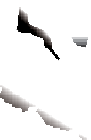

Forest red-tailed black cockatoo

I’m a splendid bird with flashy feathers. You might recognise me from the bright red plumes in my tail and my loud raucous caws.

I lay my eggs in the hollows of trees.

I live in the southwest corner of Western Australia, favouring forests and woodlands.

I eat nuts and seeds from native trees. I feed in the day and return to my favourite trees to roost at night.

My powerful, sharp beak helps me collect food. I use it to break open tough outer skins of nuts and seeds. It’s also a good

weapon if I’m threatened.

When it’s breeding time males sing and dance and display their colourful feathers to impress us girls.

I build nests to raise my chicks, in high up hollows of tall trees, where they’ll be safe from predators.

student sheet 10: my adaPtations

Platypus

I’m a monotreme; a mammal that lays eggs.

I’m an extraordinary creature, with the beak of a bird and the body of a mammal.

I live in eastern Australia in rivers and streams.

I’m semi-aquatic and a superstar at hunting underwater where I search for worms, insects and shrimp.

I’m mainly nocturnal, preferring to get out of bed in the evenings, but sometimes you can see me during the day.

When I’m not sleeping I spend most of my time in the water. I’m an excellent swimmer. I have webbed feet that propel me along, and a thick flat tail

that helps me steer.

I build burrows along waterway edges to sleep during the day. I build a deeper,

longer burrow when I’m raising my young. I line my burrow with leaves and reeds I carry with my tail. Burrows keep my young and me safe from predators.

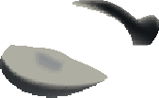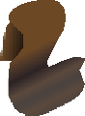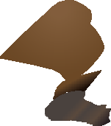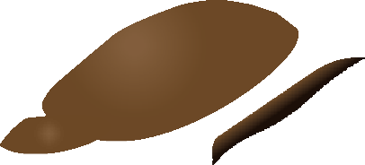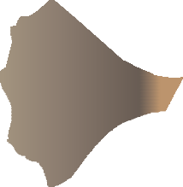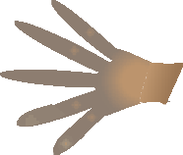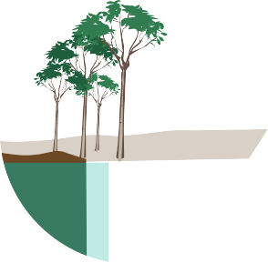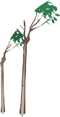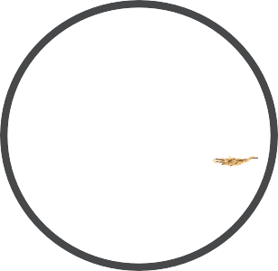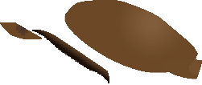

build burrows along waterway edges. I p in my burrow and also build nest ung. My burrowing is a behav

that helps me and m

student sheet 10: my adaPtations

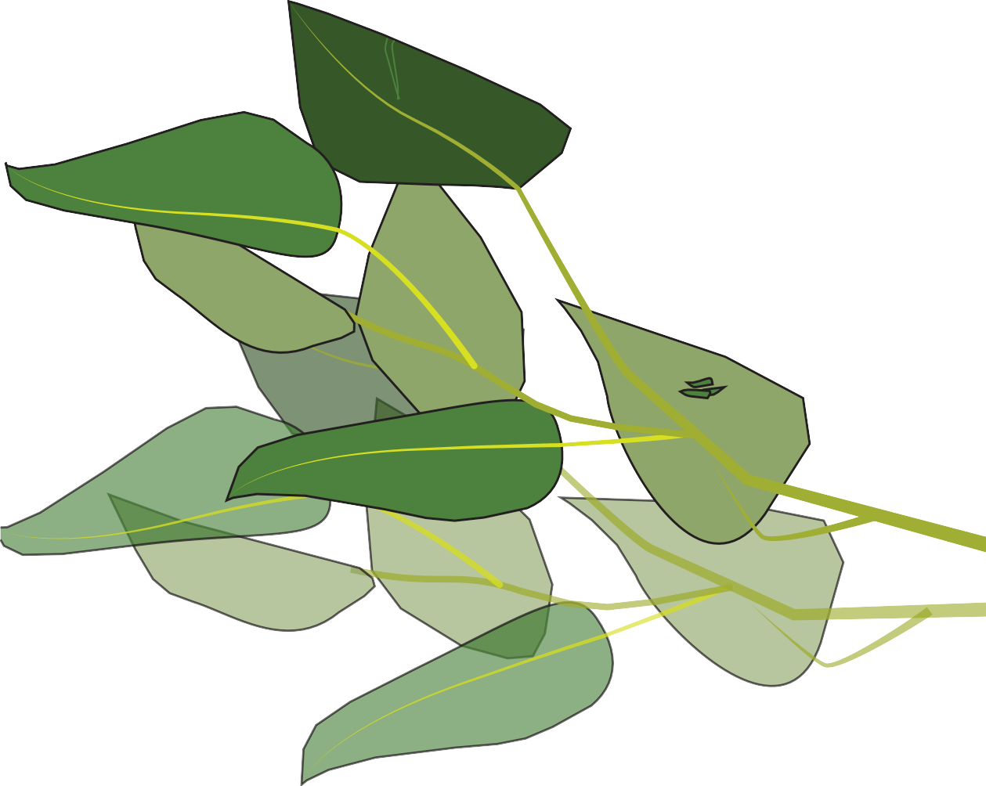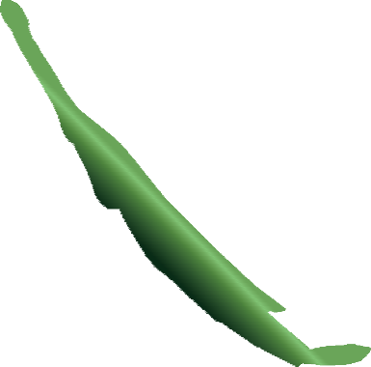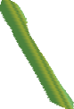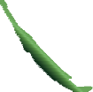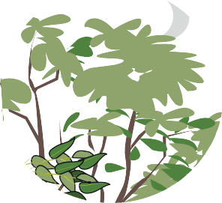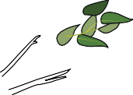

Goliath stick insect

I’m a stick insect.

I’m quite colourful: green, with spots of gold, red and purple. I’m found in most parts of Australia.

I’m one of the largest stick insects in Australia, growing over 20 centimetres long.

I prefer to live in forests where I spend my time in trees. I’m an herbivore, eating only plants.

I’m a master of camouflage. I look just like part of a plant. This means I can hide from predators, like birds, that love to eat me.

I’m nocturnal. During the day I pose like a stick or leaf, and come out to feed at night.

If a predator does catch up with me I use trickery to scare it off. I puff up my wings and flash my red undersides to make myself appear big and danger- ous. I also make a whirring noise with my

wings.