

Idea: collect cane toads and euthanase them

What is this?
Individuals and organised groups pick up cane toads and kill them. Community groups like the Kimberley Toad Busters (KTB), organise volunteers to go out in groups and collect cane toads and their eggs.
Individuals or groups may pick up cane toads by hand or use traps designed to catch them. Usually the traps have a one- way-door and a way to lure toads inside, eg lights that attract insects; audio devices making toad sounds; or poisoned baits.
There are different ways of killing cane toads, including:
- gassing with carbon dioxide,
- spraying with dettol,
- freezing in a freezer, or
- hitting with bats, clubs and so on.
As you see, some methods are more humane than others. Some are cruel and illegal.
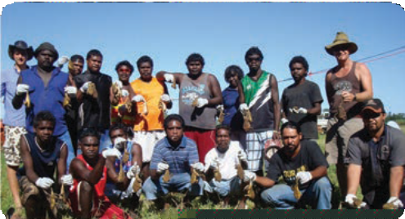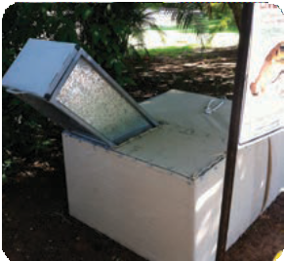
Kimberley toad busters Collecting toads Cane toad hotel

ast0905 | Feeding relationships: Cane toad control (fact sheet) |  | developed for the Department of Education WA
© The University of Western Australia 2012 |  | for conditions of use see spice.wa.edu.au/usage
version 1.1 revised November 2015 | page 1 | Licensed for NEALS

Idea: collect cane toads and euthanase them

Why it’s a good idea
  - Collecting cane toads reduces numbers in the environment. Over two million cane toads have been collected by KTB and other community groups. They believe they’ve helped slow their progress into WA.
  - Native animals may cope better with lower numbers of toads.
  - Collection of toads in small areas, such as gardens, is achievable and makes living in regions with cane toads more acceptable.
  - This is a way that everyone can contribute to the management of the cane toad problem. Anyone can pick them up and many safe disposal methods can be used. Some of these are outlined above.

Why it’s not
  - Cane toads are animals and should be treated humanely. Some listed methods for killing them aren’t humane and one of these encourages violence.
  - Collecting toads isn’t effective in eradicating them from the whole of Australia. People have been collecting toads for a long time and the population is still increasing and moving further across our country.
  - There are some negative environmental effects:
    - Native frogs may be killed by accident when people mistake them for cane toads.
    - Traps may catch native mammals, lizards and frogs.
    - Spraying dettol near waterholes may kill other aquatic wildlife, and dettol is not approved for this use.

ast0905 | Feeding relationships: Cane toad control (fact sheet) |  | developed for the Department of Education WA
© The University of Western Australia 2012 |  | for conditions of use see spice.wa.edu.au/usage
version 1.1 revised November 2015 | page 2 | Licensed for NEALS

Idea: fencing water holes

What is this?
Toad-proof fences can be built around water to prevent access to cane toads. Cane toads dehydrate quickly although there are records of toads living up to eight days, in shady places, without water. Some native frogs have adaptations to cope with longer dry conditions but cane toads don’t.

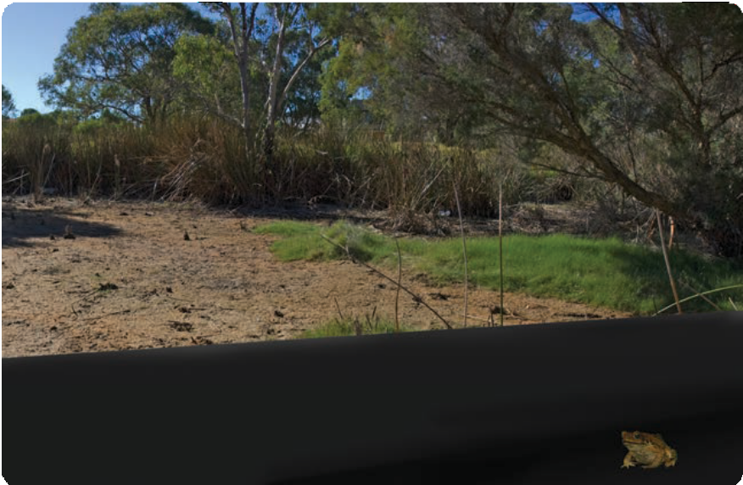

ast0905 | Feeding relationships: Cane toad control (fact sheet) |  | developed for the Department of Education WA
© The University of Western Australia 2012 |  | for conditions of use see spice.wa.edu.au/usage
version 1.1 revised November 2015 | page 3 | Licensed for NEALS

Idea: fencing water holes

Why it’s a good idea
  - Cane toads need water but can’t climb, so they gather around the outside of the fences. This makes it easy to collect and kill cane toads.
  - This idea was used effectively in a research project. Scientists from the University of Western Sydney put fences around some dams in the Northern Territory. After tagging 25 cane toads, all were found dead within 72 hours of erecting the fences.
  - Livestock that drink from dams may step over fences to access water.

Why it’s not
  - Fences can stop native wildlife accessing the water they need to live.
  - They aren’t effective for getting rid of cane toads if there are other water sources available.
  - Fences are difficult and costly to maintain.
  - Even small holes can let toads through.
  - Fences don’t work well in areas with flooding because with water on both sides of the fence, eggs or tadpoles on the outside can fit through it.
  - Livestock often trample down fences, which can also be destroyed by fire or floods.
  - Cane toads trapped by the fence die of dehydration, which is unethical.

ast0905 | Feeding relationships: Cane toad control (fact sheet) |  | developed for the Department of Education WA
© The University of Western Australia 2012 |  | for conditions of use see spice.wa.edu.au/usage
version 1.1 revised November 2015 | page 4 | Licensed for NEALS

Idea: biological control

What is this?
Biological controls may be: predators, parasites, or diseases that can be spread, to infect and kill unwanted species. ‘Team Bufo’, a group of scientists from the University of Sydney, are working on two possible biological controls for cane toads: meat ants, and a lungworm parasite from South America.
- Meat ants are native to Australia and attack baby cane toads as they emerge from the water. Team Bufo are experimenting with placing cat food around waterholes to encourage more ants to feed there, and to kill toads.
- Team Bufo found some cane toads are infected with lungworm, a parasite that can be lethal. They are researching effects of spreading this parasite.

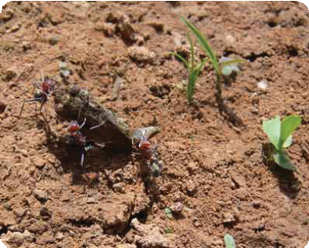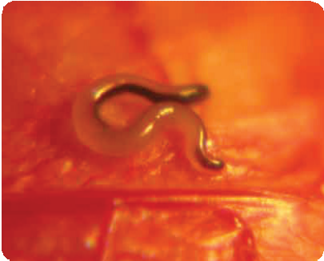

Meat ants eating cane toad. Photo by Georgia Ward-Fear.
Lungworm parasite in cane toad. Photo by Crystal Kelehear

ast0905 | Feeding relationships: Cane toad control (fact sheet) |  | developed for the Department of Education WA
© The University of Western Australia 2012 |  | for conditions of use see spice.wa.edu.au/usage
version 1.1 revised November 2015 | page 5 | Licensed for NEALS

Idea: biological control

Why it’s a good idea
Meat ants
  - They’ve been effective in a research project. Team Bufo found when they lured meat ants to a waterhole, ants killed up to 88% of baby toads.
  - This method is cheap.
  - It’d work well in small, defined areas.
  - No new predators are introduced into the environment.
  - Meat ants don’t seem to harm native frogs. Native frogs have learned to jump away to avoid them. Cane toads’ natural defence is to stand still, which allows the ants to eat them.
  - Baby toads are more active than frogs during the day, when the ants are around.
Lungworm
  - It’s had positive effects in a research project. Team Bufo found 30% of baby cane toads infected with lungworm, died, and others’ growth was stunted and they moved more slowly so don’t spread as fast.
  - Scientists found the lungworm species in cane toads is different from that found in native frogs, so toads’ lungworm won’t harm most frogs.

Why it’s not
One risk of using biological controls is that they may end up out of control – just like cane toads! Toads were introduced as a biological control for sugar cane beetles – it didn’t work but toads spread and are harming the environment. We must ensure that native wildlife won’t be affected.
Meat ants
  - Numbers would have to increase significantly for them to eat all cane toads. Do we want more meat ants in Australia?
  - It’d be time-consuming to put cat food around all water bodies across the Kimberley.
Lungworm
  - Researchers tried infecting native frogs with the type of lungworm found in cane toads and found it can kill one type of frog in the Kimberley. Lungworm may be used in areas that aren’t home to this type of frog, but if it
spreads out of control it could kill this native species, and perhaps others that haven’t yet been tested.
  - It’d take time to spread the disease throughout the cane toad population.

ast0905 | Feeding relationships: Cane toad control (fact sheet) |  | developed for the Department of Education WA
© The University of Western Australia 2012 |  | for conditions of use see spice.wa.edu.au/usage
version 1.1 revised November 2015 | page 6 | Licensed for NEALS

Idea: saving native predators

What is this?
Some people think cane toads are here to stay, so efforts should focus on teaching predatory animals that toads poison and kill, to avoid eating toads. Mammals such as quolls, as well as lizards, snakes and crocodiles are declining in number as they all eat cane toads.
Cane toad sausages
- ‘Team Bufo’ scientists at the University of Sydney, together with the Department of Environment and Conservation (DEC) in Kununurra, have been teaching predators not to eat cane toads. They feed predators either small cane toads or ‘cane toad sausages’ (both contain only a small amount of poison), laced with a nausea-inducing drug. Predators get sick (but don’t die), and learn that cane toads are not good to eat.
Island refuges
- Endangered animals could be moved to islands off the coast of the Northern Territory or northern Western Australia. The islands are too far from the coast for cane toads to swim there. This might stop the most ‘at risk’ species from becoming extinct.
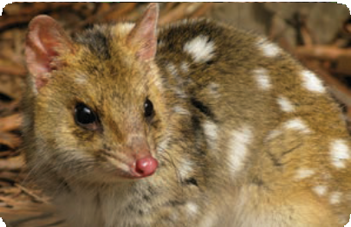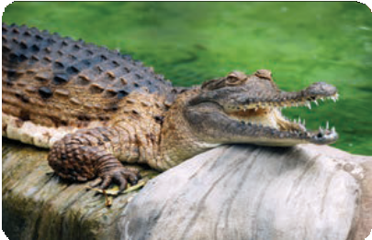
Quoll Freshwater crocodile

ast0905 | Feeding relationships: Cane toad control (fact sheet) |  | developed for the Department of Education WA
© The University of Western Australia 2012 |  | for conditions of use see spice.wa.edu.au/usage
version 1.1 revised November 2015 | page 7 | Licensed for NEALS

Idea: saving native predators

Why it’s a good idea
Cane toad sausages:
  - Trained predators may learn to avoid cane toads and teach their young to avoid them too.
  - Team Bufo had success in teaching quolls. Trained quolls are surviving long enough in the wild to breed. Team Bufo are now working with lizards. Potentially, sausage baits could be dropped from the air into areas where these animals live, particularly in regions just in front of the cane toad invasion.
Island refuges
  - Many islands are ideal habitats for species such as quolls, and would give them a chance to increase numbers while keeping them in the wild.
  - This idea has been successfully tried with a population of northern quolls in the Northern Territory. The project is called the Island Ark program.

Why it’s not
Both of these programs are expensive and labour- intensive.
Cane toad sausages
  - It may be possible to train predators on small islands, but it would be difficult to teach whole populations of native animals.
  - Some animals aren’t very trainable, for example research with snakes has shown that it’s very difficult to teach them not to eat cane toads.
  - No one knows whether trained animals retain information for a long time, or whether they teach their offspring to avoid cane toads.
Island refuges
  - Animals being saved may negatively impact on existing island ecosystems. Many islands off the coast of Australia are home to species that have already become extinct on the mainland.
  - Species that are relocated may not be able to survive on the islands. A lot of work is needed to assess suitability of islands before introducing a new species.

ast0905 | Feeding relationships: Cane toad control (fact sheet) |  | developed for the Department of Education WA
© The University of Western Australia 2012 |  | for conditions of use see spice.wa.edu.au/usage
version 1.1 revised November 2015 | page 8 | Licensed for NEALS

Idea: altering the cane toad genome

What is this?
Scientists at the University of Western Australia have been mapping the cane toad genome.
Every organism, including cane toads, has a genome containing all biological information needed to build and maintain each living organism. Genomes are ‘instructions’, inside cells in our bodies, that determine what we look like.
Biological information contained in a genome is divided into tiny units, called genes. Each of our genes has information about a different characteristic.
Once scientists have mapped the cane toad genome, they can find which gene determines their sex. Then, they can alter this gene to create, in the laboratory, a mutant cane toad that only has male offspring.
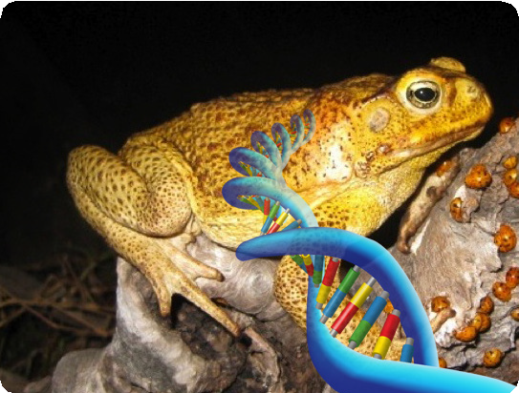
When released into toad-infested areas, this genetically altered mutant cane toad will mate with other cane toads in the wild, and there will be only male cane toad offspring. So, over time the number of female toads will decrease and, as males can’t give birth, the population will die.

ast0905 | Feeding relationships: Cane toad control (fact sheet) |  | developed for the Department of Education WA
© The University of Western Australia 2012 |  | for conditions of use see spice.wa.edu.au/usage
version 1.1 revised November 2015 | page 9 | Licensed for NEALS

Idea: altering the cane toad genome

Why it’s a good idea
  - If this works, cane toad population in Australia should decrease to zero.
  - Once the first toads are released, they’ll breed and spread without further human intervention.
  - No chemicals or introduced species are used.
  - Altering this cane toad gene will have no impact on genes of any other species of animal, so it won’t be a problem for native wildlife.
  - Mutant cane toads will perish with normal cane toads.
  - The genome work has the potential to provide additional knowledge about cane toads, which may help manage them.

Why it’s not
  - There is still a lot of work to do before genetically altered cane toads can be released into the wild. By the time it happens many more native animals and environments will be affected by toads.
  - It’ll take a long time to spread altered toads around the whole region in which toads live, and it will take several generations before they’re all male.
  - In the short term, when the first toads are released, numbers will increase. Many people don’t like the idea of adding more cane toads to an environment.
  - Cane toads are an introduced species in Australia but are native to Central and South America. Care would be needed to ensure none of the modified toads escapes to these places, causing cane toads to become extinct in their native habitats.
  - This research is expensive, time consuming, and does not guarantee an answer.

ast0905 | Feeding relationships: Cane toad control (fact sheet) |  | developed for the Department of Education WA
© The University of Western Australia 2012 |  | for conditions of use see spice.wa.edu.au/usage
version 1.1 revised November 2015 | page 10 | Licensed for NEALS

