Part 1: Primate trends
Anatomy and behaviour are important tools that scientists use to determine how organisms are related. Compare five primate skulls using the learning object, Primate trends. As you select skulls, rate each characteristic, and use this information to determine which are most closely related.
- On the ‘Meet the primates’ screen, of the learning object, compare the five skulls and list them in order from smallest to largest.

- Complete the table below as you work through Primate trends. In each column, list names of primates in order (top to bottom) from smallest to largest (or shortest to longest) skull feature. Change skull type by selecting the button at the top left of the window showing the skull you want to view.
 | SKULL FEATURE
largest (longest) → smallest (shortest) | cranial capacity | canine length | size of mandible relative to skull | size of brow ridge | length of maxilla
largest (longest) → smallest (shortest) |  |  |  | Homo  (no brow ridge)
- Using your observations, which species appear to be most closely related?

- Did you use a particular characteristic to decide on the relationships? Explain why this characteristic was more important than others; or if you didn’t use a specific characteristic, explain your reasons.

- Sexual dimorphism, or difference due to gender, is present in some of the primate species included in Primate trends. However, all images in the learning object are of masculine skulls.
Compare images of male and female Pongo skulls below, to answer questions 5 and 6.
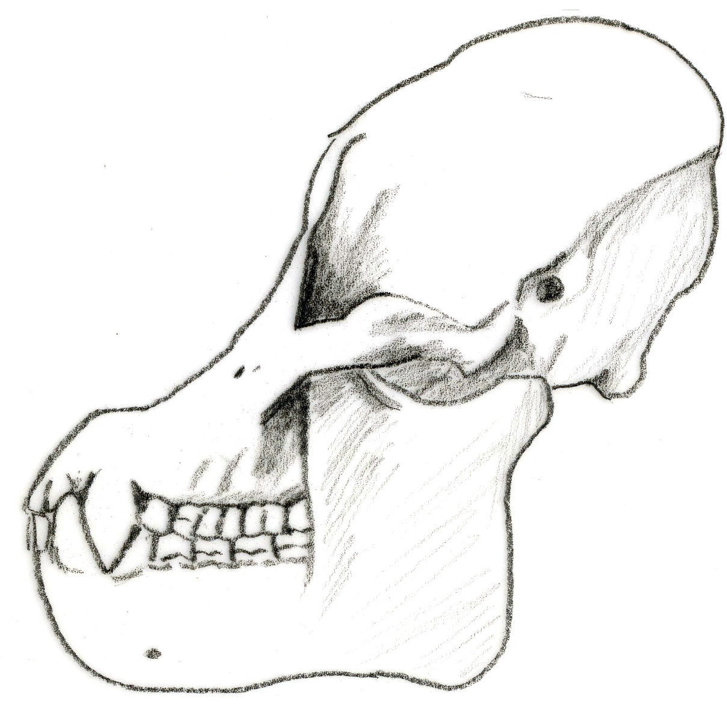 | 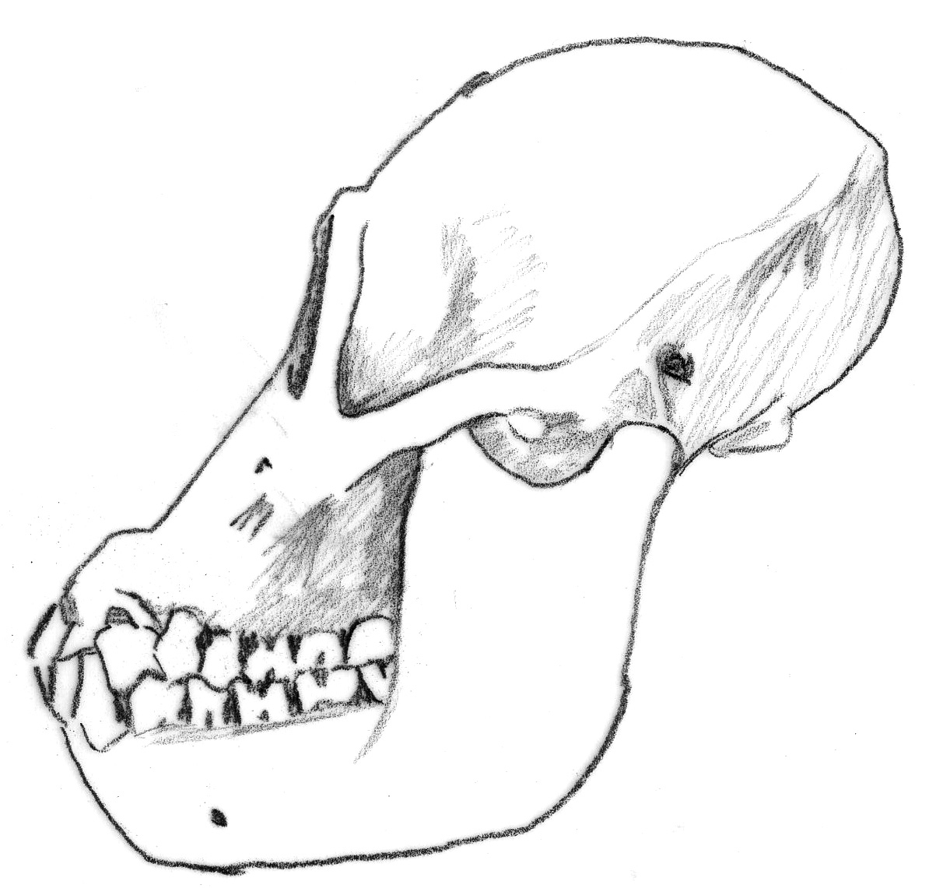
male | female
- Describe three features that demonstrate sexual dimorphism between male and female Pongo.

- Do any features of the female Pongo skull change the way you’ve described primate relationships in question 4? For example, does the female Pongo appear human-like?

- Rank skull characteristics from least to most useful in deciding who is related to whom.

- We know that Pan (chimpanzee) and Homo (human) are most closely related of these primates. Did this exercise reflect that? Why or why not?

- In this case, we’ve used a skull to determine how five primates are related. What problems are associated with looking at only a single piece of evidence?

Part 2: Virtual zoo
- Observe primates at Perth Zoo, or use the Virtual zoo interaction. Record your observations of characteristics and behaviour, in the species’ passports provided. Then collate this information using the table on page 9. Notes for humans have been completed for you.
Consider how each feature may be used to determine relatedness between these animals.

- Has observation of living primates changed your view about who is most closely related to whom? Explain your answer.

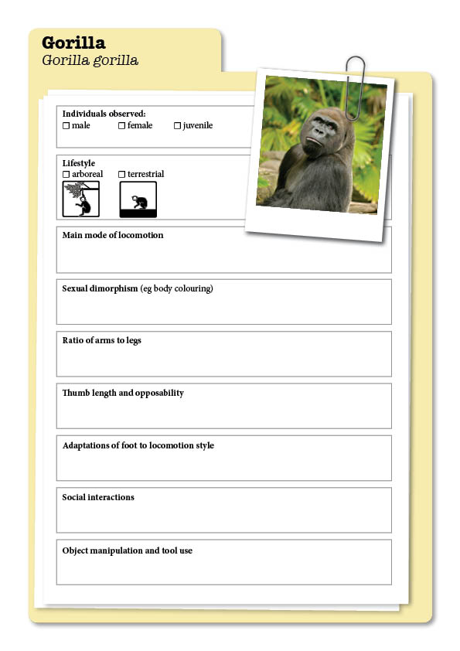
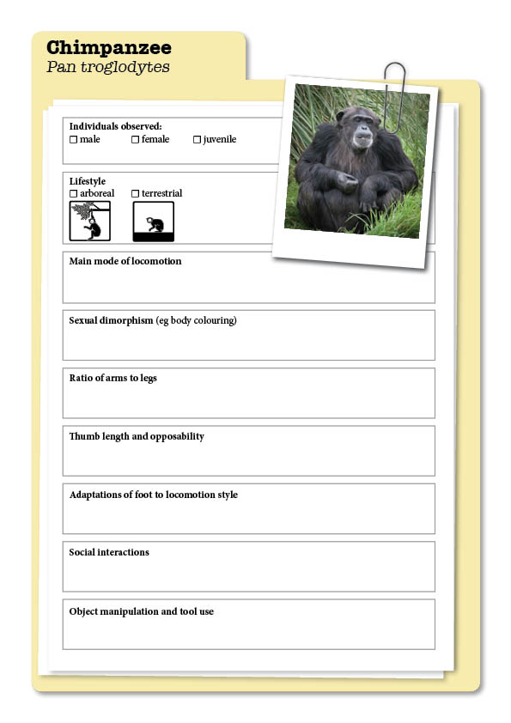
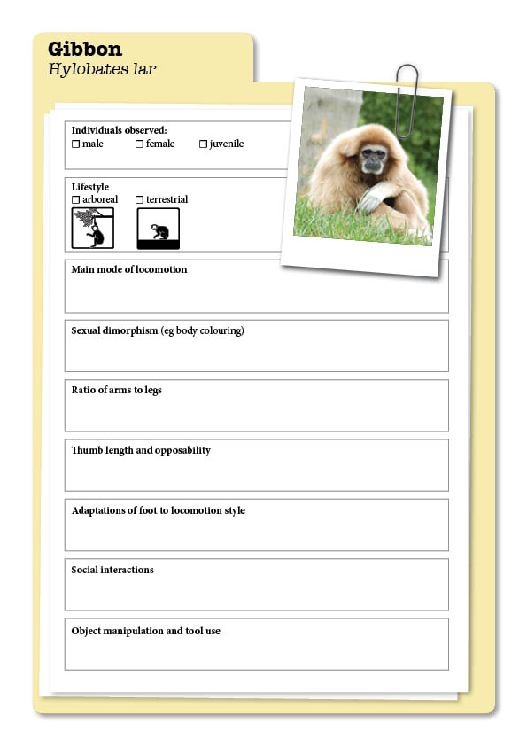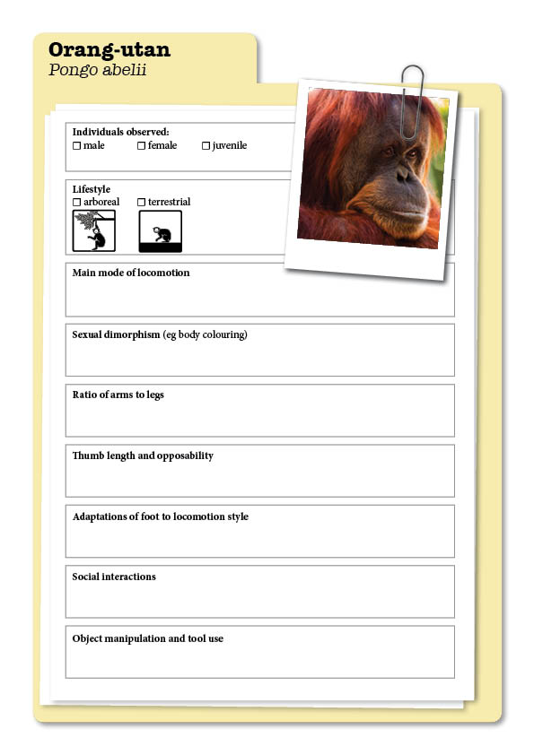
 | OBSERVED CHARACTERISTIC OR BEHAVIOUR
 | orang-utan | gibbon | chimpanzee | gorilla | human
ratio of arm to leg length |  |  |  |  | legs longer than arms
arboreal or terrestrial |  |  |  |  | terrestrial
thumb length and opposability |  |  |  |  | opposable
mode of locomotion |  |  |  |  | bipedal
foot adaptations to locomotion style |  |  |  |  | transverse and longitudinal arch
social interactions |  |  |  |  | living in groups, complex social rules
sexual dimorphism (eg colour) |  |  |  |  | minimal differences
object manipulation & tool use |  |  |  |  | advanced tool user

