**worksheet**

**Spotters guide**

# With my naked eye I saw…

Organisms on this page are to scale

### slater

1 2-10 >10

1 2-10

>10

### earwig

1 2-10 >10

## 

1

2-10

>10

### ant

1 2-10 >10

### slug

1 2-10 >10

### cricket

**spider**

1 2-10 >10

1 2-10 >10

### earthworm

segmented pink/brown

1 2-10 >10

### millipede

1 2-10 >10



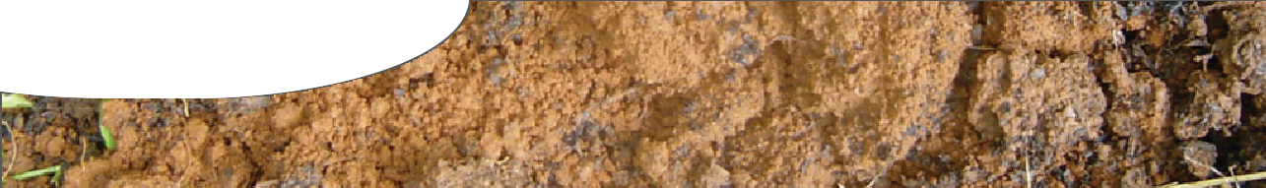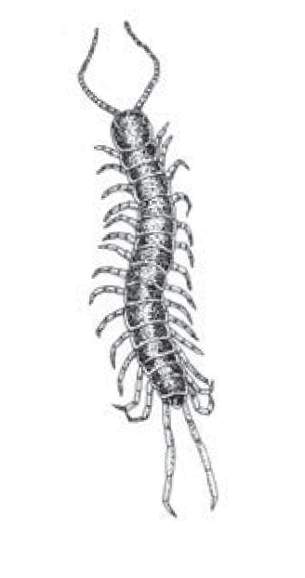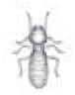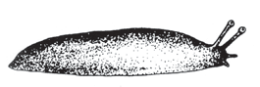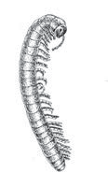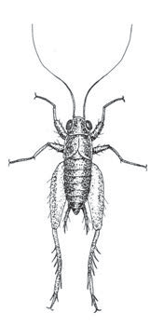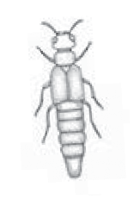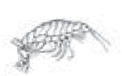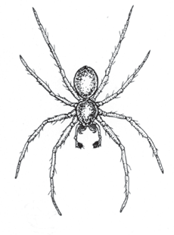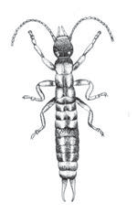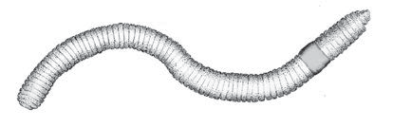



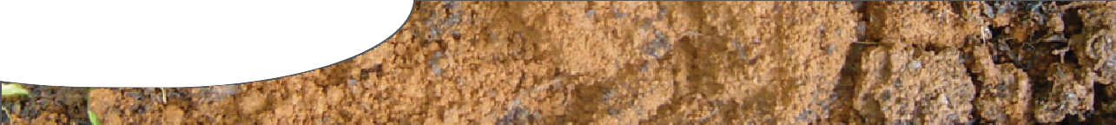

**worksheet**

**Spotters guide**

**nematode** unsegmented white/transparent

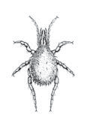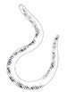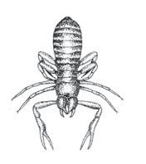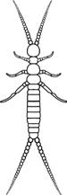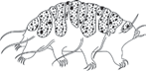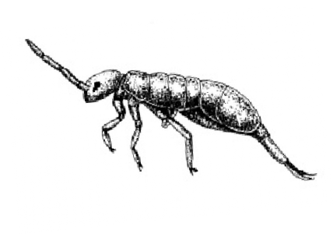

**mite**

1 2-10 >10

**pseudoscorpion**

1 2-10 >10

1 2-10 >10

**tardigrade**

1 2-10 >10

**rotifer**

1 2-10 >10

### dipluran

1 2-10 >10

|  |  |  |  |  |  |  |  |  |
| --- | --- | --- | --- | --- | --- | --- | --- | --- |
|  |  |  |  |  |  |  |  |  |