Satellites in circular orbit
A satellite can be launched into orbit around Earth by accelerating it to a high tangential speed. If its speed is too high, the satellite will break free of Earth’s gravity and escape. If it is too low, it will fall back to Earth.
The formulae that describe satellite motion are the same as those for circular motion. The centripetal acceleration of a satellite in circular orbit is given by 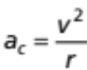. Gravity is the force that gives the satellite this acceleration:
, resultant 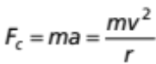 and 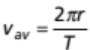.
The gravitational force and acceleration of a satellite circling the Earth are given by:
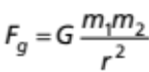, 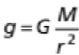
When a satellite is in circular orbit, gravity is the only force acting on it, which means that the centripetal force and gravity must be equal: 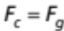.
This relationship can be used to explore the behaviour of satellites in circular orbit around the Earth and make predictions about their speed, orbital radius and period of rotation.

Questions/tasks
- Describe conditions necessary for a satellite to remain in a stable circular orbit around Earth.

- Equate the formulas for centripetal force F_{c} and gravity F_{g} and derive a formula for the satellite’s velocity v in terms of G, m and r.

- Use the formulae provided above to derive an expression for the orbital radius of a geosynchronous satellite, which is a satellite whose orbital period is equal to that of Earth.

- A geosynchronous satellite orbits with a radius of 4.23 x 10⁷ m. Use the formula provided to calculate its average orbital speed. (Earth’s rotational period = 8.64 x 10⁴ s.)

- Using the formula you derived in question 2, indicate whether the following statements are true or false. Support each of your answers with an explanation.
The speed of a satellite in orbit around Earth is independent of the satellite’s mass.
true / false | Explanation:
The speed of a satellite depends only on the mass of the body it orbits.
true / false | Explanation:
Satellites further away from Earth travel faster than those closer.
true / false | Explanation:
- Fengyun 1D is a Chinese weather data-gathering satellite that is in circular, near-polar orbit 855.5 km (8.55 x 10⁵ m) above the Earth.
radius of Earth = 6.37 x 10⁶ m, mass of Earth = 5.98 x 10²⁴ kg, G = 6.67 x 10⁻¹¹ N m² kg⁻²
Calculate:
a. the satellite’s orbital speed

b. how long it takes to complete one orbit

- Is it possible for two satellites with different speeds to occupy the same circular orbit around Earth? Explain your answer.

Satellites and the sensation of weightlessness
Astronauts in orbiting satellites experience the sensation of ‘weightlessness’ — the feeling that there are no forces acting on the body. It typically occurs when an object is in orbit or is in ‘free fall’. True weightlessness only occurs in deep space where the gravitational force on an object is zero.
A satellite in a stable circular orbit around Earth is continually in free fall. As it orbits, it experiences a gravitational force towards the centre of Earth, which causes it to change direction and ‘fall’ towards Earth. However, Earth’s surface curves away from the satellite at the same rate as the satellite falls, so it remains in orbit at the same altitude above Earth unless it loses speed.
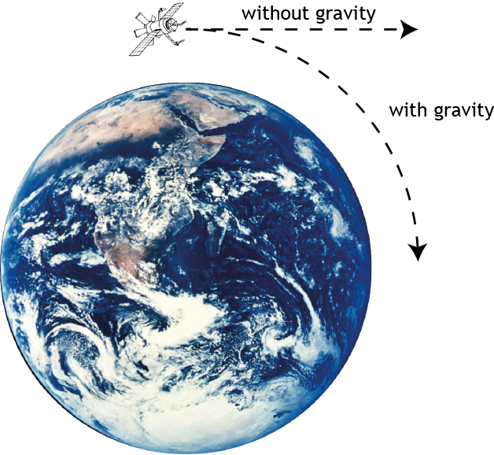
Gravity pulls a moving satellite out of a straight-line path, towards Earth.

Mass, weight and apparent weight
Objects have mass because of the matter they contain. Mass is an inertial property related to the tendency for an object to remain at constant velocity unless an external force acts on it.
Weight is a force that exists when a gravitational field acts on a mass. The weight of an object depends upon the strength of the gravitational field.
Apparent weight is the weight force that you feel. It is the reason that you feel ‘heavy’ when you are in a lift that is accelerating upwards, and ‘light’ when it accelerates down.

So what is ‘weightlessness’?
‘Weightlessness’ is the feeling that astronauts experience when their apparent weight is zero. It happens when they are falling due to gravity but aren’t in contact with any surface, or because they and the surfaces near them are falling at the same rate.
Objects inside an orbiting satellite appear to be weightless because they, and the satellite, are falling at the same rate (approximately 9.80 ms⁻²). If an astronaut were to drop an object, it wouldn’t fall — it would hover in front of him, appearing to be weightless.
In reality however, the objects and the satellite aren’t weightless because they have mass and Earth’s gravitational force is acting on them:
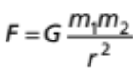
In fact, if the gravitational force wasn’t acting, the satellite couldn’t remain in orbit!
Questions
- The International Space Station (ISS) orbits at an altitude of approximately 570 km. Calculate the value of g at this altitude.
radius of Earth = 6.37 x 10⁶ m, mass of Earth = 5.98 x 10²⁴ kg, G = 6.67 x 10⁻¹¹ N m² kg⁻²

- Complete the following table for a 70 kg astronaut
situation | g (m s⁻²) | mass (kg) | weight (N)
on Earth | 9.8
in a rocket shortly after launch | 29.4
on the International Space Station (Use your answer from question 8.)
on the Moon | 1.63

Comment on the astronaut’s mass and weight.

- Indicate whether the following statements are true or false. Support each of your answers with an explanation.
Objects in deep space are weightless because there is no gravitational force on them.
true / false | Explanation:
Astronauts in the International Space Station (ISS) appear to be weightless because they are so far from Earth that its gravity has no effect on them.
true / false | Explanation:

