Rehabilitation site - match the plant with the zone.
Think about adaptations of each species of samphire and decide in which zone each samphire would grow.

Tecticornia pergranulata
- C3 photosynthesis
- adventitious roots containing aerenchyma grow from woody basal stem region
- aquatic roots in larger plants that can photosynthesise
- succulent stems
- sprawling shrub, up to 1 m tall
- swollen branches with small leaf lobes

Sarcocornia quinqueflora
- accumulates salt in swollen leaf bases which fall off to remove excess salt
- roots at the nodes
- grows to height of 50 cm
- sprawling plant that grows in thick clumps
- older plants are woody at the base
- stems are leafless, fleshy and jointed
- C3 photosynthesis

Tecticornia indica
- reduced leaves
- succulent stems
- C4 photosynthesis
- Kranz anatomy in leaves and stem cortex
- sprawling shrub that grows to 2 m

Zone A - Tidal flats
- area between the shoreline and banks of dunes
- highly saline, periodically inundated with salt water
- salt deposits accumulate
- muddy
- alternate flooding and exposure
- harsh and unpredictable environment
Zone B - Sand dunes
- mounds of sand
- formed by wind erosion and tidal movements
- arid region
- very dry, well-drained sandy or stony soil
- unstable soil that lacks nutrients
Zone C - Clay pan
- a depression in the landscape
- elevated from salt lakes and not quite as saline
- non-porous, high clay content soil
- fills with fresh water after rainstorms
- can take months to dry out
- mud is hard when dry and sticky when wet

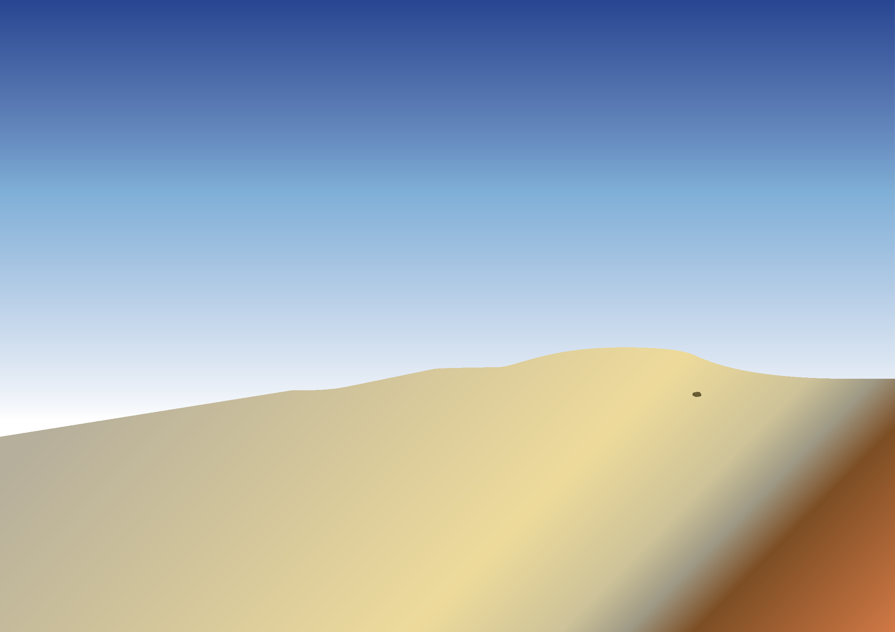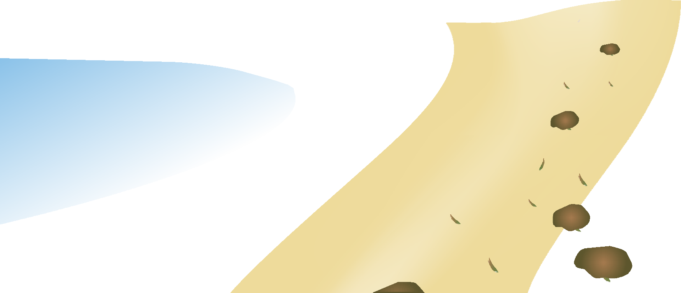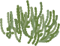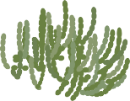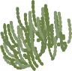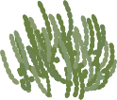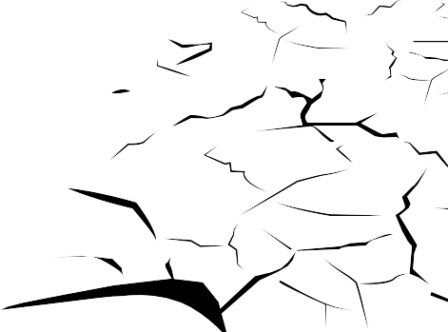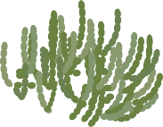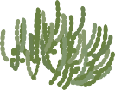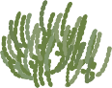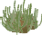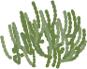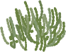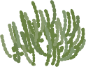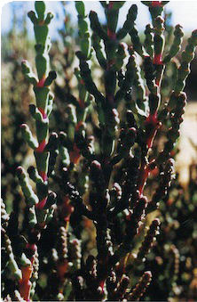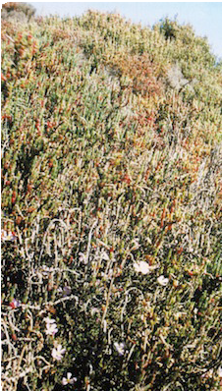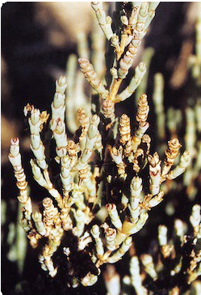
ast0839 | Adaotations 4: Rehabilitation site (worksheet)
© The University of Western Australia 2012 version 1.0 reviewed October 2012

developed for the Department of Education WA for conditions of use see spice.wa.edu.au/usage
Licensed for NEALS

