The US Department of Commerce/National Oceanic & Atmospheric Administration (NOAA) has collected data about sea surface temperatures (SST), over many years, to produce annual maps similar to that shown in Figure 1.
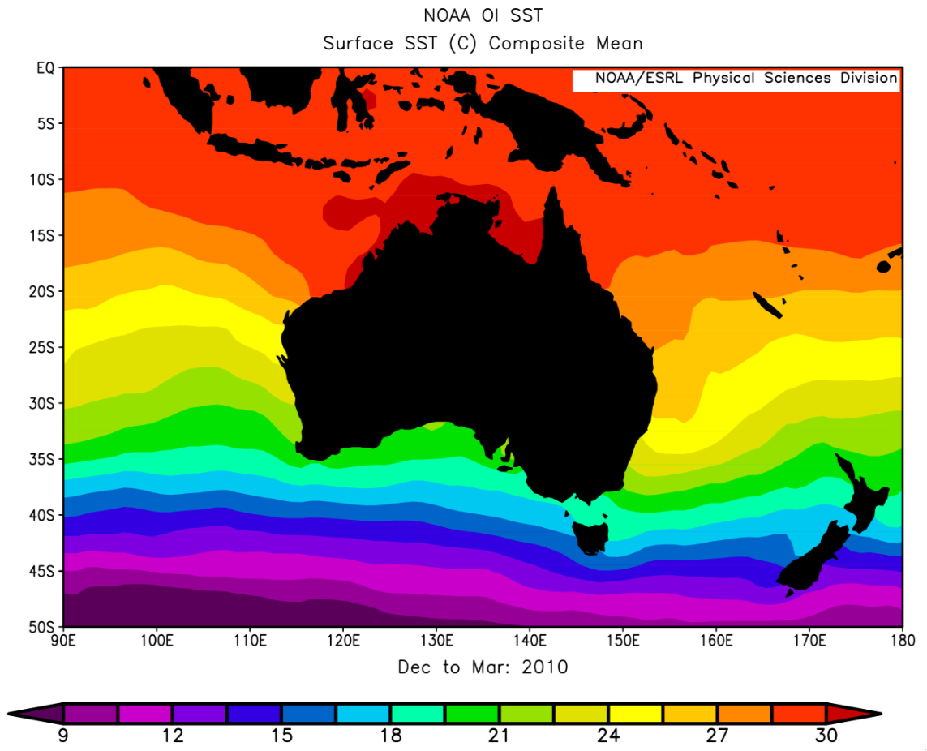
Figure 1: sea surface temperatures in the Australian region (source: NOAA)
January is the middle of the cyclone season in Western Australia, so January maps for 1985–2010 have been used to extract SST data for six WA coastal towns. These data are shown in Table 1.
 | Broome | Port Hedland | Carnarvon | Geraldton | Perth | Albany
1985 | 29 | 29 | 24 | 22 | 19.5 | 19
1987 | 29 | 28.5 | 25 | 22.5 | 19.5 | 19
1990 | 29 | 28 | 26 | 22 | 20.5 | 19
1993 | 29.5 | 28.5 | 26.5 | 22.5 | 20.5 | 19.5
1995 | 29.5 | 28.5 | 26.5 | 22.5 | 20.5 | 19.5
1997 | 29.5 | 29 | 26 | 22.5 | 20 | 19
2000 | 30 | 29 | 26 | 22.5 | 20.5 | 19
2003 | 29.5 | 29.5 | 26 | 22.5 | 21 | 19.5
2005 | 30 | 30 | 24.5 | 23 | 21 | 19.5
2007 | 30.5 | 29.5 | 25 | 23 | 21 | 19.5
2010 | 30.5 | 29 | 26 | 24 | 21.5 | 20
Table 1: mean January sea surface temperatures for six Western Australian coastal towns
Graph data from Table 1, either on graph paper below or use a spreadsheet. Plot ‘year’ on the x-axis and ‘sea surface temperature’ on the y-axis. Plan to extend the x-axis to the year 2100 and the y-axis to 35 °C in a later activity.

Figure 2: mean January sea surface temperatures for Western Australian towns
Figure 3 shows observed and predicted increases in global mean surface temperatures. To make these predictions scientists divide the Earth into sections and model what will happen to surface temperatures into the future. In some sections surface temperature increases and in others it decreases, but through careful analysis of all models a global-mean surface temperature is calculated.
Two scenarios for projected global mean surface temperature are included in Figure 3: one where carbon dioxide emissions are limited; and one where there is no climate policy. In a group, discuss how to use Figure 3, and your graph in Figure 2, to make predictions about future sea surface temperatures and tropical cyclone activity for Western Australian towns, up to the year 2100. You will need to make decisions about which global temperature scenario to use and how much it will affect sea surface temperatures for each town. A map of Western Australia is provided in Figure 4.
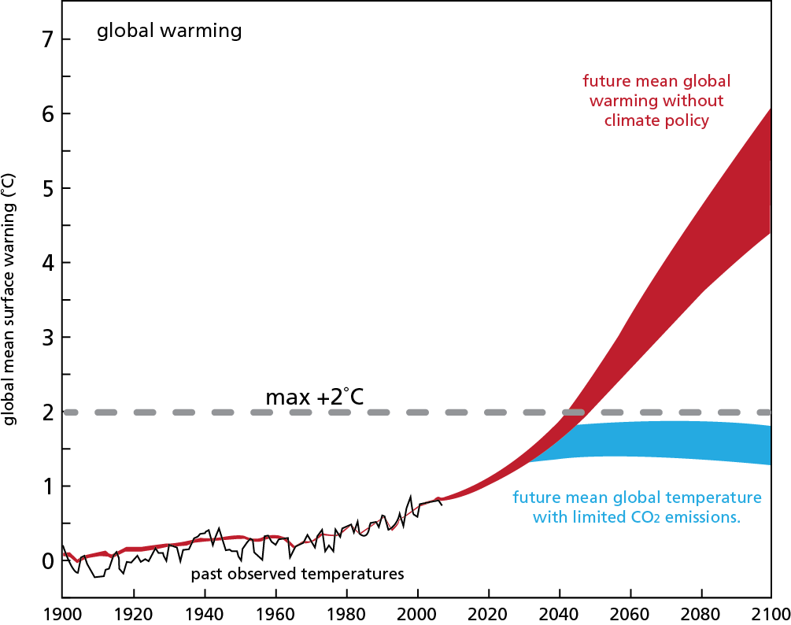
Figure 3: observed and predicted increases in global mean surface temperatures, 1900–2100
(source: The Science of Climate Change: Questions and Answers, Australian Academy of Science, 2010)

When you have finished, present a report to the class about your predictions that justifies your position and describes evidence and assumptions you have used.

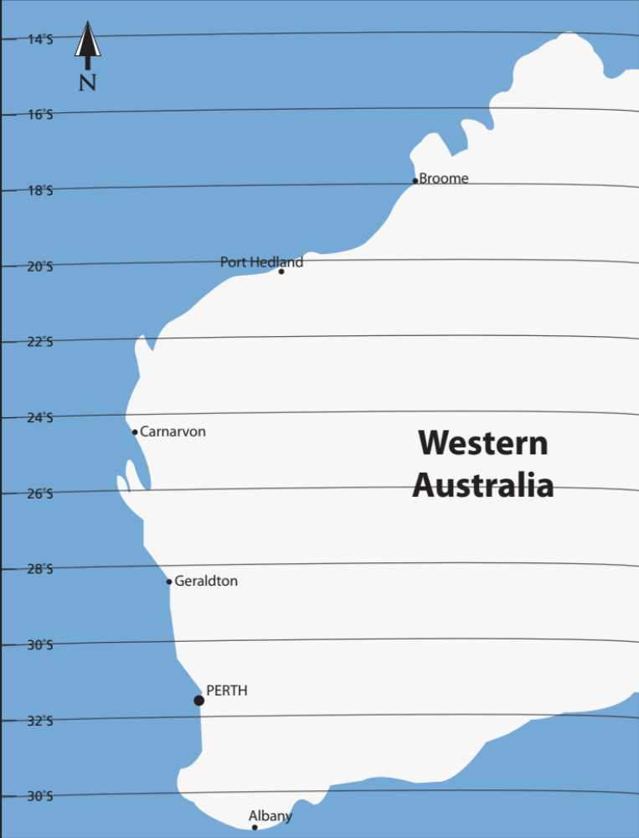
Figure 4: Western Australia

