Use this worksheet to record data from the learning object, Sink or swim.

Part 1

Diving prediction
- Use the information from the ‘Diving prediction’ screen to record your predicted dive depth and time for each animal, on the diagram below.
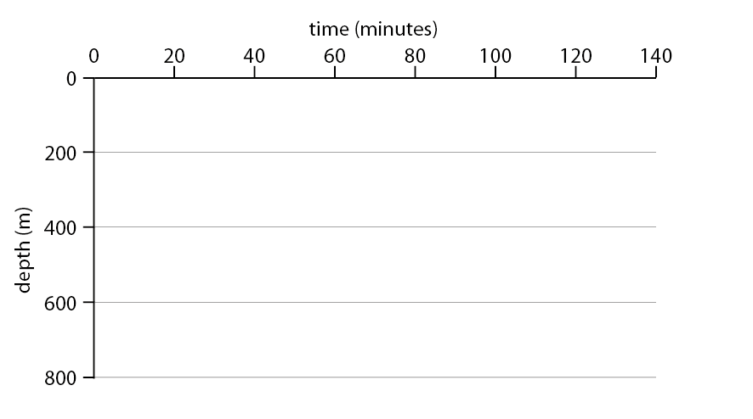
- Which features of the animals did you consider when making your prediction?

Oxygen storage
- Record the oxygen storage capacity of the respiratory system, blood and muscle, for each animal, in the table below.
 | PERCENTAGE OF OXYGEN STORED IN
 | RESPIRATORY SYSTEM | BLOOD | MUSCLE
emperor penguin
Weddell seal
sea otter
elegant sea snake
human freediver

- When air-breathing animals dive they hold their breath, so a large oxygen store is very important. Having big lungs isn’t necessarily the answer to storing oxygen; in fact research shows the lungs of most deep divers are the same size as those of terrestrial animals and that deep-divers do not rely on the respiratory system for oxygen storage.
- Where do Weddell seals and emperor penguins store most of their oxygen, and what might this suggest about the best place to store oxygen in deep diving animals?

Blood composition
- Record body mass, blood volume and haemoglobin (Hb) concentration, for each animal, in the table below. Remember haemoglobin is the oxygen-binding protein of the blood, and is responsible for oxygen transport to the tissues and organs.
 | BODY MASS  (kg) | TOTAL BLOOD VOLUME  (mL kg⁻¹) | Hb CONCENTRATION  (g / 100 mL BLOOD)
emperor penguin
Weddell seal
sea otter
elegant sea snake
human freediver
- Research shows that having a large blood volume is an advantage for diving animals, frequently associated with increased dive times. In this exercise which animal would have an advantage based on their blood volume? Why is large blood volume an advantage?

- Body mass (size of an animal) is known to have a significant impact on various biological processes, including heart rate, metabolic rate and lifespan. Larger animals have lower heart rates and metabolic rates, and longer lifespans than smaller animals. Consider the body mass of featured diving animals. Would body mass influence their diving ability?

Muscle composition
- Record percentage muscle mass and myoglobin (Mb) concentration, for each animal, in the table below.
 | MUSCLE MASS  (% OF BODY MASS) | Mb CONCENTRATION  (g / 100 g WET MUSCLE TISSUE)
emperor penguin
Weddell seal
sea otter
elegant sea snake
human freediver
- The muscle mass of featured diving animals does not vary significantly, but their diving abilities are very different. What might be the reason for this?

- Myoglobin is the oxygen-binding protein of muscles, enabling oxygen storage within them. Suggest how a high myoglobin concentration might affect an animal’s diving ability.

- No data are available for muscle mass and myoglobin levels of elegant sea snakes, but a percentage figure for respiration through skin is supplied (see ‘Oxygen Storage’ screen). Do you think this would be an advantage or disadvantage to sea snakes? Explain your answer.

- Write a brief summary about adaptations of diving animals that increase oxygen storage capacity.

Heart rate
- Record pre-dive, dive and post-dive heart rate, for each animal, in the table below.
 | HEART RATE  PRE-DIVE (bpm) | HEART RATE  DIVE (bpm) | HEART RATE  POST-DIVE (bpm)
emperor penguin
Weddell seal
sea otter
elegant sea snake
human freediver
- Compare the pre-dive heart rate and dive heart rate of all animals. What do you notice about heart rate during the dive phase for all animals? Suggest reasons for any notable changes.

- The post-dive heart rate (immediately after a dive) for most featured animals is higher than the pre-dive heart rate. What might be the reason for this change?

- Resting heart rates of emperor penguins averages 73 bpm. Research shows that prior to diving the heart rate of emperor penguins increases dramatically, up to 180-220 bpm. This increase in pre-dive heart rate is not seen in any other diving animal featured in this exercise. How are emperor penguins different from other diving animals?

Anatomy
- Explore the anatomy of each animal and fill in the table below by writing a brief comment on each structural adaptation. (If the adaptation is not present in an animal leave the space blank.)
 | BODY SHAPE | SKIN | FEET | FLIPPERS | TAIL | SPINE
emperor penguin
Weddell seal
sea otter
elegant sea snake
human freediver
- Comment on any similarities between structural adaptations of each diving animal.

- How might these structural adaptations influence oxygen use during a dive?

Diving behaviour
- Watch the diving animation of each animal. Select REVIEW for more information and record your observations about their dive behaviour in the table below.
DIVE PHASE | DESCENT | TRANSIT | ASCENT
emperor penguin
Weddell seal
sea otter
elegant sea snake
human freediver
- Comment on similarities and differences between diving behaviour of featured animals, including the human freediver.

- Air-breathing, diving animals must take their entire oxygen supply with them when they dive. Using this oxygen efficiently is very important, as making it last longer potentially means they can dive longer. How might diving behaviour of the animals influence oxygen use during a dive?

- Write a brief summary of adaptations of diving animals that help them use their available oxygen stores efficiently.

Who dives deepest and longest?
- Did you make any changes to your original prediction? Comment on why your prediction may have changed.

- Click the reveal button. Were any of the diving depths and times unexpected, and if so why?

- Categorise each adaptation in the table below as structural, physiological or behavioural, and suggest their function.
ADAPTATION | TYPE | FUNCTION
body mass
blood volume
haemoglobin concentration
muscle mass
myoglobin concentration
changes in heart rate
body shape
modified limbs
long transverse processes
permeable skin
gliding

Part 2
Use data collected in part 1 of this worksheet to answer the following questions on diving adaptations of air-breathing animals.
- Construct a graph and plot body mass (in kilograms) and dive time (in minutes) for animals listed in the table below.
ANIMAL | BODY MASS  (kg) | MAXIMUM DIVE TIME (minutes)
Weddell seal | 400 | 82
emperor penguin | 25 | 23
sea otter | 28 | 4
human | 70 | 4
northern elephant seal | 400 | 119
hooded seal | 350 | 52
grey seal | 240 | 23

- Many whales have a large body mass and are able to dive for lengthy periods. Sperm whales, which have a mass of about 10 000 kg, have a maximum recorded dive time of 138 minutes. Is there a trend between body mass and dive duration? Explain why.

- Construct a graph and plot percentage oxygen storage in the respiratory system, and dive time (in minutes), for animals listed in the table below.
ANIMAL | OXYGEN STORAGE LUNGS  % | MAXIMUM DIVE TIME  (minutes)
Weddell seal | 5 | 82
emperor penguin | 19 | 23
sea otter | 55 | 4
human | 36 | 4
sperm whale | 4 | 138
bottlenose dolphin | 34 | 8
northern elephant seal | 4 | 119

- Does the graph reveal a trend between oxygen storage in the lungs and dive duration? Explain why.

- Construct a graph and plot total blood volume (in millilitres per kilogram) and dive time (in minutes) for animals listed in the table below.
ANIMAL | BLOOD VOLUME  (ml / kg) | MAXIMUM DIVE TIME (minutes)
Weddell seal | 210 | 82
emperor penguin | 100 | 23
sea otter | 91 | 4
human | 75 | 4
sperm whale | 200 | 138
hooded seal | 106 | 52
bottlenose dolphin | 71 | 8
Northern elephant seal | 216 | 119
- Does the graph reveal a trend between total blood volume and dive duration? Explain why.

- Why do you think elegant sea snakes were excluded from the graphing activity? How might the graphs be affected if these data were included?

- Weddell seals are the deepest diver of featured animals. List physiological adaptations, and their function, that enable it to reach such depths.

- Elegant sea snakes dive for the longest period of time, of featured animals. Which adaptation do you think is most important for sea snakes?

