# Part 1: Freediving

Freediving is an extreme sport, involving diving to depth on a single breath. There are different disciplines, for example: diving with weights or fins, being towed underwater by sled, and breath-hold at the surface.

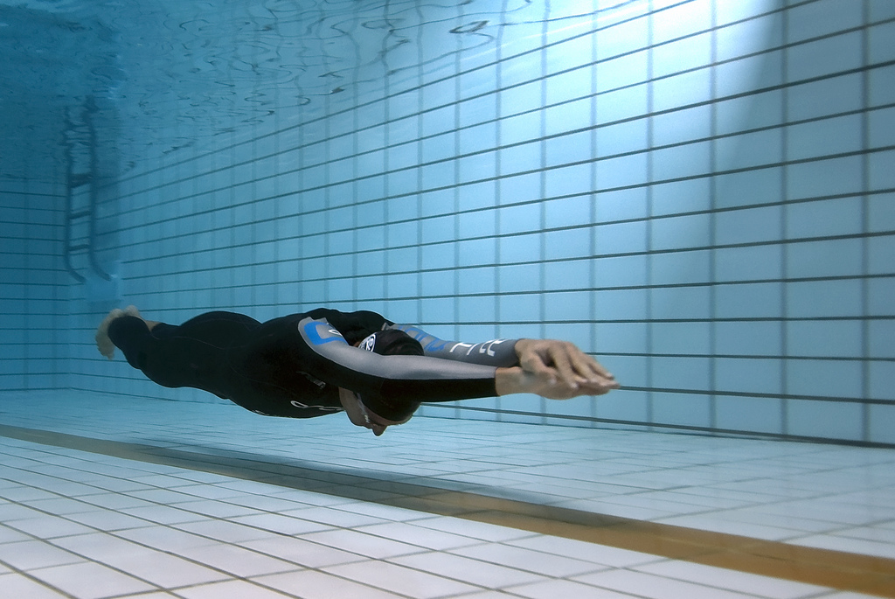

figure 1: William Trubridge underwater glide, photo by Jayhem

Champion freediver, William Trubridge, holds the world record in the freediving discipline ‘constant weight without fins’ of 101 m. This means he dives without weights and without fins — with no assistance. Trubridge completed his record dive in 4 minutes and 8 seconds. That’s a long time, and a deep dive, on a single breath.

To put it in perspective, depth limit for recreational scuba divers is 30 m, and most who snorkel make it to less than 10 m. Of course, scuba divers have a tank of oxygen: they don’t have to hold their breath.

* Watch the video of William Trubridge’s freedive to 88 m, then answer the following questions.

1. What specialised diving adaptations do freedivers have? Are there other factors that could be responsible for their underwater feats?

* Acclimatisation refers to the process of individuals responding to changes in their external or internal environment, such as temperature, altitude or an increased exercise program. Responses may occur in a short period of time (days or weeks), but are not passed on to the next generation.

1. List some examples of humans acclimatising to their environment.

* Watch the freediving video again, then answer the following questions about the freediver’s swimming style.

1. During the dive’s descent phase, the freediver stops active swimming and appears to be sinking toward the bottom. Explain what you think might be happening?

1. 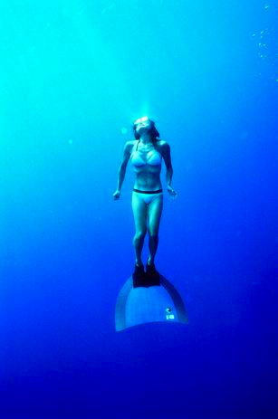The freediver maintains a slow and measured swimming pace during ascent and descent. Why is this important?

*figure 2: Freediver with monofin, photo by aquaxel*

1. What do you notice about shape or posture of the diver’s body, during the dive?

* Freedivers are elite athletes; they achieve these incredible diving depths through hard work, dedication, and lots of training. Most freedivers spend hours training each day. Some techniques they use include: cardiac fitness; weights; exercises to strengthen the chest; yoga; and meditation.

1. What might benefits of meditation and yoga be for a freediver?

There are many risks for professional freedivers associated with enormous changes in pressure and prolonged periods without oxygen. Both can have serious consequences and may result in death. You definitely shouldn’t try anything like this at home!

# Part 2: The problem with pressure

At sea level, pressure of the surrounding air is 1 atmosphere (atm), but underwater pressure increases by 1 atm every 10 m. This means that external pressure at a depth of 10 m is 2 atms. The deeper you dive underwater, the greater the water pressure around you.

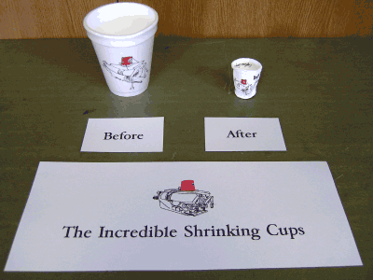

figure 3: This is what happens to a styrofoam cup taken 300–400 m underwater.  
Styrofoam is a hydrocarbon polymer made up of 95 % air.  
photo by Captain Gary Chiljean **©** Nautical Vows

As water pressure increases it squeezes or compresses air-filled spaces — this is what happened to the styrofoam cup. Under pressure, all compressible spaces shrink in size, because external pressure is greater than internal pressure.

Some tissues in the human body have air spaces, which means they too are compressible under increased water pressure.

1. List structures of the human body that have air spaces.

For human divers, differences in pressure between the external environment and air spaces within their internal structures increase risks of barotrauma, or damage to tissues due to compression and distortion.

# Types of barotrauma

|  |  |
| --- | --- |
| **Ear and sinus barotrauma** | **Pulmonary barotrauma** |
| The human body’s middle ear and sinus passages contain air. Under pressure this air compresses, resulting in pain, and in severe cases damage to sinuses and rupture of the eardrum. Divers must equalise pressure in the middle ear and sinuses prior to a dive, and throughout a dive, as external pressure changes. | For freedivers, risk of pulmonary barotrauma is greatest during descent, as air in their lungs is continually compressed at increasing depth. As human lungs compress, capillaries distend and fill with blood plasma. If these blood capillaries distend excessively they will rupture and divers will suffer lung haemorrhage.  For scuba divers the risk of pulmonary barotrauma is greatest during ascent, because volume increases as pressure decreases. Air trapped in a diver’s lungs expands upon ascent which can cause lungs to overinflate. Divers must exhale during ascent; holding breath can result in excessive pulmonary pressures and serious injuries to lungs. |

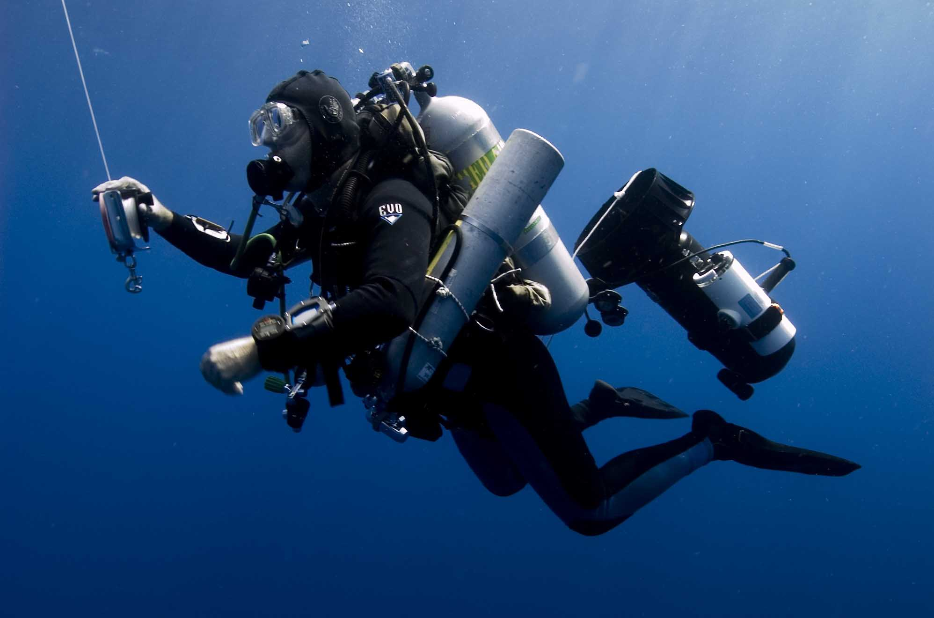

figure 4: Diving archaeologist descending. Photo by Tane Casserley **©** NOAA/MONITOR NMS

1. Freedivers use training techniques to overinflate their lungs before descent. How would these techniques minimise the risk of pulmonary barotrauma?

**Gas change under pressure: decompression sickness**

Decompression sickness, or the bends, results from changes that occur to gases under pressure that result in nitrogen bubbles forming in the blood stream.

Air is composed of 78% nitrogen and 21% oxygen with argon, carbon dioxide and water vapour making up the remaining 1%. As pressure increases, nitrogen diffuses from air in the lungs into solution in blood and tissues. Usually our bodies can clear this nitrogen naturally, through our lungs.

For freedivers, repeated dives without allowing sufficient time for clearing of nitrogen can result in saturation. Similarly for scuba divers, very long dives or breathing compressed air can lead to large amounts of dissolved nitrogen accumulating in their bodies.

:Graphics:Figure3.ai

*figure 5: An increase in pressure leads to the more gas dissolving in solution.*

If a diver ascends too quickly external pressure decreases sharply, nitrogen bubbles come out of solution, and may lodge in blood vessels, tissues and nerves resulting in decompression sickness. Symptoms include joint pain, rashes, neurological problems, chest pain and problems with balance. Decompression sickness can be fatal if untreated.

Sea otters have large lungs, which carry around 55% of their air supply. Their lung walls are reinforced with a combination of cartilage and muscle, which allows gas to be displaced from pulmonary capillary blood during lung compression.

1. Would a freediver be at risk of the bends?

**Gas change under pressure: nitrogen narcosis**

Another problem with nitrogen is its anaesthetising effect under high pressure which leads to a condition referred to as ‘rapture of the deep’, where increased amounts of nitrogen dissolved in the body lead to feelings of euphoria, disorientation, and lapses of concentration. For both freedivers and scuba divers this poses a serious risk, and is a reason why professionals never dive alone.

Sea snakes dive for lengthy periods and ascend to the surface at rapid speed yet show no signs of decompression sickness. Scientists theorise sea snakes avoid decompression sickness by offloading excess nitrogen through their permeable skin.

1. What preventative or safety measures did the freediver in the video take to avoid conditions like nitrogen narcosis?

# Part III: Diving animals

Air-breathing, diving animals don’t suffer the same problems as human divers, avoiding conditions like barotraumas, the bends, and nitrogen narcosis, through specialised adaptations.

Investigate these adaptations by taking a dive with a Weddell seal (see figure 6).

1. Complete the table below by indicating what adaptation enables the Weddell seal to avoid the diving-related condition. Indicate in your answer the type of each adaptation (structural, physiological or behavioural). (Hint: There may be more than one adaptation for each condition.)

|  |  |  |
| --- | --- | --- |
| CONDITION | ADAPTATION | TYPE |
| middle ear barotrauma |  |  |
| pulmonary barotrauma |  |  |
| decompression sickness |  |  |
| nitrogen narcosis |  |  |

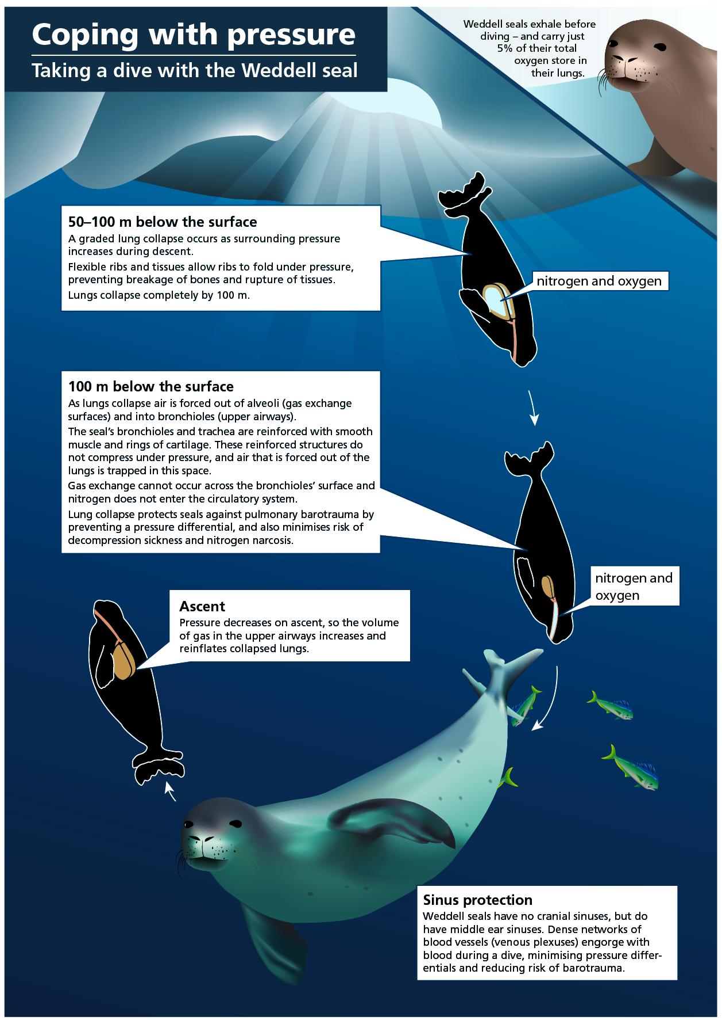

*figure 6: diving with Weddell seals*

* Cuvier’s beaked whale, a deep-diving species, has similar adaptations to the Weddell seal providing protection against pressure related injury. In 2002 a group of beached Cuvier’s beaked whales were found to have symptoms of decompression sickness. This beaching event was linked to military sonar in the area. Researchers are investigating if sonar may cause whales to alter their usual diving patterns. By engaging in repeated shallow dives (< 80 m) this species could be at risk of decompression sickness.

1. Why might repeated shallow dives increase the risk of decompression sickness in Cuvier’s beaked whale?

1. What do you conclude about risks of diving for air-breathing animals, compared to risks for humans? Reflect on adaptations in your answer.

1. Research shows deep-diving animals do not rely on their respiratory system as the major oxygen store. Instead most oxygen is stored in blood and muscles. Why is the respiratory system not a great place to store oxygen for deep-diving animals?