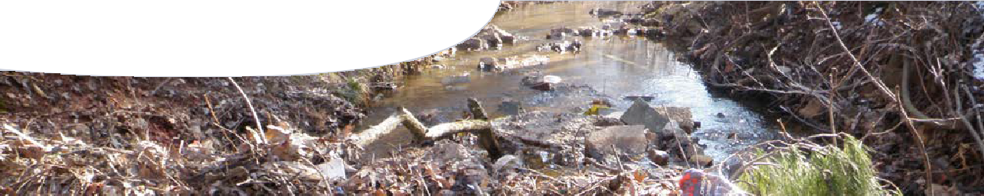
worksheet
Water quality 3

What do you think might happen to water quality in each of the following situations?
Complete mind maps to show how physical, chemical and biological characteristics of water quality might be affected.

Use symbols to indicate changes to water quality measurments:
+ measurement increases
− measurement decreases
= measurement doesn’t change

Use arrows ( ) to show how a change to one water quality characteristic impacts others. To get you started a sample mind map is provided below.

Sample scenario: acid chemical spill contaminates lake
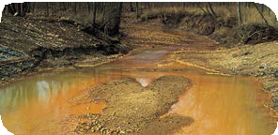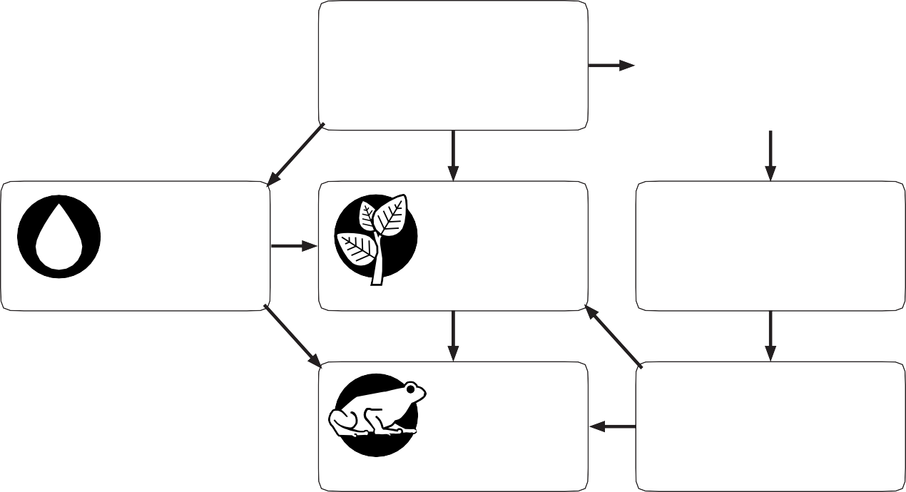
+
turbidity
✓
PH
balance
−
−
+
pH vegetation temperature
−
oxygen
15.999
O
8
−
animals
dissolved oxygen

Scenario 1

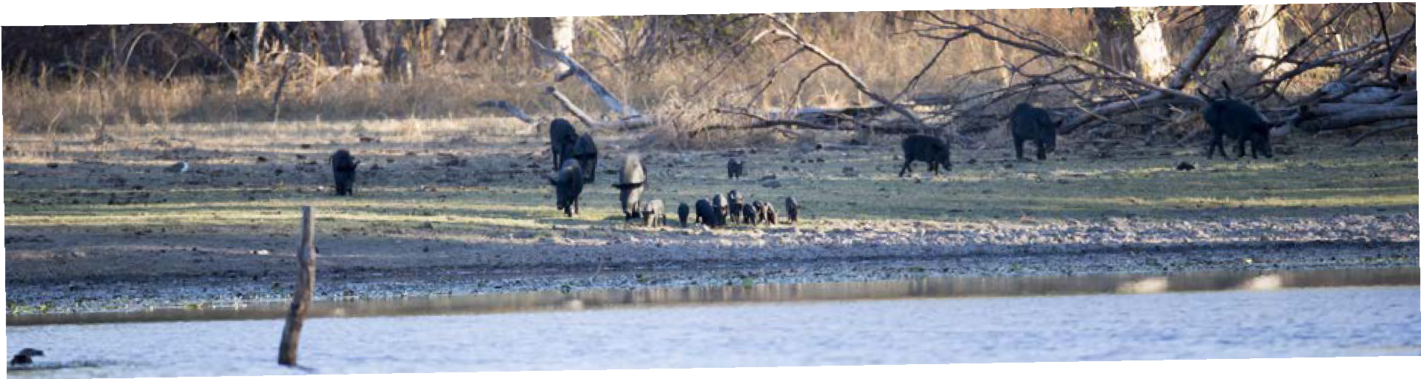Complete the mind map to show how feral animals, such as donkeys, pigs and horses, affect water quality.
Drought conditions in the Australian interior have forced large numbers of thirsty feral animals to congregate around shrinking waterholes.
Feral animals destroy waterholes

Scenario 1: feral animals damage waterhole

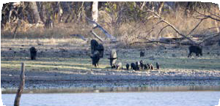

E. coli

turbidity

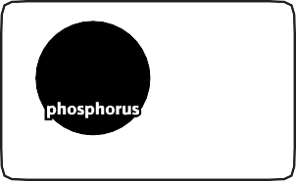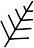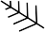
P
30.974
nutrients
15

vegetation

temperature

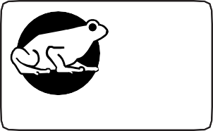

animals
8
oxygen
15.999

dissolved oxygen
O

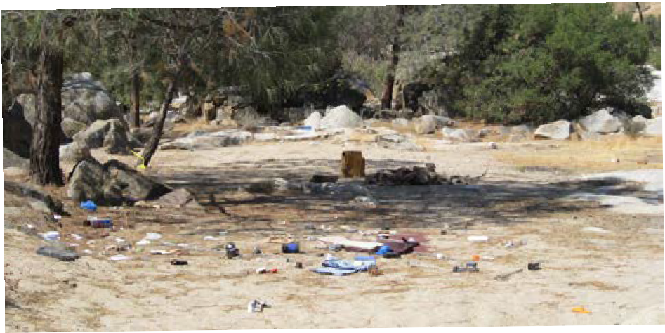Scenario 2
Campers leave
litter behind
They might enjoy the great outdoors but some visitors aren’t doing the right thing around water bodies.

Complete the mind map to show how leisure activity, such as camping, affects water quality.

Scenario 2: campers leave litter behind

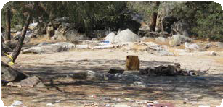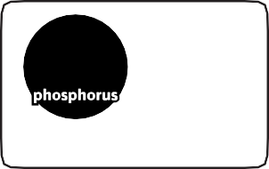

E. coli
P
30.974
nutrients
15

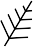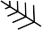

✓
PH
balance

pH

vegetation

temperature

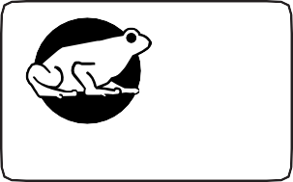

animals
8
oxygen
15.999

dissolved oxygen
O

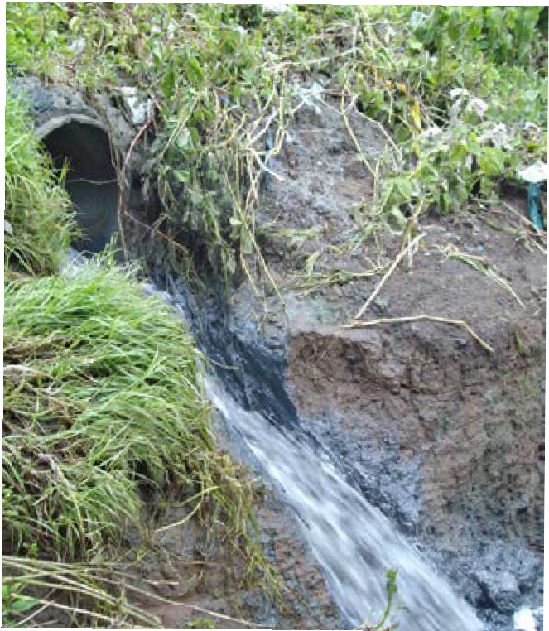Scenario 3
Sewage spill contaminates river
Residents have been warned to stay out of the local river after thousands of litres of raw sewage leaked into the water.

Complete the mind map to show how contamination, such as leaking sewage, affects water quality.

Scenario 3: sewage contaminates local river

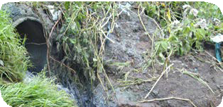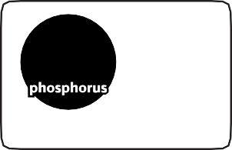

E. coli
P
30.974
15
nutrients

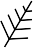

✓
PH
balance

pH

vegetation

turbidity

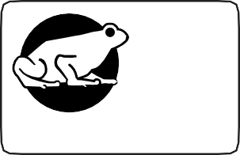

animals
8
oxygen
15.999

dissolved oxygen
O

temperature

