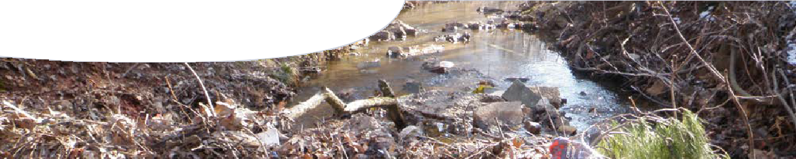
worksheet
Water quality 1

Think about impacts upon water quality of the three scenarios presented in this worksheet. How might physical, chemical and biological characteristics of water quality be affected?
Represent impacts of each scenario with a mind map that displays interactions between water quality characteristics.
Use ‘+’, ‘-’ and ‘=’ symbols to show which characteristics increase, decrease or stay the same. Use arrows to show how changes in one characteristic affect others.

Sample scenario: acid chemical spill contaminates lake

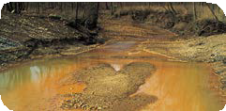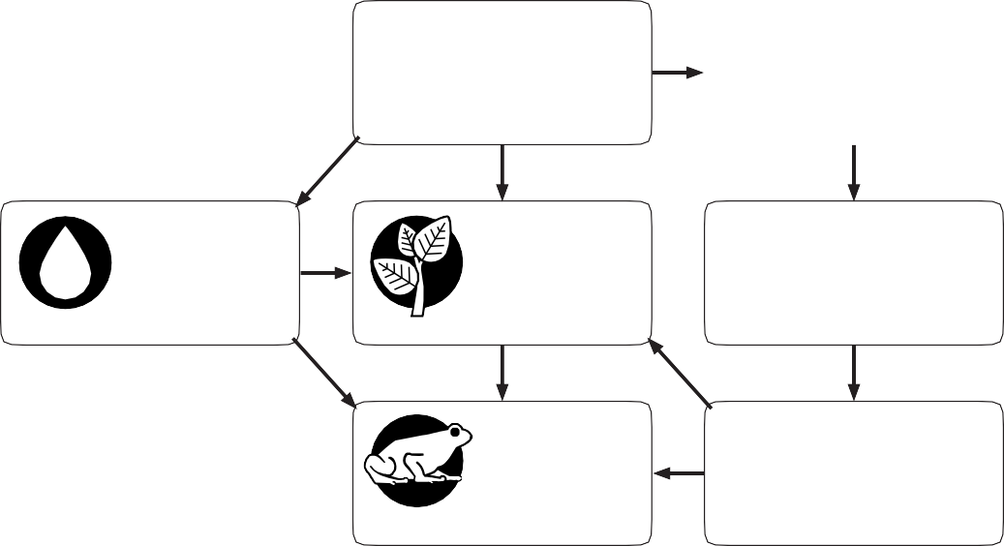Include any or all of the water quality characteristics below in your mind map.
+
turbidity
✓
PH
balance
−
−
+
pH vegetation temperature
−
oxygen
15.999
O
8
−
animals
dissolved oxygen

PHYSICAL CHARACTERISTICS

temperature turbidity

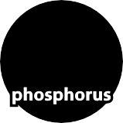CHEMICAL CHARACTERISTICS
pH
salinity
dissolved oxygen
PH
balance

nutrients
✓
8
O
oxygen
15.999
7
N
nitrogen
14.007
15
P
30.974

BIOLOGICAL CHARACTERISTICS

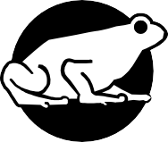
E.coli vegetation animals

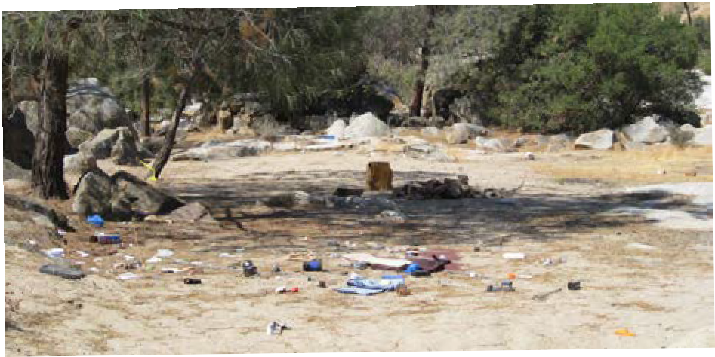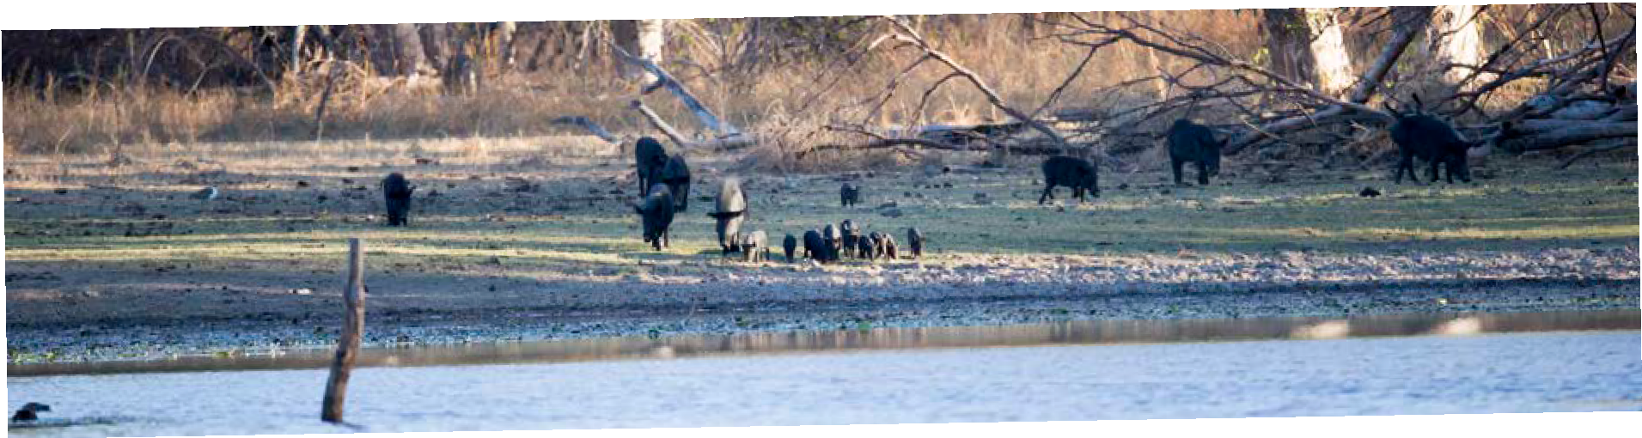Scenario 1
Scenario 2
compete
with
is left, they
also
urinate and defecate in the water, and they’re coming in such large numbers they destroy the banks and trample vegetation.’
horses
Feral donkeys,
and
native animals, who also rely on these water sources for survival,’ ranger Pete Barker said.
Australia
precious
Western
destroying
conditions northern
Drought
animals
parts
of
numbers
of
in some
The large
problem,
surrounds
another
waterhole
Pigs
are
damaging
around
in the
seriously
to aggregate
sources
of animals
from limited
sedimentation.
and are
erosion
dying,
also
Animals
areas
is
water
in these
‘The
land managers
leaving
water holes,
dwindling
are dismayed these animals
park rangers
and
carcasses
that
rotting
behind
and bacteria
the damage
nutrients
by
levels
of
Sturgeon
worried.
excessive,’ ‘We’re
Jerry
really
said.
aren’t
just
animals
says,
they
‘Feral
Sturgeon,
Farmer,
Jerry
We’re waiting for rain.’
polluting what little water there
and donkeys
‘The horses
chemical residues.
All of these litter items, and more, have a negative impact on water quality.
Kelly Bastian says, ‘Litter can alter the water’s pH, and human waste increases the levels of nutrients and bacteria in the water. We don’t want to end up with a
situation where we’re forced to close waterholes due to a
risk to people’s health.’

Drought conditions in the Australian interior have forced large numbers of thirsty feral animals to congregate around shrinking waterholes.
Feral animals destroy waterholes
in outback have been waterholes.
pigs,
Australia have forced large herds
forced to get what water they can
scarce
region.
water
supplies
as they dig for food, increasing
impacts on water quality.
Agriculturalists,
becoming trapped in mud around
becoming undrinkable, even for livestock. It’s muddy, warm, and
have caused local water bodies.
contaminate the water supply.
are

Campers leave litter behind
Local rangers have been dismayed by the poor behaviour of leisure seekers around local waterholes.
‘They camp too close to the water edges, and they leave litter and toilet waste on the banks. These items often end up in the water,’ ranger Kelly Bastian commented.
Some of the items rangers have discovered in water bodies include discarded fishing tackle, leaking fuel cans, used nappies, along with detergent and other

They might enjoy the great outdoors but some visitors aren’t doing the right thing around water bodies.
Rangers and concerned community members are meeting today to decide the best way forward. Local community spokesperson, Fran Boldy says, ‘We all want to enjoy these recreational places, but the poor behaviour of a few could change that for many. Educating the people that do visit them is key.’

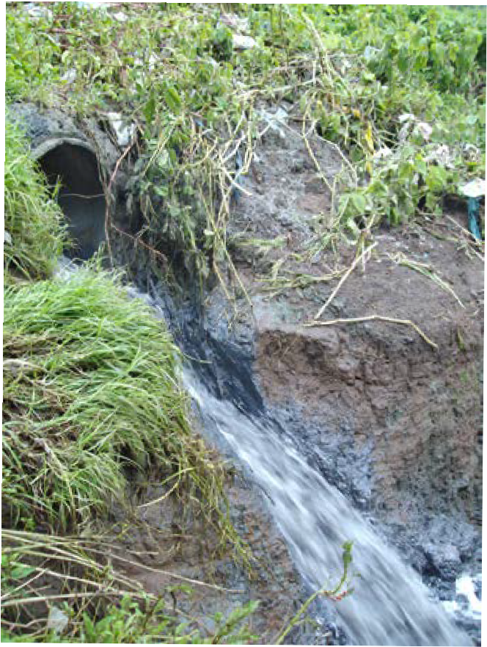Scenario 3
Sewage spill contaminates river
Warning signs have been erected along a 1-kilometre stretch of the Madder River after a local waste treatment plant discovered raw sewage was leaking directly into the water body. Residents are being urged to stay away.
Local Mayor, Sharon Dunstan said, ‘People should not enter the river to swim, and they definitely must not drink water from within the vicinity of the leak.’
Water department staff is on site to monitor the impacts of the leak and to work with the local authority on waste management to discuss the best possible solution to the problem.
Raw sewage is currently no longer leaking into the Madder but due to sluggish currents and poor rains the sewage may take longer than usual to disperse.
Water department spokesman, Lionel Stern said, ‘We’re monitoring the situation very closely. Untreated sewage poses a real risk to people because of increases in bacteria.’

Residents have been warned to stay out of the local river after thousands of litres of raw sewage leaked into the water.
As well as being a risk to human health river pollution can lead to algal blooms due to an increase in nutrients. Only two years ago the Madder was site of a spectacular algal bloom that resulted in widespread fish deaths, and extensive damage to local vegetation.

