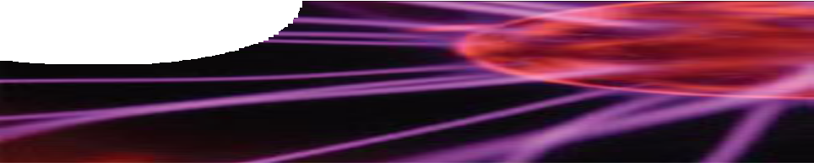
fact sheet
The Large Hadron Collider

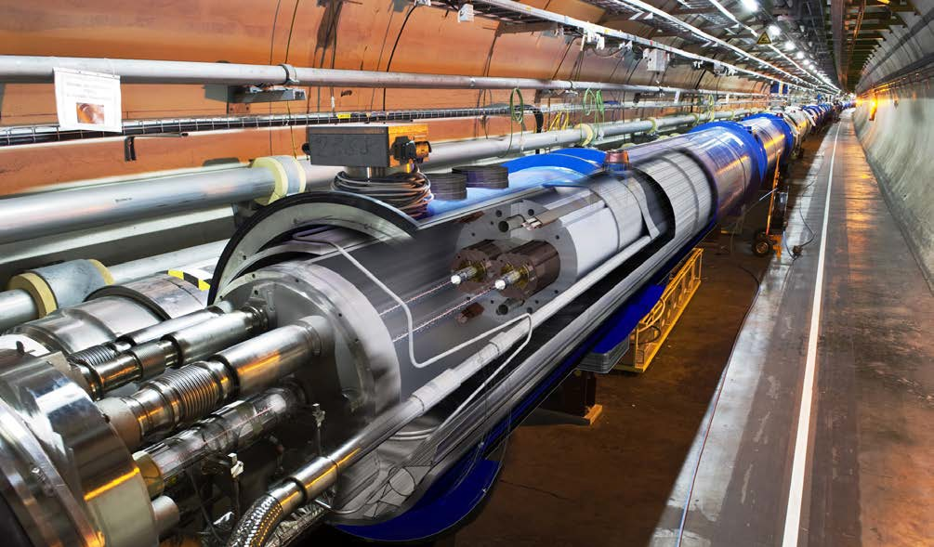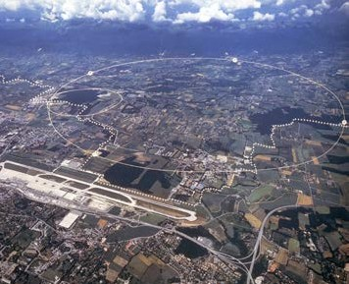More than 10 000 scientists and engineers were involved in its design and construction. Most of the complex is buried between 50 and 175 m underground on the border of France and Switzerland, near Geneva.
© CERN
Scientists designed the Large Hadron Collider to enable them to probe deeper into the atom and gain greater understanding about the structure of matter.
© CERN
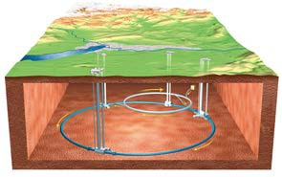
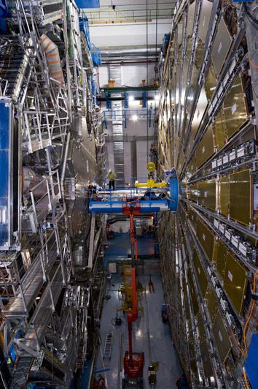
Our current knowledge about matter is summarised in the ‘standard model’ of particle physics. This model, developed in the early 1970s, has been used successfully to explain many experimental results and predict a wide range of phenomena. However, physicists recognise that our knowledge is not yet complete.
The LHC will equip them in the search for answers to some of the remaining mysteries.

What is the Large Hadron Collider?
The LHC is the world’s largest and most powerful particle accelerator.
It consists of two circular vacuum chambers (pipes), 27 km in circumference, in which particles are accelerated almost to the speed of light.
Particles travel through ultra-high vacuum chambers, guided by strong magnetic fields provided by superconducting electromagnets.
The electromagnets are made using special cables that conduct electricity with zero energy loss. To maintain super-conductivity the magnets are cooled to -271.3 °C (1.9 K) using liquid helium. Particles travel in opposite directions in separate beam pipes before being forced together in large detectors where collisions are observed.
© CERN

fact sheet
The Large Hadron Collider

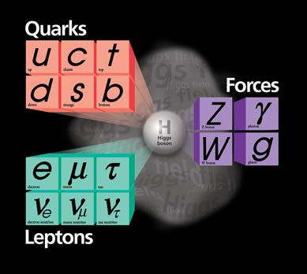What are hadrons?
The standard model of particle physics
Hadrons are sub-atomic particles made up of quarks held together by strong forces. Protons and neutrons are hadrons composed of two different types of quark called ‘up’ and ‘down’. ‘Up’ quarks have a charge of +⅔ and ‘down’ quarks have a charge of -⅓.
© Fermi National Accelerator Laboratory
- Protons consist of three quarks (up, up and down) giving an overall charge of +1.
- Neutrons are also made up of three quarks (up, down and down) giving them zero charge.
- Mesons are also hadrons, but they are made up of one quark and one antiquark.

What happens when hadrons collide?
At maximum power, protons race around the LHC accelerator ring 11 245 times per second, travelling at 99.99% the speed of light before colliding with a similar beam travelling in the opposite direction. Physicists expect to create around 600 million collisions every second.
Particle collisions release massive amounts of energy, some of which is carried away by fragments of the original particles, and some is converted to mass according to Einstein’s equation, E = mc2.
Detectors record and produce images of particle collisions enabling physicists to determine the identity of particles from evidence about their speed, mass and electric charge.

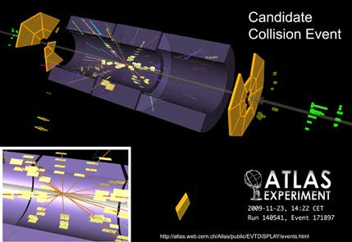
Record of a particle collision in the Atlas experiment
© CERN

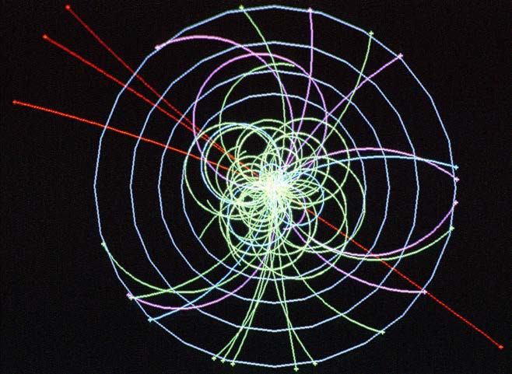
The question of mass
Newton’s Law of Universal Gravitation describes the force between masses and explains phenomena such as: why objects fall to the ground; why the Moon stays in orbit around Earth; and why the Earth orbits the Sun. However, it doesn’t tell us what mass really is; why particles have mass; or why some particles have no mass.
In fact, physicists today still can’t answer these questions! The most promising explanation is that the ‘Higgs field’ is responsible for giving particles their mass. The Higgs boson is an essential part of the standard model and shows the existence of the Higgs field. In 2012 LHC researchers announced the discovery of the Higgs boson with a mass of 125 GeV/c2.
© CERN

Simulated data of a decay path of a Higgs boson produced by the collision of two protons

Sources of more information on the Large Hadron Collider
- CERN European Organisation for Nuclear Research, http://public.web.cern.ch/public/en/LHC/Facts-en.html
- Brian Cox: CERN’s supercollider, http://www.ted.com/talks/lang/eng/brian_cox_on_cern_s_supercollider.html
- Brian Cox: What went wrong at the LHC, http://www.ted.com/talks/lang/eng/brian_cox_what_went_wrong_at_the_lhc.html

