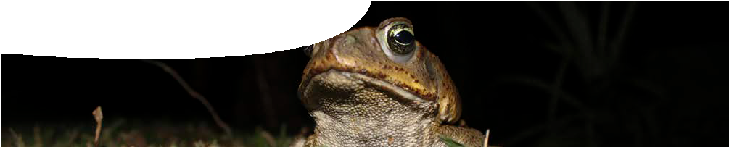
teacher guide
Feeding relationships 5:
Managing cane toads

Components

 | NAME DESCRIPTION AUDIENCE
 | Managing cane toads  teacher guide | This guide outlines a ‘dilemma’ approach for students to debate five suggestions for controlling an introduced species. | teachers
 | Cane toad control  fact sheets | This fact sheet contains information about five different methods of dealing with cane toads. | students

Purpose
To examine and debate five suggested solutions to the cane toad problem that are currently being trialled in Australia.

Activity summary
Outcomes
Students:
- understand that the introduction of a new species in an area affects existing organisms;
- appreciate that a range of methods are available to try to control the spread of a pest species;
- realise that science is an on-going endeavour;
- value and understand different people’s perspectives;
- make judgements about five different suggestions for solving the cane toad problem; and
- understand that animals must be treated humanely.

ACTIVITY POSSIBLE STRATEGY
Ask students to make suggestions of ways to deal with cane toads. | whole class
Explain to the class that they will debate how to deal with cane toads, as explained in Teacher notes. | whole class
Divide students into small groups. Give each group a fact sheet, from Cane toad control, that outlines one method of dealing with cane toads. Groups read and discuss their fact sheet. | small groups
Bring the class back together to debate, as outlined in Teacher notes. | whole class

Technical requirements
The teachers guide and fact sheets require Adobe Reader (version 5 or later), which is a free download from www.adobe.com.

Teacher notes

Introduce the debate
- Cane toads have crossed the Western Australian border. They eat native wildlife; they poison animals that try to eat them; and they compete with other native animals for food. The toads have potential
to change the native ecosystem of the Kimberley, forever. So, what should we do about them?
- Many different solutions for dealing with the cane toad invasion have been suggested. In this activity we are going to debate five of them.

Structure of the debate
- Hold a class council meeting to debate what you should do about cane toads, which are fast approaching your town in the Kimberley.
- Nominate one class member as mayor, to run the meeting.
- Appoint some class members as councillors.
- Form remaining students into small groups.
- Distribute a different solution outlined on the fact sheets, Cane toad control, to each group.
- Give students preparation time to read their sheet and discuss it in groups.
- Councillors may use preparation time to explore and discuss all options that groups receive, so they may point out problems with each, as it’s discussed during the meeting.
- Then, each group, in turn, describes their solution to the council meeting and explains why it’s the best option. For the purpose of this debate, it doesn’t matter if you think it’s a good idea or not. Your group is presenting the affirmative point of view.
- After your presentation, councillors and other group members present the negative side by asking questions and pointing out problems with the idea.
- Once each group has had a turn to explain their solution, and discussion has finished, councillors will vote to decide the best solution.

Image credits
banner image: ‘Cane toad’ by Brian Gratwicke, CC-BY-2.0, commons.wikimedia.org/wiki/File:Cane_toad.jpg

Acknowledgements
Thanks to Kimberley Toad Busters, Corrin Everett (Program Leader State Cane Toad Initiative, Dept Environment and Conservation), Staff and students from Kununurra District High School, Dr Munish Meta, (Bioinformatics Officer, Cane Toad Genome Project, Western Australian Institute for Medical Research).
Designed and developed by the Centre for Learning Technology, The University of Western Australia.
Production team: Anton Ball, Pauline Charman, Alwyn Evans, Jenny Gull, Sally Harban, Dan Hutton, Emma Pointon, Paul Ricketts, Jodie Ween and Michael Wheatley, with thanks to Bob Fitzpatrick and Wendy Sanderson.

SPICE resources and copyright
SPICE resources and copyright All SPICE resources are available from the Centre for Learning Technology at The University of Western Australia (‘UWA’). Selected SPICE resources are available through the websites of Australian State and Territory Education Authorities.
Copyright of SPICE Resources belongs to The University of Western Australia unless otherwise indicated.
Teachers and students at Australian and New Zealand schools are granted permission to reproduce, edit, recompile and include in derivative works the resources subject to conditions detailed at spice.wa.edu.au/usage.

Associated SPICE resources

All questions involving copyright and use should be directed to SPICE at UWA.
Web: spice.wa.edu.au Email: spice@uwa.edu.au Phone: (08) 6488 3917
Centre for Learning Technology (M016) The University of Western Australia
35 Stirling Highway
Crawley WA 6009

Feeding relationships 5: Managing cane toads may be used in conjunction with related SPICE resources to address the broader topic of food chains and webs.

DESCRIPTION LEARNING PURPOSE
Feeding relationships (overview)
This learning pathway shows how a number of SPICE resources can be combined to teach the topic of food chains and webs.
Feeding relationships 1: Animal interactions  Students watch a video designed to engage students and provoke questions about animal feeding relationships and introduced species. Students then read a book extract, raising further discussion about cane toads and their impacts. | Engage
Feeding relationships 2: Predators and prey  Students explore concepts of feeding relationships and food chains by competing against each other in three activities: a quiz about what animals eat; a card game; and an outdoor role-play game. | Explore
Feeding relationships 3: Food webs  Food webs are explained in a student fact sheet. Students use an iPad app or a cut-and- paste activity to create a food web that shows feeding relationships between animals in the Kimberley. Students introduce cane toads into their web to examine effects on other species in the ecosystem. They answer questions on an accompanying worksheet to check understanding. | Explain
Feeding relationships 4: Impact of cane toads  This resource elaborates the topic of introduced species. Students watch video clips of people living in the Kimberley describing impacts of cane toads. An accompanying worksheet probes students’ understanding. | Elaborate
Feeding relationships 5: Managing cane toads  This resource extends and applies students’ understanding of cane toads as an example of impacts caused by introduced species. Students suggest ways to solve the cane toad problem; read fact sheets that include up-to-date science research; and participate in a class debate to determine the best solution. They need to develop a persuasive argument that considers ethics, cost and viability of their option. | Elaborate
Feeding relationships 6: Kimberley creations  This resource encourages students to employ techniques used in Aboriginal art to make their own symbolic representation of feeding relationships in an environment of their choice. | Elaborate

