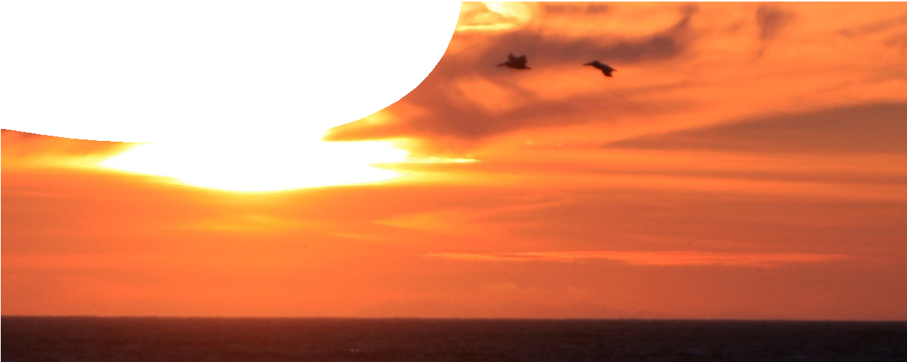
teacher guide
Life in the Solar System 3:
Planetary atmospheres

Components

 | NAME | DESCRIPTION | AUDIENCE
 | Planetary atmospheres  teacher guide | The guide provides information on how to use the learning object in this resource. | teachers
 | Atmospheric explorer  learning object | Students interact with the learning object to compare the atmospheric conditions of selected astronomical bodies. | students
 | Planetary atmospheres  worksheet | This detailed worksheet leads students through an activity. | students

Purpose
To Explain the similarities and differences in atmospheric composition of a selected number of bodies in the Solar System.

Activity summary
Outcomes
Students will be able to:
- describe the similarities and differences in the surface conditions of a number of bodies in the Solar System;
- explain that planetary atmospheres change over time; and
- explain the significance of the change in Earth’s atmosphere over time, and the possibility that life may exist on other planets.

ACTIVITY | POSSIBLE STRATEGY
Students use the learning object, Atmospheric explorer, to compare atmospheric characteristics of Mercury, Venus, Earth, Mars, Io and Titan while responding to questions posed in the worksheet. | individually or in pairs
Discuss with students the worksheet, additional questions and points from this guide. | teacher-led whole group

Technical requirements
The learning object requires Adobe Flash Player version 8 or later (this is a free download from www. adobe.com). It can be placed on a web or file-server and run either locally or remotely in a web browser.
The guide and worksheets require Adobe Reader which is a free download from www.adobe.com. The worksheets are also provided in Microsoft Word format.

Associated SPICE resources
Life in the Solar System 3: Planetary atmospheres may be used in conjunction with related SPICE resources.

DESCRIPTION | LEARNING PURPOSE
Life in the Solar System
This learning pathway combines a number of SPICE resources to address the topic of the search for life in the Solar System.
Life in the Solar System 1: Conditions for life  A presentation challenges students to think about where life is found. | Engage
Life in the Solar System 2: Exploring environments  Students explore different environments to compare surface conditions and abundance of life. | Explore
Life in the Solar System 3: Planetary atmospheres  Students compare atmospheric conditions on various bodies in the Solar System. | Explain
Life in the Solar System 4: Life under extreme conditions  Life exists in extreme environments on Earth, which suggests that it may also be found in unknown environments in space. | Elaborate

Acknowledgements
Designed and developed by the Centre for Learning Technology, The University of Western Australia.
Production team: Leanne Bartoll, Alwyn Evans, Bob Fitzpatrick, Trevor Hutchison, Paul Luckas, Paul Ricketts, Jodie Ween and Michael Wheatley, with thanks to Roger Dickinson, Jenny Gull and Wendy Sanderson.

SPICE resources and copyright
All SPICE resources are available from the Centre for Learning Technology at The University of Western Australia (“UWA”). Selected SPICE resources are available through the websites of Australian State and Territory Education Authorities.
Copyright of SPICE Resources belongs to The University of Western Australia unless otherwise indicated.
Teachers and students at Australian schools are granted permission to reproduce, edit, recompile and include in derivative works the resources subject to conditions detailed at spice.wa.edu.au/usage.
All questions involving copyright and use should be directed to SPICE at UWA.
Web: spice.wa.edu.au Email: spice@uwa.edu.au Phone: (08) 6488 3917

Centre for Learning Technology (M016) The University of Western Australia
35 Stirling Highway
Crawley WA 6009

