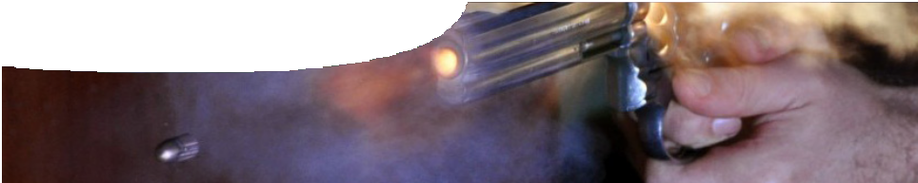
teachers guide
Atoms and elements 1:
Elementary forensics

Components

 | NAME | DESCRIPTION | AUDIENCE
 | Elementary forensics  teachers guide | This guide explains how to use a video to engage student interest in atoms and elements, through the context of ballistics. | teachers
 | Fingerprinting bullets  video | This video introduces concepts of atoms and elements by exploring ballistics research at The University of Western Australia that uses trace metal analysis, based on element mass. | students
 | What is ICP-MS?  background sheet | This background sheet explains how inductively coupled plasma mass spectrometry works. This is the process used in the video to analyse bullets. | teachers

Purpose
To Engage student interest in atoms and elements, by recognising how knowledge of elements can help solve crimes.

Activity summary
Outcomes
Students:
- understand that everything is made up of different elements;
- understand that atoms of different elements have different masses;
- see how scientists separate different elements based on their mass; and
- understand that scientists use scientific knowledge as a basis for research.

ACTIVITY | POSSIBLE STRATEGY
Students watch the video, Fingerprinting bullets. | whole class
Discuss the video. See Teacher notes below for key questions. | whole class

Technical requirements
The teachers guide requires Adobe Reader (version 5 or later), which is a free download from www.adobe. com.
QuickTime version 7 or later is required to view the video. This is a free download from www.apple.com/ quicktime. A high quality MP4 version of the video with subtitles is available on CD-ROM or download from the SPICE website.

Teacher notes
Information about the analytical technique Anna uses to fingerprint bullets (inductively coupled plasma – mass spectrometry) is included in the background sheet, What is ICP-MS?
Questions below may be used to promote class discussion after watching the video, Fingerprinting bullets.

DISCUSSION POINT | SUGGESTED RESPONSE
What physical characteristics can be used to distinguish bullets? | size, shape, colour, rifling marks
Why can’t bullets always be distinguished using physical characteristics? | Some bullets are fragmented when they hit an object.  Rifling marks can only be used when scientists have the gun.  Shotgun pellets don’t have rifling marks.  Bullets are often very similar in size, shape and colour.
Why do different bullets contain different trace elements? | Bullets are often made from scrap metal and scraps used vary between batches.
What is the advantage of using a laser in Anna’s research? | Only a tiny sample of bullet is needed for testing.
What property of elements in bullets allows them to be sorted? | Different elements have different masses.
Why do you think that particles of different elements have different masses? | This question is for student reflection. They will learn the answer as they follow the sequence, so it is best to leave it open for now.  The answer is: because different elements have different atomic composition.

Acknowledgements
Designed and developed by the Centre for Learning Technology, The University of Western Australia.
Production team: Designed and developed by the Centre for Learning Technology, The University of Western Australia. Production team: Sally Harban, Bob Fitzpatrick, Jodie Ween, Kate Vyvyan, Anton Ball, Alwyn Evans, Dan Hutton, Paul Ricketts and Michael Wheatley, with thanks to Pauline Charman, Jenny Gull and Wendy Sanderson.
Thanks to Anna Bradley (Centre for Forensic Science, The University of Western Australia); Sergeant Gary Hyde and Senior Constable Heath Powell (Western Australian Police, Forensic Field Operations); Stephen Key (Senior Technician, School of Physics, The University of Western Australia); and Kim Foo (Senior Technician, School of Chemistry and Biochemistry, The University of Western Australia).
Banner image: ‘Bullet coming from Smith & Wesson revolver’ by Niels Noordhoek. CC-BY-SA-3.0, commons.wikimedia.org/ wiki/File:Bullet_coming_from_S%26W.jpg

SPICE resources and copyright
All SPICE resources are available from the Centre for Learning Technology at The University of Western Australia (“UWA”). Selected SPICE resources are available through the websites of Australian State and Territory Education Authorities.
Copyright of SPICE resources belongs to The University of Western Australia unless otherwise indicated.
Teachers and students at Australian and New Zealand schools are granted permission to reproduce, edit, recompile and include in derivative works the resources subject to conditions detailed at spice. wa.edu.au/usage.
All questions involving copyright and use should be directed to SPICE at UWA.
Web: spice.wa.edu.au Email: spice@uwa.edu.au Phone: (08) 6488 3917
Centre for Learning Technology (M016) The University of Western Australia
35 Stirling Highway
Crawley WA 6009

Associated SPICE resources
Atoms and elements 1: Elementary forensics may be used in conjunction with related SPICE resources to teach the topic of atomic structure.

DESCRIPTION | LEARNING PURPOSE
Atoms and elements (overview)
Atoms and elements 1: Elementary forensics  A video shows how a forensic scientist uses knowledge of differences between elements to characterise bullets. | Engage
Atoms and elements 2: Looking at atoms  Students use an interactive learning object to explore how advances in scientific understanding have lead to knowledge of atomic structure that explains differences between elements. | Explore
Atoms and elements 3: Creating atoms  Students use an interactive learning object to create elements from protons, electrons and neutrons. | Explain
Atoms and elements 4: Element fingerprints  Students research trace element analysis and its applications in forensic science. | Elaborate

