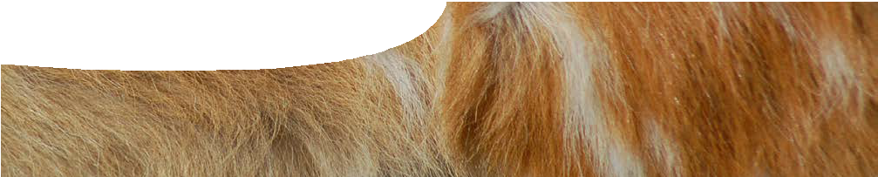
teacher guide
Feeding relationships 2:
Predators and prey

Components

 | NAME | DESCRIPTION | AUDIENCE
 | Predators and prey  teacher guide | This guide describes three activities that may be used to explore feeding relationships. | teachers
 | Restaurant rules  interactive quiz | This quiz encourages students to think about what animals eat in the wild, and explores ideas of feeding relationships. | students
 | Predator or prey?  worksheet | This worksheet contains rules for the card game, Predator or prey?. These are followed by questions for students  to answer after playing, designed to probe student understandings of food chains. | students
 | Predator or prey?  card game | This card game uses Australian plants and animals that live in the Kimberley, to develop the concept of feeding relationships forming food chains. | students
 | Feeding frenzy  worksheet | This worksheet describes an outdoor tag game where students take on the role of animals in a food chain, to explore their interactions. | students

Purpose
To Explore feeding relationships between animals in an ecosystem. Students will see how these relationships form a chain of events, which can be developed into food chains.

Activity summary
Outcomes
Students:
- understand that animals are connected through their diet;
- link animals by what they eat; and
- create simple food chains, for species within an environment, to show feeding relationships.

ACTIVITY | POSSIBLE STRATEGY
Students play the interactive quiz, Restaurant rules. This can be played as a whole class as teams or by up to 4 individuals. | whole class (suited to IWB)
Students play the card game, Predator or prey?. This has three stages of increasing complexity, beginning with matching pairs of predator and prey, then creating food chains. It is best played in small groups, and concludes with some team work. | pairs or small groups
Students answer questions relating to the card game on the worksheet, Predator or prey?. Discuss answers. | individually then whole class
Students use the worksheet, Feeding frenzy, to learn rules for an outdoor game that is explained in more detail in the teachers notes below. | whole class
Do the activity, outside. Students will need to record their results, as they go, on the worksheet, Feeding frenzy. Back inside, students answer questions on the same worksheet. | whole class then individual

Teachers notes
These activities provide students with an opportunity to explore the concept of feeding relationships in ecosystems by first testing their prior knowledge of the types of food eaten by a range of animals in the interactive quiz, Restaurant rules. Next, students use the card game, Predator or prey, to begin exploring how organisms in the Kimberley region of Western Australia can be linked, based on their feeding relationships. Finally, an outdoor game introduces concepts around balanced food chains.
Activities are best presented in the order suggested below to allow ideas to develop.
Restaurant rules (interactive quiz)
In this activity students explore what different animals eat. They are given a series of animals from around the world, and need to choose which food each would eat in the wild. The student who chooses the most correct responses, in the fastest time, wins. Students will need to draw on their general knowledge to come up with answers. The quiz is well-suited to presentation on an interactive whiteboard (IWB).
Predator or prey (card game)
This card game is played in stages, using the same playing cards, that show flora and fauna from the Kimberley region of Western Australia. In the first stage, students play a ‘memory’ style game, matching predator with prey. This game builds on the ideas from the interactive quiz, Restaurant rules.
In the second stage, students use a game board that contains a blank food chain. They take it in turns
to turn over a card and see if it can be added to their food chain. Each food chain must begin with a producer, so students need to find a plant first. Subsequent cards can only be added if the pictured animal preys on the previous species.
The final challenge for students is to work as a team to create food chains, with four species in each, using all of the cards.
Complete rules may be found found on the student worksheet, Predator or prey?.
Feeding frenzy (outdoor game)
In this game students further investigate food chains by role-playing the feeding behaviour of animals in an ecosystem.
The food chain represented in this game is: grass → grasshoppers → frogs → quolls
All food chains begin with a producer, which is symbolised by popcorn in this game. Students take the part of the producers: grasshoppers, frogs and quolls. In later stages of this game, students vary the rules, allowing them to see how changing one organism in an ecosystem has impacts on the whole system.

Equipment required for Feeding frenzy
- sandwich bags (one per student) with two pre-ruled lines across them: one 4 cm from bottom of bag; and one 6.5 cm from bottom
- equal amounts (totalling number of students playing) of three different coloured bibs or ribbons, and in addition, double the amount of one of the colours
- about 5 litres of popcorn (or equivalent small item)
- timer
- large outdoor space defined with lines or witches’ hats
How to play Feeding frenzy
- Allocate different colour to each group: grasshoppers, frogs and quolls.
- Students each collect bib, or ribbon to tie onto arm, to show which group they’re in – each group has same number of ‘animals’.
- Students collect sandwich bag each. Bag represents animal’s stomach.
- Go outside and scatter popcorn (representing ‘grass’) over game area.
- Play round one following game rules on procedure sheet, Feeding frenzy. Start timer to commence.
- Count surviving animals, in each group, at end of round.
- Ask students to suggest ways rules may be altered to produce balanced food chain.
- Make suggested rule changes.
- Play another round.
- Change rules again.
- Play until you manage to get a balanced chain.
If students get stuck, the following rule changes may be suggested to students to make a balanced food chain:
- change numbers of grasshoppers, frogs and quolls
- make frogs jump, or quolls crawl
- make quolls ‘sleep’ at intervals
- have a safe tree for grasshoppers or frogs – maybe a maximum number allowed on tree at once, or a time limit – no eating on tree
- timed release for frogs and quolls (eg grasshoppers start 30 seconds before everyone else)
Food frenzy is based on the ‘Food chain game’ from Outdoor Biology Instructional Strategies, located at Lawrence Hall of Science at the University of California, Berkeley

Kimberley food chains
As an extra challenge in the worksheet, Predator or prey?, students are asked to put all cards into four-card chains. This is one solution to the exercise.
goanna
sand
termites

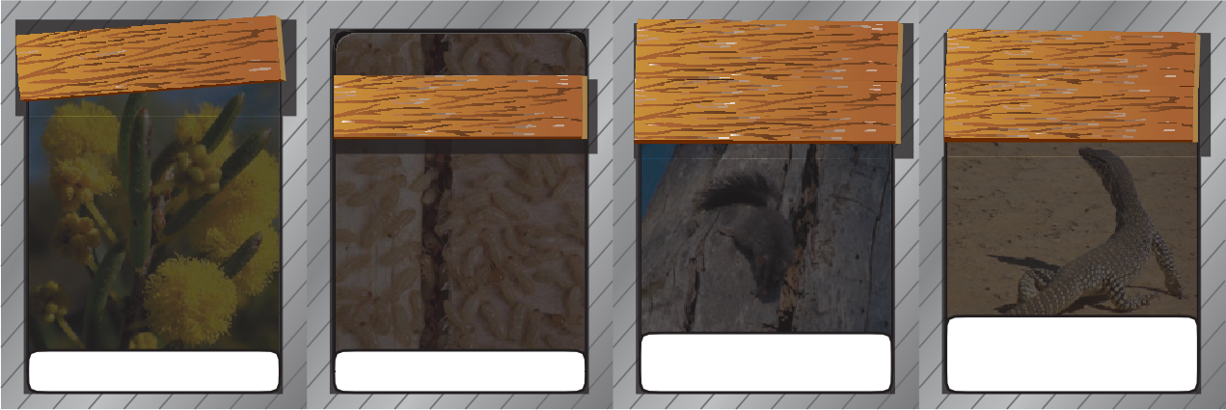
Producer

Diet: insects, lizards, frogs, toads, spiders, snakes, small mammals
Diet: grass, spinifex, trees

Diet: insects, spiders, frogs, toads, nectar, centipedes

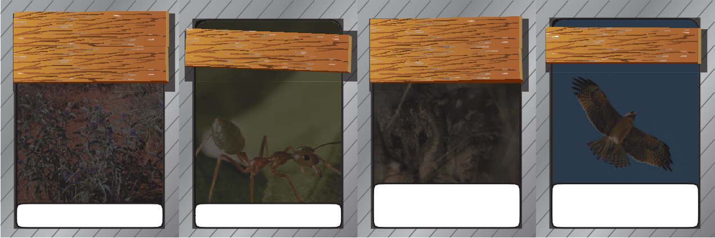
t bushe
little eagle
omato s

Diet: small mammals, insects, smaller birds, small
reptiles, frogs, toads

Diet: small mammals, small reptiles, insects, spiders, frogs, toads

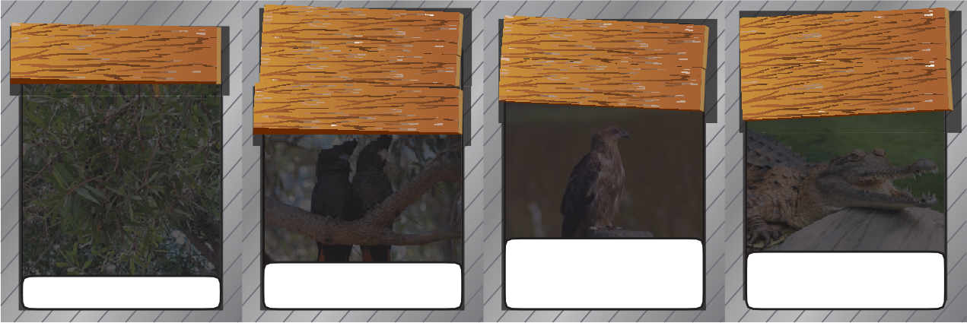
Producer Diet: small insects, nectar
melaleuca

Diet: small mammals, smaller birds, fish, small reptiles, frogs, toads, insects, crustaceans, spiders

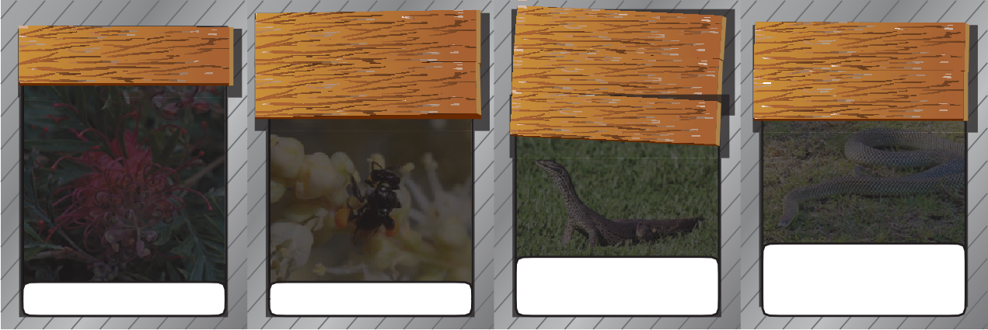
Producer
ngless
sti nativebee

Diet: seeds from flowering trees, grubs

Diet: insects, spiders, snakes, small mammals, lizards, turtle eggs, frogs, toads
grevillea
king brown
snake
Diet: fish, frogs, toads, lizards, turtles, crayfish, birds, small mammals, bats

Producer
Diet: pollen, nectar

Diet: fish, frogs, toads, small reptiles, reptile eggs, small birds, small mammals, insects, snails, spiders

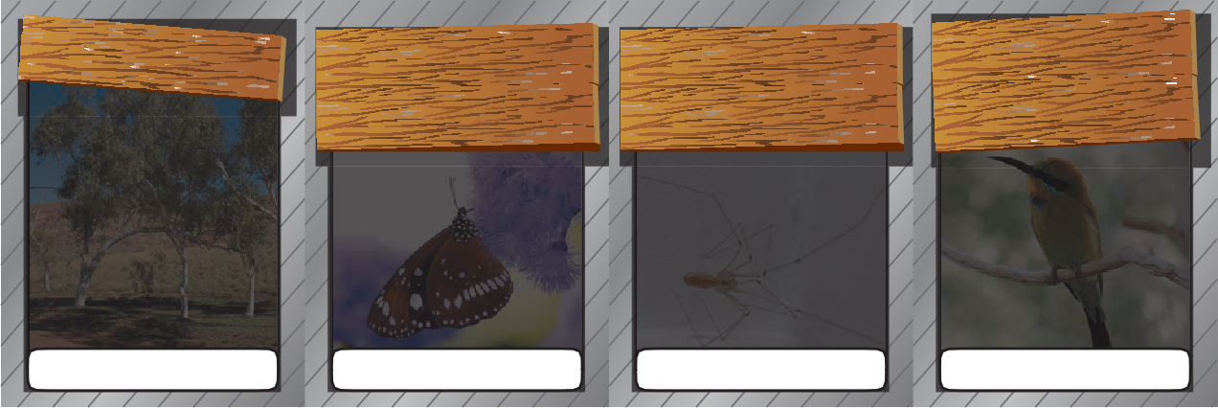
Producer Diet: nectar

cicada

Diet: insects, spiders

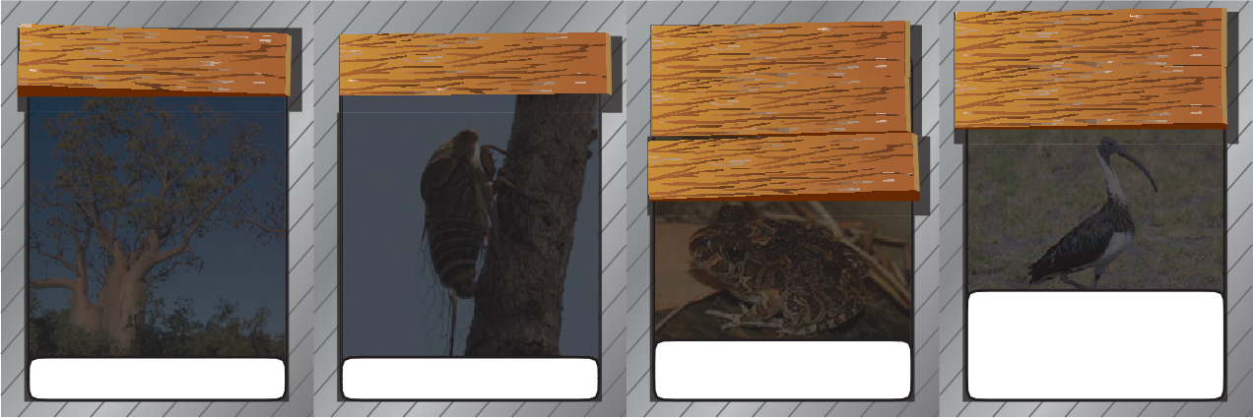
n straw

Diet: bees, flying insects

ecked ibis
Producer
Diet: plant sap

Diet: insects, spiders, smaller frogs

Diet: molluscs, fish, grasshoppers, crickets, locusts, frogs, toads, small mammals, crabs, lizards, small snakes, marine plants, worms

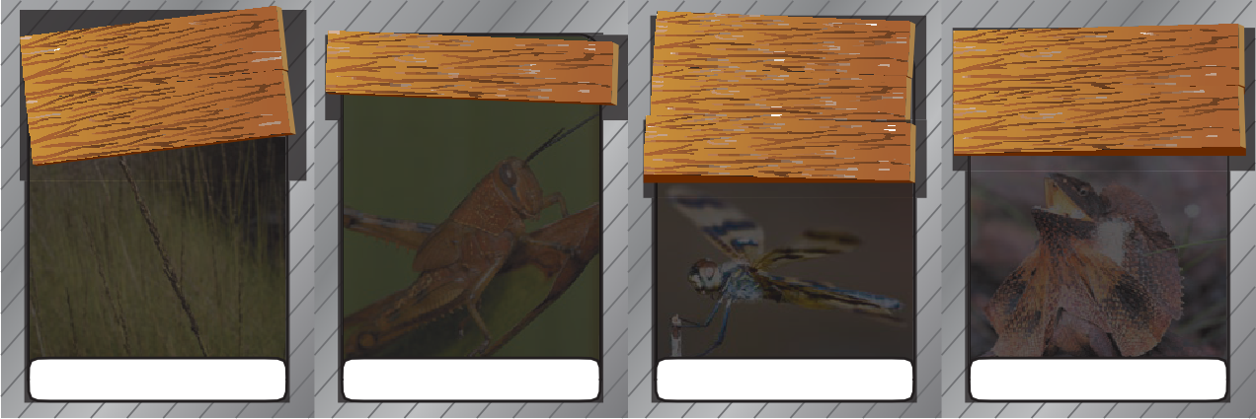
Diet: grass, leaves

Producer
Diet: small flying insects
Diet: insects, spiders, toads

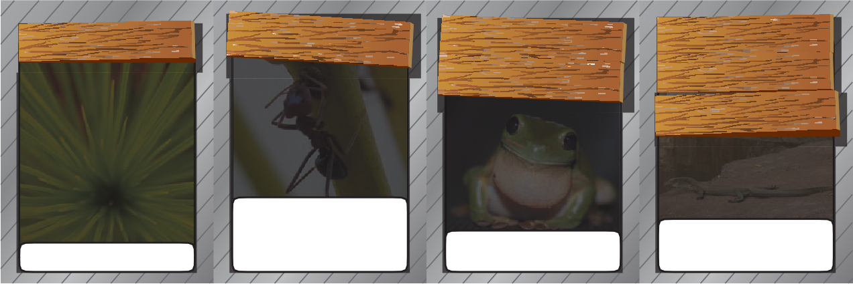
Diet: plants, insect secretions, toads, dead insects, dead spiders, dead mammals, dead reptiles, dead amphibians, dead birds
Producer

Diet: insects, spiders, smaller frogs, very small mammals

Diet: fish, frogs, insects, spiders, turtle eggs, small mammals, smaller lizards



Technical requirements
The teachers guide, card game, procedure sheet and worksheet require Adobe Reader (version 5 or later), which is a free download from www.adobe.com.
The worksheet is also available in Microsoft Word format.
The interactive quiz runs in a web browser.
Decks of cards for the game, Predator or prey?, are available from the Centre for Learning Technology (www.spice.wa.edu.au).

Image credits
  - ‘Freshwater Crocodile at Lone Pine Koala Sanctuary’ by Richard Fisher, CC-BY-2.0, commons.wikimedia.org/ wiki/File:Freshwater_Crocodile_at_Lone_Pine_Koala_ Sanctuary.jpg
  - ‘Yellow-spotted monitor’ by Brad Weinert, used by permission, herpindiego.com
  - ‘Native stingless bee’ by teejaybee, CC-BY-NC-ND 2.0, www.flickr.com/photos/teejaybee/475357387/
  - ‘Green tree frog’ by Stephen Michael Barnett, CC-BY 2.0, commons.wikimedia.org/wiki/File:Green_Tree_Frog_ (Litoria_caerulea).jpg
  - ‘Cicada’ by Brad Weinert, used by permission, herpindiego.com
  - ‘Frilled-neck lizard’ by Brad Weinert, used by permission, herpindiego.com
  - ‘Merops ornatus (rainbow bee-eater)’ by Richard Fisher, CC-BY-2.0, commons.wikimedia.org/wiki/File:Merops_ ornatus_-Alice_Springs_Desert_Park,_Northern_ Territory,_Australia-8a_(1).jpg
  - ‘Australian meat ant found in Central Queensland, Australia’ by Vicki Nunn, PD, commons.wikimedia.org/ wiki/File:Australian_Meat_Ant.jpg
  - ‘Dasyurus hallucatus (northern quoll)’ by Wildlife Explorer, CC-BY-3.0, commons.wikimedia.org/wiki/ File:Dasyurus_hallucatus_-Queensland-8.jpg
  - ‘Eucalyptus victrix’ by Peter McKiernan, CC-BY- NC-ND-2.0, www.flickr.com/photos/86978295@ N00/4798713783/
  - ‘Threskiornis spinicollis (straw-necked ibis)’ by Kenneth Fairfax, CC-BY 2.0, commons.wikimedia.org/wiki/ File:Threskiornis_spinicollis_-Bunbury,_Western_ Australia,_Australia-8.jpg
  - ‘Sand couch (tussock grass)’ by John Tann, CC-BY-2.0, www.flickr.com/photos/31031835@N08/3392259844/
  - ‘Cane toad’ by Sam Fraser-Smith, CC-BY-2.0, commons. wikimedia.org/wiki/File:Bufo_marinus_1_(1).jpg
  - ‘Seed pods of Western Salwood’ by John Tann, CC-BY-2.0, www.flickr.com/photos/31031835@N08/5189604544/
  - ‘Common Australian crow butterfly” by Daniel Julie, CC- BY-2.0, commons.wikimedia.org/wiki/File:Euploea_core_ corinna_1.jpg
  - ‘Macro ornate burrowing frog’ by Ursula Skjonnemand, CC-BY-NC-2.0, www.flickr.com/photos/ursula_ skjonnemand/3641753957/
  - ‘Whistling kite at Fogg Dam’ by Stephen Michael Barnett, CC-BY-2.0, commons.wikimedia.org/wiki/ File:Whistling_Kite_at_Fogg_Dam.jpg
  - ‘Varanus mertensi (Mertens’ water monitor)’ by Zoharby, GNU FDL, commons.wikimedia.org/wiki/File:Varanus_ mertensi_-_Wyndham_WA.jpg
- ‘Red-tailed black cockatoo’ by Scarlet at en.wikipedia, GFDL, commons.wikimedia.org/wiki/File:Red-tailed_ Black_Cockatoo_(Calyptorhynchus_banksii)_on_ Casuarina_tree.jpg
- ‘Varanus gouldii (sand goanna)’ by Alan Couch, CC- BY-2.0, commons.wikimedia.org/wiki/File:Varanus_ gouldii.jpg
- ‘King brown snake’ by F Delventhal, CC-BY-2.0, commons. wikimedia.org/wiki/File:Pseudechis_australis_2.jpg
- ‘Little eagle’ by Parks Victoria, CC-BY-NC-2.0, www.flickr. com/photos/parks_victoria/5976613255/
- ‘White ants’, US Department of Agriculture, PD, commons.wikimedia.org/wiki/File:White_Ants_ (Termites)147.jpg
- ‘Graphic flutterer dragonfly (Rhyothemis graphiptera)’ by Jon Clark, CC-BY-NC-2.0, www.flickr.com/photos/ jonclark2000/4620981685/
- ‘Boab tree’ by Hamiltonstone at en.wikipedia, GFDL, commons.wikimedia.org/wiki/File:Boab_tree_in_ February,_Kimberley_region,_Western_Australia.jpg
- ‘Melaleuca leucadendra foliage’ by Eug, PD, commons. wikimedia.org/wiki/File:Melaleuca_leucadendra-foliage. jpg
- ‘Grevillea heliosperma’ by Tatiana Gerus, CC-BY-2.0, www.flickr.com/photos/tgerus/4631961468/
- ‘Spinifex’ by Rob and Stephanie Levy, CC-BY-2.0, www. flickr.com/photos/robandstephanielevy/4779654697/ sizes/z/in/photostream/
- ‘Brush-tailed phascogale’ by Brian Chambers, used by permission
- ‘Daddy long legs’ by servitude, CC-BY-NC-2.0, www.flickr. com/photos/32977858@N02/3478786747/
- ‘Orthoptera’ by Sam Fraser-Smith, CC-BY-2.0, www.flickr. com/photos/samfrasersmith/4483175595/
- ‘Bush tomatoes’ by Pauline Cockrill (History SA), used by permission, www.flickr.com/photos/ communityhistorysa/5686417462/
banner image: Animal fur texture by David Edwards, www. cgtextures.com

Acknowledgements
Designed and developed by the Centre for Learning Technology, The University of Western Australia.
Production team: Anton Ball, Pauline Charman, Alwyn Evans, Sally Harban, Dan Hutton, Emma Pointon, Jodie Ween and Michael Wheatley, with thanks to Bob Fitzpatrick, Jenny Gull and Wendy Sanderson.

SPICE resources and copyright
SPICE resources and copyright All SPICE resources are available from the Centre for Learning Technology
at The University of Western Australia (‘UWA’). Selected SPICE resources are available through the websites of Australian State and Territory Education Authorities.
Copyright of SPICE Resources belongs to The University of Western Australia unless otherwise indicated.
Teachers and students at Australian and New Zealand schools are granted permission to reproduce, edit, recompile and include in derivative works the resources subject to conditions detailed at spice.wa.edu.au/usage.

Associated SPICE resources

All questions involving copyright and use should be directed to SPICE at UWA.
Web: spice.wa.edu.au Email: spice@uwa.edu.au Phone: (08) 6488 3917
Centre for Learning Technology (M016) The University of Western Australia
35 Stirling Highway
Crawley WA 6009

Feeding relationships 2: Predators and prey may be used in conjunction with related SPICE resources to address the broader topic of food chains and webs.

DESCRIPTION | LEARNING PURPOSE
Feeding relationships (overview)
This learning pathway shows how a number of SPICE resources can be combined to teach the topic of food chains and webs.
Feeding relationships 1: Animal interactions  Students watch a video designed to engage students and provoke questions about animal feeding relationships and introduced species. Students then read a book extract, raising further discussion about cane toads and their impacts. | Engage
Feeding relationships 2: Predators and prey  Students explore concepts of feeding relationships and food chains by competing against each other in three activities: a quiz about what animals eat; a card game; and an outdoor role-play game. | Explore
Feeding relationships 3: Food webs  Food webs are explained in a student fact sheet. Students use an iPad app or a cut-and- paste activity to create a food web that shows feeding relationships between animals in the Kimberley. Students introduce cane toads into their web to examine effects on other species in the ecosystem. They answer questions on an accompanying worksheet to check understanding. | Explain
Feeding relationships 4: Impact of cane toads  This resource elaborates the topic of introduced species. Students watch video clips of people living in the Kimberley describing impacts of cane toads. An accompanying worksheet probes students’ understanding. | Elaborate
Feeding relationships 5: Managing cane toads  This resource extends and applies students’ understanding of cane toads as an example of impacts caused by introduced species. Students suggest ways to solve the cane toad problem; read fact sheets that include up-to-date science research; and participate in a class debate to determine the best solution. They need to develop a persuasive argument that considers ethics, cost and viability of their option. | Elaborate
Feeding relationships 6: Kimberley creations  This resource encourages students to employ techniques used in Aboriginal art to make their own symbolic representation of feeding relationships in an environment of their choice. | Elaborate

