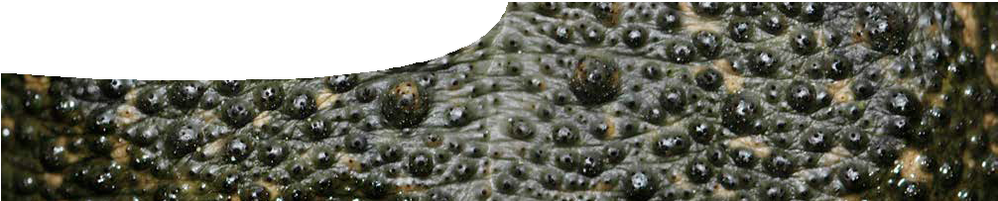
teacher guide
Feeding relationships 4:
Impact of cane toads

Components

 | NAME | DESCRIPTION | AUDIENCE
 | Impact of cane toads  teacher guide | This guide describes how to use audio recordings of community members to elaborate on students’  understanding of impacts of cane toads in the Kimberley. | teachers
 | Talking about cane toads  audio | Kimberley community members speak about the impact the cane toads have had on their lives and the environment. | students
 | Thinking about cane toads  worksheet | This worksheet prompts students to think about different people’s opinions about an introduced species, such as the cane toad. | students

Purpose
This resource elaborates on students’ understanding of impacts of an introduced species like the cane toad. Students listen to opinions from different Kimberley community members, then reflect on them by working through questions on the worksheet provided.

Activity summary
Outcomes
Students:
- reflect on the opinions of Kimberley community members;
- compare and contrast opinions to gain a better understanding of the full impact an introduced species can have on a community and its environment; and
- reflect on how they would react to a similar invasion of an introduced species in their suburbs.

ACTIVITY | POSSIBLE STRATEGY
Students read quotes from six Kimberley community members on the worksheet, Thinking about cane toads, and try to match quotes to individuals. | individually
Students listen to audio recordings of community members talking about cane toads and their impacts on communities and the environment. | in groups or individually
Students complete questions on the worksheet, Thinking about cane toads. | individually
Discuss answers. | whole class

Teacher notes
Encourage students to consider what impacts cane toads have had on the community and the environment. This may take the form of a class discussion before listening to the audio.
Allow students to work individually or in groups on Talking about cane toads. They begin by matching quotes provided by seven community members with a photo of each person or group that they think provided that opinion. After matching all quotes, students check their selections by listening to the recordings.

This may be followed by discussion of their decisions or by allowing time to answer questions on the worksheet, Thinking about cane toads.
Students should be encouraged to express their own opinions about they how would feel if cane toads invaded their suburb, and acknowledge that impacts of introduced species are many and varied.

Technical requirements
The teacher guide and worksheet require Adobe Reader (version 5 or later), which is a free download from www. adobe.com. Talking about cane toads, requires a modern browser (eg Internet Explorer 9 or later, Google Chrome, Safari 5.0+, Opera or Firefox). The worksheet is also available in Microsoft Word format.

Acknowledgements
Thanks to Corrin Everitt (Program Manager, State Cane Toad Initiative, Department of Conservation and Environment), Kimberley Toad Busters, staff and students of Kununurra District High School.
Designed and developed by the Centre for Learning Technology, The University of Western Australia.
Production team: Anton Ball, Pauline Charman, Jan Dook, Alwyn Evans, Jenny Gull, Sally Harban, Dan Hutton, Emma Pointon, Paul Ricketts, Kate Vyvyan,
Jodie Ween and Michael Wheatley, with thanks to Pauline Charman, Bob Fitzpatrick and Wendy Sanderson.

Associated SPICE resources
SPICE resources and copyright
SPICE resources and copyright All SPICE resources are available from the Centre for Learning Technology at The University of Western Australia (‘UWA’). Selected SPICE resources are available through the websites of Australian State and Territory Education Authorities.
Copyright of SPICE Resources belongs to The University of Western Australia unless otherwise indicated.
Teachers and students at Australian and New Zealand schools are granted permission to reproduce, edit, recompile and include in derivative works the resources subject to conditions detailed at spice.wa.edu.au/usage.
All questions involving copyright and use should be directed to SPICE at UWA.
Web: spice.wa.edu.au Email: spice@uwa.edu.au Phone: (08) 6488 3917
Centre for Learning Technology (M016) The University of Western Australia
35 Stirling Highway
Crawley WA 6009

Feeding relationships 4: Impact of cane toads may be used in conjunction with related SPICE resources to address the broader topic of food chains and webs.

DESCRIPTION | LEARNING PURPOSE
Feeding relationships (overview)
This learning pathway shows how a number of SPICE resources can be combined to teach the topic of food chains and webs.
Feeding relationships 1: Animal interactions  Students watch a video designed to engage students and provoke questions about animal feeding relationships and introduced species. Students then read a book extract, raising further discussion about cane toads and their impacts. | Engage
Feeding relationships 2: Predators and prey  Students explore concepts of feeding relationships and food chains by competing against each other in three activities: a quiz about what animals eat; a card game; and an outdoor role-play game. | Explore
Feeding relationships 3: Food webs  Food webs are explained in a student fact sheet. Students use an iPad app or a cut-and- paste activity to create a food web that shows feeding relationships between animals in the Kimberley. Students introduce cane toads into their web to examine effects on other species in the ecosystem. They answer questions on an accompanying worksheet to check understanding. | Explain
Feeding relationships 4: Impact of cane toads  This resource elaborates the topic of introduced species. Students watch video clips of people living in the Kimberley describing impacts of cane toads. An accompanying worksheet probes students’ understanding. | Elaborate
Feeding relationships 5: Managing cane toads  This resource extends and applies students’ understanding of cane toads as an example of impacts caused by introduced species. Students suggest ways to solve the cane toad problem; read fact sheets that include up-to-date science research; and participate in a class debate to determine the best solution. They need to develop a persuasive argument that considers ethics, cost and viability of their option. | Elaborate
Feeding relationships 6: Kimberley creations  This resource encourages students to employ techniques used in Aboriginal art to make their own symbolic representation of feeding relationships in an environment of their choice. | Elaborate

