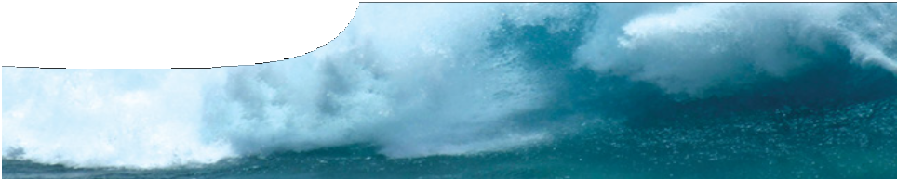
teacher guide
Mechanical waves 4: Tsunami problems

Components

 | NAME | DESCRIPTION | AUDIENCE
 | Tsunami problems  teacher guide | This shows how the resource may be used to engage student interest in the properties of mechanical waves. It provides advice on the use of the various learning assets and suggests questions for group discussion. | teachers
 | Tsunami! Waves of destruction  fact sheet | This shows students how the characteristics of tsunamis change with varying water depth and reveals how the 2004 Boxing Day tsunami spread out around the globe. | students
 | Tsunami problems  worksheet | This offers a range of problems for students to solve in the context of the Boxing Day tsunami. Where did it originate, how did the waves spread out and what effect did the geography of the sea-floor and coastlines have upon the waves where they crashed ashore? | students

Purpose
To Elaborate and extend students’ understandings of the wave properties of tsunamis. The resource
may also be used to evaluate student understandings of wave properties, their ability to interpret information and data, and make connections between science and its influence on society.

Outcomes
Students:
- interpret data and information to explain events caused by tsunamis; and
- explain the importance of science in society.

Activity summary

ACTIVITY | POSSIBLE STRATEGY
Distribute the fact sheet Tsunami! Waves of destruction to students and clarify any questions that students have regarding the information presented. | Think, Pair, Share to identify questions that require clarification
Distribute the worksheet Tsunami problems.  Students work individually or in groups to respond to questions posed. | individual or small group
Discuss responses to questions. The background sheet, Tsunami physics in Mechanical waves 1: The physics of tsunamis, and this guide provide additional information to support teachers in this discussion. | callout with each group responsible for presenting responses to a specific question  an envoy strategy could also be used

Technical requirements
The teacher guide, fact sheet and worksheet require Adobe Reader (version 5 or later), which is a free download from www.adobe.com. The worksheet is also provided in Microsoft Word format.

Using this resource
This SPICE resource is intended to challenge students to apply their understanding of mechanical wave properties to solve questions based upon the 2004 Boxing Day tsunami. Some of the answers to the worksheet Tsunami problems appear in the fact sheet Tsunami! Waves of destruction, so the fact sheet may be distributed once students have completed the worksheet.

The importance of ocean depth
Ocean depth has a strong influence on tsunami characteristics. As depth decreases, wave speed and wavelength also decrease. As a wave approaches shallow waters it also increases in height.
In the open ocean, where the seafloor is over four kilometres below the surface, the Boxing Day tsunami would have been travelling at up to 700 km h-1 with a massive wavelength of nearly 100 km. Such a large wave would have taken almost an hour to pass. To a boat in the open ocean the rapidly moving wave would have been a gentle, undetectable rise and fall.
However, as the wave approached shore its speed rapidly dropped, its wavelength shrunk and its height increased massively. Scientists estimated that the run-up height of the wave on the western coast of Indonesia reached 30 m (1). Banda Aceh, on the northern coast, had waves of 10 – 15 m. Considering that the wave was measured to be just 60 cm tall in the open ocean this represents a 50-fold increase in height.
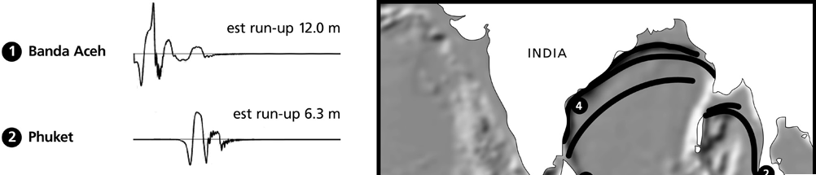

1) Borrero, J.C. (2005). Field Data and Satellite Imagery of Tsunami Effects in Banda Aceh. Science Magazine 308(5728), 1596.

Worksheet activities
Some issues that may be raised from the worksheet are discussed below.

Question 1
The readings at the left clearly indicate a time when the wave struck each location. Students can then multiply the number of hours it took for the wave to strike by the estimated average speed of the wave, 700 km h-1. The calculated figure is an estimate of distance to the wave origin.
Students can then draw arcs from each location, using a compass, to show possible points of origin for the earthquake. In theory, if the wave was travelling at a uniform speed, this method of triangulation will give a clear single point of origin where each arc intersects.
The students should find that there is no single point of origin and conclude that either there was an area of origin (rather than a single point) or that the method is flawed. In either case, they need greater understanding of factors affecting wave speed.

Question 2
Plotting the graphs should show that changing ocean depth has a dramatic effect upon wave speed and wavelength. So triangulation (question 1) does not necessarily locate a point of origin unless ocean depth is taken into account.

Question 3
As a tsunami interacts with the ocean floor and run-up height increases, some kinetic energy is converted to potential energy. In addition, some kinetic energy is transferred from the wave to sand and rocks over which it passes (e g as heat energy).

Question 4
Estimating the point of origin in this question can be achieved by finding the perpendicular bisection of chords from the spreading wave. To lessen the effect of shallow water, these should be drawn in areas where waves are in deep water and still hold a radial shape. Intersection of student’s chords should give a fair estimation of the point of origin (just to the west of Aceh).

Question 5
Students should realise that the distance of the 90-minute warning line from the coast is directly related to ocean depth (i e a line close to the coast indicates shallow water where the tsunami will travel slowly).

Question 6
Perhaps the most surprising fact is that the tsunami does not necessarily hit nearby towns first (i e those closer to the earthquake origin), nor are wave heights necessarily directly related to distance from origin (compare
Carnarvon and Bunbury). The shape of the seafloor near a town has a dramatic effect on wave height and arrival time.
There is a pattern to the arrival time of the waves: most seem to arrive around the same time on Boxing Day. The wave travels rapidly through deep water and then slows in shallow water. Another factor to discuss is tide height in different areas.
Clues to the discrepancy between Geraldton and other sites may be gleaned from the map. Encourage students to consider how the Abrolhos Islands off Geraldton may affect wave speed. A second discussion point is that tsunamis, like all waves, can diffract around objects that are narrower than the wavelength, and constructive and destructive interference can occur. Might this have led to high amplitude waves at Geraldton?

Associated SPICE resources
Mechanical waves 4: Tsunami problems may be used in conjunction with related SPICE resources to address the broader topic of mechanical waves.

DESCRIPTION | LEARNING PURPOSE
Mechanical waves
This learning pathway shows how a number of SPICE resources can be combined to teach the topic of mechanical waves.
Mechanical waves 1: The physics of tsunamis  Video and a fact sheet compare surface waves with tsunami waves. | Engage
The sequence overview in Mechanical waves contains suggested Explore activities suitable for use at this point. | Explore
Mechanical waves 2: Wave properties  This resource includes a learning object (in which students interact with a variety of waves to understand their properties), and associated student worksheets. | Explain
Mechanical waves 3: Graphing waves  These student worksheets describe experiments with longitudinal waves. | Elaborate
Mechanical waves 4: Tsunami problems  These student worksheets cover a range of problems concerning the physics of tsunamis and other waves. | Elaborate
The sequence overview in Mechanical waves contains suggested Explore/Explain  activities suitable for use at this point. | Explore/Explain
Mechanical waves 5: The physics of whale stranding  An interview with physicist Dr Ralph James illustrates how his research into microwaves led him to develop and test a theory to explain whale beaching. | Elaborate

Acknowledgements
Concept design: Bob Fitzpatrick (Armadale Senior High School). Science advisor: Professor Charitha Pattiaratchi (School of Environmental Systems Engineering, The University of Western Australia). Production by DUIT Multimedia (The University of Western Australia).

SPICE resources and copyright
All SPICE resources are available from the Centre for Learning Technology at The University of Western Australia (“UWA”). Selected SPICE resources are available through the websites of Australian State and Territory Education Authorities.
Copyright of SPICE Resources belongs to The University of Western Australia unless otherwise indicated.
Teachers and students at Australian and New Zealand schools are granted permission to reproduce, edit, recompile and include in derivative works the resources subject to conditions detailed at spice.wa.edu.au/usage.
All questions involving copyright and use should be directed to SPICE at UWA.
Web: spice.wa.edu.au Email: spice@uwa.edu.au Phone: (08) 6488 3917
Centre for Learning Technology (M016) The University of Western Australia
35 Stirling Highway
Crawley WA 6009

