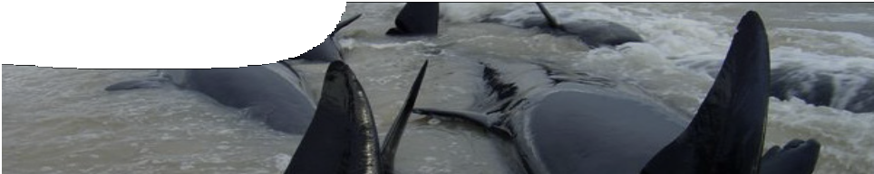
teacher guide
Mechanical waves 5: The physics of whale stranding

Components

 | NAME | DESCRIPTION | AUDIENCE
 | The physics of whale stranding  teacher guide | This shows how this resource may be used to stimulate group discussion about the way in which scientists formulate a hypothesis. Students may be asked how they would test the hypothesis developed by Dr Ralph James. The guide suggests suitable questions for group discussion. | teacher
 | Beached! The physics of whale stranding  video | In this video interview, physicist Ralph James explains how his work with microwaves lead to a hypothesis about the cause of whale strandings. | students
 | Whales and microwaves  background sheet | This summarises a hypothesis developed by physicist Dr Ralph James about a cause of whale strandings. It also provides information not given in the associated video to help teachers facilitate classroom discussion. | teachers
 | A whale of a time  fact sheet | This provides students with some interesting facts about whales and their use of echolocation as they navigate through the world’s oceans. | students

Purpose
To apply and Elaborate on wave properties through the work of a scientist investigating a reason for whale stranding.

Outcomes
Students:
- describe the way scientists research to find explanations for natural events; and
- explain use of waves for navigation by animals in the ocean.

Activity summary

ACTIVITY | POSSIBLE STRATEGY
Show the video Beached! The physics of whale stranding and discuss the process of scientific inquiry used by the scientist. Discussion points are listed below. | teacher-led class discussion
Distribute the fact sheet A whale of a time and allow students time for reading. | KWL chart could follow videoclip and reading
Discussion in small groups of questions such as those listed below. | envoy or jigsaw
Technical requirements
A modern browser (eg Internet Explorer 9 or later, Google Chrome, Safari 5.0+, Opera or Firefox) is required to view the video. A high quality MP4 version of the video is available by download from the SPICE website.
The guide, background sheet and fact sheet require Adobe Reader (version 5 or later), which is a free download from www.adobe.com.

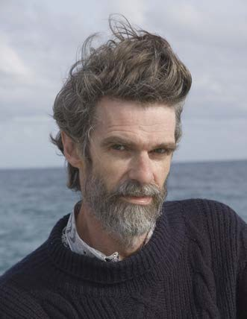
About the scientist
Dr Ralph James is a researcher and lecturer in the School of Physics at The University of Western Australia. He has applied his research into microwaves and how to attenuate them using geometric absorbers to a very different problem — the question of why apparently healthy whales beach themselves.
Dr James explains how he became involved with whales and how he formulated his hypothesis about how environmental and other factors upset the echo-location of the whales and lead to disaster.

Using the video
Student discussion following the video can be teacher-led, whole-group discussion on the work of scientists. Discussion points:
- Scientific research often emerges from a person’s interests. Dr James had no thoughts of researching whale strandings until he volunteered to help with whales stranded on the south coast of WA.
- Scientists have minds that ask questions about the world, why things are the way they are, and what makes things work. Dr James’ curious mind led him to question what caused whales to beach.
- Scientists think logically. He looked at features that could influence whales to beach and isolated those that might be a cause.
- Scientists make connections. His research into wave attenuation led him to consider a connection between this work and an application of laboratory ideas into a real life application.
- Scientists propose new ideas to explain phenomena based on their observations that might be different from views held by other scientists or popular opinion. Dr James’ idea that strandings might be linked to ocean floor shape was different from hypotheses proposed by other scientists.
- Scientists develop models to explain phenomena, and then devise experiments to collect data and information that test their models.

Students may be posed questions to discuss as a whole group, or in groups using strategies such as a jigsaw or an envoy.
- What questions would Dr James need to answer to gain information to support his hypothesis?
- What experiments could he do to answer these questions?
- If Dr James is correct about causes of whale strandings, what could we do to prevent it happening?
- What other factors do you think might contribute to whale strandings? (e g sound pollution in oceans, disease etc) How could scientists investigate your ideas?
- Does this kind of scientific research matter?

Sound issues – applications in other contexts
Students may research how wave characteristics are applied in the context of human use of sound and seismic waves. This may be an extension or evaluation activity.
It may be done as a class jigsaw or envoy activity using PMI charts, or as a straightforward research and report back session. Students could expand upon what they have learned about wave characteristics and discuss issues related to the ethical use of science and its related technology.

Issues for researching:
- What causes strandings of whales and dolphins on our shores? An interview with Dr Ralph James gives a snapshot of recent theories about how and why whales beach themselves.
- Why has USA banned the use of certain types of sonar in some waters?
- How do fish finders work? Is it a good thing to have every fishing boat, amateur and professional, equipped with a fish finder?
- Do MP3 players or iPods cause deafness? Is it the electronic devices or the headphones that cause the problem?
- How do noise cancellation and noise isolation headphones work? Which is better for our ears? Can damaged hearing be saved?
- How does ultrasound imaging work? Are there any problems associated with ultrasound scans and how do they compare to X-rays?
- Seismic waves are produced by earthquakes. How do we make use of these waves and human-generated shockwaves to find out about the inside of the Earth? Are there effects upon the environment or other organisms that we should consider?

Focus questions for each of the above issues
- What kinds of waves are involved?
- What is the source of waves?
- How is energy produced, transferred and absorbed?
- What wave properties are important? Explain why.
- In your opinion, are waves being used or misused in this situation? (You could complete a PMI chart to help form your response to this question).
- Suggest a solution or solutions to any problems identified.

Associated SPICE resources
Mechanical waves 5: The physics of whale stranding may be used in conjunction with related SPICE resources to address the broader topic of mechanical waves.

DESCRIPTION | LEARNING PURPOSE
Mechanical waves
This learning pathway shows how a number of SPICE resources can be combined to teach the topic of mechanical waves.
Mechanical waves 1: The physics of tsunamis  Video and a fact sheet compare surface waves with tsunami waves. | Engage
The sequence overview in Mechanical waves contains suggested Explore activities suitable for use at this point. | Explore
Mechanical waves 2:Wave properties  This resource includes a learning object (in which students interact with a variety of waves to understand their properties), and associated student worksheets. | Explain
Mechanical waves 3: Graphing waves  These student worksheets describe experiments with longitudinal waves. | Elaborate
Mechanical waves 4: Tsunami problems  These student worksheets cover a range of problems concerning the physics of tsunamis and other waves. | Elaborate
The sequence overview in Mechanical waves contains suggested Explore/Explain  activities suitable for use at this point. | Explore/Explain
Mechanical waves 5: The physics of whale stranding  An interview with physicist Dr Ralph James illustrates how his research into microwaves led him to develop and test a theory to explain whale beaching. | Elaborate

Acknowledgements
Concept design: Bob Fitzpatrick (Armadale Senior High School). Science advisor: Dr Ralph James (School of Physics, The University of Western Australia).
Whale photography by Heidi Taylor, Tangaroa Blue. Video footage of San Francisco and Sea Wolf class submarines courtesy of U. S. Navy Video. Production by DUIT Multimedia, The University of Western Australia.

SPICE resources and copyright
All SPICE resources are available from the Centre for Learning Technology at The University of Western Australia (“UWA”). Selected SPICE resources are available through the websites of Australian State and Territory Education Authorities.
Copyright of SPICE Resources belongs to The University of Western Australia unless otherwise indicated.
Teachers and students at Australian and New Zealand schools are granted permission to reproduce, edit, recompile and include in derivative works the resources subject to conditions detailed at spice.wa.edu.au/usage.
All questions involving copyright and use should be directed to SPICE at UWA.
Web: spice.wa.edu.au Email: spice@uwa.edu.au Phone: (08) 6488 3917
Centre for Learning Technology (M016) The University of Western Australia
35 Stirling Highway
Crawley WA 6009

