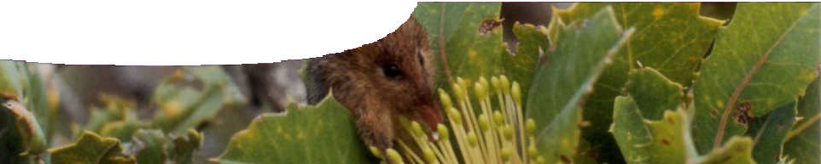
teachers guide

Food and energy 1:
The honey possum

Components

 | NAME | DESCRIPTION | AUDIENCE
 | The honey possum  teachers guide | The teachers guide shows how this resource may be used to engage student interest in the biology of the honey possum (Tarsipes rostratus). It explains the use of the video and fact sheet, and suggests suitable questions for group discussion. | teachers
 | Features of the honey possum  fact sheet | This fact sheet presents a series of unusual or unique facts about the honey possum (Tarsipes rostratus) to help stimulate student engagement and promote questions. | students
 | A unique marsupial  video | This videoclip engages the interest of students in the honey possum: a rare and unusual Australian marsupial. Zoologist Professor Don Bradshaw tells how he became interested in the species, and describes some of their unique adaptations. | students

Purpose
To use the unique features of a honey possum to Engage students’ interest and curiosity in the survival of native animals in an ecosystem.

Outcomes
Students:
- describe some features of the honey possum and unique adaptations it has evolved to help it live a highly specialised lifestyle, and
- identify what they know and want to know about the honey possum using information from the video and fact sheet.

Activity summary

ACTIVITY | POSSIBLE STRATEGY
Show the video, A unique marsupial. | whole group
Discuss video (see Using the video below) . | small group discussion
Distribute and use the fact sheet, Features of the honey possum, to assist students identify what they want to learn about the honey possum in its ecosystem. | KWL chart

Technical requirements
QuickTime version 7 or later is required to view the video, A unique marsupial. This is a free download from www.apple.com/quicktime. A high quality MP4 version of the video can be downloaded from the SPICE website.
The guide and fact sheet require Adobe Reader (version 5 or later), which is a free download from www.adobe.com.

Using the video
Play the video, A unique marsupial.
Ask students to draw up a KWL chart, complete the ‘K’ (what I know) column, and encourage them to write questions in the ‘W’ (what I want to know) column. This may be done in small groups of two or three.
Ask students to read the fact sheet, Features of a honey possum. If this answers some of their questions they may add these to the ‘L’ (what I have learned) column. The sheet may also stimulate additional questions to add to their ‘W’ column. As students continue to learn about the honey possum through later activities they may add questions, and write their own answers.

KWL example

What I already Know | What I Want to know | What have I Learned?
very small feeds on nectar  lives in Scott National Park is a marsupial  male and female differ in size | Why does it only feed on nectar and pollen?  Does it live in other locations in WA?  Is it endangered?  Why is its closest relative in South America?  How can we save native animals when we set fires to stop wild fires?  What are its predators? | To fill in some time later

Associated SPICE resources
Food and energy 1: The honey possum may be used in conjunction with related SPICE resources to address the broader topic of how scientists determine energy requirements of a species.

DESCRIPTION | LEARNING PURPOSE
Food and energy (overview)
This learning pathway shows how a number of SPICE resources may be combined to teach the topic of food and energy.
Food and energy 1: The honey possum  In a video interview, zoologist Professor Don Bradshaw tells how he became interested in the honey possum, a rare and unusual Australian marsupial, and describes some of their unique adaptations. | Engage
Food and energy 2: Pollen  Students use a virtual microscope to examine pollen from a range of plants, measure the size of pollen grains, and learn about features such as pore width and cell wall width. | Explore
Food and energy 3: Fauna surveys  Students explore factors controlling abundance and distribution of organisms, and occupation of particular habitats. | Explore
Food and energy 4: Honey possum respiration  Students use a worksheet to explore the process of respiration in heterotrophic organisms. | Explain
Food and energy 5: Animal release  Students answer questions to identify an environment that will effectively sustain a released population of honey possums. | Elaborate

Acknowledgements
Thanks to Professor Don Bradshaw (School of Animal Biology, The University of Western Australia).
Images of Dromiciops australis courtesy of Christiaan Muñoz Salas. Additional images courtesy of Tom Alford (Friends of Kings Park) and Professor Don Bradshaw.
Designed and developed by the Centre for Learning Technology, The University of Western Australia.
Project team: Dawn Smith (Churchlands Senior High School), Roger Dickinson, Jan Dook, Paul Ricketts and Michael Wheatley, with thanks to Fred Deshon and Wendy Sanderson.

SPICE resources and copyright
All SPICE resources are available from the Centre for Learning Technology at The University of Western Australia (“UWA”). Selected SPICE resources are available through the websites of Australian State and Territory Education Authorities.
Copyright of SPICE Resources belongs to The University of Western Australia unless otherwise indicated.
Teachers and students at Australian schools are granted permission to reproduce, edit, recompile and include in derivative works the resources subject to conditions detailed at spice.wa.edu.au/usage.
All questions involving copyright and use should be directed to SPICE at UWA.
Web: spice.wa.edu.au Email: spice@uwa.edu.au Phone: (08) 6488 3917
Centre for Learning Technology (M016) The University of Western Australia
35 Stirling Highway
Crawley WA 6009

