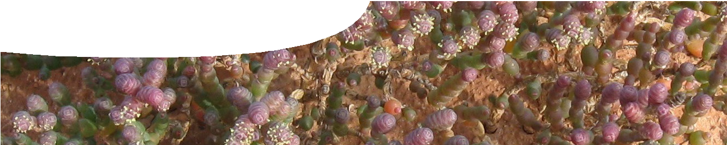
teachers guide
Adaptations 4
Samphires

Components

 | NAME | DESCRIPTION | AUDIENCE
 | Samphires  teachers guide | This guide shows how the concept of adaptations can be explained in the context of samphires. | teachers
 | Surviving extremes  fact sheet | How do samphires survive in conditions that would kill most plants? This fact sheet describes and explains adaptations samphires have to cope with their environment. | students
 | Rehabilitation site  worksheet | This worksheet presents a profile diagram of a lake for students to use in a group activity. | students
 | Salt, sand and samphires  worksheet | This student worksheet contains questions about samphires and their adaptations that relate to the fact sheet and group activity. | students
 | Researching samphires  fact sheet | This fact sheet profiles the work of two scientists at The University of Western Australia who are researching samphires and their uses. | students

Purpose
To Explain how plants can have specific adaptations that enable them to live in particular environments.

Activity summary
Outcomes
Students:
- understand that plants have structural and physiological adaptations that enable them to survive in particular environments;
- analyse data from graphs; and
- work as a group to analyse the relative importance of different adaptations.

ACTIVITY | POSSIBLE STRATEGY
Distribute copies of fact sheet, Surviving extremes, and worksheet, Rehabilitation site, to each group. If possible, print the worksheet A3 size. | groups of three
The teacher describes the activity to the class (see Teacher notes, below). | whole class
Students read fact sheet, Surviving extremes. Each group member reads a different section (the fact sheet contains three sections). | groups of three
Students report information they read, then work together to decide where different samphires live. Compile group results on worksheet, Rehabilitation site. | groups of three
Students answer questions on worksheet, Salt, sand and samphires. | individually
Discuss answers to both worksheets. | whole class

Teachers notes
The following scenario is one way to use the fact sheet.
An environmental group has decided to revegetate an arid area of the Goldfields in Western Australia left barren after mining and over-farming. The area includes a salt lake and a clay pan. Students work in groups of three to plan rehabilitation. Each person in a group receives information on one environmental condition: salinity, drought or flooding.

Groups are given information about the rehabilitation site and three samphire species available for planting. Students need to consider adaptations shown by each species of samphire, then work together to decide the best place to plant them.
Students are expected to have prior knowledge of plant photosynthesis and transpiration.

Technical requirements
The teachers guide, fact sheet and worksheets require Adobe Reader (version 5 or later), which is a free download from www.adobe.com. The worksheets are also available in Microsoft Word format

Acknowledgements
Thanks to Winthrop Professor Tim Colmer (School of Plant Biology, UWA), Dr Kelly Shepherd (Herbarium of Western Australia) and Bindy Datson (Actis environmental Services).
Designed and developed by the Centre for Learning Technology, The University of Western Australia.
Production team: Jan Dook, Alwyn Evans, Jenny Gull, Sally Harban, Dan Hutton, Emma Pointon, Jodie Ween and Michael Wheatley. Thanks to Pauline Charman, Bob Fitzpatrick, Charmaine White and Wendy Sanderson.
Banner image: ‘Tecticornia mellaria male flowers’ by Bindy Datson, Actis Environmental Services, used by permission.

SPICE resources and copyright
All SPICE resources are available from the Centre for Learning Technology at The University of Western Australia (“UWA”). Selected SPICE resources are available through the websites of Australian State and Territory Education Authorities.
Copyright of SPICE Resources belongs to The University of Western Australia unless otherwise indicated.
Teachers and students at Australian schools are granted permission to reproduce, edit, recompile and include in derivative works the resources subject to conditions detailed at spice.wa.edu.au/usage.
All questions involving copyright and use should be directed to SPICE at UWA.
Web: spice.wa.edu.au Email: spice@uwa.edu.au Phone: (08) 6488 3917
Centre for Learning Technology (M016) The University of Western Australia
35 Stirling Highway
Crawley WA 6009

Associated SPICE resources
Adaptations 4: Samphires may be used in conjunction with related SPICE resources to study structural, physiological and behavioural adaptations.

DESCRIPTION | LEARNING PURPOSE
Adaptations (overview)
This learning pathway shows how a number of SPICE resources can be combined to teach the concept of adaptations in plants and animals.
Adaptations 1: Defining adaptations  An interactive quiz encourages students to differentiate between different types of adaptation: structural, behavioural or physiological. | Engage
Adaptations 2: Emperor penguins  Students conduct experiments to model structural, physiological and behavioural adaptations of emperor penguins. | Explore
Adaptations 3: Barrow Island marsupials  Students use a learning object to investigate adaptations of four marsupials that live on Barrow Island. | Explain
Adaptations 4: Samphires  A profile diagram of a lake provides students with an opportunity to determine which species of samphire would be mostly likely to survive in particular locations. | Explain
Adaptations 5: Diving adaptations  Students use a learning object to compare and contrast physiological, structural and behavioural adaptations of air-breathing diving animals. | Explain
Adaptations 6: Freediving  Students watch a video of a human freediver and consider differences between acclimatisation and adaptation. Students review risks of diving associated with pressure. | Elaborate

