teacher guide
Hydrocarbon chemistry 3:
Naming hydrocarbons

Components

 | NAME | DESCRIPTION | AUDIENCE
 | Naming hydrocarbons  teacher guide | This guide describes use of a learning object to teach students about how hydrocarbons are named, and different models that can be used to represent their structure. | teachers
 | How to name hydrocarbons  fact sheet | This fact sheet introduces IUPAC naming of alkanes, alkenes and alkynes to students, with examples. | students
 | Hydrocarbon explorer  learning object | Students use this learning object to construct models of alkanes, alkenes, alkynes and cycloalkanes with their correct name. Properties and 3-D views of selected hydrocarbons are also displayed. | students
 | Hydrocarbon models  worksheet | This worksheet accompanies the learning object,  Hydrocarbon explorer. | students

Purpose
To Explain how hydrocarbons are named. Students use a computer animation to look at different models of alkanes, alkenes, alkynes and cycloalkanes.

Activity summary

Outcomes
Students:
- draw and name alkanes, alkenes and alkynes;
- describe differences in the structures and properties of alkanes, alkenes and alkynes.

ACTIVITY | POSSIBLE STRATEGY
Distribute and read through the fact sheet, How to name hydrocarbons. Teachers may ask students to draw and name additional examples of hydrocarbons. | whole group
Students explore the learning object, Hydrocarbon explorer. It may be useful for students to use a ‘ball and stick’ model kit to make some models that they observe in the learning object. | pairs
Students complete the worksheet, Hydrocarbon models, while using the learning object, then discuss results with a peer. | pairs, share

Technical requirements
The guide, fact sheet and worksheet require Adobe Reader (version 5 or later), which is a free download from www.adobe.com. The worksheet is also provided in Microsoft Word format.
The learning object may be placed on a web or file-server, and run locally or remotely in any modern browser on computer or tablet. Jmol/JSmol software is used to display 3-D models. This requires Java or HTML5 support.
The learning object can also be accessed online at http://spice.wa.edu.au/resources/hydrocarbon-explorer/

Using the learning object
The learning object Hydrocarbon explorer allows users to interactively construct models of acyclic and cyclic hydrocarbons, see how they are named and look up their basic physical properties.

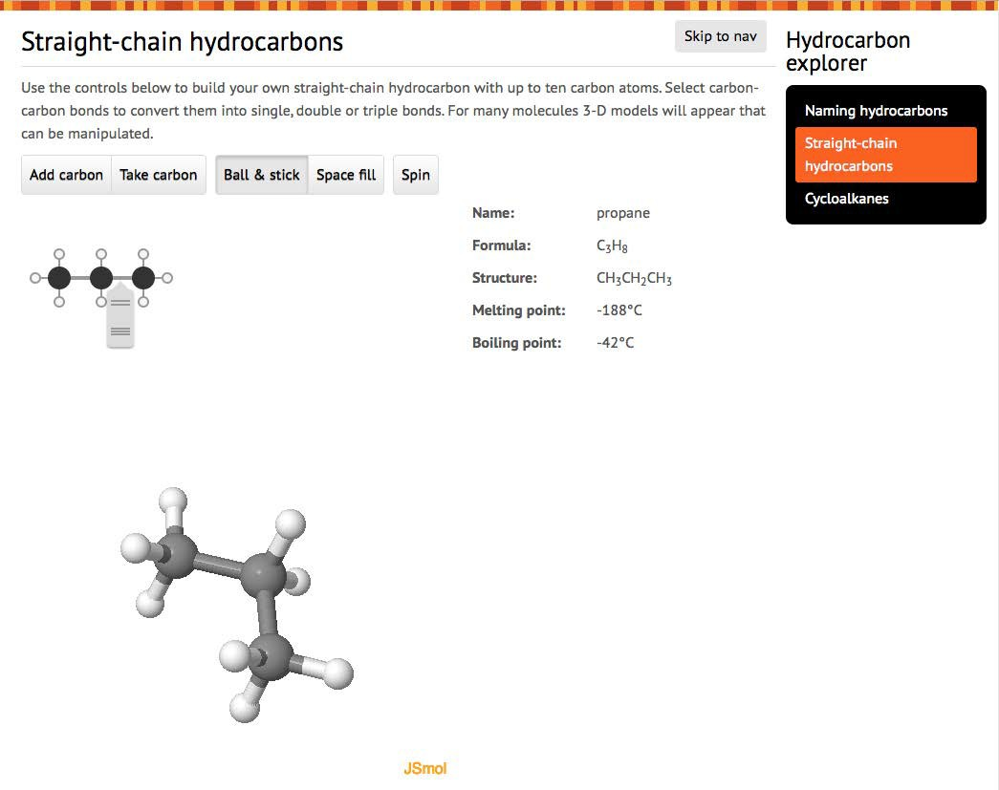

C

B

A

The second screen of the learning object (Straight- chain hydrocarbons) is divided into three sections (A, B and C), as shown above.
The molecule is built in section A; properties of the molecule are displayed in section B; and a 3-D model displayed in section C.
Initially methane will be displayed. Build a molecule by selecting Add carbon to make progressively longer alkanes (ethane, propane, ... , up to decane). Take carbon reverses the process.
To insert a double or triple bond in the molecule, hover over any carbon-carbon bond in section A to display a pop-up bond menu. Select the bond type you want. Neighbouring bonds will be changed if the molecule you create is not possible (eg if you select a triple bond next to an existing double bond then the double bond will be reduced to a single bond).
As the molecule is changed, section B displays its IUPAC name, formula, structure and, where available, its melting point and boiling point.
At the same time, a 3-D ‘Jmol’ model of the molecule is displayed in section C. This model can be rendered as either Ball & stick or Space fill. It can be dragged with the mouse to display the molecule from different view points, or set to Spin automatically.
Additional Jmol options are available by right- clicking in the window (control-click for Macintosh users). A guide to using Jmol is available at http:// wiki.jmol.org/index.php/Mouse_Manual
Select Next to display a similar page for cyclic hydrocarbons (propane to decane).

3-D models are available for only some of the molecules that can be created in the top section. Those currently available in the learning object are listed below.

ALKANES | ALKENES | ALKYNES | CYCLIC HYDROCARBONS
methane | ethene | ethyne | cyclopropane
ethane | propene | propyne | cyclobutane
propane | propa-1,2-diene | but-1-yne | cyclopentane
butane | but-1-ene | but-2-yne | cyclohexane
pentane | but-2-ene | pent-1-yne | cycloheptane
hexane | buta-1,3-diene | pent-2-yne | cyclooctane
heptane | pent-1-ene | hex-1-yne
octane | pent-2-ene | hex-2-yne
nonane | hex-3-ene | hex-3-yne
decane |  | non-1-yne
 |  | nona-1-en-7-yne
 |  | dec-4-yne

Acknowledgements
Original concept design: Don Marshall and Sally Harban (John Curtin College of the Arts).
Designed and developed by the Centre for Learning Technology, The University of Western Australia, Production team: Anton Ball, Alwyn Evans, Bob Fitzpatrick, Jenny Gull, Dan Hutton and Michael Wheatley.
Molecular models in Hydrocarbon explorer are represented using JSmol (an extension of the Java- based molecular visualization applet, Jmol, as an HTML5 JavaScript-only web app). See http://www. jmol.org/ for details.
Jmol data files used to construct the models in
Hydrocarbon explorer come from two sources:
- Prof Albert Pratt, Dublic City University http://webpages.dcu.ie/~pratta/jmgallery/
- Dr Dave Woodcock, Okanagan University College http://elchem.kaist.ac.kr/jhkwak/okanaganpdb97/ molecule/molecule.html

SPICE resources and copyright
All SPICE resources are available from the Centre for Learning Technology at The University of Western Australia (“UWA”). Selected SPICE resources are available through the websites of Australian State and Territory Education Authorities.
Copyright of SPICE Resources belongs to The University of Western Australia unless otherwise indicated.
Teachers and students at Australian schools are granted permission to reproduce, edit, recompile and include in derivative works the resources subject to conditions detailed at spice.wa.edu.au/usage.
All questions involving copyright and use should be directed to SPICE at UWA.
Web: spice.wa.edu.au Email: spice@uwa.edu.au Phone: (08) 6488 3917
Centre for Learning Technology (M016) The University of Western Australia
35 Stirling Highway
Crawley WA 6009

Associated SPICE resources
Hydrocarbon chemistry 3: Naming hydrocarbons may be used in conjunction with related SPICE resources to address the broader topic of organic chemistry.

DESCRIPTION | LEARNING PURPOSE
Hydrocarbon chemistry
This learning pathway shows how a number of SPICE resources can be combined to teach the topic of organic chemistry.
Hydrocarbon chemistry 1: Coconut oil  This resource engages students in organic chemistry by showing them how fuel can be made from plants in a very basic home set-up. | Engage
Hydrocarbon chemistry 2: Biodiesel  This resource further explores biodiesel production as students make their own biodiesel and compare its properties with those of other fuels. | Explore
Hydrocarbon chemistry 3: Naming hydrocarbons  This resource explains to students how hydrocarbons can be drawn and systematically named. | Explain
Hydrocarbon chemistry 4: Hydrocarbon economy  Australia uses a wide range of hydrocarbons for domestic and industrial purposes. How is this range supplied from available sources? | Elaborate

