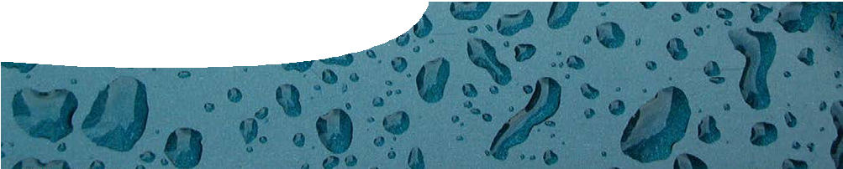
teachers guide
Soft drink science 4
Making soft drink

Components

 | NAME | DESCRIPTION | AUDIENCE
 | Making soft drink  teachers guide | This guide shows how experiments with soft drink can be used to explore the science of solutions. | teachers
 | Investigating solutions procedure sheet | Students use the ingredients of a soft drink to investigate dissolving a solute in a solvent, in both saturated and supersaturated solutions, then use crystallisation to get the solute out of solution. | students
 | Mix your own soft drink  procedure sheet | Students perform a series of procedures to make their own soft drink. | students

Purpose
To investigate solutions using soft drink science. Before using different techniques to make a soft drink, students investigate how solutes are dissolved in solvents to form solutions.

Activity summary
Outcomes
Students:
- understand scientific terminology relating to solutions,
- understand saturated and supersaturated solutions, and
- use crystallisation to separate a solution.

ACTIVITY | POSSIBLE STRATEGY
Students perform experiments described in the procedure sheet, Investigating solutions. | small groups
Students complete questions on the procedure sheet as they work through the experiments. | individual
Students choose a recipe to follow to make a soft drink then complete the activity ‘Adding the fizz’ from the procedure sheet, Mix your own soft drink. | small groups
Students discuss the different methods they have used to separate solutions. | class discussion

Teacher notes

Discussion on methods of separating solutions
Remind students of different separation techniques undertaken over the last few lessons. Start a conversation about what separation techniques they have used, or could use, in making their soft drink.
Procedure, Investigating solutions, Part D: Instant crystallisation
Sodium ethanoate is also known as sodium acetate. It has a variety of uses including as a food additive (E262) and concrete sealant.
A video of the experiment is available at http://www. stevespanglerscience.com/product/instant-hot-ice (select video tab).

To make sodium ethanoate you need: sodium bicarbonate, white vinegar, a microwaveable ceramic container and coffee filters.
Place 1 heaped tablespoon of sodium bicarbonate in container. Add vinegar, a little at a time, until mixture stops bubbling. Use microwave to boil down solution to about a tenth of its volume. This will take about
20 minutes, but stop when you hear popping sounds. It should still be liquid (supersaturated solution).
Caution: container will be hot!
Allow to cool to a translucent gel. Scrape gel from container and transfer to coffee filters. Allow to dry to a powder, then grind to break up powder. If it is sticky return to coffee filters to dry further.

Mix your own soft drink
This activity must be carried out in a Home Economics area or similar. No food should be prepared or consumed in a science laboratory.

Ways to add fizz to a drink
There are a couple of ways to add carbon dioxide to drinks to make them fizz.
- Dry ice can be used to carbonate water and other drinks. Place drink in a cup and add some dry ice, allow it to bubble. When all the dry ice is gone, the drink remaining should be slightly bubbly.
- Commercial drink makers using carbon dioxide gas cylinders can be used to create carbonated drinks. Costs range from $40–$100.
- Sodium bicarbonate can be used in drinks with an acidic substance (such as lemon). Most recipes
suggest 2 teaspoons sodium bicarbonate per litre of water.

Technical requirements
The teachers guide and procedure sheets require Adobe Reader (version 5 or later), which is a free download from www.adobe.com. The procedure sheets are also provided in Microsoft Word format.

Safety notes

Sodium ethanoate
caution: may cause irritation to skin, eyes and respiratory system
SAF-T-DATA ratings
- health rating: 1 – slight
- flammability rating: 0 – none
- reactivity rating: 0 – none
- contact rating: 1 – slight
Lab protective equipment: goggles, lab coat Storage colour code: orange (general storage)

Acknowledgements
Designed and developed by the Centre for Learning Technology, The University of Western Australia.
Production team: Jan Dook, Alwyn Evans, Bob Fitzpatrick, Sally Harban, Dan Hutton, Emma Pointon, Paul Ricketts, Jodie Ween, Michael Wheatley, with thanks to Wendy Sanderson and Charmaine White.

SPICE resources and copyright
All SPICE resources are available from the Centre for Learning Technology at The University of Western Australia (“UWA”). Selected SPICE resources are available through the websites of Australian State and Territory Education Authorities.
Copyright of SPICE Resources belongs to The University of Western Australia unless otherwise indicated.
Teachers and students at Australian schools are granted permission to reproduce, edit, recompile and include in derivative works the resources subject to conditions detailed at spice.wa.edu.au/usage.
All questions involving copyright and use should be directed to SPICE at UWA.
Web: spice.wa.edu.au Email: spice@uwa.edu.au Phone: (08) 6488 3917
Centre for Learning Technology (M016) The University of Western Australia
35 Stirling Highway
Crawley WA 6009

Associated SPICE resources
Soft drink science 4: Making soft drink may be used in conjunction with related SPICE resources.

DESCRIPTION | LEARNING PURPOSE
Soft drink science (overview)
This learning pathway shows how a number of SPICE resources can be combined to assist with teaching the topic of states of matter and solutions.
Soft drink science 1: Soft drink fountain  A teacher demonstration engages students’ interest in the three states of matter, solutions and separating techniques. | Engage
Soft drink science 2: Investigating soft drink  Students separate and investigate the components of soft drink through practical activities. | Explore
Soft drink science 3: States of matter  Students use worksheets and an interactive learning object to construct an explanation of the particle model of matter. | Explain
Soft drink science 4: Making soft drink  Students investigate solutions and use their knowledge to make a soft drink. | Explore
Soft drink science 5: Solutions  Students use worksheets and an interactive learning object to construct an explanation of separation techniques, using the particle model of matter. | Explain
Soft drink science 6: Separation techniques  A video about a forensic food scientist illustrates the importance of different separation techniques. Students perform their own practical investigation that involves separation techniques. | Elaborate

