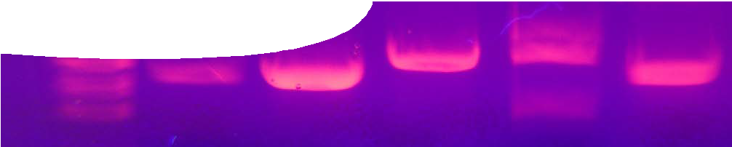
teachers guide
Proteins 2:
Looking at proteins

Components

 | NAME | DESCRIPTION | AUDIENCE
 | Looking at proteins  teachers guide | This guide provides background information for teachers on protein electrophoresis. Protocols for preparation of required reagents and agar gels are included. | teachers
 | Protein electrophoresis  procedure sheet | This procedure describes a method for visualising proteins, using gel electrophoresis. | students
 | Protein visualisation  fact sheet | This fact sheet provides an overview of proceures for gel electrophoresis and western blotting. | students

Purpose
To Explore how proteins may be visualised in the laboratory.

Activity summary
Outcomes
Students:
- separate proteins in tissue samples, using gel electrophoresis; and
- make observations of results and discuss ways that further analysis may quantify proteins.

ACTIVITY | POSSIBLE STRATEGY
Students read the first part of the fact sheet, Protein visualisation, then complete parts II, III and IV of Protein electrophoresis (assuming solutions in part I have been prepared by teacher or laboratory technician). Students examine their gels to compare and contrast proteins in each sample. | individually or in small groups
Students complete reading the fact sheet, Protein visualisation, and discuss why it may be useful to determine the quantity of protein found in a sample. | individually or in pairs, with teacher-led discussion

Notes on gel electrophoresis
Gel electrophoresis is useful in determining whether a protein is present in a sample, however further treatment, such as western blotting, is required to quantify its amount. Protein is transferred from a gel to a stable membrane then exposed to specific antibodies.
Western blotting can also be diagnostic, eg detection of HIV antibodies in human serum by exposure to a membrane carrying HIV proteins. If a serum contains antibodies that bind to target proteins, then a positive result can be seen through chemiluminescent detection. Additionally, western blotting may be used to detect protein expression in certain cancers, and
to detect antibodies to bovine spongiform encephaly (BSE or mad cow disease).

Following western blotting, quantification of a protein is performed using densitometry. A western blot that has been exposed to antibody, and a chemiluminescent agent, is placed in a densitometer. A light beam is shone through and the amount of light disruption measured. Proteins present in large amounts disrupt the light beam more than those present in small amounts. Samples are compared with standards to determine how much protein is present.

Procedure notes
Gel electrophoresis is a technique used to isolate and identify proteins through visualisation on a gel. While this protocol uses an agarose gel, most laboratories use SDS polyacrylamide gels that result in better protein band resolution. SDS polyacrylamide gels are not recommended for classroom laboratories as required chemicals are toxic.
In this activity, samples of beef, pork, chicken, lamb, fish or any other protein-based tissues, are chemically and physically prepared, then loaded into an agarose gel to separate component molecules. After staining, students observe banding on gels and comment on similarities and differences between samples.
The laboratory procedure contains four parts: gel preparation, sample preparation, sample electrophoresis, and gel staining and analysis.
- To save time, part I may be done by a laboratory technician. Two buffers, a fixative and a stain are required. These solutions may be purchased, or prepared a day or two before the laboratory is scheduled, then stored at room temperature.
Instructions for preparation of these solutions may be found in Appendix 1 of this guide. Instructions for preparation of agarose gels (part I of the procedure) may be found in Appendix 2 of this guide.
- Part II can be completed in one 40-60 minute lesson. Samples may be kept overnight, on ice, if required.
- Teachers should instruct students on handling and use of micropipettes, prior to starting part III of this activity. Before loading their samples, it is
strongly advised that students have opportunities to practise pipetting. Coloured water is suitable for this purpose.
- Part III takes approximately 60 minutes. Electrophoresis equipment should be set up somewhere where it will not be disturbed whilst connected to a power supply (eg laboratory preparation area).
- In part IV, gels are stained and left overnight.
De-staining time can vary in length, but changing distilled water at least three or four times over a day should result in sufficiently clear, dark bands.
- Glacial acetic acid is required in fixative and stain solutions. As it is deemed a flammable, corrosive liquid it is recommended that lab technicians prepare these solutions and that usual safety precautions (ie safety glasses and gloves) be taken when students are using them.

Suggested answers to questions in the procedure,
Protein electrophoresis
- Small, light proteins move the greatest distance through the gel, while large, heavy proteins move the shortest distance.
- Samples were physically broken apart (a small piece cut off and shaken in buffer) to expose proteins from all cell types, in the tissue sample. The buffer used contains a detergent, SDS. This has three functions: it coats proteins to give them an overall negative charge that causes them to move towards the positive anode when current is applied; it causes lipid-based cell membranes to break down and release proteins; and it partially denatures proteins. Heating totally disrupts a protein’s 3-D structure, making it more linear, so it moves more easily through the gel.
- Species that share similar proteins may be more closely related than those that do not. Protein comparison can be used to establish evolutionary relatedness between species.

Acknowledgements
Special thanks to Steve Garrett of Bio-Tek Australia and Associate Professor Elizabeth Quail (School of Chemistry and Biochemistry, UWA) for their assistance in development of the protocol.
Designed and developed by the Centre for Learning Technology, The University of Western Australia.
Production team: Helen Billiald, Pauline Charman, Jan Dook, Alwyn Evans, Dan Hutton, Bec McKinney, Emma Pointon Jodie Ween and Michael Wheatley, Paul Ricketts. Thanks to Bob Fitzpatrick, Jenny Gull, Charmaine White and Wendy Sanderson.

Technical requirements
The teachers guide, procedure sheet and fact sheet require Adobe Reader (version 5 or later), which is a free download from www.adobe.com.

SPICE resources and copyright
All SPICE resources are available from the Centre for Learning Technology at The University of Western Australia (UWA). Selected SPICE resources are available through the websites of Australian State and Territory Education Authorities.
Copyright of SPICE Resources belongs to The University of Western Australia unless otherwise indicated.
Teachers and students at Australian schools are granted permission to reproduce, edit, recompile and include in derivative works the resources subject to conditions detailed at spice.wa.edu.au/usage.
All questions involving copyright and use should be directed to SPICE at UWA.
Web: spice.wa.edu.au Email: spice@uwa.edu.au Phone: (08) 6488 3917
Centre for Learning Technology (M016) The University of Western Australia
35 Stirling Highway
Crawley WA 6009

Associated SPICE resources
Proteins 2: Looking at proteins may be used in conjunction with related SPICE resources to teach the topic of proteins.

DESCRIPTION | LEARNING PURPOSE
Proteins (overview)
This learning pathway shows how a number of SPICE resources can be combined to teach the topic of proteins.
Proteins 1: The importance of proteins  A video highlights the essential role played by proteins in living organisms. | Engage
Proteins 2: Looking at proteins  Students complete a practical activity to isolate and visualise proteins in tissue samples, using gel electrophoresis. | Explore
Proteins 3: Protein molecules  Students work through an interactive learning object that explains the molecular structure of proteins. | Explain
Proteins 4: Making proteins  Students work through an interactive learning object that explains how proteins are made by living organisms. A fact sheet summarises the main stages of transcription and translation. | Explain
Proteins 5: Defective proteins  What happens when the process of protein formation goes wrong? A case study about Kuro disease explains some implications. | Elaborate

APPENDIX 1: Protocols for the preparation of buffers, fixative and stain

This laboratory procedure requires preparation of two buffers, a fixative and a stain. These solutions may be purchased pre-prepared or prepared a day or two before the laboratory is scheduled, and stored at room temperature.

Tris-glycine SDS buffer (TGS), pH 8.3
If you are provided with, or purchase, a buffer solution it is likely to be at 10X concentration. See instructions below to dilute it to concentration required for part III of the procedure.
Each group will require 20 ml 10X TGS buffer and 250 mL dilute TGS buffer (assuming they are using a single tank). A large tank, able to hold six gels, requires 1 L of dilute TGS buffer.

Materials
- 3.03 g tris
- 14.41 g glycine
- 1.0 g SDS (sodium docecyl sulfate)
- distilled water

Method
To make 100 mL 10X TGS buffer:
- Dissolve tris, glycine and SDS in about 50 mL distilled water.
- Make up to 100 mL with distilled water. To make dilute TGS buffer:
- Dilute 10X TGS buffer (as prepared above) with water in the ratio 10 parts buffer to 90 parts water.
Dilute buffer solution contains:
- 25 mM tris (formula weight 121.4),
- 192 mM glycine (formula weight 75.07) and
- 0.1% SDS.

Laemmli sample buffer
Each group will need 250 μL Laemmli sample buffer per tissue sample.

Materials
- 1.52 g tris
- 1M hydrochloric acid
- 20 mL 20% SDS solution (4 g SDS dissolved in 20 mL water)
- 25 mL glycerol
- 0.05 g bromophenol blue
- water

Method
To make 100 mL Laemmli sample buffer:
- Dissolve tris in approximately 20 mL water.
- Adjust to pH 6.8 with 1M HCl then add water to make up to 30 mL.
- Prepare 20 mL 20% SDS solution (dissolve 4 g SDS in 20 mL water).
- Combine prepared tris and SDS solutions, add 25 mL glycerol and stir until homogenous.
- Add 0.05 g bromophenol blue.
- Make up to 100 mL with water (approximately 5 mL should be required).
This solution is viable for 12 months when stored at room temperature.
Laemmli sample buffer contains:
- 125 mM tris (formula weight 121.14)
- 4% SDS
- 25% glycerol
- 0.05% bromophenol blue

Fixative
Each group will require 100 mL fixative.

Materials
- 10 mL glacial acetic acid
- 40 mL methanol
- 50 mL distilled water

Method
1. Combine all materials and stir until homogenous.

Stain
Each group will require 100 mL stain.

Materials
- 10 mL glacial acetic acid
- 40 mL methanol
- 0.1% Coomassie Brilliant Blue R-250
- 50 mL distilled water

Method
1. Combine all materials and stir until homogenous.

Appendix 2: Gel preparation (3% agarose)

This is part 1 of the procedure, Protein electrophoresis.

Materials
These quantities will make about six gels.
- 6 g agarose powder
- 20 mL 10X TGS buffer (warm)
- 180 mL distilled water
- 50 mL measuring cylinder
- 200 mL measuring cylinder
- electronic balance
- petri dish
- spatula
- 500 mL beaker for waste

Method

- 250 mL conical flask
- mould/casting tray and comb
- masking tape
- cling film
- pipette tip (for removing bubbles)
- gloves
- safety glasses
- access to microwave oven
- paper towel or tea towel

Ensure you are wearing gloves and safety glasses before beginning.

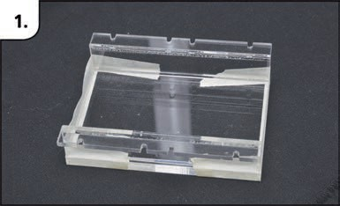 | - Tape ends of mould/casting tray tightly.  - Make sure tape extends over sides and bottom edges so there is a good seal when pressed into place.
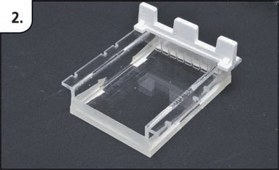 | - Put comb in place, across notches at one end of tray.
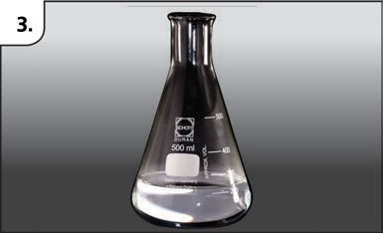 | - Place agarose and distilled water in conical flask.  - Cover with cling film and heat in microwave, in 60 second bursts, agitating gently in between, until gel is dissolved. Monitor carefully.  - Continue until solution begins to boil.
4. Allow to boil for 15 seconds then carefully remove (you may need to use paper towel or tea towel to protect your hands). Allow to cool for 1-2 mins.
5. Return flask to microwave and heat until boiling. Boil for 15 seconds, remove and cool. If agarose crystals still undissolved, repeat until they are gone and solution is clear.
6. Add 20 mL warm 10X TGS buffer, gently swirl to mix. Avoid shaking and formation of air bubbles.

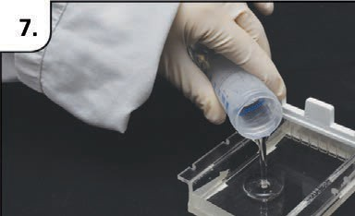 | - Pour 25 mL liquid agarose into mould/casting tray while hot (50-55°C).
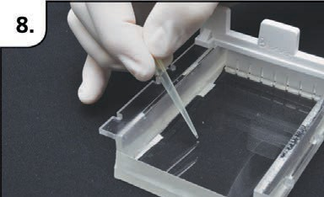 | - Use pipette tip to carefully drag any bubbles to side.  - Allow to set (approximately 20 minutes).
Gels must be handled carefully after they have set. Store them where they will not be damaged or dry out before use. Careful wrapping in cling film may help.

